吉林省医疗保障信息平台事前提醒

联调方案（基线版1.5）

目 录

吉林省医疗保障信息平台事前提醒联调方案（基线版1.5）
1组织接口改造 - 4 -
2触发场景 - 4 -
3接入流程 - 5 -
4上线试运行阶段 - 9 -
5系统访问地址： - 9 -
5.1正式系统 - 9 -
5.2测试地址 - 9 -
6联调沟通方式 - 9 -
7数据字典 10
8附录 10

版本号 | 更改条款及内容 | 更改日期
1.0 | 吉林省医疗保障信息平台事前提醒联调方案基线版 | 2023-5-19
1.1 | 替换数据字典 | 2023-06-25
1.2 | 事中接口3102作废，事中接口3102合并为3101接口 | 2024-12-20
1.3 | 修改事前提醒、事中字典表为1.1 | 2025-07-15
1.4 | 修改事前提醒、事中字典表为1.2，修改附录样例报文 | 2025-08-15
1.5 | 优化方案中的文字描述 | 2026-02-11

一、组织接口改造
由定点医药机构信息系统开发商根据吉林省医疗保障信息平台定点基线版医药机构接口规范(最新版，下载方式请进入吉林省医疗保障公共服务平台“定点医药机构专版”下载)，对当前定点医药机构信息系统进行接口改造开发，具体开发接口如下：

表1 接口改造清单
序号 | 接口名称 | 说明
1 | 【3101】明细审核事前提醒分析服务 | 必须实现
2 | 【3103】事前提醒服务反馈服务 | 必须实现
明细审核事前提醒分析服务：是在患者就诊登记、医师开具处方、护士执行医嘱、实际结算或预结算等场景时，通过调用事前提醒服务，返回违规提醒结果，并告知医疗服务提供者。
事前提醒服务反馈服务：通过此交易进行事前提醒后医药机构端的处理方式（继续执行医嘱（处方）、返回修改医嘱（处方））的信息采集功能。

二、触发场景
下表为事前提醒分别对应触发场景，定点医药机构会在不同的场景下调用事前提醒接口、事前提醒服务反馈服务。反馈服务触发场景在调用事前提醒接口后，用于反馈给出提醒后继续执行医嘱（处方）、返回修改医嘱（处方）。

表2 触发场景清单
接口编号 | 规则类型 | 触发场景编码(trig_scen) | 触发场景名称
3101 | 事前提醒 | 1 | 门诊挂号
3101 | 事前提醒 | 2 | 门诊收费登记
3101 | 事前提醒 | 3 | 住院登记
3101 | 事前提醒 | 4 | 住院收费登记
3101 | 事前提醒 | 5 | 住院执行医嘱
3101 | 事前提醒 | 6 | 门诊结算
3101 | 事前提醒 | 7 | 门诊预结算
3101 | 事前提醒 | 8 | 住院结算
3101 | 事前提醒 | 9 | 住院预结算
3101 | 事前提醒 | 10 | 购药划卡

三、接入流程

3.1事前提醒流程说明
定点医药机构在患者办理门诊挂号、门诊收费登记、住院登记、住院收费登记、住院执行医嘱时、门诊结算、门诊预结算、住院结算、住院预结算都可以调用明细审核事前提醒分析服务。如下示例为办理住院登记流程调用事前提醒接口流程，其他场景可参考此流程。

3.1.1住院登记流程图
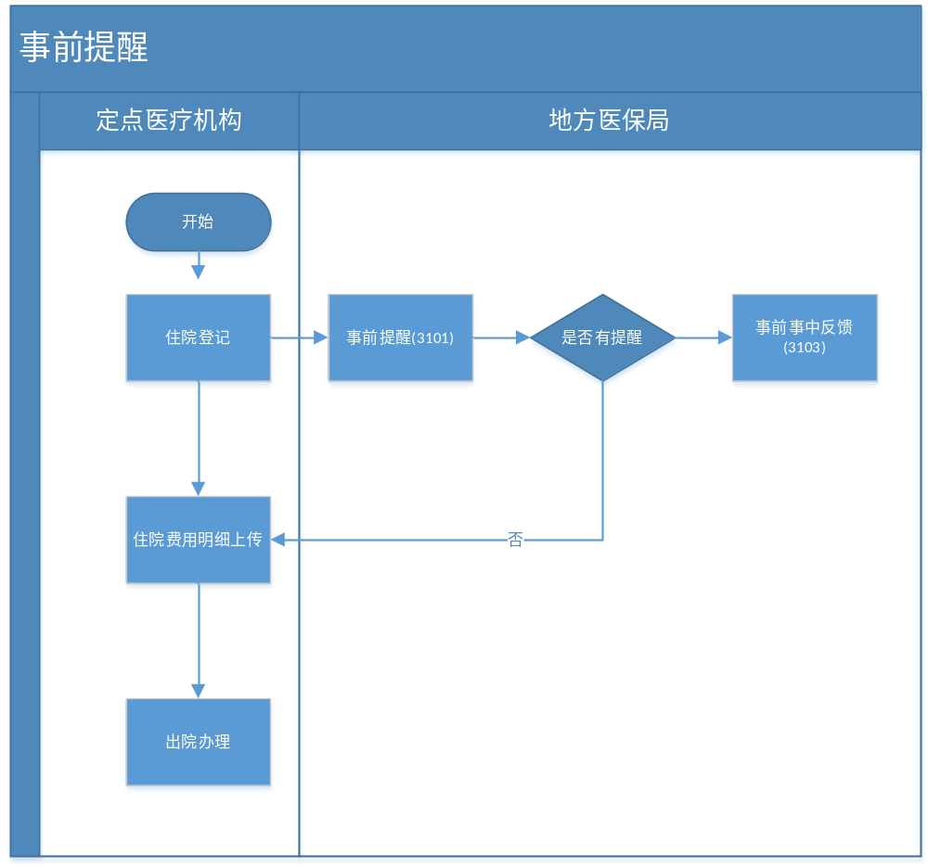
图1住院登记流程图

3.1.2流程说明
1.参保人出示身份证、医保电子凭证等身份证明，医药机构验证其身份；
2.医药机构为参保人办理住院登记后，调用医保局事前提醒接口，如有提醒，选择继续执行医嘱（处方）或返回修改医嘱（处方）后，调用医保局事前提醒服务反馈接口。
3.调用医保局事前提醒服务反馈接口后继续后续流程操作。

3.1.3住院结算流程图
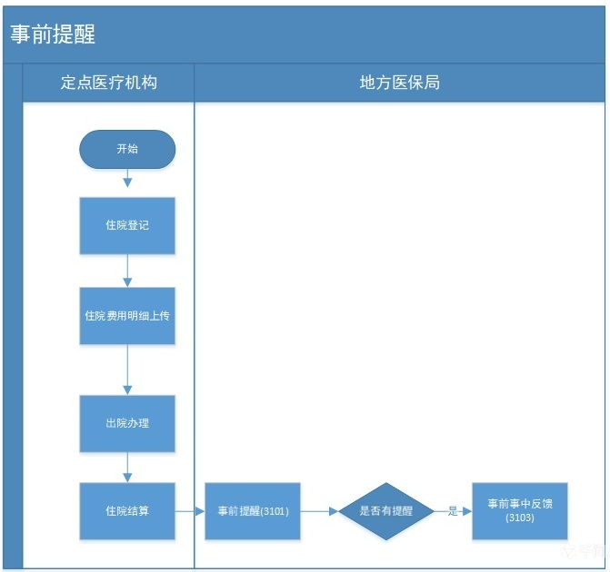
图2住院结算流程图

3.1.4流程说明
1.参保人出示身份证、医保电子凭证等身份证明，医药机构验证其身份；
2.医药机构为参保人办理入院后，上传费用明细；
3.办理出院后，不允许再上传费用明细，医药机构发起住院结算，调用医保局事前提醒接口，如有提醒，选择继续执行医嘱（处方）或返回修改医嘱（处方）后，调用医保局事前提醒服务反馈接口。
4.调用医保局事前提醒服务反馈接口后继续后续流程操作。

3.1.5购药划卡流程图
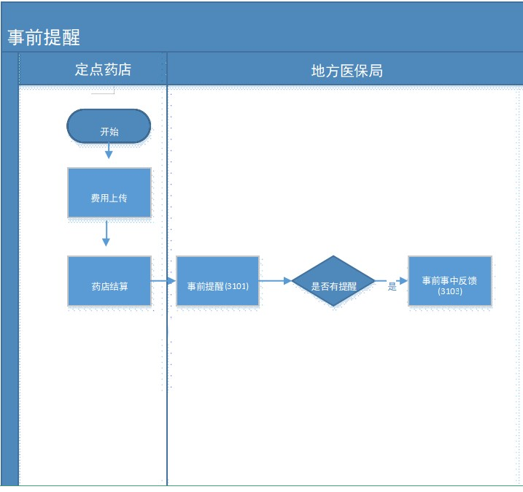
图3购药划卡流程图

3.1.6流程说明
1.参保人出示身份证、医保电子凭证等身份证明，医药机构验证其身份；
2.医药机构为参保人上传费用明细；
3.医药机构发起药店结算，调用医保局事前提醒接口，如有提醒，选择继续执行医嘱（处方）或返回修改医嘱（处方）后，调用医保局事前提醒服务反馈接口；
4.调用医保局事前提醒服务反馈接口后继续后续流程操作。

四、上线试运行阶段
定点医药机构系统开发商在接口开发完成后，在测试环境与医保系统联调并通过后再在正式环境下使用。

五、系统访问地址

5.1正式系统
正式医保接口地址： http://ddjk.jlhs.gov.cn:20215/mbs/fmi/fsi/api/callFsiService/callService

5.2测试地址
测试医保接口地址：http://10.47.0.126:8080/mbs/fmi/fsi/api/callFsiService/callService

六、联调沟通方式
如存在技术问题，请定点医药机构系统开发商在每个地市的HIS接口运维群与我们负责的“基金监管-赵振兴”工程师联系。电话：13944190707

七、数据字典
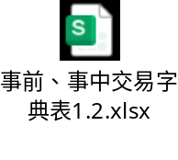
注意：接口中入参涉及到字段内容必须严格按照数据字典内容输入。

八、附录
1.明细审核事前提醒分析服务示例代码
1.1 报文输入示例-明细审核事前提醒分析服务
{
"input": {
"data": {
"syscode": "ims",
"rule_ids": null,
"task_id": null,
"trig_scen": "2",
"patient_dtos": [
{
"patn_id": "149402417",
"patn_name": "公务员退休",
"gend": "1",
"brdy": "1919-01-01",
"poolarea": "220299",
"curr_mdtrt_id": "149402417",
"fsi_encounter_dtos": [
{
"mdtrt_id": "149402417",
"medins_id": "H22020300392",
"medins_name": "测试医院",
"medins_admdvs": "220299",
"medins_type": "A",
"medins_lv": "11",
"wardarea_codg": null,
"wardno": null,
"bedno": null,
"adm_date": "2023-07-30 10:58:54",
"dscg_date": "2023-08-30 10:58:54",
"dscg_main_dise_codg": "Z00.001",
"dscg_main_dise_name": "Z00.001",
"fsi_diagnose_dtos": [
{
"dise_id": "Z00.001",
"inout_dise_type": "1",
"maindise_flag": "1",
"dias_srt_no": "1",
"dise_codg": "N80.809",
"dise_name": "胸腔子宫内膜异位症",
"dise_date": "2023-08-30 08:46:02"
}
],
"dr_codg": "D220104017206",
"adm_dept_codg": "A50.03 ",
"adm_dept_name": "普通妇一科",
"dscg_dept_codg": "A50.03 ",
"dscg_dept_name": "普通妇一科",
"med_mdtrt_type": "2",
"med_type": "21",
"fsi_order_dtos": [
{
"rx_id": "1054440262",
"rxno": "1024313560",
"grpno": null,
"long_drord_flag": "0",
"hilist_type": "101",
"chrg_type": "05",
"drord_bhvr": "0",
"hilist_code": "ZD02AAK0062010305555",
"hilist_name": "抗妇炎胶囊0.35g*48粒",
"hilist_dosform": "120312",
"hilist_lv": "01",
"hilist_pric": 0.0,
"lv1_hosp_item_pric": null,
"lv2_hosp_item_pric": null,
"lv3_hosp_item_pric": null,
"hilist_memo": null,
"hosplist_code": "24408",
"hosplist_name": "抗妇炎胶囊0.35g*48粒",
"hosplist_dosform": "120312",
"cnt": 1.0,
"pric": 31.92,
"sumamt": 31.92,
"ownpay_amt": 0.0,
"selfpay_amt": 0.0,
"spec": "0.35g*48粒",
"spec_unt": "盒",
"drord_begn_date": "2023-08-30 08:55:59",
"drord_stop_date": "2023-08-30 08:55:59",
"drord_dept_codg": "A50.03 ",
"drord_dept_name": "普通妇一科",
"drord_dr_codg": "D220104017206",
"drord_dr_name": "测试医生",
"drord_dr_profttl": "1",
"curr_drord_flag": "1"
},
{
"rx_id": "1054440261",
"rxno": "1024313560",
"grpno": null,
"long_drord_flag": "0",
"hilist_type": "101",
"chrg_type": "05",
"drord_bhvr": "0",
"hilist_code": "003112010130000-A311201013",
"hilist_name": "连花清瘟颗粒6g*10袋",
"hilist_dosform": "120312",
"hilist_lv": "01",
"hilist_pric": 0.0,
"lv1_hosp_item_pric": null,
"lv2_hosp_item_pric": null,
"lv3_hosp_item_pric": null,
"hilist_memo": null,
"hosplist_code": "22697",
"hosplist_name": "连花清瘟颗粒6g*10袋",
"hosplist_dosform": "120312",
"cnt": 3.0,
"pric": 23.57,
"sumamt": 70.71,
"ownpay_amt": 0.0,
"selfpay_amt": 0.0,
"spec": "6g*10袋",
"spec_unt": "盒",
"drord_begn_date": "2023-08-30 08:55:59",
"drord_stop_date": "2023-08-30 08:55:59",
"drord_dept_codg": "A50.03 ",
"drord_dept_name": "普通妇一科",
"drord_dr_codg": "D220104017206",
"drord_dr_name": "测试医生",
"drord_dr_profttl": "1",
"curr_drord_flag": "1"
},
{
"rx_id": "1054440263",
"rxno": "1024313560",
"grpno": null,
"long_drord_flag": "0",
"hilist_type": "101",
"chrg_type": "05",
"drord_bhvr": "0",
"hilist_code": "XG01AXT021A009010204021",
"hilist_name": "盐酸特比萘芬阴道泡腾片50mg*7片",
"hilist_dosform": "120312",
"hilist_lv": "01",
"hilist_pric": 0.0,
"lv1_hosp_item_pric": null,
"lv2_hosp_item_pric": null,
"lv3_hosp_item_pric": null,
"hilist_memo": null,
"hosplist_code": "24656",
"hosplist_name": "盐酸特比萘芬阴道泡腾片50mg*7片",
"hosplist_dosform": "120312",
"cnt": 1.0,
"pric": 41.58,
"sumamt": 41.58,
"ownpay_amt": 0.0,
"selfpay_amt": 0.0,
"spec": "50mg*7片",
"spec_unt": "盒",
"drord_begn_date": "2023-08-30 08:55:59",
"drord_stop_date": "2023-08-30 08:55:59",
"drord_dept_codg": "A50.03 ",
"drord_dept_name": "普通妇一科",
"drord_dr_codg": "D220104017206",
"drord_dr_name": "测试医生",
"drord_dr_profttl": "1",
"curr_drord_flag": "1"
},
{
"rx_id": "1542699439",
"rxno": "1467923472",
"grpno": null,
"long_drord_flag": "0",
"hilist_type": "201",
"chrg_type": "05",
"drord_bhvr": "0",
"hilist_code": "001206000020000-120600002",
"hilist_name": "大换药（创面在30-50cm2（含50cm2）之间）",
"hilist_dosform": "",
"hilist_lv": "01",
"hilist_pric": 0.0,
"lv1_hosp_item_pric": null,
"lv2_hosp_item_pric": null,
"lv3_hosp_item_pric": null,
"hilist_memo": null,
"hosplist_code": "55261",
"hosplist_name": "大换药（创面在30-50cm2（含50cm2）之间）",
"hosplist_dosform": "",
"cnt": 2.0,
"pric": 40.0,
"sumamt": 80.0,
"ownpay_amt": 0.0,
"selfpay_amt": 0.0,
"spec": "次",
"spec_unt": "次",
"drord_begn_date": "2023-08-30 08:55:52",
"drord_stop_date": "2023-08-30 08:55:52",
"drord_dept_codg": "A50.03 ",
"drord_dept_name": "普通妇一科",
"drord_dr_codg": "D220104017206",
"drord_dr_name": "测试医生",
"drord_dr_profttl": "1",
"curr_drord_flag": "1"
},
{
"rx_id": 28667187,
"rxno": 28667186,
"grpno": "",
"long_drord_flag": "0",
"hilist_type": "201",
"chrg_type": "05",
"drord_bhvr": "0",
"hilist_code": "002206000010000220600001",
"hilist_name": "普通心脏M型超声检查",
"hilist_dosform": "",
"hilist_lv": "01",
"hilist_pric": "6.00",
"lv1_hosp_item_pric ": "",
"lv2_hosp_item_pric ": "",
"lv3_hosp_item_pric ": "",
"hilist_memo": "",
"hosplist_code": "220600001",
"hosplist_name": "普通心脏M型超声检查",
"hosplist_dosform": "",
"cnt": 1,
"pric": "6.00",
"sumamt": "6.00",
"ownpay_amt": "6.00",
"selfpay_amt": "6.00",
"spec": "-",
"spec_unt": "次",
"drord_begn_date": "2023-09-03 23:47:00",
"drord_stop_date": "",
"drord_dept_codg": "0200044",
"drord_dept_name": "综合内科",
"drord_dr_codg": "D220322000519",
"drord_dr_name": "吴岩",
"drord_dr_profttl": "233",
"curr_drord_flag": "1"
},
{
"rx_id": 28667186,
"rxno": 28667186,
"grpno": "",
"long_drord_flag": "0",
"hilist_type": "201",
"chrg_type": "05",
"drord_bhvr": "0",
"hilist_code": "002206000020000-220600002",
"hilist_name": "普通二维超声心动图",
"hilist_dosform": "",
"hilist_lv": "01",
"hilist_pric": "26.00",
"lv1_hosp_item_pric ": "",
"lv2_hosp_item_pric ": "",
"lv3_hosp_item_pric ": "",
"hilist_memo": "",
"hosplist_code": "220600002",
"hosplist_name": "普通二维超声心动图",
"hosplist_dosform": "",
"cnt": 1,
"pric": "26.00",
"sumamt": "26.00",
"ownpay_amt": "26.00",
"selfpay_amt": "26.00",
"spec": "-",
"spec_unt": "次",
"drord_begn_date": "2023-09-03 23:47:00",
"drord_stop_date": "",
"drord_dept_codg": "0200044",
"drord_dept_name": "综合内科",
"drord_dr_codg": "D220322000519",
"drord_dr_name": "吴岩",
"drord_dr_profttl": "233",
"curr_drord_flag": "1"
},
{
"rx_id": "YZ250708000361",
"rxno": "CF250708000185",
"grpno": 2,
"long_drord_flag": "0",
"hilist_type": "102",
"chrg_type": "05",
"drord_bhvr": "0",
"hilist_code": "ZA12HAX0869040201641",
"hilist_name": "血塞通注射液",
"hilist_dosform": "",
"hilist_lv": "01",
"hilist_pric": 0,
"lv1_hosp_item_pric": "",
"lv2_hosp_item_pric": "",
"lv3_hosp_item_pric": "",
"hilist_memo": "",
"hosplist_code": "YP001137",
"hosplist_name": "血塞通注射液",
"hosplist_dosform": "",
"cnt": 1,
"pric": "21.00",
"sumamt": 21,
"ownpay_amt": 0,
"selfpay_amt": 0,
"spec": "每片重0.24g*100片，一次6片，一次3次",
"spec_unt": "瓶",
"drord_begn_date": "2023-08-30 16:23:41",
"drord_stop_date": "",
"drord_dept_codg": "KS000004",
"drord_dept_name": "慢病科",
"drord_dr_codg": "D220202035793",
"drord_dr_name": "马天文",
"drord_dr_profttl": "234",
"curr_drord_flag": "1"
}
],
"matn_stas": "0",
"medfee_sumamt": 224.21,
"ownpay_amt": 0.0,
"selfpay_amt": 0.0,
"acct_payamt": null,
"ma_amt": null,
"hifp_payamt": 100,
"setl_totlnum": 1,
"insutype": "310",
"reim_flag": "1",
"out_setl_flag": null,
"operation_dtos": []
}
],
"fsi_his_data_dto": {}
}
]
}
},
"infno": "3101",
"msgid": "H22020400020202303231104040942",
"mdtrtarea_admvs": "220299",
"insuplc_admdvs": "220299",
"recer_sys_code": "MBS_LOCAL",
"dev_no": "",
"dev_safe_info": "",
"cainfo": "",
"signtype": "",
"infver": "1.0",
"opter_type": "1",
"opter": "D1069",
"opter_name": "测试医生",
"inf_time": "2023-08-30 11:03:41",
"fixmedins_code": "H22020300392",
"fixmedins_name": "测试医院",
"sign_no": "220000202303230906210106092971"
}

1.2 报文输出示例-明细审核事前提醒分析服务
{
"output": {
"result": [
{
"judge_result_detail_dtos": [
{
"vola_item_type": "1",
"mdtrt_id": "149402417",
"jrd_id": "5112185d-59b2-4d35-a0f2-09998da19582",
"patn_id": "149402417",
"rx_id": "YZ250708000361",
"vola_amt": 21.0
}
],
"rule_id": "220000202507091522001000054004",
"vola_evid": "2",
"mdtrt_id": "149402417",
"rule_name": "药品限制性规则_事前提醒",
"vola_amt_stas": "1",
"jr_id": "d83e4a1f-03ab-4345-b172-1be96c3abf80",
"patn_id": "149402417",
"sev_deg": "1",
"vola_amt": 21.0,
"vola_bhvr_type": "2",
"vola_cont": "根据《国家基本医疗保险、工伤保险和生育保险药品目录》，血塞通注射液限限二级及以上医药机构。，现开具的药品超出医保限定支付范围。"
},
{
"judge_result_detail_dtos": [
{
"vola_item_type": "1",
"mdtrt_id": "149402417",
"jrd_id": "099c3594-c297-4365-880d-dbf5a45ad720",
"patn_id": "149402417",
"rx_id": "",
"vola_amt": 224.21
}
],
"rule_id": "220000202508151458441000056002",
"vola_evid": "基本临床诊疗规范",
"mdtrt_id": "149402417",
"rule_name": "男性患者就诊妇产科_事前提醒",
"vola_amt_stas": "1",
"jr_id": "9795982f-5e12-447e-b169-469a7a15d504",
"patn_id": "149402417",
"sev_deg": "2",
"vola_amt": 224.21,
"vola_bhvr_type": "1",
"vola_cont": "根据参保人信息显示为【男】，但挂了【普通妇一科】"
},
{
"judge_result_detail_dtos": [
{
"vola_item_type": "1",
"mdtrt_id": "149402417",
"jrd_id": "27014d67-9e10-4a54-a15d-a3e5f338362d",
"patn_id": "149402417",
"rx_id": "",
"vola_amt": 224.21
}
],
"rule_id": "220000202505211735481000055008",
"vola_evid": "诊断学",
"mdtrt_id": "149402417",
"rule_name": "单次就诊诊断与患者性别不符_事前提醒",
"vola_amt_stas": "1",
"jr_id": "d9eb5991-b663-4e21-b9b0-85b84dffd761",
"patn_id": "149402417",
"sev_deg": "2",
"vola_amt": 224.21,
"vola_bhvr_type": "1",
"vola_cont": "N80.809/胸腔子宫内膜异位症与患者性别不符，患者性别为男性，却给患者下了女性专有的诊断"
},
{
"judge_result_detail_dtos": [
{
"vola_item_type": "2",
"mdtrt_id": "149402417",
"jrd_id": "1d18d8ae-7f8b-475b-9898-fc02b2e95fff",
"patn_id": "149402417",
"rx_id": "28667186",
"vola_amt": 0.0
},
{
"vola_item_type": "1",
"mdtrt_id": "149402417",
"jrd_id": "5108b8cc-27dc-4819-9472-91f5716e2e2b",
"patn_id": "149402417",
"rx_id": "28667187",
"vola_amt": 6.0
}
],
"rule_id": "220000202404231632051000041006",
"vola_evid": "根据本地《医保诊疗项目收费标准》中的项目内涵及其含义解读，两个项目同时收费属于重复收费",
"mdtrt_id": "149402417",
"rule_name": "单次就诊诊疗项目重复收费_事前提醒",
"vola_amt_stas": "1",
"jr_id": "e380ea90-9844-4bb0-b12b-599c43ef2eac",
"patn_id": "149402417",
"sev_deg": "2",
"vola_amt": 6.0,
"vola_bhvr_type": "2",
"vola_cont": "〖普通二维超声心动图/普通二维超声心动图〗与〖普通心脏M型超声检查/普通心脏M型超声检查〗属同类型项目，已构成项目重复使用"
},
{
"judge_result_detail_dtos": [
{
"vola_item_type": "1",
"mdtrt_id": "149402417",
"jrd_id": "f3e36b43-0240-4faa-b06a-59d0f5c0bff9",
"patn_id": "149402417",
"rx_id": "1054440262",
"vola_amt": 0.0
}
],
"rule_id": "220000202507021536571000055010",
"vola_evid": "为女性使用药品",
"mdtrt_id": "149402417",
"rule_name": "单次就诊性别用药禁忌_事前提醒",
"vola_amt_stas": "1",
"jr_id": "be0fba54-c816-4b80-b6ed-47a30b75d434",
"patn_id": "149402417",
"sev_deg": "2",
"vola_amt": 0.0,
"vola_bhvr_type": "2",
"vola_cont": "[抗妇炎胶囊0.35g*48粒/抗妇炎胶囊0.35g*48粒]为女性使用药物，参保人当前信息显示性别为：男"
},
{
"judge_result_detail_dtos": [
{
"vola_item_type": "1",
"mdtrt_id": "149402417",
"jrd_id": "41519ddd-13a5-4051-a91d-5bcce9c08885",
"patn_id": "149402417",
"rx_id": "1054440263",
"vola_amt": 0.0
}
],
"rule_id": "220000202507021536571000055010",
"vola_evid": "为女性使用药品",
"mdtrt_id": "149402417",
"rule_name": "单次就诊性别用药禁忌_事前提醒",
"vola_amt_stas": "1",
"jr_id": "a8e98078-922d-4eff-878b-cd079f5eed49",
"patn_id": "149402417",
"sev_deg": "2",
"vola_amt": 0.0,
"vola_bhvr_type": "2",
"vola_cont": "[盐酸特比萘芬阴道泡腾片50mg*7片/盐酸特比萘芬阴道泡腾片50mg*7片]为女性使用药物，参保人当前信息显示性别为：男"
}
]
},
"infcode": 0,
"warn_msg": null,
"cainfo": null,
"err_msg": "成功",
"refmsg_time": "20250815150314648",
"signtype": null,
"respond_time": "20250815150314955",
"inf_refmsgid": "220000202508151503140000095029"
}

2.明细审核事前提醒分析服务示例代码
2.1 报文输入示例-明细审核事前提醒分析服务
{
"infno": "3101",
"msgid": "H22032200011-202404221125592",
"mdtrtarea_admvs": "220322",
"insuplc_admdvs": "220322",
"recer_sys_code": "HIS",
"dev_no": "",
"dev_safe_info": "",
"cainfo": "",
"signtype": "",
"infver": "V1.0",
"opter_type": "1",
"opter": "000001",
"opter_name": "系统管理员",
"inf_time": "2024-04-22 11:25:59",
"fixmedins_code": "H22032200011",
"fixmedins_name": "测试医院",
"sign_no": "220000202404220845280111353579",
"input": {
"data": {
"debug": true,
"syscode": "ASZH",
"rule_ids": "",
"ask_id": "",
"trig_scen": "5",
"patient_dtos": {
"patn_id": "744852_3",
"patn_name": "测试人员",
"gend": "女",
"brdy": "1936-02-02",
"poolarea": "220322",
"curr_mdtrt_id": "744852_3",
"fsi_his_data_dto": "",
"fsi_encounter_dtos": {
"mdtrt_id": "744852_3",
"medins_id": "H22032200011",
"medins_name": "测试医院",
"medins_admdvs": "220322",
"medins_type": "A",
"medins_lv": "02",
"wardarea_codg": "",
"wardno": "",
"bedno": "",
"adm_date": "2023-09-03 23:19:00",
"dscg_date": "2023-09-04 11:08:00",
"dscg_main_dise_codg": "K81.900",
"dscg_main_dise_name": "胆囊炎",
"dr_codg": "D220322000519",
"adm_dept_codg": "0200044",
"adm_dept_name": "综合内科",
"dscg_dept_codg": "0200044",
"dscg_dept_name": "综合内科",
"med_mdtrt_type": 2,
"med_type": "21",
"matn_stas": "0",
"medfee_sumamt": 2161.29,
"ownpay_amt": 2161.29,
"selfpay_amt": 2161.29,
"acct_payamt": 0,
"ma_amt": 0,
"hifp_payamt": 100,
"setl_totlnum": 1,
"insutype": "390",
"reim_flag": "1",
"out_setl_flag": "1",
"fsi_operation_dtos": "",
"fsi_diagnose_dtos": [
{
"dise_id": "4287883",
"inout_dise_type": "1",
"maindise_flag": 1,
"dias_srt_no": 1,
"dise_codg": "K81.900",
"dise_name": "胆囊炎",
"dise_date": "2023-09-04 08:51:53"
},
{
"dise_id": "4300744",
"inout_dise_type": "1",
"maindise_flag": 0,
"dias_srt_no": 2,
"dise_codg": "K81.900",
"dise_name": "胆囊炎",
"dise_date": "2023-09-12 10:16:35"
}
],
"fsi_order_dtos": [
{
"rx_id": 28667187,
"rxno": 28667186,
"grpno": "",
"long_drord_flag": "0",
"hilist_type": "201",
"chrg_type": "03",
"drord_bhvr": "1",
"hilist_code": "002206000010000-220600001",
"hilist_name": "普通心脏M型超声检查",
"hilist_dosform": "",
"hilist_lv": "01",
"hilist_pric": "6.00",
"lv1_hosp_item_pric ": "",
"lv2_hosp_item_pric ": "",
"lv3_hosp_item_pric ": "",
"hilist_memo": "",
"hosplist_code": "220600001",
"hosplist_name": "普通心脏M型超声检查",
"hosplist_dosform": "",
"cnt": 1,
"pric": "6.00",
"sumamt": "6.00",
"ownpay_amt": "6.00",
"selfpay_amt": "6.00",
"spec": "-",
"spec_unt": "次",
"drord_begn_date": "2023-09-03 23:47:00",
"drord_stop_date": "",
"drord_dept_codg": "0200044",
"drord_dept_name": "综合内科",
"drord_dr_codg": "D220322000519",
"drord_dr_name": "测试医生",
"drord_dr_profttl": "233",
"curr_drord_flag": "1"
},
{
"rx_id": 28667186,
"rxno": 28667186,
"grpno": "",
"long_drord_flag": "0",
"hilist_type": "201",
"chrg_type": "03",
"drord_bhvr": "1",
"hilist_code": "002206000020000-220600002",
"hilist_name": "普通二维超声心动图",
"hilist_dosform": "",
"hilist_lv": "01",
"hilist_pric": "26.00",
"lv1_hosp_item_pric ": "",
"lv2_hosp_item_pric ": "",
"lv3_hosp_item_pric ": "",
"hilist_memo": "",
"hosplist_code": "220600002",
"hosplist_name": "普通二维超声心动图",
"hosplist_dosform": "",
"cnt": 1,
"pric": "26.00",
"sumamt": "26.00",
"ownpay_amt": "26.00",
"selfpay_amt": "26.00",
"spec": "-",
"spec_unt": "次",
"drord_begn_date": "2023-09-03 23:47:00",
"drord_stop_date": "",
"drord_dept_codg": "0200044",
"drord_dept_name": "综合内科",
"drord_dr_codg": "D220322000519",
"drord_dr_name": "测试医生",
"drord_dr_profttl": "233",
"curr_drord_flag": "1"
}
]
}
}
}
}
}

2.2 报文输出示例-明细审核事前提醒分析服务
{
"output": {
"result": [
{
"judge_result_detail_dtos": [
{
"vola_item_type": "2",
"mdtrt_id": "744852_3",
"jrd_id": "33b7e37e-c5ab-4fbb-a9e4-f5b92bd36657",
"patn_id": "744852_3",
"rx_id": "28667186",
"vola_amt": 0.0
},
{
"vola_item_type": "1",
"mdtrt_id": "744852_3",
"jrd_id": "26cd02e7-5c57-4362-a525-26872e073d66",
"patn_id": "744852_3",
"rx_id": "28667187",
"vola_amt": 6.0
}
],
"rule_id": "220000202404231632051000041006",
"vola_evid": "根据本地《医保诊疗项目收费标准》中的项目内涵及其含义解读，两个项目同时收费属于重复收费",
"mdtrt_id": "744852_3",
"rule_name": "单次就诊诊疗项目重复收费_事前提醒",
"vola_amt_stas": "1",
"jr_id": "845d8687-a24e-4528-8c0a-731f3369e95f",
"patn_id": "744852_3",
"sev_deg": "2",
"vola_amt": 6.0,
"vola_bhvr_type": "2",
"vola_cont": "〖普通二维超声心动图/普通二维超声心动图〗与〖普通心脏M型超声检查/普通心脏M型超声检查〗属同类型项目，已构成项目重复使用"
}
]
},
"infcode": 0,
"warn_msg": null,
"cainfo": null,
"err_msg": "成功",
"refmsg_time": "20250815152539184",
"signtype": null,
"respond_time": "20250815152539375",
"inf_refmsgid": "220000202508151525390000095087"
}

3.事前提醒服务反馈服务示例代码
3.1 报文输入示例-事前提醒服务反馈服务
{
"input": {
"data": {
"warn_type":"2",
"warns":[
{
"warn_rslt_id":"3d932016-ac20-4157-9d1e-d240b6cc3991",(3101中jrd_id)
"dspo_way_rea":"修改医嘱",
"dspo_way":"1"
}
]
}
},
"infno": "3103",
"msgid": "H22010400562202303231104040942",
"mdtrtarea_admvs": "229900",
"insuplc_admdvs": "229900",
"recer_sys_code": "MBS_LOCAL",
"dev_no": "",
"dev_safe_info": "",
"cainfo": "",
"signtype": "",
"infver": "1.0",
"opter_type": "1",
"opter": "D1069",
"opter_name": "张三",
"inf_time": "2023-03-23 11:03:41",
"fixmedins_code": "H22010400562",
"fixmedins_name": "测试医院",
"sign_no": "220000202303230906210106092971"
}

3.2 报文输出示例-事前提醒服务反馈服务
{
"output": null,
"infcode": 0,
"warn_msg": null,
"cainfo": null,
"err_msg": "成功",
"refmsg_time": "20230519144551737",
"signtype": null,
"respond_time": "20230519144551811",
"inf_refmsgid": "220000202305191445510000840260"
}
4.明细审核事前提醒分析服务(药店)示例代码
4.1 报文输入示例-明细审核事前提醒分析服务
{
"input": {
"data": {
"syscode": "ims",
"rule_ids": null,
"task_id": null,
"trig_scen": "10",
"patient_dtos": [
{
"patn_id": "149402417",
"patn_name": "测试药店人员",
"gend": "1",
"brdy": "1998-01-01",
"poolarea": "220299",
"curr_mdtrt_id": "149402417",
"fsi_encounter_dtos": [
{
"mdtrt_id": "149402417",
"medins_id": "P22020300392",
"medins_name": "测试药店",
"medins_admdvs": "220299",
"medins_type": "A",
"medins_lv": "11",
"wardarea_codg": null,
"wardno": null,
"bedno": null,
"adm_date": "2026-03-30 10:58:54",
"dscg_date": "2026-03-30 10:58:54",
"dscg_main_dise_codg": "001",
"dscg_main_dise_name": "默认诊断",
"fsi_diagnose_dtos": [
{
"dise_id": "Z00.001",
"inout_dise_type": "1",
"maindise_flag": "1",
"dias_srt_no": "1",
"dise_codg": "001",
"dise_name": "默认诊断",
"dise_date": "2026-03-30 10:58:54"
}
],
"dr_codg": "D220104017206",
"adm_dept_codg": "LD-99",
"adm_dept_name": "LD-99",
"dscg_dept_codg": "LD-99",
"dscg_dept_name": "LD-99",
"med_mdtrt_type": "3",
"med_type": "41",
"fsi_order_dtos": [
{
"rx_id": "1054440262",
"rxno": "1024313560",
"grpno": null,
"long_drord_flag": "0",
"hilist_type": "101",
"chrg_type": "05",
"drord_bhvr": "0",
"hilist_code": "ZD02AAK0062010305555",
"hilist_name": "抗妇炎胶囊0.35g*48粒",
"hilist_dosform": "120312",
"hilist_lv": "01",
"hilist_pric": 0.0,
"lv1_hosp_item_pric": null,
"lv2_hosp_item_pric": null,
"lv3_hosp_item_pric": null,
"hilist_memo": null,
"hosplist_code": "24408",
"hosplist_name": "抗妇炎胶囊0.35g*48粒",
"hosplist_dosform": "120312",
"cnt": 1.0,
"pric": 31.92,
"sumamt": 31.92,
"ownpay_amt": 0.0,
"selfpay_amt": 0.0,
"spec": "0.35g*48粒",
"spec_unt": "盒",
"drord_begn_date": "2026-03-30 10:58:54",
"drord_stop_date": "2026-03-30 10:58:54",
"drord_dept_codg": "LD-99",
"drord_dept_name": "LD-99",
"drord_dr_codg": "D220104017206",
"drord_dr_name": "默认药师",
"drord_dr_profttl": "1",
"curr_drord_flag": "1"
}
],
"matn_stas": "0",
"medfee_sumamt": 31.92,
"ownpay_amt": 0.0,
"selfpay_amt": 0.0,
"acct_payamt": null,
"ma_amt": null,
"hifp_payamt": 0.0,
"setl_totlnum": 1,
"insutype": "310",
"reim_flag": "1",
"out_setl_flag": null,
"operation_dtos": []
}
],
"fsi_his_data_dto": {}
}
]
}
},
"infno": "3101",
"msgid": "H22020400020202303231104040942",
"mdtrtarea_admvs": "220299",
"insuplc_admdvs": "220299",
"recer_sys_code": "MBS_LOCAL",
"dev_no": "",
"dev_safe_info": "",
"cainfo": "",
"signtype": "",
"infver": "1.0",
"opter_type": "1",
"opter": "D1069",
"opter_name": "测试医师",
"inf_time": "2026-03-30 11:03:41",
"fixmedins_code": "P22020300392",
"fixmedins_name": "测试药店",
"sign_no": "220000202303230906210106092971"
}
4.2 报文输出示例-明细审核事前提醒分析服务
{
"output": {
"result": [
{
"judge_result_detail_dtos": [
{
"vola_item_type": "1",
"mdtrt_id": "149402417",
"jrd_id": "b6df3dcb9f764b1485615b183501cc1b",
"patn_id": "149402417",
"rx_id": "1054440262",
"vola_amt": 31.92
}
],
"rule_id": "220000202603171556171000059004",
"vola_evid": null,
"mdtrt_id": "149402417",
"rule_name": "药品区分性别使用_事前提醒",
"vola_amt_stas": "1",
"jr_id": "3f8e13d1962a41488b732f7431af570a",
"patn_id": "149402417",
"sev_deg": "1",
"vola_amt": 31.92,
"vola_bhvr_type": "2",
"vola_cont": "[抗妇炎胶囊0.35g*48粒/抗妇炎胶囊0.35g*48粒]为女性使用药物，参保人当前信息显示性别为：男"
},
{
"judge_result_detail_dtos": [
{
"vola_item_type": "1",
"mdtrt_id": "149402417",
"jrd_id": "38206dd6c82a4c819c2e54d13ab5c303",
"patn_id": "149402417",
"rx_id": "1054440262",
"vola_amt": 31.92
}
],
"rule_id": "220000202604091214131000061008",
"vola_evid": "为女性使用药品",
"mdtrt_id": "149402417",
"rule_name": "单次就诊性别用药禁忌_事前提醒",
"vola_amt_stas": "1",
"jr_id": "55d962b0d4004350b0c6927c9f9b3eca",
"patn_id": "149402417",
"sev_deg": "2",
"vola_amt": 31.92,
"vola_bhvr_type": "2",
"vola_cont": "[抗妇炎胶囊0.35g*48粒/抗妇炎胶囊0.35g*48粒]为女性使用药物，参保人当前信息显示性别为：男"
}
]
},
"infcode": 0,
"warn_msg": null,
"cainfo": null,
"err_msg": "成功",
"refmsg_time": "20260409121756781",
"signtype": null,
"respond_time": "20260409121756894",
"inf_refmsgid": "220000202604091217560000606066"
}

