Cat–cert
1학기 과제물

학과: ICT 공학계열
학번: 202221124
이름: 윤태호
제출기한:--
스터디 내용: WEB-5

<과제 내용>

[#실습1] -정규표현식

<?php
$word = $_POST['alpha'];
$word2 = $_POST['dot'];
$word3 = $_POST['email'];
if (ereg("^[[:alnum:]]{6,10}$", $word)) { //6~10 영어숫자
echo '6~10word: '.$word."<br>";
} // 자릿수체크
if (ereg("^[[:digit:]]+\.+[[:digit:]]{1,4}$", $word2)) { // 소수점 4자리까지 검사
echo 'number: '.$word2."<br>";
}
if (ereg("^[[:alnum:]]+@+[[:alpha:]]+\.+[[:alpha:]]+$", $word3)) { //이메일양식 검사
echo 'email: '.$word3;
}
?>

<html>
<head>
<h1> 정규식 </h1>
</head>
<body>
<form method= "POST" action= "">
<div> 6~10 </div>
<div> <input type = "input" name = "alpha" \>
<input type="submit" name = "sub"\>
</div>
<div> dot </div>
<div> <input type = "input" name = "dot" \> </div>
<div> e-mail </div>
<div> <input type = "input" name = "email" > </div>
</form>
</body>
</html>

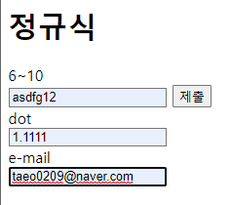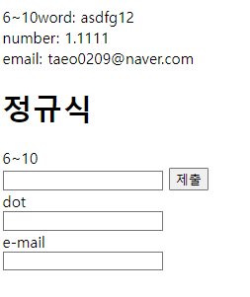

[#과제]

– new/old member 테이블 만들기
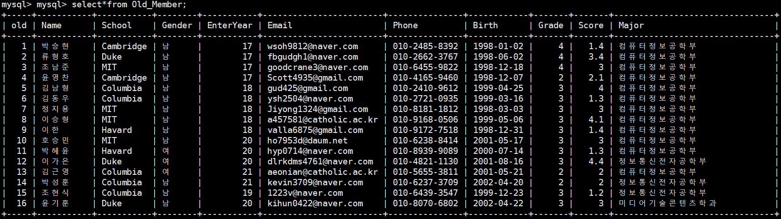
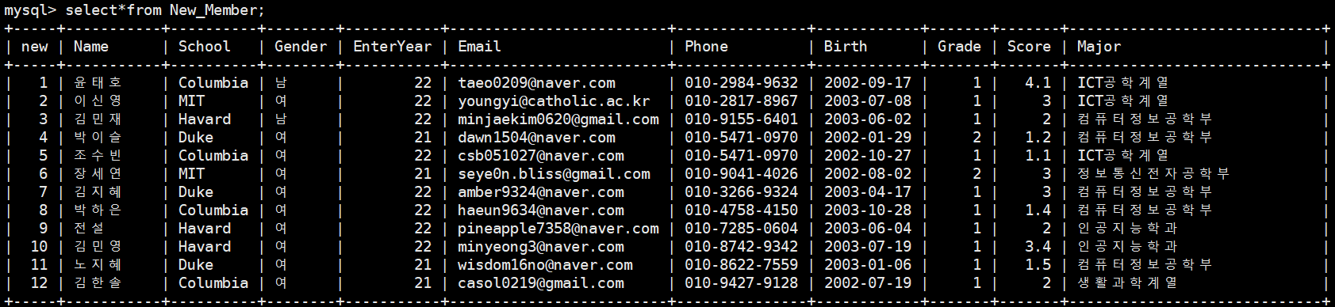
– 입학년도별 인원수 구하기
select count(EnterYear), EnterYear from (select EnterYear from Old_Member union all select EnterYear from New_Member)as two group by EnterYear;

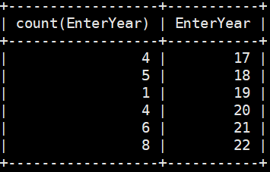

– MIT 학생들의 학교, 이름, 학과 출력
select School, Name, Major from (select School, Name, Major from Old_Member union all select School, Name, Major from New_Member) as t where School='MIT';

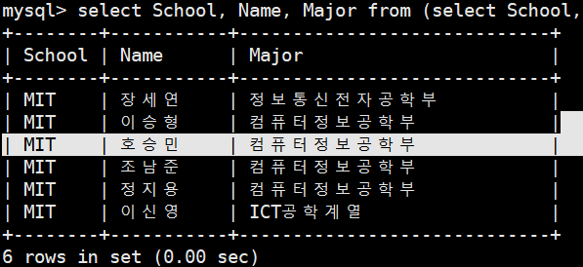
– Duke와 Harvard를 다니는 학생들의 모든 정보 출력
select*from (select*from Old_Member union all select*from New_Member) as t where (School='Duke') or (School = 'Havard');
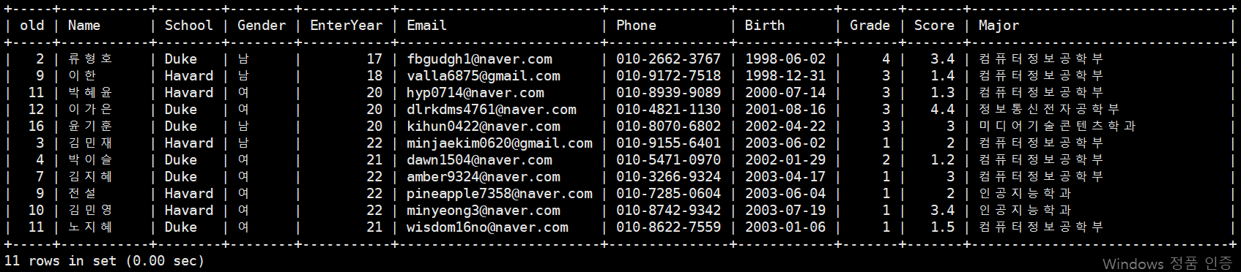

–컴공에 다니지 않는 학생들의 이름/학교/메일주소 출력
select Name, School, Email from (select*from Old_Member union all select*from New_Member) as t where Major !='컴퓨터정보공학부';

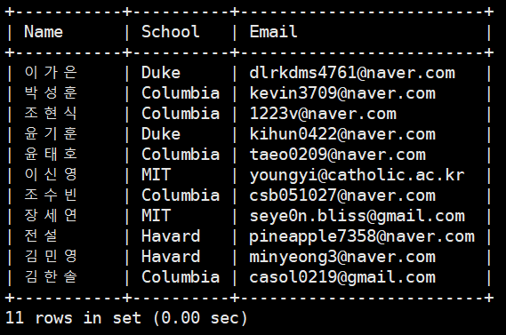
–컴공 학생들의 학교/성별/학번을 내림차순으로 출력
select School, Gender,Grade from (select*from Old_Member union all select*from New_Member) as t where Major ='컴퓨터정보공학부' order by Grade DESC;

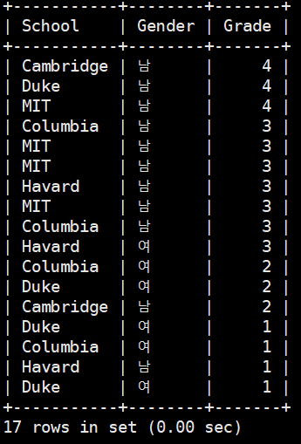

–columbia에 다니는 학생들의 학교를 Yeil로 수정
update Old_Member set School = 'Yeil' where School ='Columbia';
update New_Member set School = 'Yeil' where School ='Columbia';

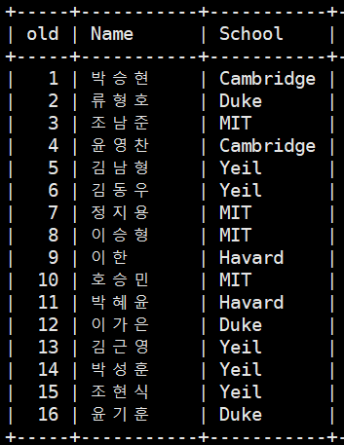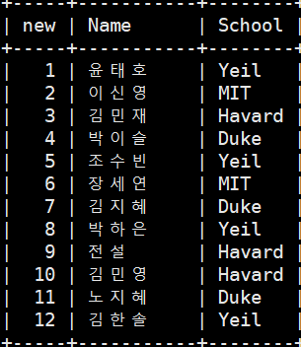

–학생들의 학점 수정하기
update Old_Member set Score = case when Name = "호승민" then 4.5 when Name = "조현식" then 1.9 end where Name="호승민" or Name="조현식";
- Old member
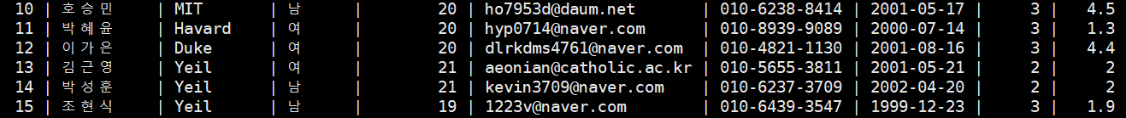

update New_Member set Score = case when Name = "윤태호" then 3 when Name="이신영" then 2 when Name = "노지혜" then 1 when Name="김한솔" then 4 end where Name="윤태호" or Name="이신영" or Name="노지혜" or Name="김한솔";
->New Member
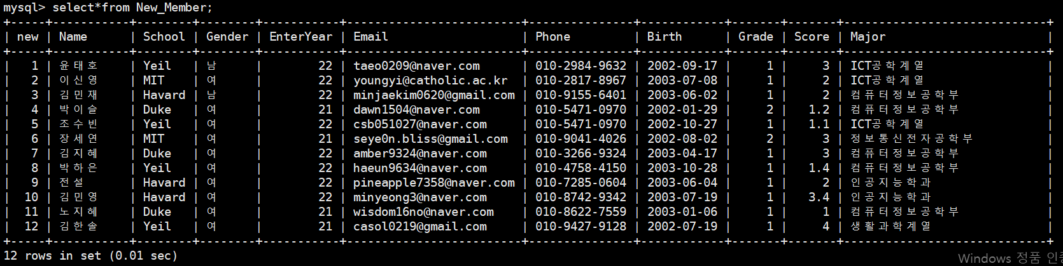

–학점이 1.75 이하의 학생들의 이름출력, 학고 출력
1.
select Name as 학고 from (select*from Old_Member union all select*from New_Member) as 학고 where Score<1.75;
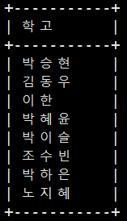
2.
select "학고", Name from (select*from Old_Memmysql> select "학고" Name from (select*from Old_Member union all select*from New_Member) as a where Score<1.75;

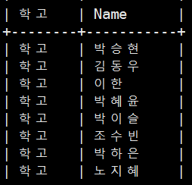

–catholic 와 gmail 사용하는 학생들을
학과(내림) 순으로 정렬하되 같은 학과일 경우, 학번(오름)순으로 정렬 (10)
select Major, EnterYear from Old_Member where EnterYear>18 and Email like '%catholic%' or Email like '%gmail%' order by Major desc, EnterYear asc;

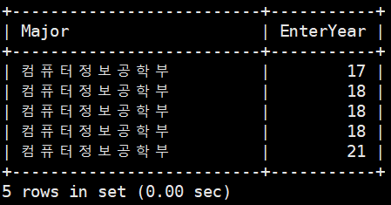

–old_member에서 naver를 사용하는 사람들 중에서 남자가 많으면 ‘남’을 여자가 많으면 ‘여’를 출력하고, 해당 +개수를 출력

select Gender as 성별, count(Gender) as 명수 from (select Gender,Email from Old_Member where Email like '%naver%') as a group by Gender order by count(Gender) desc limit 0,1;

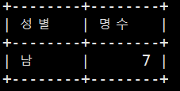

–new_member에서 학점이 가장 높은 사람과 old_member에서 학점이 가장 낮은 사람을 합쳐서 출력

select (select min(Score) from Old_Member) + (select max(Score) from New_Member) as 학점합;

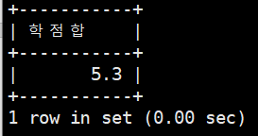

–학점을 기준으로 두 member 테이블을 합쳐서 정렬후 학년별로 학점의 평균계산

select Grade, avg(Score) as 평균 from (select Grade, Score from Old_Member union all select Grade,Score from New_Member) as a group by Grade;

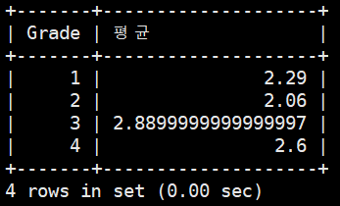

–old_member 와 new_member의 입학년도와 학점 순으로 오름차순 정렬
select EnterYear, Score from (select EnterYear ,Score from Old_Member union all select EnterYear, Score from New_Member) as a order by EnterYear asc, Score asc;
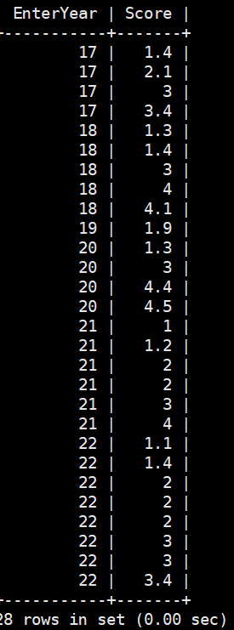
–old_member 의 학번과 동일한 new_member중 학점이 더 높은 사람의 학점과 이름을 출력하시오

select a.Name,a.Score from New_Member as a inner join Old_Member as b on a.EnterYear = b.EnterYear where a.Score > b.Score;
