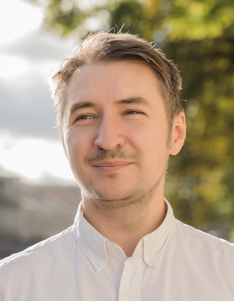
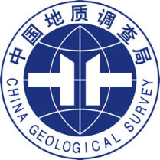
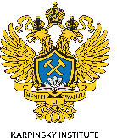
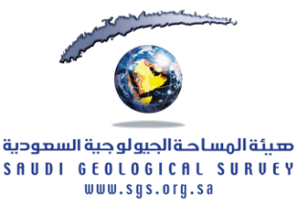

Aleksei Pakhalko

Geologist

Geological Data Automation & QA/QC Specialist
Geologist with 15+ years of experience in geological mapping, petrography, and geochemistry, specializing in digital workflow automation. Developed expertise in VBA scripting for Excel-based data processing and Android application development during the Arabian Shield Mapping Project (GMAS). Successfully integrated IT solutions into field data collection, validation, and reporting pipelines, reducing manual errors and improving operational efficiency.
Saint Petersburg, Russia
Work Experience
2025 — present | Geological mapping of Arabian Shield (GMAS), Saudi Arabia
Field team leader, field geologist
- Conducted lithological, structural, and mineralization analysis within 1:100 000 scale geological mapping; performed systematic sampling and structural measurements.
- Developed VBA scripts for Excel to automate validation of geological observation logs against project lexicons, reducing manual QC time by ≈40% and ensuring data consistency across field teams.
- Designed and built a native Android application in Kotlin based on GMAS methodological manuals to digitize field data entry support, implement real-time QA/QC checks.
- Managed field team operations: route planning, QA/QC oversight, GIS-based spatial analysis (ArcGIS), and technical training of staff on digital tools.
2012 — present | Karpinsky Russian Geological Research Institute, VSEGEI
Leading engineer
- Prepared geological reports synthesizing field, geochemical, and isotopic datasets for regional studies and mineral potential assessments. Performed microscopic analysis of rocks and ores in transmitted and reflected light for mineral identification and textural interpretation
- GIS-based mapping and processing of geochemical/isotopic results; coordinated deliverables for international collaborative projects.
- Represented the institute at scientific conferences; managed thematic project timelines, budgets, and stakeholder communication.
2011-2012 | Chinese academy of geological science, Beijing
Geologist
- Conducted comparative studies on layered mafic and magmatic complexes of Russia and China; processed geochemical and isotopic data for correlation analysis. Contributed to peer-reviewed publications and joint Sino-Russian research initiatives.
2010-2011 | CSC RJC Group, Saint-Petersburg
Geologist
- Documented drilling core and provided geological support for exploration drilling at "Pavlik" (Magadan Region) and "Zun-Holba" (Buryatia) gold deposits
+7 (904) 6374416 / +7 (927) 2344525
Core competencies
Geological Expertise: Geological mapping (1:100 000 – 1:50 000), structural geology, petrography, applied geochemistry, isotopic studies, core logging, field team leadership.
IT & Automation: VBA/Excel (automation of field data collection, validation and reporting), Kotlin/Android (mobile apps for field data support), SQL, API testing.
Software & Tools: ArcGIS (2D/3D, geodatabase design), STATISTICA, AutoCAD, CorelDraw, MS Office Suite, Android Studio, Postman.
Languages: Russian (Native), English (Upper-Intermediate), Chinese (HSK 3, Pre-Intermediate).
Education
2023, Yandex academy
QAQC engineer
Specialization: Web/mobile application testing, API testing, SQL, test automation fundamentals

2010-2014, Saint Petersburg
Postgraduate education
Karpinsky Russian Geological Research Institute (Karpinsky Institute, VSEGEI)
Specialization: Geology, Geological survey and Minerageny

2005 – 2010, Saint Petersburg
Mining engineer
Saint Petersburg Mining University
Specialization: Mineralogy, petrography and applied geochemistry

79046374416@yandex.ru
Field work experience
2025 – 2026, Arabian Shield
Field geologist
- Lithological, structural and mineralization analysis within 1:100000 geological mapping and sampling
2011, CSC RJC Group
Field geologist
- Mineralogical researches and sampling of the Au-bearing ores
- Control on geological drilling
2009 – 2013, Monchegorsk mafic-ultramafic layered intrusion
Field geologist
- Detailed geological mapping and sampling
- Planning of fieldwork
- Sample preparation and data analysis
2008, Karpinsky Institute, VSEGEI, Uranium mineralization of Kichany field, Karelia region
Field geologist
- Detailed geological mapping and checking uranium anomalies
- Planning of fieldwork

Publications
Pahalko A. G., Kashin S. V. Metasomatic assemblages of mafic rocks in the Vuruchuaivench massif, Monchegorsk pluton // Regional geology and metallogeny. – 2022. – № 90. – pp. 15–25. (in Russian) DOI: 10.52349/0869-7892_2022_90_15-25
Bochkarev V.S., Ivanov K.S., Pahalko A.G., Sergeev S.A. Features of the geological structure of the basement of the Trans-Urals and the age of the rhyolites of the Turin series // Uralian geological journal. – 2022. – № 6. – pp. 55–74. (in Russian)
P. Rekant, N. Sobolev, A. Portnov, B. Belyatsky, G. Dipre, A. Pakhalko, V. Kaban’kov, I. Andreeva, Basement segmentation and tectonic structure of the Lomonosov Ridge, arctic Ocean: Insights from bedrock geochronology, Journal of Geodynamics, Volume 128, 2019, Pages 38-54, ISSN 0264-3707, https://doi.org/10.1016/j.jog.2019.05.001.
Technical Certifications

- ArcGIS: Introduction to ArcGIS, Geodatabase Design, 3D Analyst
- HSK Level 3 (Chinese Proficiency)
- Internal GMAS Training: Field Data Standards, Digital Workflow Protocols

Awards & recognition
- Certificate of Appreciation, Ministry of Natural Resources of the Russian Federation
- Active participant in international geological conferences and workshops
- Recognized for digital workflow innovation within GMAS field operations (2025)

