Template Shell

Analyst at TNTP

August 25, 2016

##### Page Break

# Executive Summary

This report is really empty. Please give me some better text here.

##### Page Break

## Key Findings

* Key finding 1
* Key finding 2
* Key finding 3

##### Page Break

## Recommendations

* Recommendation 1
* Recommendation 2
* Recommendation 3

##### Page Break

# Section Heading

Text...

## Subheading

More explanatory text...

Table 1. Distribution of cars by cylinder count

|  |  |  |
| --- | --- | --- |
| Cylinders | Count | Percent |
| 4 | 11 | 0.34 |
| 6 | 7 | 0.22 |
| 8 | 14 | 0.44 |

Here's a crosstab showing distribution of engine cylinder by number of carburetors:

Table 2. Crosstab of cars by cylinder count

|  |  |  |  |
| --- | --- | --- | --- |
| Carburetors | 4 cylinders | 6 cylinders | 8 cylinders |
| 1 | 71.4% (5) | 28.6% (2) | 0.0% (0) |
| 2 | 60.0% (6) | 0.0% (0) | 40.0% (4) |
| 3 | 0.0% (0) | 0.0% (0) | 100.0% (3) |
| 4 | 0.0% (0) | 40.0% (4) | 60.0% (6) |
| 6 | 0.0% (0) | 100.0% (1) | 0.0% (0) |
| 8 | 0.0% (0) | 0.0% (0) | 100.0% (1) |

##### Page Break

Here's that same data, visualized:

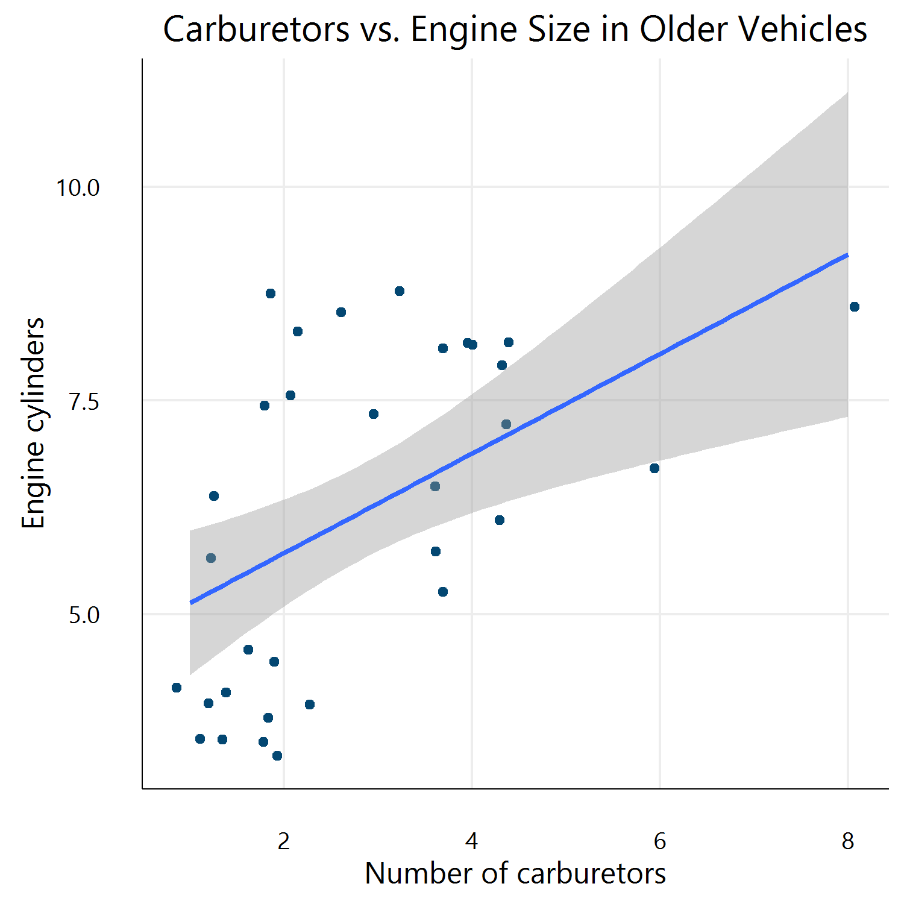

Figure 1. Carburetors vs. Engine Size in Older Vehicles