UOC LUONG MO HINH

NGUYEN QUANG DONG

January 15, 2023

library(sandwich)  
library(car)

## Loading required package: carData

library(lmtest)

## Loading required package: zoo

##   
## Attaching package: 'zoo'

## The following objects are masked from 'package:base':  
##   
## as.Date, as.Date.numeric

library(carData)  
library(ggplot2)

## UOC LUONG HAM SAN XUAT Y=f(K,L)

# setwd("D:/dataR/ch123")  
ch3bt4=read.table("ch3bt4_K_L.txt",header=TRUE)  
# View(ch3bt4)  
Y=ch3bt4$Y  
K=ch3bt4$K  
L=ch3bt4$L  
  
# summary(ch3bt4)

## UOC LUONG HAM COBB-DOUGLAS

# Y output, L- lao dong, K- von  
# Hoi quy Y = b0 K^b1 L^2b2  
  
reg1=lm(log(Y)~log(K)+log(L))  
summary(reg1)

##   
## Call:  
## lm(formula = log(Y) ~ log(K) + log(L))  
##   
## Residuals:  
## Min 1Q Median 3Q Max   
## -0.56455 -0.21716 0.03205 0.16651 0.42318   
##   
## Coefficients:  
## Estimate Std. Error t value Pr(>|t|)   
## (Intercept) 9.77025 0.22857 42.745 < 2e-16 ***  
## log(K) 0.52370 0.09376 5.586 3.28e-05 ***  
## log(L) 0.69301 0.14054 4.931 0.000127 ***  
## ---  
## Signif. codes: 0 '***' 0.001 '**' 0.01 '*' 0.05 '.' 0.1 ' ' 1  
##   
## Residual standard error: 0.282 on 17 degrees of freedom  
## Multiple R-squared: 0.7814, Adjusted R-squared: 0.7557   
## F-statistic: 30.39 on 2 and 17 DF, p-value: 2.436e-06

# Tinh/hien thị cac gia tri Yhat  
LYhat1=fitted(reg1)  
# Tinh/hien thi phan dư  
e1=resid(reg1)  
# Hien thi cac betahat  
beta=coef(reg1)  
beta

## (Intercept) log(K) log(L)   
## 9.7702509 0.5236994 0.6930054

beta[1]

## (Intercept)   
## 9.770251

anova(reg1)

## Analysis of Variance Table  
##   
## Response: log(Y)  
## Df Sum Sq Mean Sq F value Pr(>F)   
## log(K) 1 2.9002 2.90017 36.461 1.33e-05 ***  
## log(L) 1 1.9341 1.93408 24.315 0.0001266 ***  
## Residuals 17 1.3522 0.07954   
## ---  
## Signif. codes: 0 '***' 0.001 '**' 0.01 '*' 0.05 '.' 0.1 ' ' 1

# Hien gia tri RSS  
deviance(reg1)

## [1] 1.352226

covbetahat=vcov(reg1)  
covbetahat

## (Intercept) log(K) log(L)  
## (Intercept) 0.05224348 -0.012182545 -0.023211362  
## log(K) -0.01218254 0.008790028 -0.001147648  
## log(L) -0.02321136 -0.001147648 0.019751448

plot(log(Y), type="o", col="blue", pch="o", lty=1, ylim=c(0,max(log(Y))))  
lines(LYhat1, col="dark red", lty=3)  
points(e1, col="dark red",pch="+")

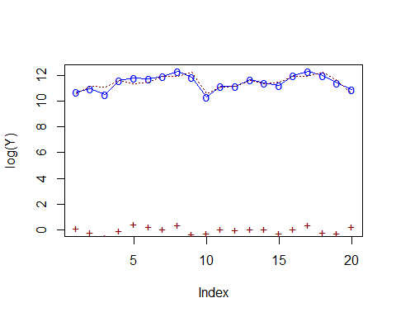

# legend(0,10,legend=c("LY","LYhat1","e1"), col=c("blue","red","black"), pch=c("o","*","+"),lty=c(1,2,3), ncol=1)  
  
plot(log(Y), type="o", col="blue", pch="o", lty=1, ylim=c(8,max(log(Y))))  
lines(LYhat1, col="dark red", lty=3)

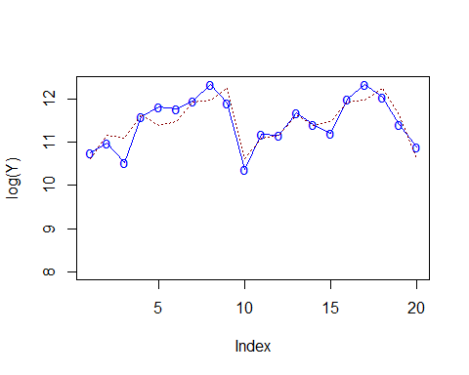 # Kiem dinh gia thiet

# Kiem dinh b1=0  
linearHypothesis(reg1,c("log(K)"))

## Linear hypothesis test  
##   
## Hypothesis:  
## log(K) = 0  
##   
## Model 1: restricted model  
## Model 2: log(Y) ~ log(K) + log(L)  
##   
## Res.Df RSS Df Sum of Sq F Pr(>F)   
## 1 18 3.8341   
## 2 17 1.3522 1 2.4818 31.201 3.28e-05 ***  
## ---  
## Signif. codes: 0 '***' 0.001 '**' 0.01 '*' 0.05 '.' 0.1 ' ' 1

# Kiem dinh b1=0.6  
linearHypothesis(reg1,c("log(K)=0.6"))

## Linear hypothesis test  
##   
## Hypothesis:  
## log(K) = 0.6  
##   
## Model 1: restricted model  
## Model 2: log(Y) ~ log(K) + log(L)  
##   
## Res.Df RSS Df Sum of Sq F Pr(>F)  
## 1 18 1.4049   
## 2 17 1.3522 1 0.052682 0.6623 0.427

# Kiem dinh b1=b2=0  
linearHypothesis(reg1,c("log(K)", "log(L)"))

## Linear hypothesis test  
##   
## Hypothesis:  
## log(K) = 0  
## log(L) = 0  
##   
## Model 1: restricted model  
## Model 2: log(Y) ~ log(K) + log(L)  
##   
## Res.Df RSS Df Sum of Sq F Pr(>F)   
## 1 19 6.1865   
## 2 17 1.3522 2 4.8343 30.388 2.436e-06 ***  
## ---  
## Signif. codes: 0 '***' 0.001 '**' 0.01 '*' 0.05 '.' 0.1 ' ' 1

# Kiem dinh b1=b2  
# linearHypothesis(reg1,c("log(K)=log(L)"))  
linearHypothesis(reg1,c("log(K) - log(L)=0"),test="F")

## Linear hypothesis test  
##   
## Hypothesis:  
## log(K) - log(L) = 0  
##   
## Model 1: restricted model  
## Model 2: log(Y) ~ log(K) + log(L)  
##   
## Res.Df RSS Df Sum of Sq F Pr(>F)  
## 1 18 1.4262   
## 2 17 1.3522 1 0.07394 0.9296 0.3485

# Kiem dinh gia thiet b1+b2=1  
lht(reg1,c("log(K) + log(L)=1"),test="F")

## Linear hypothesis test  
##   
## Hypothesis:  
## log(K) + log(L) = 1  
##   
## Model 1: restricted model  
## Model 2: log(Y) ~ log(K) + log(L)  
##   
## Res.Df RSS Df Sum of Sq F Pr(>F)  
## 1 18 1.4946   
## 2 17 1.3522 1 0.14232 1.7893 0.1986

# Kiem dinh gia thiet b1+b2=1, b2=0.3  
# Myh0=c(log(K) + log(L)=1,log(L)=0.3))  
lht(reg1,c("log(K) + log(L)=1","log(L)=0.3"),test="F")

## Linear hypothesis test  
##   
## Hypothesis:  
## log(K) + log(L) = 1  
## log(L) = 0.3  
##   
## Model 1: restricted model  
## Model 2: log(Y) ~ log(K) + log(L)  
##   
## Res.Df RSS Df Sum of Sq F Pr(>F)   
## 1 19 2.1890   
## 2 17 1.3522 2 0.83676 5.2598 0.01667 *  
## ---  
## Signif. codes: 0 '***' 0.001 '**' 0.01 '*' 0.05 '.' 0.1 ' ' 1

# Khoang tin 95% cho cac he so  
confint(reg1, level=0.95)

## 2.5 % 97.5 %  
## (Intercept) 9.2880139 10.2524879  
## log(K) 0.3258933 0.7215055  
## log(L) 0.3964923 0.9895186

# khoang tin cay cho he so cua log(K)  
confint(reg1,"log(K)",level=0.90)

## 5 % 95 %  
## log(K) 0.3606023 0.6867965

# khoang tin cay cho b1+b2  
seb1b2= sqrt(covbetahat[2,2]+covbetahat[3,3]+2*covbetahat[2,3])  
seb1b2

## [1] 0.1620067

beta[2]+beta[3]+c(-1,1)*seb1b2

## [1] 1.054698 1.378712

# Du bao  
# newdata=data.frame(data)  
K=c(50,45)  
L=c(35,32)  
newdata=cbind(K,L)  
newdata

## K L  
## [1,] 50 35  
## [2,] 45 32

newdata=data.frame(newdata)  
# Dự bao diem  
prereg1=predict(reg1,newdata)  
prereg1

## 1 2   
## 14.28285 14.16557

# Du bao khoang  
prereg2=predict(reg1,newdata,interval = 'confidence', level=0.95)  
prereg2

## fit lwr upr  
## 1 14.28285 13.48183 15.08387  
## 2 14.16557 13.39632 14.93482