GoldOilPrice-time series

Nguyen Quang Dong

26/2/2023

library(lmtest)

## Loading required package: zoo

##   
## Attaching package: 'zoo'

## The following objects are masked from 'package:base':  
##   
## as.Date, as.Date.numeric

library(car)

## Loading required package: carData

library(carData)  
library(ggplot2)  
library(zoo)  
# Modul "sandwich": Tính lại Se khi co PSSS thay doi/Tu tuong quan; vcov=vcovHC  
library(sandwich)  
# Modul "dynlm" - Ước lượng khi có biến trễ, sai phân  
library(dynlm)  
# Modul "tseries": Phân tích time series  
library(tseries)

## Warning: package 'tseries' was built under R version 4.2.3

## Registered S3 method overwritten by 'quantmod':  
## method from  
## as.zoo.data.frame zoo

# Modul "orcutt": Điều chỉnh tự tương quan băng phương pháp orcut  
# library(orcutt)  
library(forecast)  
library(tseries)  
library(urca)

## TAO Random Walk

# Tao truc toa do x= (0,50), y=(-18,18), gốc (0,0)  
plot(c(0,50),c(0,0),type="b", lwd=2,ylim=c(-18,18), main= "Random Walk")  
#lopp over draw  
for (r in 1:30){  
 # i.i.d stadard normal shock  
 e=rnorm(50)  
 # Random Walk as cummulative sum shocks  
 y=ts(cumsum(e))  
 # Add line to graph  
 lines(y,col=gray(.6))  
}

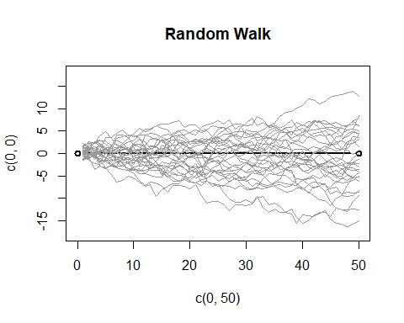

## TAO RA Random Walk with Drift

plot(c(0,50),c(0,0),type="b", lwd=2,ylim=c(-18,18), main="Random Walk with Drift")  
#lopp over draw  
for (r in 1:30){  
 # i.i.d stadard normal shock  
 e=rnorm(50)  
 # Random Walk as cummulative sum shocks  
 y=ts(cumsum(1+e))  
 # Add line to graph  
 lines(y,col=gray(.6))  
}

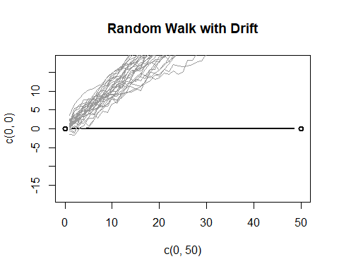

## SAI PHAN CUA Random Walk with Drift

# Tao 1000 phần tử từ phân bố chuẩn hóa  
# u=rnorm(1000, 0, 1)  
plot(c(-50,50), c(0,0),type="b",ylim=c(-3,3), main="First Difference of Random Walk")  
#lopp over draw  
for (r in 1:10){  
 # i.i.d stadard normal shock  
 # Random Walk with Drift as cummulative sum shocks  
 u=rnorm(50, 0, 1)  
 y=ts(cumsum(1+u))  
 #First Difference  
 Dy=diff(y)  
 # Add line to graph  
 lines(Dy,col=gray(.6))  
}

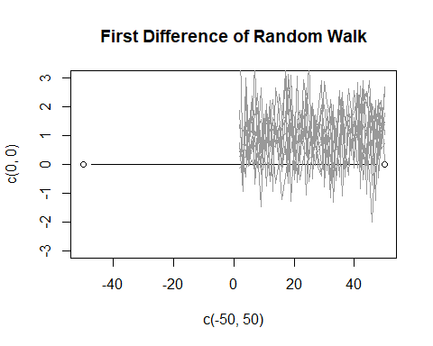 ## Process u(t)= ro*u(t-1)

# Tao 1000 phần tử từ phân bố chuẩn hóa  
# u=rnorm(1000, 0, 1)  
plot(c(-10,50), c(0,0),type="b",ylim=c(-3,10), main="u(t)= ro*u(t-1)")  
#lopp over draw  
 u=rnorm(500, 0, 1)  
 y1=ts(5+u)  
 y2=0.4*lag(u,1)  
 lines(y1,col="blue",lwd=2)  
 lines(y2,col="red",lwd = 1)  
 legend("topleft",c("y1","y2"), fill=c("blue","red"))

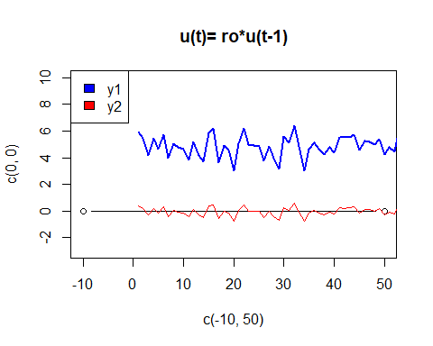

## ĐỌC SỐ LIỆU VÀ BIẾN SỐ

library(readxl)  
setwd("D:/dataR/chuong 6+7")  
goldoilprice=read_excel("goldoilprice.xls")  
  
# View(goldoilprice)  
  
# Gán thời gian cho file số liệu. Năm frequency=1; Quý: frequency=4; Tháng: frequency=12  
  
# Chuyển thành chuối thời gian  
  
goldprice=ts(goldoilprice$goldprice, start=c(2006,7), frequency=12)  
  
plot(goldprice,xlab="Time", ylab="goldprice", lwd = 2, col=2)

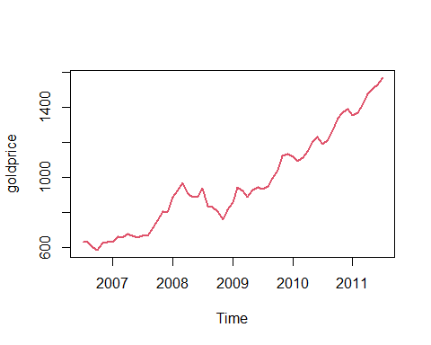

oilprice=ts(goldoilprice$oilprice, start=c(2006,7), frequency=12)  
  
plot(oilprice,xlab="Time", ylab="oildprice", lwd = 1, col=3)

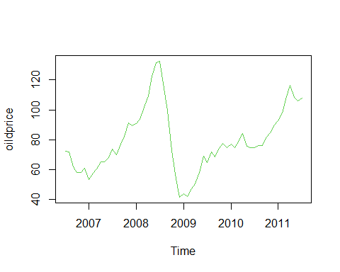

# plot(oilprice, goldprice,xlab="Oilprice", ylab="Goldprice", lwd = 2)   
  
  
par(mfrow = c(2,2))  
plot(goldprice, main = "Goldprice")  
plot(oilprice, main = "Oilprice")  
  
plot(goldprice,  
main="Overlaying Graphs",  
ylim= c(50,2000),  
type="l",  
col="blue")  
lines(oilprice, col="red")  
legend("topleft",  
c("Goldprice","Oilprice"),  
fill=c("blue","red")  
)  
  
  
  
par(mfrow = c(1,1))

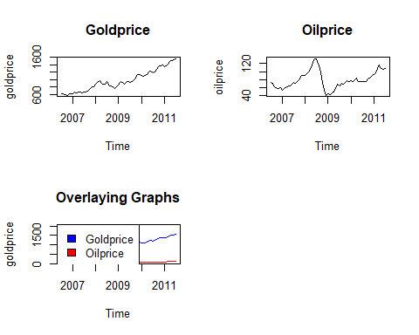

plot(goldoilprice$oilprice,goldoilprice$goldprice, xlab="Oilprice", ylab="Goldprice",col="red" )

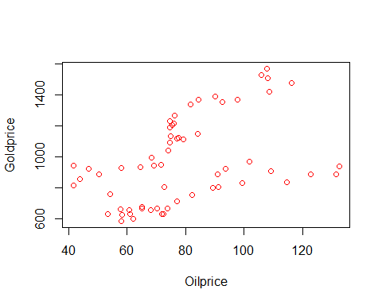

plot(goldoilprice$goldprice,type = "o",col = "red", xlab = "Month", ylab="",ylim=c(20,2000))  
lines(goldoilprice$oilprice, type = "o", col = "blue")

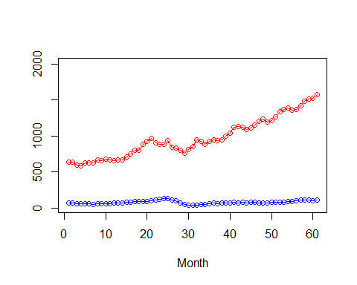

# Tạo biến gỉa theo thời vụ  
  
library(tsutils)

## Warning: package 'tsutils' was built under R version 4.2.3

seasd= seasdummy(length(oilprice),12)  
seasd=ts(seasd,start=c(2006,7), frequency=12)  
seasd

## Series 1 Series 2 Series 3 Series 4 Series 5 Series 6 Series 7  
## Jul 2006 1 0 0 0 0 0 0  
## Aug 2006 0 1 0 0 0 0 0  
## Sep 2006 0 0 1 0 0 0 0  
## Oct 2006 0 0 0 1 0 0 0  
## Nov 2006 0 0 0 0 1 0 0  
## Dec 2006 0 0 0 0 0 1 0  
## Jan 2007 0 0 0 0 0 0 1  
## Feb 2007 0 0 0 0 0 0 0  
## Mar 2007 0 0 0 0 0 0 0  
## Apr 2007 0 0 0 0 0 0 0  
## May 2007 0 0 0 0 0 0 0  
## Jun 2007 0 0 0 0 0 0 0  
## Jul 2007 1 0 0 0 0 0 0  
## Aug 2007 0 1 0 0 0 0 0  
## Sep 2007 0 0 1 0 0 0 0  
## Oct 2007 0 0 0 1 0 0 0  
## Nov 2007 0 0 0 0 1 0 0  
## Dec 2007 0 0 0 0 0 1 0  
## Jan 2008 0 0 0 0 0 0 1  
## Feb 2008 0 0 0 0 0 0 0  
## Mar 2008 0 0 0 0 0 0 0  
## Apr 2008 0 0 0 0 0 0 0  
## May 2008 0 0 0 0 0 0 0  
## Jun 2008 0 0 0 0 0 0 0  
## Jul 2008 1 0 0 0 0 0 0  
## Aug 2008 0 1 0 0 0 0 0  
## Sep 2008 0 0 1 0 0 0 0  
## Oct 2008 0 0 0 1 0 0 0  
## Nov 2008 0 0 0 0 1 0 0  
## Dec 2008 0 0 0 0 0 1 0  
## Jan 2009 0 0 0 0 0 0 1  
## Feb 2009 0 0 0 0 0 0 0  
## Mar 2009 0 0 0 0 0 0 0  
## Apr 2009 0 0 0 0 0 0 0  
## May 2009 0 0 0 0 0 0 0  
## Jun 2009 0 0 0 0 0 0 0  
## Jul 2009 1 0 0 0 0 0 0  
## Aug 2009 0 1 0 0 0 0 0  
## Sep 2009 0 0 1 0 0 0 0  
## Oct 2009 0 0 0 1 0 0 0  
## Nov 2009 0 0 0 0 1 0 0  
## Dec 2009 0 0 0 0 0 1 0  
## Jan 2010 0 0 0 0 0 0 1  
## Feb 2010 0 0 0 0 0 0 0  
## Mar 2010 0 0 0 0 0 0 0  
## Apr 2010 0 0 0 0 0 0 0  
## May 2010 0 0 0 0 0 0 0  
## Jun 2010 0 0 0 0 0 0 0  
## Jul 2010 1 0 0 0 0 0 0  
## Aug 2010 0 1 0 0 0 0 0  
## Sep 2010 0 0 1 0 0 0 0  
## Oct 2010 0 0 0 1 0 0 0  
## Nov 2010 0 0 0 0 1 0 0  
## Dec 2010 0 0 0 0 0 1 0  
## Jan 2011 0 0 0 0 0 0 1  
## Feb 2011 0 0 0 0 0 0 0  
## Mar 2011 0 0 0 0 0 0 0  
## Apr 2011 0 0 0 0 0 0 0  
## May 2011 0 0 0 0 0 0 0  
## Jun 2011 0 0 0 0 0 0 0  
## Jul 2011 1 0 0 0 0 0 0  
## Series 8 Series 9 Series 10 Series 11  
## Jul 2006 0 0 0 0  
## Aug 2006 0 0 0 0  
## Sep 2006 0 0 0 0  
## Oct 2006 0 0 0 0  
## Nov 2006 0 0 0 0  
## Dec 2006 0 0 0 0  
## Jan 2007 0 0 0 0  
## Feb 2007 1 0 0 0  
## Mar 2007 0 1 0 0  
## Apr 2007 0 0 1 0  
## May 2007 0 0 0 1  
## Jun 2007 0 0 0 0  
## Jul 2007 0 0 0 0  
## Aug 2007 0 0 0 0  
## Sep 2007 0 0 0 0  
## Oct 2007 0 0 0 0  
## Nov 2007 0 0 0 0  
## Dec 2007 0 0 0 0  
## Jan 2008 0 0 0 0  
## Feb 2008 1 0 0 0  
## Mar 2008 0 1 0 0  
## Apr 2008 0 0 1 0  
## May 2008 0 0 0 1  
## Jun 2008 0 0 0 0  
## Jul 2008 0 0 0 0  
## Aug 2008 0 0 0 0  
## Sep 2008 0 0 0 0  
## Oct 2008 0 0 0 0  
## Nov 2008 0 0 0 0  
## Dec 2008 0 0 0 0  
## Jan 2009 0 0 0 0  
## Feb 2009 1 0 0 0  
## Mar 2009 0 1 0 0  
## Apr 2009 0 0 1 0  
## May 2009 0 0 0 1  
## Jun 2009 0 0 0 0  
## Jul 2009 0 0 0 0  
## Aug 2009 0 0 0 0  
## Sep 2009 0 0 0 0  
## Oct 2009 0 0 0 0  
## Nov 2009 0 0 0 0  
## Dec 2009 0 0 0 0  
## Jan 2010 0 0 0 0  
## Feb 2010 1 0 0 0  
## Mar 2010 0 1 0 0  
## Apr 2010 0 0 1 0  
## May 2010 0 0 0 1  
## Jun 2010 0 0 0 0  
## Jul 2010 0 0 0 0  
## Aug 2010 0 0 0 0  
## Sep 2010 0 0 0 0  
## Oct 2010 0 0 0 0  
## Nov 2010 0 0 0 0  
## Dec 2010 0 0 0 0  
## Jan 2011 0 0 0 0  
## Feb 2011 1 0 0 0  
## Mar 2011 0 1 0 0  
## Apr 2011 0 0 1 0  
## May 2011 0 0 0 1  
## Jun 2011 0 0 0 0  
## Jul 2011 0 0 0 0

trend=seq(from=1,to = length(goldoilprice$date),by=1)  
trend

## [1] 1 2 3 4 5 6 7 8 9 10 11 12 13 14 15 16 17 18 19 20 21 22 23 24 25  
## [26] 26 27 28 29 30 31 32 33 34 35 36 37 38 39 40 41 42 43 44 45 46 47 48 49 50  
## [51] 51 52 53 54 55 56 57 58 59 60 61

## HỒI QUY, PHÂN TÍCH

reg1=lm(goldprice ~ oilprice+seasd[,1]+seasd[,3])  
summary(reg1)

##   
## Call:  
## lm(formula = goldprice ~ oilprice + seasd[, 1] + seasd[, 3])  
##   
## Residuals:  
## Min 1Q Median 3Q Max   
## -398.44 -230.62 24.08 182.12 463.59   
##   
## Coefficients:  
## Estimate Std. Error t value Pr(>|t|)   
## (Intercept) 515.678 123.687 4.169 0.000105 ***  
## oilprice 5.872 1.512 3.884 0.000270 ***  
## seasd[, 1] -40.511 109.029 -0.372 0.711599   
## seasd[, 3] -83.389 117.424 -0.710 0.480503   
## ---  
## Signif. codes: 0 '***' 0.001 '**' 0.01 '*' 0.05 '.' 0.1 ' ' 1  
##   
## Residual standard error: 250.3 on 57 degrees of freedom  
## Multiple R-squared: 0.2168, Adjusted R-squared: 0.1755   
## F-statistic: 5.258 on 3 and 57 DF, p-value: 0.002844

reg2=lm(goldprice ~ oilprice+trend)  
summary(reg2)

##   
## Call:  
## lm(formula = goldprice ~ oilprice + trend)  
##   
## Residuals:  
## Min 1Q Median 3Q Max   
## -139.617 -46.750 6.014 51.619 117.316   
##   
## Coefficients:  
## Estimate Std. Error t value Pr(>|t|)   
## (Intercept) 357.5639 32.3435 11.05 6.62e-16 ***  
## oilprice 2.2361 0.4095 5.46 1.04e-06 ***  
## trend 14.0345 0.4974 28.21 < 2e-16 ***  
## ---  
## Signif. codes: 0 '***' 0.001 '**' 0.01 '*' 0.05 '.' 0.1 ' ' 1  
##   
## Residual standard error: 65 on 58 degrees of freedom  
## Multiple R-squared: 0.9462, Adjusted R-squared: 0.9444   
## F-statistic: 510.5 on 2 and 58 DF, p-value: < 2.2e-16

# Kiểm định dạng hàm, thiếu biến  
resettest(reg2,power=c(2))

##   
## RESET test  
##   
## data: reg2  
## RESET = 57.166, df1 = 1, df2 = 57, p-value = 3.697e-10

# Kiểm định PSSS bằng BP TEST  
  
bptest(reg2)

##   
## studentized Breusch-Pagan test  
##   
## data: reg2  
## BP = 4.9518, df = 2, p-value = 0.08409

# Kết luận?  
  
# Kiểm định WHITE TEST cho PSSS  
  
  
bptest(reg2,~I(oilprice^2))

##   
## studentized Breusch-Pagan test  
##   
## data: reg2  
## BP = 4.927, df = 1, p-value = 0.02644

bptest((resid(reg2))^2 ~ oilprice+trend+I(oilprice^2))

##   
## studentized Breusch-Pagan test  
##   
## data: (resid(reg2))^2 ~ oilprice + trend + I(oilprice^2)  
## BP = 3.1458, df = 3, p-value = 0.3697

# Perform Breusch-Godfrey test for first-order serial correlation  
bgtest(reg2,order=1)

##   
## Breusch-Godfrey test for serial correlation of order up to 1  
##   
## data: reg2  
## LM test = 41.901, df = 1, p-value = 9.604e-11

bgtest(reg2,order=4)

##   
## Breusch-Godfrey test for serial correlation of order up to 4  
##   
## data: reg2  
## LM test = 43.118, df = 4, p-value = 9.779e-09

# Cụ thể test BG bậc 1  
  
reg4= dynlm(resid(reg1)~L(resid(reg1)))  
summary(reg4)

## Warning in summary.lm(reg4): essentially perfect fit: summary may be unreliable

##   
## Time series regression with "numeric" data:  
## Start = 1, End = 61  
##   
## Call:  
## dynlm(formula = resid(reg1) ~ L(resid(reg1)))  
##   
## Residuals:  
## Min 1Q Median 3Q Max   
## -7.702e-14 -1.984e-14 -8.730e-15 1.890e-15 6.841e-13   
##   
## Coefficients:  
## Estimate Std. Error t value Pr(>|t|)   
## (Intercept) 3.232e-29 1.183e-14 0.000e+00 1   
## L(resid(reg1)) 1.000e+00 4.888e-17 2.046e+16 <2e-16 ***  
## ---  
## Signif. codes: 0 '***' 0.001 '**' 0.01 '*' 0.05 '.' 0.1 ' ' 1  
##   
## Residual standard error: 9.236e-14 on 59 degrees of freedom  
## Multiple R-squared: 1, Adjusted R-squared: 1   
## F-statistic: 4.185e+32 on 1 and 59 DF, p-value: < 2.2e-16

# Kiểm định TTQ bậc 1 bằng Durbin-Watson (DW)  
dwtest(reg2)

##   
## Durbin-Watson test  
##   
## data: reg2  
## DW = 0.30328, p-value < 2.2e-16  
## alternative hypothesis: true autocorrelation is greater than 0

library(zoo)  
library(orcutt)

## Warning: package 'orcutt' was built under R version 4.2.3

reg3=cochrane.orcutt(reg2)  
summary(reg3)

## Call:  
## lm(formula = goldprice ~ oilprice + trend)  
##   
## Estimate Std. Error t value Pr(>|t|)   
## (Intercept) 294.54967 83.85036 3.513 0.0008754 ***  
## oilprice 1.72866 0.57938 2.984 0.0041881 **   
## trend 16.82212 1.87493 8.972 1.715e-12 ***  
## ---  
## Signif. codes: 0 '***' 0.001 '**' 0.01 '*' 0.05 '.' 0.1 ' ' 1  
##   
## Residual standard error: 34.0288 on 57 degrees of freedom  
## Multiple R-squared: 0.6448 , Adjusted R-squared: 0.6323  
## F-statistic: 51.7 on 2 and 57 DF, p-value: < 1.542e-13  
##   
## Durbin-Watson statistic   
## (original): 0.30328 , p-value: 2.868e-20  
## (transformed): 1.63404 , p-value: 4.827e-02

bgtest(reg3)

##   
## Breusch-Godfrey test for serial correlation of order up to 1  
##   
## data: reg3  
## LM test = 1.8798, df = 1, p-value = 0.1704

resettest(reg3)

##   
## RESET test  
##   
## data: reg3  
## RESET = 0.9252, df1 = 2, df2 = 55, p-value = 0.4025