BOOK
Home Dr. Kang New Patient Services Treats VA& Insurance Contact

- Dr. Kang
Meet Dr. Hyo-won Kang
Why Choose Dr. Kang?
Chronic & complex Diseases

- New Patient

- Services
Acupuncture
Electric-Acupuncture
Facial Acupuncture
Ear Acupuncture
Moxa
Medical Massage
Lymphatic Massage
Herbal Medicine
Auto Injury

- Treats

- VA & Insurance

- Contact

- Dr. Kang
Meet Dr. Hyo-won Kang
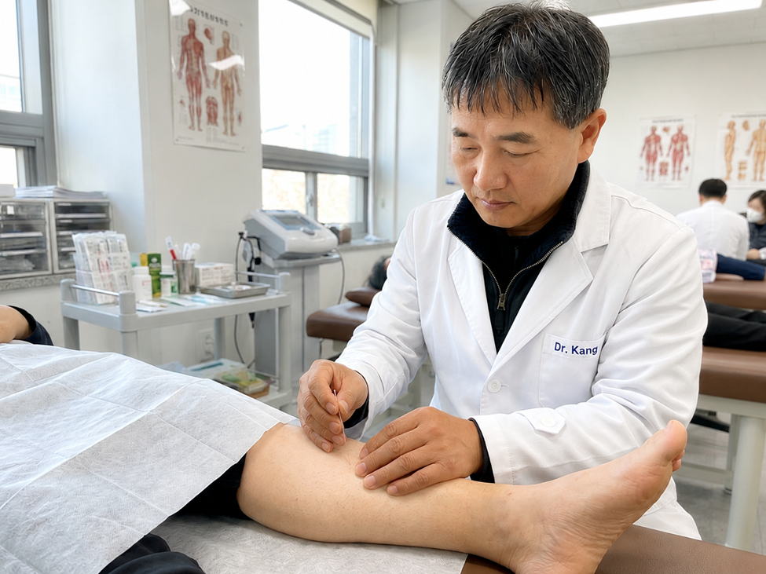
Born in Korea, he majored in theology at Sungwha Theology, completed his Master's degree in Oriental Medicine at Samra Acupuncture School, and pursued his Doctor of Acupuncture and Oriental Medicine (DAOM) at South Baylor Acupuncture School. Coming from a family of traditional practitioners, he learned acupuncture and herbal medicine from a young age. He also studied therapeutic massage, osteopathy, and spiritual healing under various mentors. Gifted with sharp intuition and refined tactile senses, he possesses a strong ability to diagnose patients through pulse diagnosis and physical palpation, identifying the root causes of illnesses and determining the appropriate treatments. Recognizing that he is human and cannot accurately diagnose or cure every condition, he always pours his utmost sincerity and dedication into patient diagnosis and treatment. Before diagnosing and treating his patients, he offers a prayer, wishing for God's miracles to be with everyone who seeks his care.

Why Choose Dr. Kang?
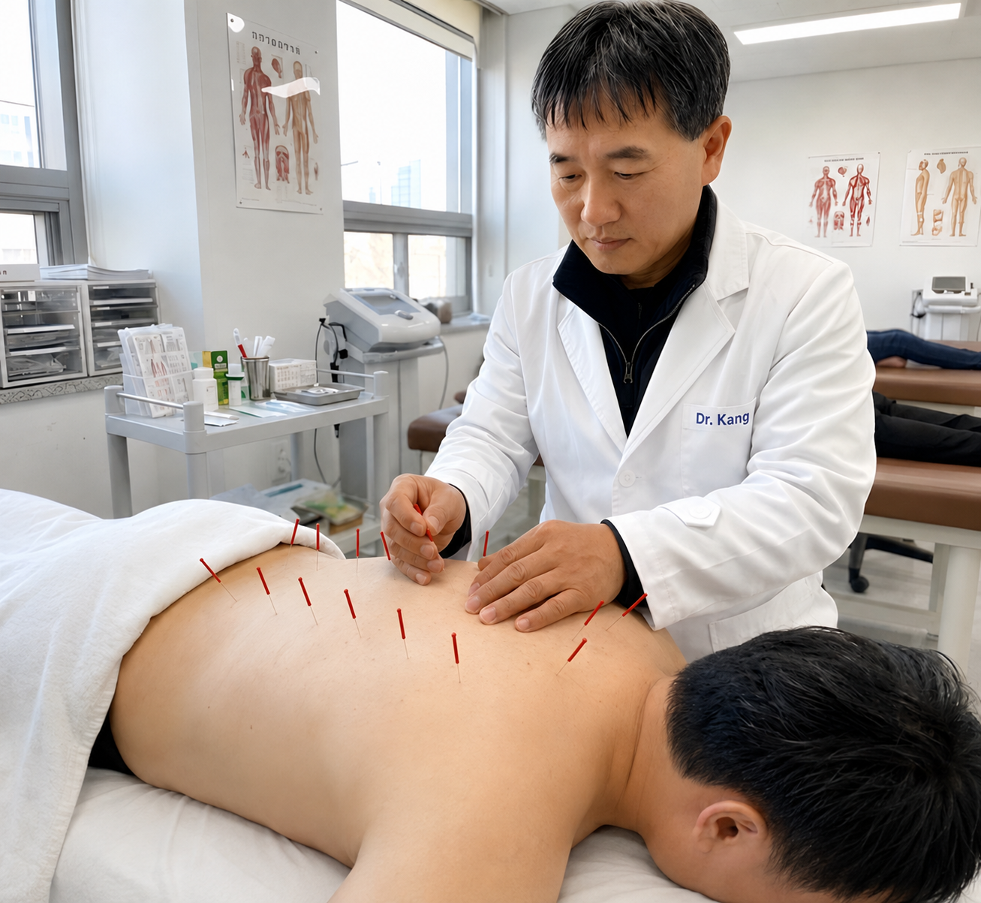
He has a deep love for his patients and a strong determination to heal them well. As a third-generation descendant carrying on a traditional medicine heritage, he possesses 28 years of rich clinical experience and the ability to interpret traditional medicine through a modern lens. He has the ability to diagnose unseen internal illnesses within the body. Rather than merely treating surface-level symptoms, his treatments focus on identifying the root cause of an illness to provide fundamental healing at its source. Every individual has a different constitution, family diet, lifestyle habits, genetic factors, and life circumstances. Moreover, different illnesses manifest depending on the seasons, weather, and temperature. By analyzing these diverse factors, treatments must be tailored to the individual. His 28 years of experience and diverse studies enable him to provide you with personalized care. Choosing Dr. Kang means encountering his experience and capability, which have been dedicated to disease treatment for a lifetime. He is truly sincere about healing his patients.

Chronic & Complex Diseases

Most chronic and complex diseases are caused by multiple factors, including genetics, lifestyle, aging, immune dysfunction, chronic inflammation, poor circulation, and nervous system imbalance. Because of this, they often require a comprehensive and personalized approach rather than a single treatment.
Conditions such as cancer, allergies, arthritis, Parkinson's disease, stroke recovery, chronic fatigue, insomnia, anxiety, and depression often improve most when expert medical care is combined with healthy lifestyle changes and active patient participation.
Dr. Hyo-won Kang focuses on identifying the underlying causes of illness while evaluating each patient's overall health. By providing personalized, integrative care, his goal is not only to relieve symptoms but also to restore the body's natural balance, support its healing capacity, and help patients achieve a healthier, better quality of life.
***************************************************************************
New Patient

#5. What to Expect:

Your First Visit
Your journey to wellness at Marin Holy Hill Acupuncture Clinic starts here. We’ve designed a simple 6-step process to ensure you feel comfortable and cared for from the moment you walk in.

1. Check-in & Registration
To make your visit smooth and stress-free:
- Arrival: Please arrive 15 minutes early to complete your new patient paperwork.
- What to bring: A valid Photo ID and your Insurance Card.

2. Initial Assessment
Our staff will review your basic health history and current concerns to ensure we have a complete picture of your wellbeing.

3. Comprehensive Consultation
Meet with our licensed expert for an in-depth discussion about:
- Your medical history and lifestyle habits.
- Your specific health goals.
- TCM Diagnosis: A traditional assessment of your tongue and pulse to identify internal imbalances.

4. Personalized Care Plan
Based on your diagnosis, we collaboratively build a treatment plan tailored to your individual needs—focusing on both symptoms and the root cause.

5. Your First Treatment
Experience the healing power of Integrated TCM:
- Acupuncture: Gentle and precise needle placement in a relaxing environment.
- Additional Therapies: Cupping, moxibustion, or Tui Na massage as needed.
- Herbal Medicine: Custom formulas to support your body from the inside out.

6. Aftercare & Next Steps
Healing continues even after you leave the clinic:
- Self-Care: Receive dietary and lifestyle tips based on TCM principles.
- Follow-up: We will recommend a treatment schedule to help you achieve long-term wellness.

Quick Tips for a Better Experience:
- Food: Eat a light meal 1–2 hours before your appointment.
- Clothing: Wear loose, comfortable clothes for easy access to treatment areas.
- Rest: Avoid strenuous activity after your session to support your recovery.

At Marin Holy Hill Acupuncture Clinic, we are committed to your health through personalized, compassionate care.

#6. Treatment Plan
At Marin Holy Hill Acupuncture Clinic, every treatment plan is fully customized to fit your unique needs. All of our therapies work in harmony with your body’s natural self-healing mechanisms, utilizing both primary and supportive modalities for comprehensive care. We naturally integrate acupuncture, cupping, moxibustion, and personalized herbal medicine to optimize your recovery. Depending on each individual's unique condition, advanced or specialized therapies may also be introduced.
The healing process varies for everyone; some patients experience immediate relief, while others notice gradual, progressive improvement over time. Partner with Dr. Kang today to design a dedicated treatment plan and embark on your pathway to full, long-lasting wellness.

The 3 Phases of Healing

1. Relief Phase (1–4 Weeks)
- The Goal: Prioritize comfort by reducing acute pain and easing primary symptoms.
- Focus: Focused acupuncture combined with targeted therapies such as cupping, massage, and herbal support to calm inflammatory responses.

2. Corrective Phase (4–12 Weeks)
- The Goal: Address root causes and stabilize structural balance.
- Focus: Weekly or biweekly sessions aimed at long-term correction. This phase focuses on nourishing the body to ensure more stable energy, improved sleep, and better digestion.

3. Wellness Phase (Ongoing)
- The Goal: Maintain long-term health and prevent future imbalances.
- Focus: "Tune-up" sessions every 2–4 weeks or seasonally. By strengthening immunity and emotional resilience, we ensure lasting vitality and prevent the recurrence of chronic issues.

What to Expect
- Progressive Improvement: Experience a gradual shift toward deeper relaxation and diminished pain as your body regains its equilibrium.
- Lifestyle Partnership: We believe healing continues outside the clinic. We partner with you to optimize your diet, sleep, and stress management.
- Individualized Care: Every body tells a different story. Our practitioners continuously adjust your plan to match your personal rate of recovery.

#7. Post-Treatment Wellness Guide
Healing doesn’t stop when you leave Marin Holy Hill Acupuncture Clinic. To ensure your body processes the treatment effectively and to maximize your recovery, please follow these simple aftercare recommendations.

Quick Guide: Dos & Don’ts

Please Avoid

High-intensity workouts

Ice-cold drinks or raw meals

Alcohol and stimulants

Overeating or heavy, greasy food

Digital strain (excessive screen time)

Please Focus On

Staying hydrated with filtered water

Warm, easy-to-digest nourishment

Listening to your body’s signals

Deep rest and quality sleep

Keeping the treated areas warm

Specific Aftercare by Treatment

Acupuncture Recovery
- It is very common to feel deeply relaxed, light-headed, or even slightly fatigued after a session.
- Allow yourself time to rest if you feel sleepy.
- Avoid touching or scratching the points where needles were placed.
- Minor bruising is rare but normal; it will fade within a few days.

Cupping Therapy Care
- The characteristic circular marks and slight tenderness are signs of toxin release and increased blood flow. They typically disappear in 3–5 days.
- Crucial: Keep the area covered and protected from cold drafts. Wait at least 24 hours before taking a cold shower.
- Refrain from scratching the marks as the skin may be sensitive.

Moxibustion (Heat Therapy)
- You may feel a lingering, pleasant warmth in the treated area for several hours.
- Protect your body from sudden temperature changes (cold wind or cold water).
- Sip warm tea or water to help maintain the improved circulation.

Medical Massage, Foot, and Manual therapy
- You might experience mild "good" soreness similar to the feeling after a workout.
- Increase your water intake to help flush out any metabolic waste released during therapy.
- Avoid heavy lifting or strenuous physical labor for the remainder of the day.

Herbal Medicine Protocol
- Consistency is key—take your herbal formulas exactly as prescribed by your practitioner.
- Try to avoid spicy or highly processed foods, as they can interfere with the herbs' effectiveness.
- If you experience any unexpected changes, please notify us immediately.

When to Contact Us
Please reach out to the clinic if:
- You feel persistent dizziness or discomfort that doesn’t subside with rest.
- You have questions regarding your specific herbal dosage or self-care routine.
- You need to adjust your upcoming treatment schedule to better fit your recovery pace.
Your wellness is our priority. We look forward to supporting your continued healing.

************************************************************************

VA & Health Insurance
Price

#26 VA & Health Insurance
Marin Holy Hill Acupuncture Clinic welcomes both VA insurance and general health insurance. Notably, we are an official VA Acupuncture Provider clinic. We are dedicated to providing excellent care to all VA insurance patients who have served in the military for the peace of the United States and humanity.
We also welcome UnitedHealthcare (UHC), Blue Cross Blue Shield (BCBS), UMR, Cigna, Scan, Humana (Medicare), Aetna, and Workers' Compensation insurance.

1. In-Network Providers
We are proud to be in-network with the following major insurance carriers:
- UnitedHealthcare (UHC)
- Blue Cross Blue Shield (BCBS)
- Cigna
- Scan
- Humana (Medicare)
- Aetna
- Federal Employee Insurance
Note: Acupuncture coverage depends on your individual insurance plan. Please call your insurance company first to confirm whether your benefits include acupuncture.

2. Specialized Coverage
- Motor Vehicle Accidents (MVA): Acupuncture is often covered as part of your accident recovery. We provide full documentation and billing support.
- Veterans Affairs (VA): We proudly support our veterans through VA programs (requires prior authorization).
- Workers’ Compensation: We coordinate directly with your case manager to ensure seamless care for workplace injuries.

3. Health & Savings Accounts (HSA / FSA)
- HSA: Use your Health Savings Account card directly at checkout for acupuncture and holistic therapies.
- FSA: We accept Flexible Spending Account cards and provide Itemized Receipts for your reimbursement records.

4. Out-of-Network Plans
If your provider is not listed above, you may still have out-of-network benefits. We will provide a Superbill (detailed receipt) for you to submit to your insurance for direct reimbursement.
5. International Travel Insurance: Coverage varies by provider, but acupuncture is generally included. Please contact your travel insurance company to verify your benefits.


#27. Price
At Marin Holy Hill, we offer three flexible payment methods to suit your individual needs:
- Pay-per-visit: Pay as you go for each session.
- Package Plans: Pre-paid bundles for consistent care at a better value.(Discount $$$)
Note: New pricing takes effect on January 1st of each year.

Services & Pricing

Initial Consultation & Treatment (New Patient) $130.00

Comprehensive Follow-up Visit $120.00

Focused Acupuncture Only (Follow-up) $80.00
Medical Massage (MET) $80.00
Facial Acupuncture $80.00
Cupping $50.00
Moxibustion $50.00
Facial Acupressure $50.00
Foot Reflexology $50.00
Custom Herbal Formula $80.00
Note: Prices may vary depending on the specific herbal ingredients.

New Patient Experience $130.00
- In-depth Consultation: A private 1:1 session with the doctor to evaluate your overall health.
- Strategic Planning: A personalized treatment plan designed during your initial visit.
- Precision Treatment: Comprehensive care utilizing acupuncture, cupping, moxibustion, massage, or herbal remedies tailored to your needs.

Established Patient Follow-up Visit

Established Patient Follow-up Visit

Returning Patient Visit — $120.00
- Clinical Consultation: A 1:1 session with the doctor to monitor your progress and current health status.
- Plan Alignment: Adjusting and implementing the treatment protocol based on your recovery goals.
- Integrated Therapy: Tailored care using acupuncture, cupping, moxibustion, massage, or herbal medicine.
- Lifestyle Coaching: Professional guidance on habits and lifestyle adjustments to support lasting wellness.

Acupuncture Only (Returning Patients) — $80.00
- Clinical Consultation: A 1:1 session with the doctor to evaluate your progress and current health status.
- Plan Alignment: Precise implementation of your treatment protocol based on established recovery goals.
- Focused Acupuncture: Targeted acupuncture therapy specifically selected to optimize your healing.
- Lifestyle Guidance: Professional advice on habit and lifestyle adjustments for sustained wellness.

