Lab 1: Introduction to LabView

# \\icnas3.cc.ic.ac.uk\py715\Desktop\Comms\fahrenheit_to_celsius_formulas.pngEx1-Data Types in LabView

* Convert each letter of a string into ASCII code.
* Convert each integer of Fahrenheit temperature to Celsius.
* Average value of the temperature is calculated.

Figure 1 Fahrenheit -> Celsius

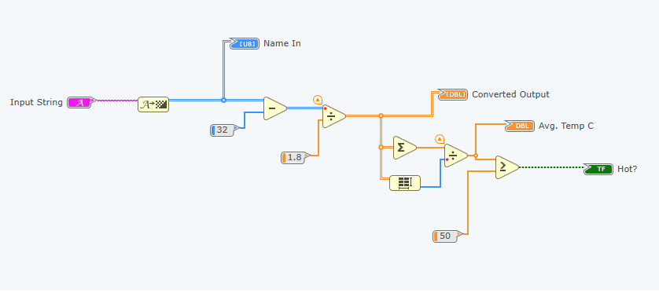

Figure 2 Diagram of the Converter

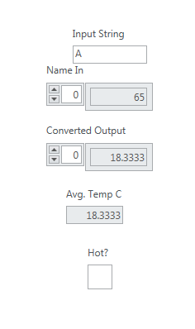 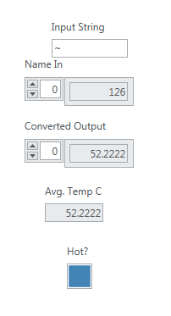

Figure 3 Input ~ Figure 4 Input A

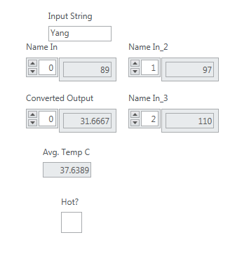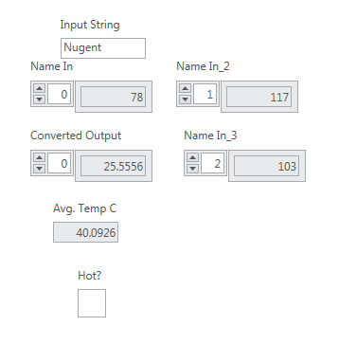

Figure 5 Input Nugent Figure 6 Input Yang

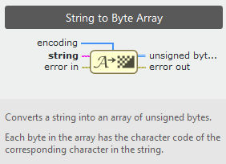

Figure 7 String to Byte Array

# Ex2-Implementation of the Central Limit Theorem (CLT)

CLT: When independent random variables are added, their sum tends toward a normal distribution. (Sufficiently large sample has finite level of variance, mean of the sample is approximately equal to the mean of the whole data.)

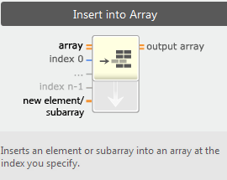

Figure 8 Insert into Array

* Tunnels: specify how the data will be transferred through the frame.

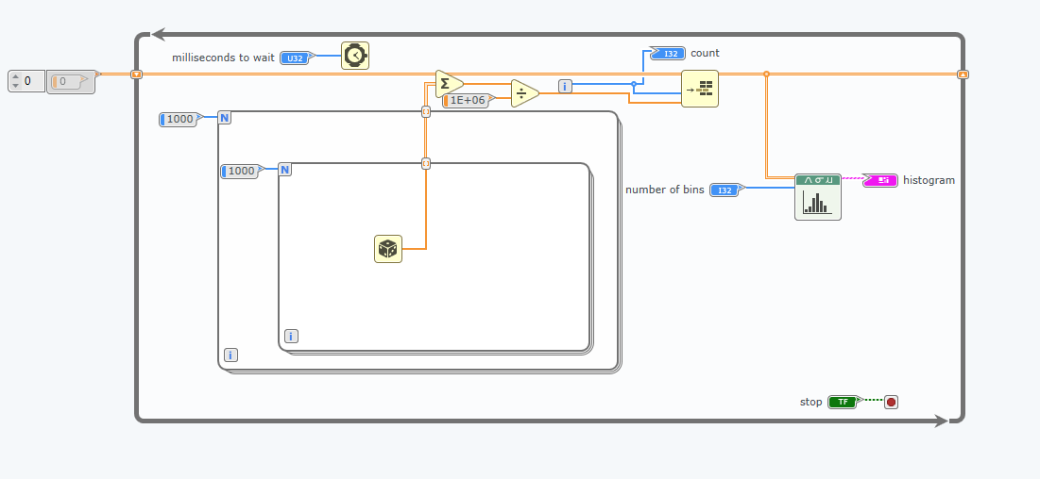

Figure 9 Diagram 1

* Mean-> use divide function to divide the total value of the randomly generated data by the size of the 2D array.
* Shift register is a type of tunnel that carries information from an iteration to the next one. So the tunnel on the left carrier the data from the last iteration to the next.

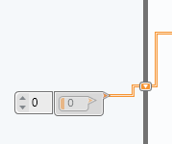

Figure 10 Initialise the array to 0

* Number of bins: the number of interval between the grid.

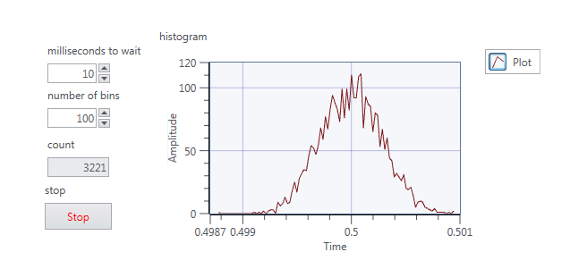

Figure 11 Output

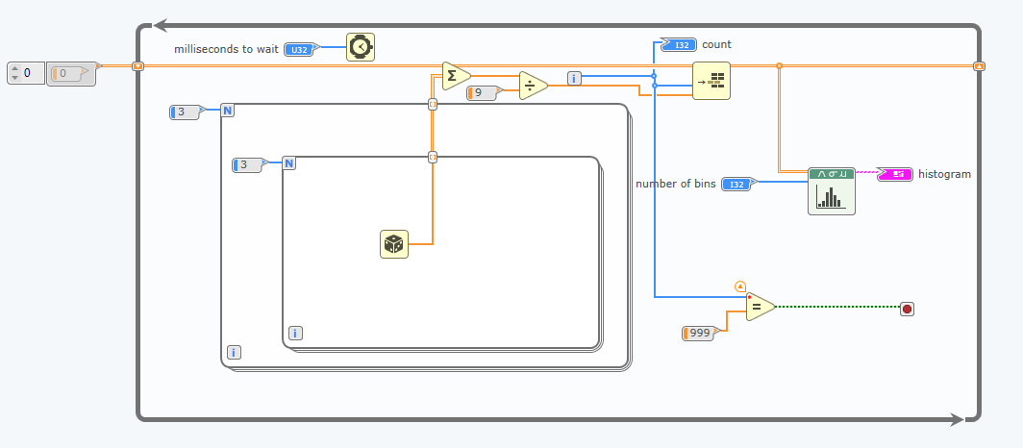

Figure 12 1k iteration

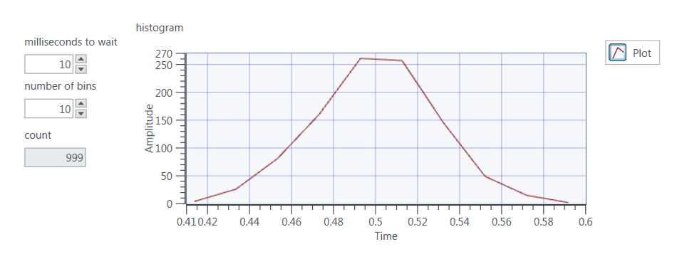

Figure 13 100 iteration

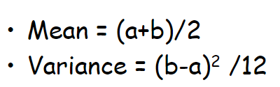

Figure 14 Formula

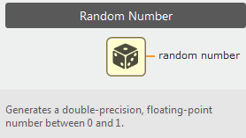

Figure 15 Random Number Generator

Before normalisation, the distribution has mean equal to 0.5, because the range of the number generated is from 0 to 1. Using the formula in Figure 14, we got mean = 0.5.

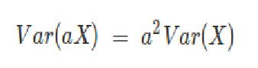In order to have standard normal distribution (mean = 0 & variance = 1), we need to shift the distribution graph to left. So we minus 0.5 from the randomly generated sample -> mean now is 0; for variance, we have this formula.

The variance before normalise is 1/12, so if we want to obtain variance = 1, we need to multiply 12.\\icnas3.cc.ic.ac.uk\py715\Desktop\Comms\Var1over12.png \\icnas3.cc.ic.ac.uk\py715\Desktop\Comms\var1.png

Hence, we can multiply sqrt(12) in order to get Var(X) = 1. Outside the loop, we divided by 100, so for the same reason, we need to multiply by 10. Hence \\icnas3.cc.ic.ac.uk\py715\Desktop\Comms\sqrt12 times 10.png.

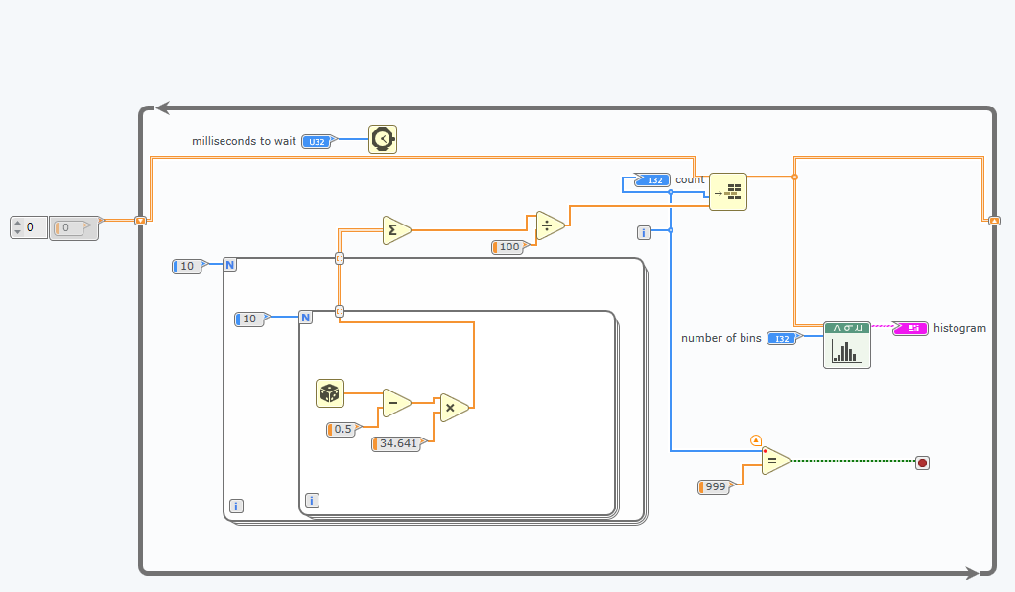

Figure 16 Unit Variance and 0 mean

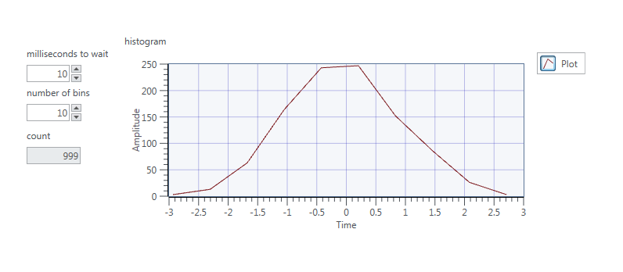

Figure 17 Unit Variance and 0 Mean Output

# Ex3-Waveforms

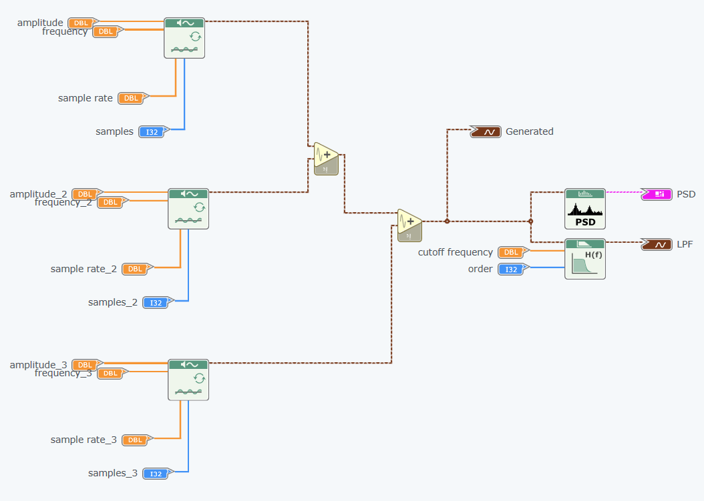

Figure 18 Initial diagram

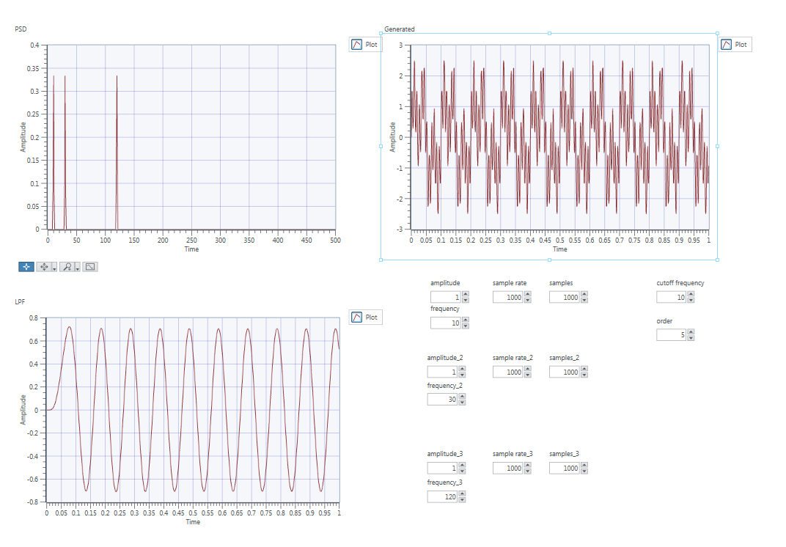

Figure 19 Initial panel

In order to get the sin wave with frequency 30, we adjust the cut-off frequency to around 30, we choose the range from 25(low cut-off) to 35(high cut-off) in this case. 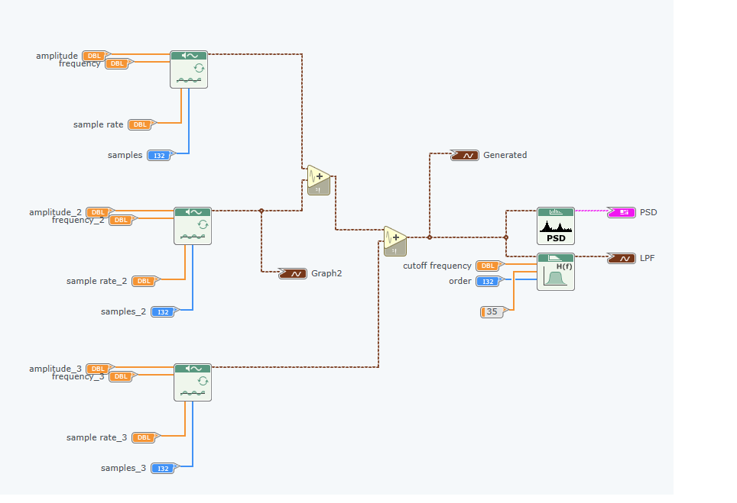

Figure 20 Frequency 30

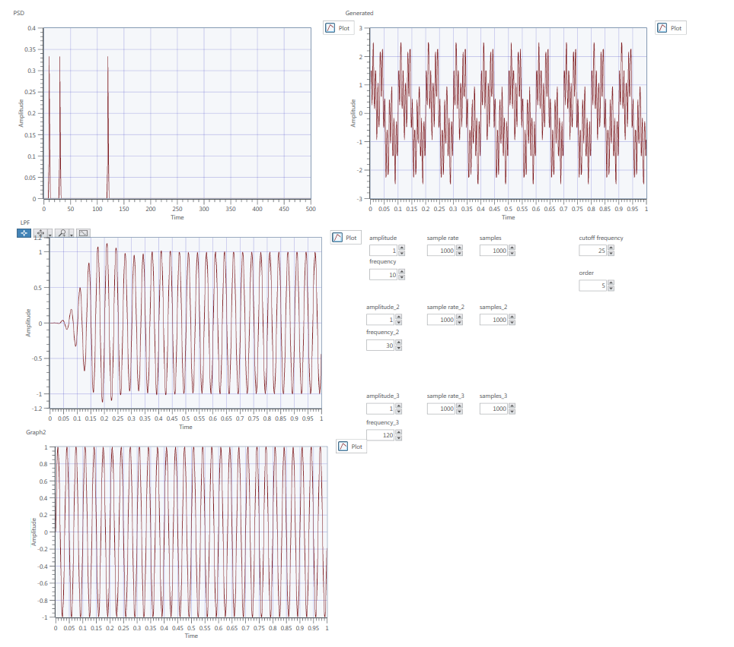

Figure 21 Frequency 30

Lab 2: AM Simulation and USRP

## Ex1-AM Modulator

* 𝒔(𝒕)=[𝑨𝒄+𝑨𝒎𝐜𝐨𝐬(𝟐𝝅𝒇𝒎𝒕)]𝐜𝐨𝐬(𝟐𝝅𝒇𝒄𝒕) 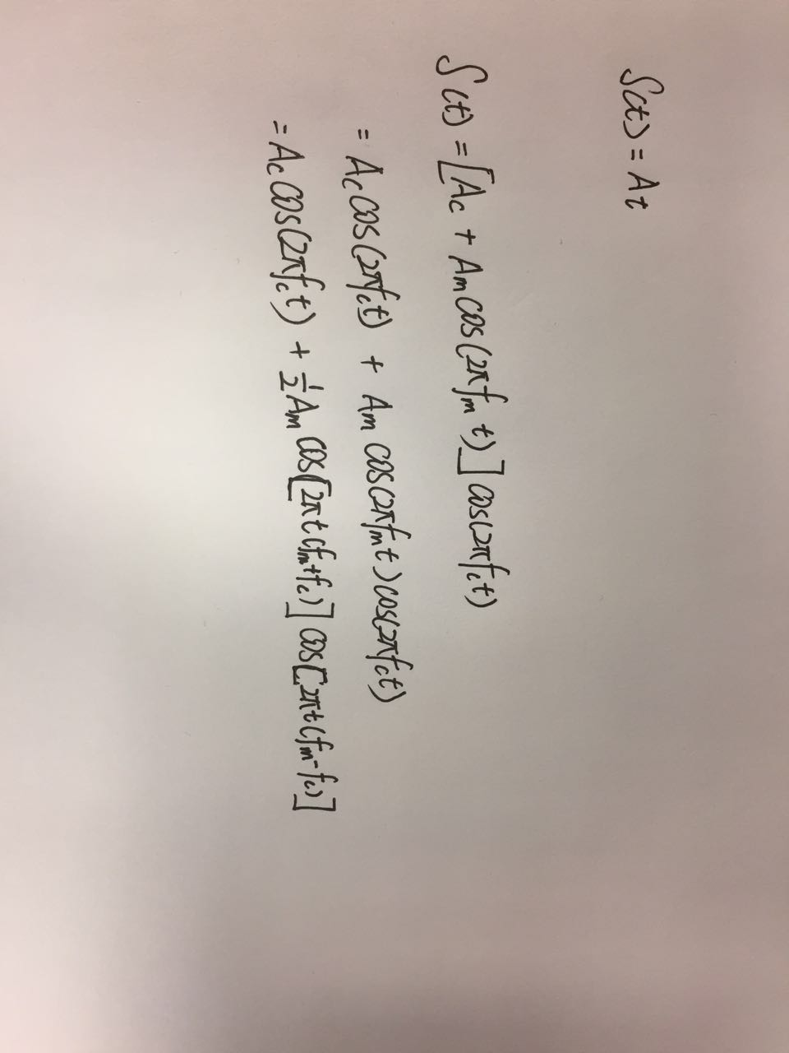

Figure 22 AM signal

* Modulation index: 𝜇=𝐴𝑚/𝐴𝑐

S(t) can also be expressed into the expresion in figure 22. So in the AM.gvi, first we have two sine waveform generator to generate carrier and message signal. We use a divide function to get cos(2𝝅𝒇𝒄𝒕), then a mutiplier function is used to get the combined waveform. Sum the signals (figure 22 euqation) to obtain AM signal.

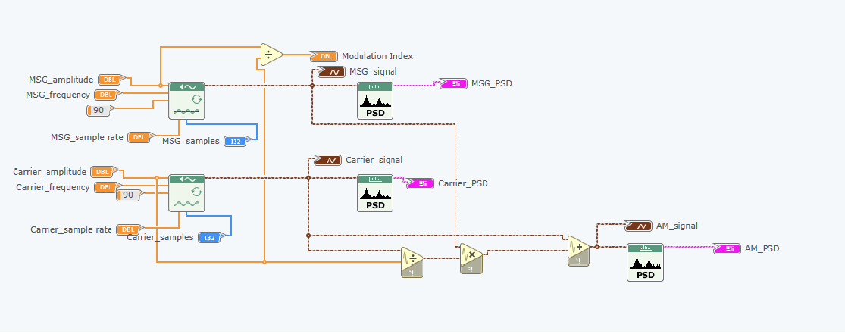

Figure 23 Diagram

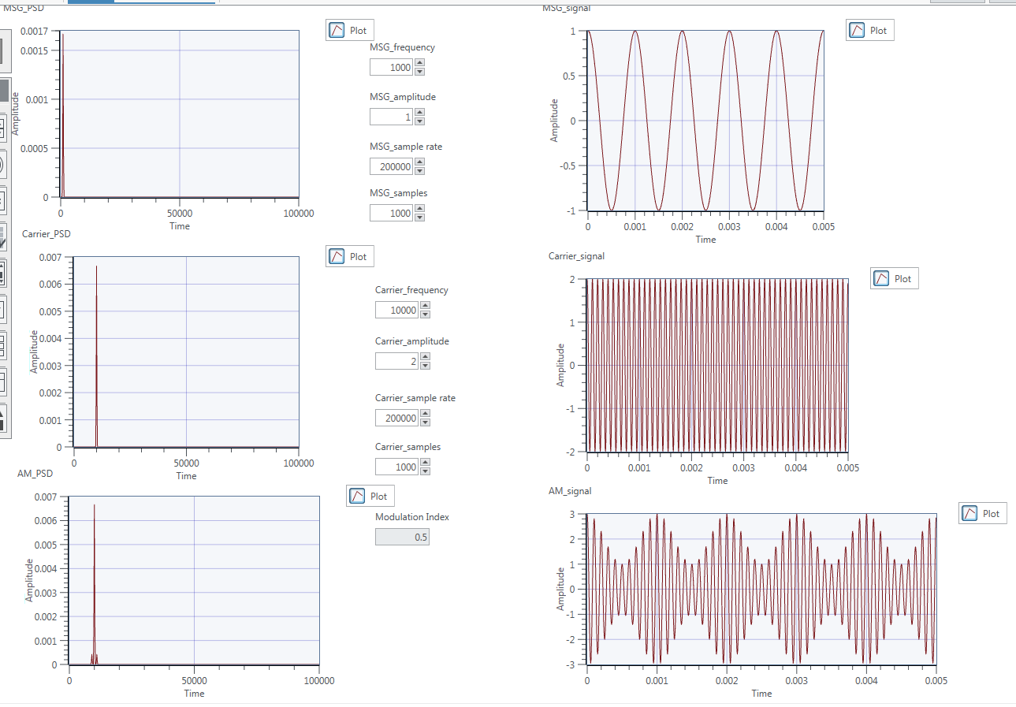

Figure 24 Modulation Index = 0.5

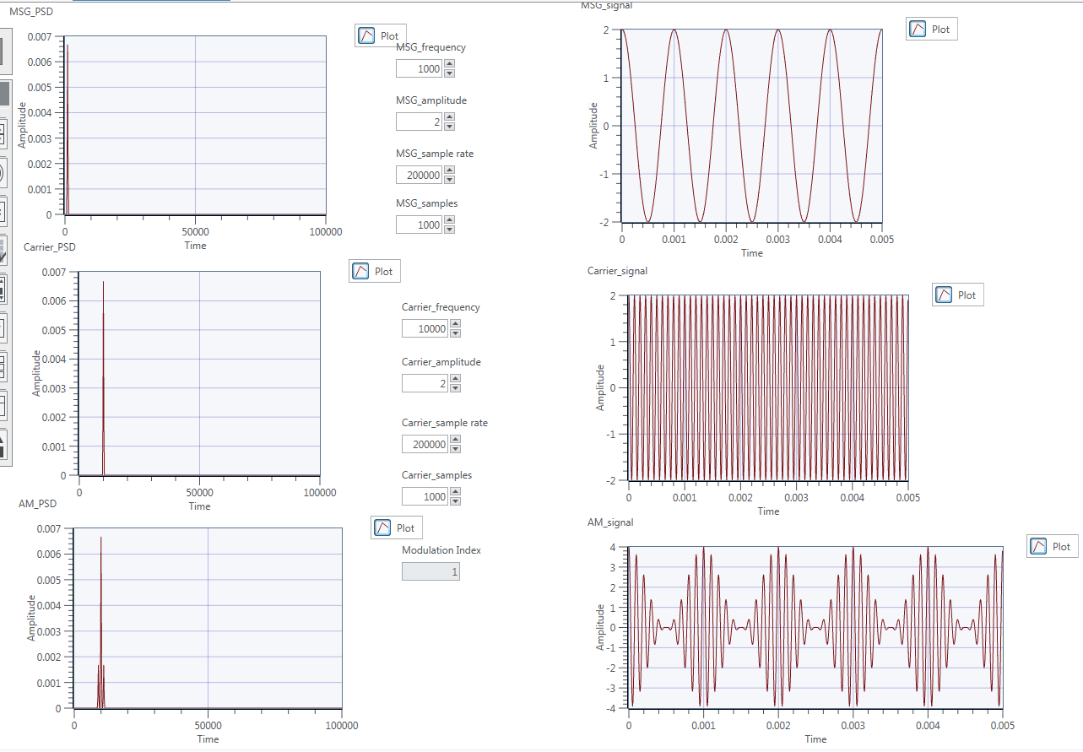

Figure 25 Modulation Index = 1

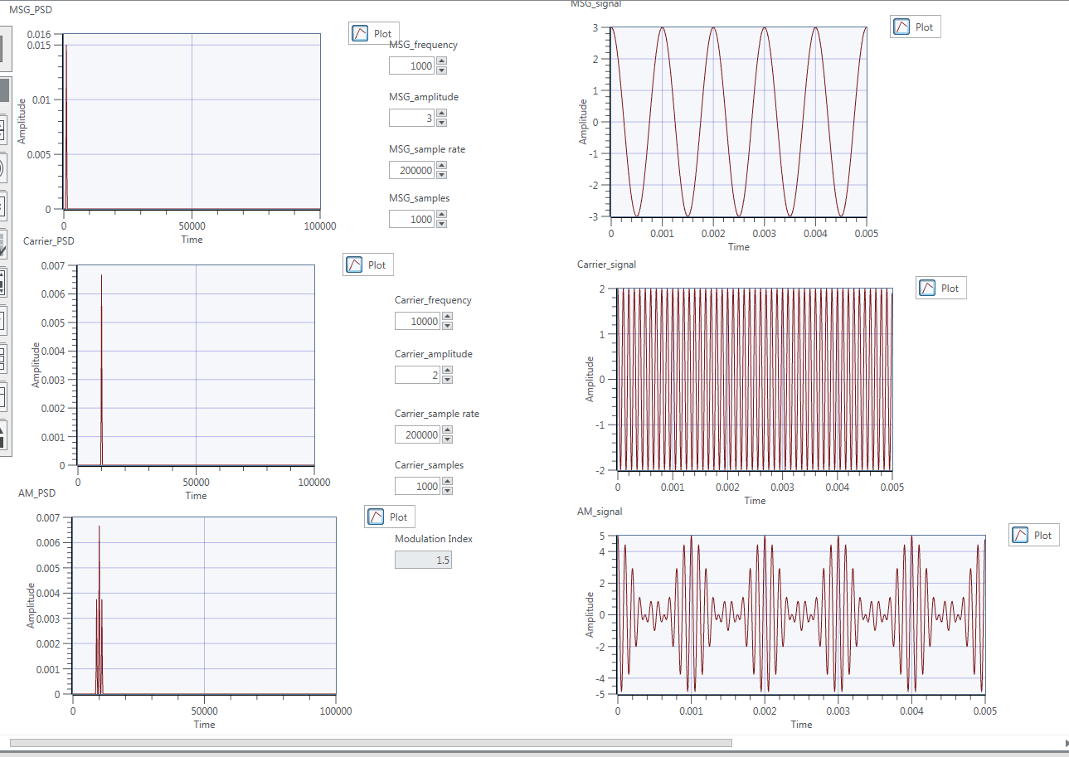

Figure 26 Modulation Index = 1.5

Above, we change the modulation index from 0.5 to 1.5, we get the conclusion that the smaller the modulation index, the less varies of the unmodulated level.

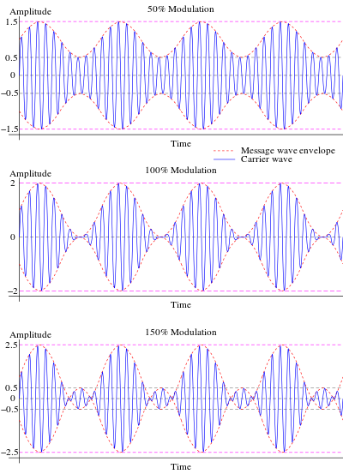

Figure 27 Modulation index

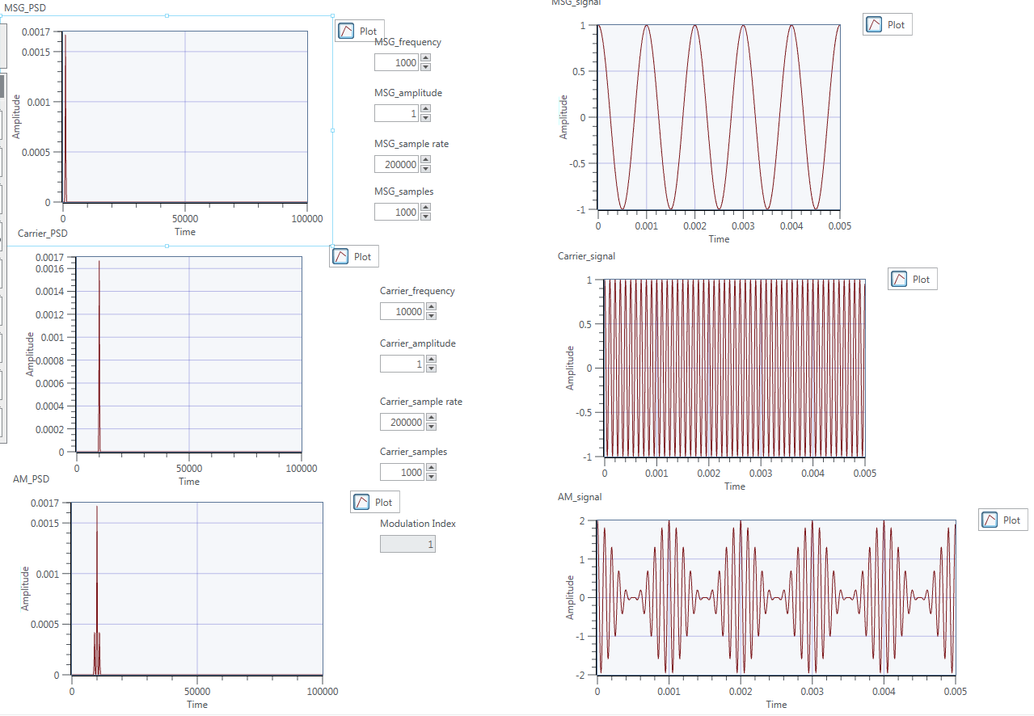

Figure 28 MSG frequency = 1k

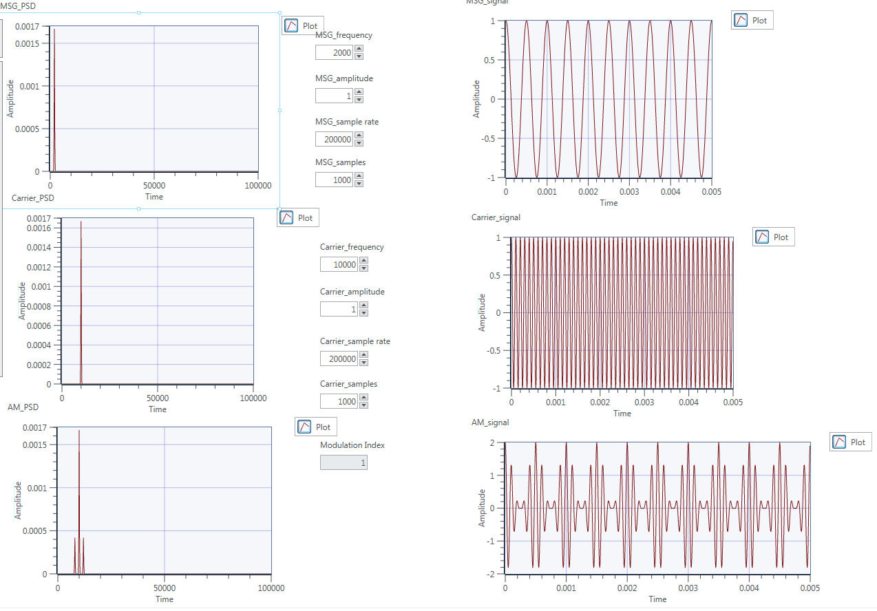

Figure 29 MSG frequency = 2k

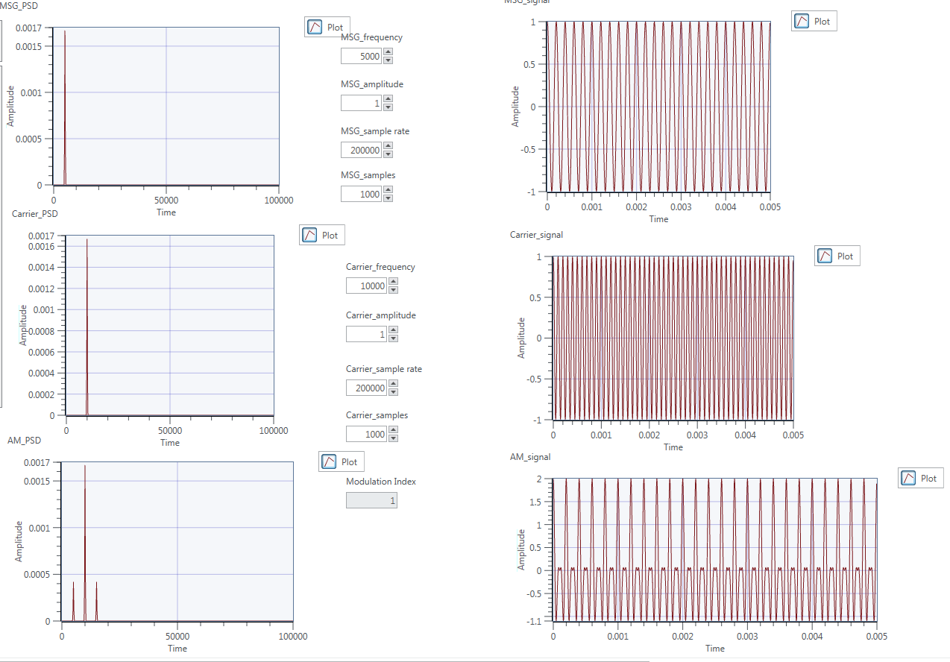

Figure 30 MSG frequency = 5k

Figure 28-30 shows how the message frequency affected the waveform of the AM signal. They show that the less difference between the message signal and the transmitted signal, the harder the transmission happened.

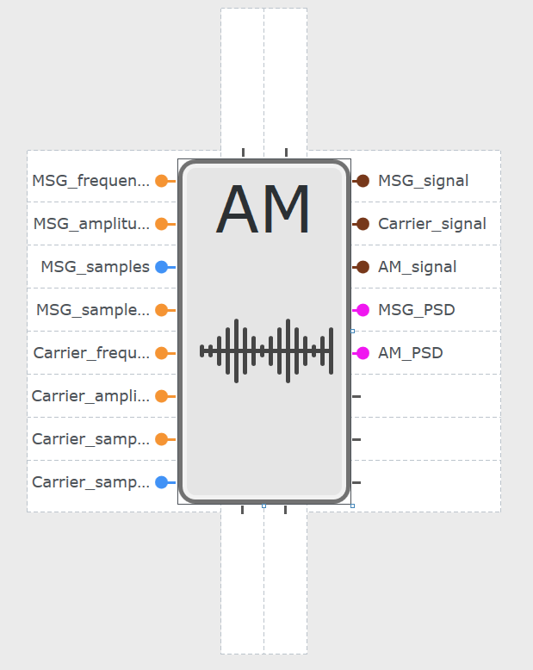

Figure 31 AM sub-vi

# Ex 2: AM Demodulators

## Ex 2a: Coherent Detection

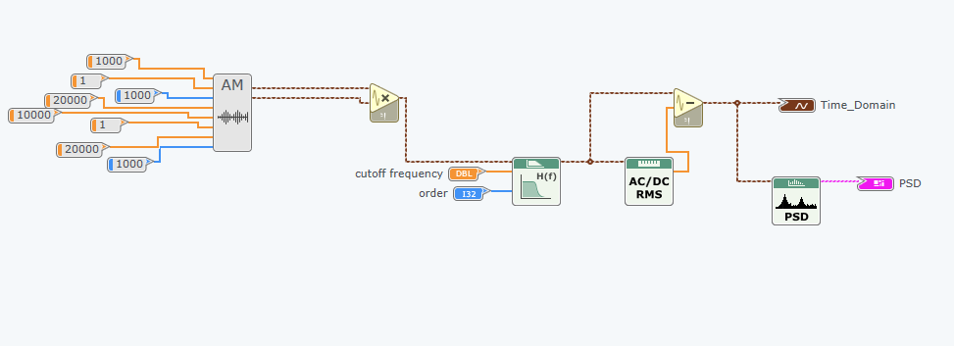

Figure 32 Design diagram

We can use coherent detection to demodulate the signal by first multiplying the AM signal with carrier signal, then pass it to the low pass filter to filter the high frequency part of the signal. Next, eliminate the DC component to get the demodulated signal.

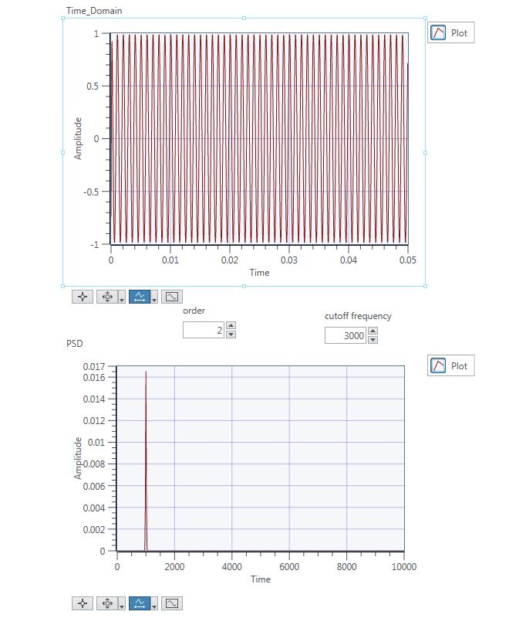

# Ex 2b: Envelope Detection

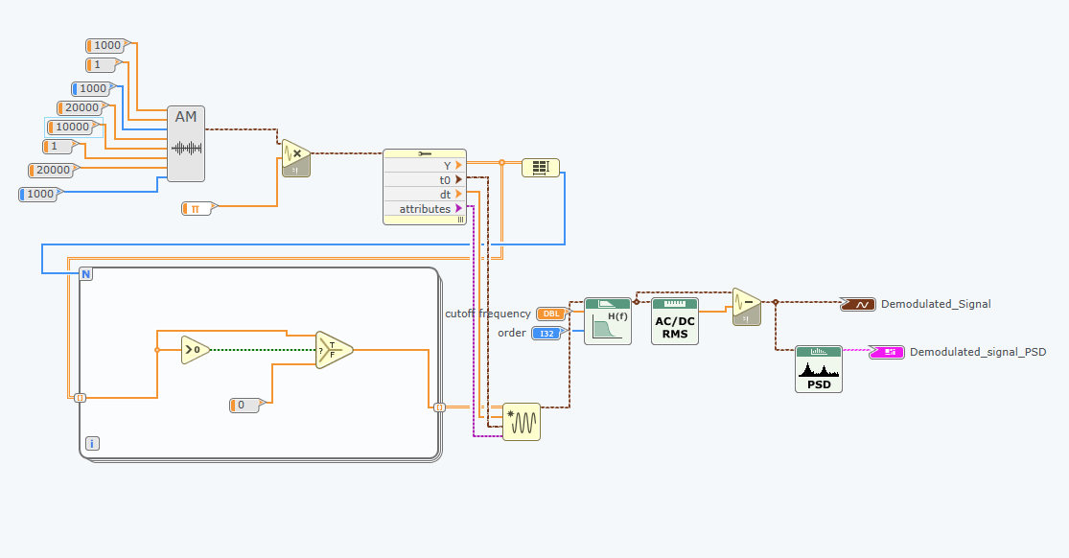

Figure 33 Design diagram

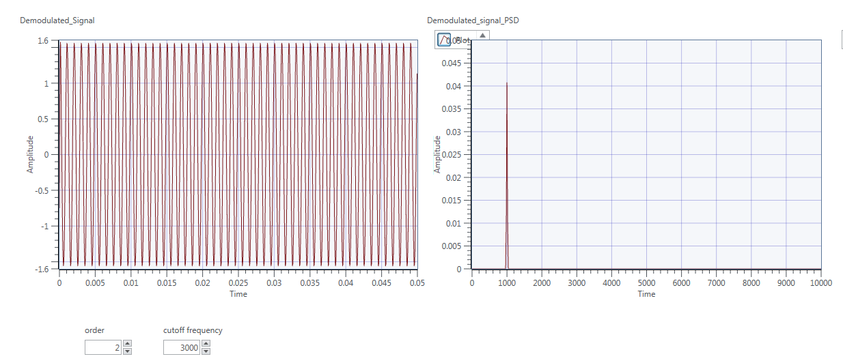

Figure 34 Panel Output

The for loop function used in order to select half the waveform. After the selection, we do the same thing as the coherent detection to demodulated the signal.

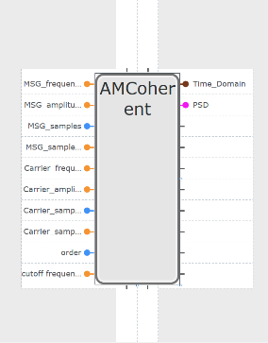 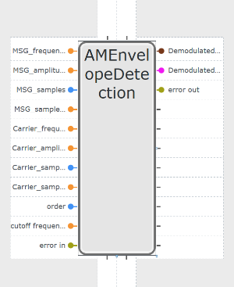

Figure 35 Corherent Detection sub-vi

# Ex 3: AM Simulation

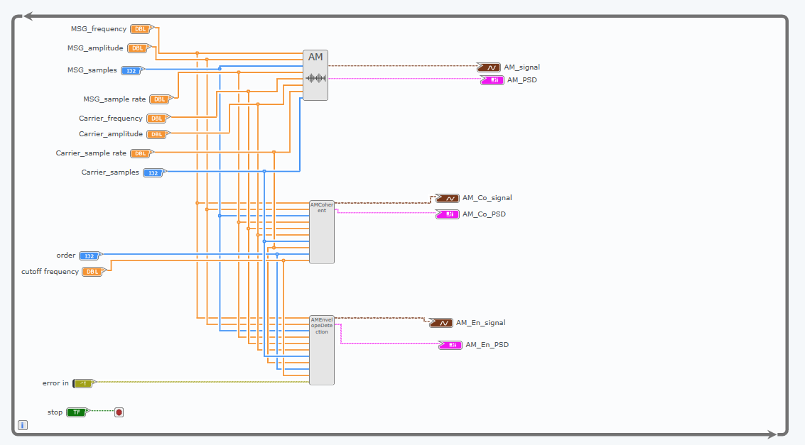

Figure 36 Design Diagram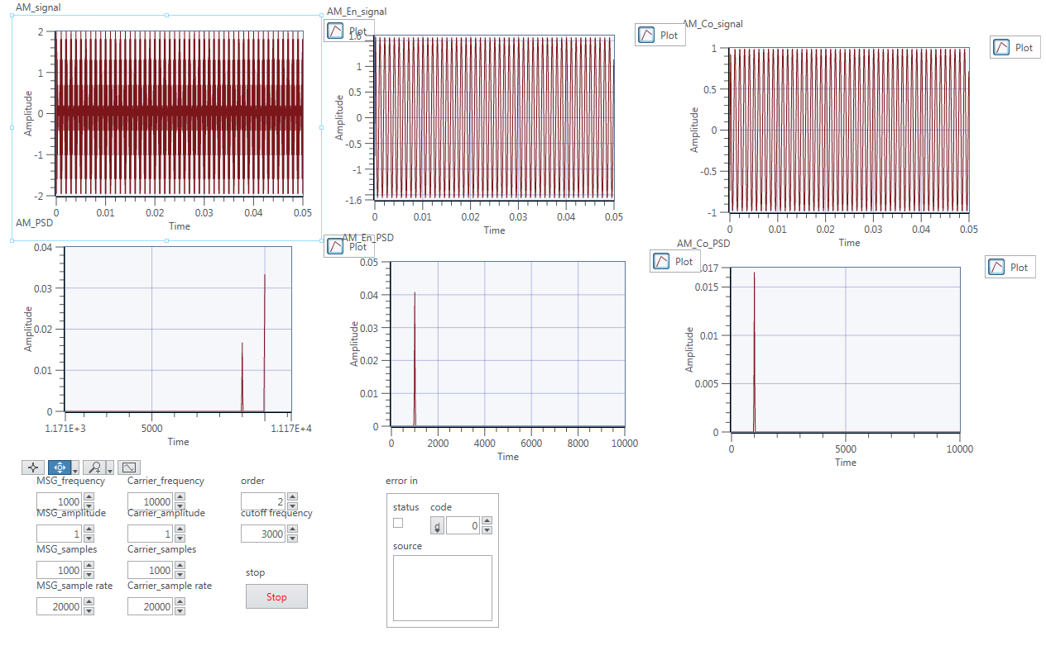

Figure 37 General Output

The figures represent the amplitude of the message change from 1 to 4.

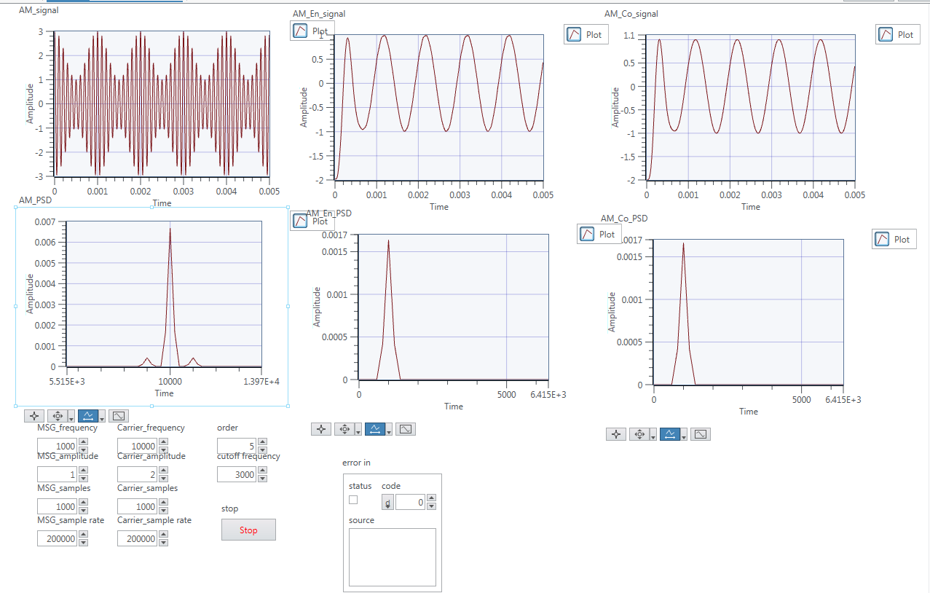

Figure 38 Amp = 1

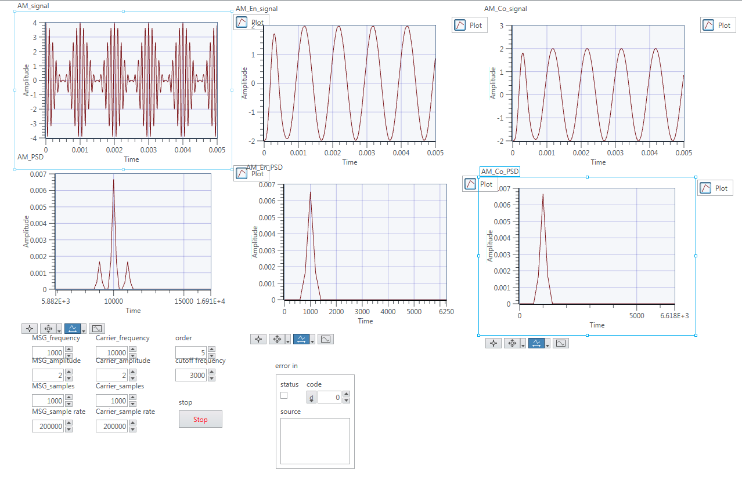

Figure 39 Amp = 2

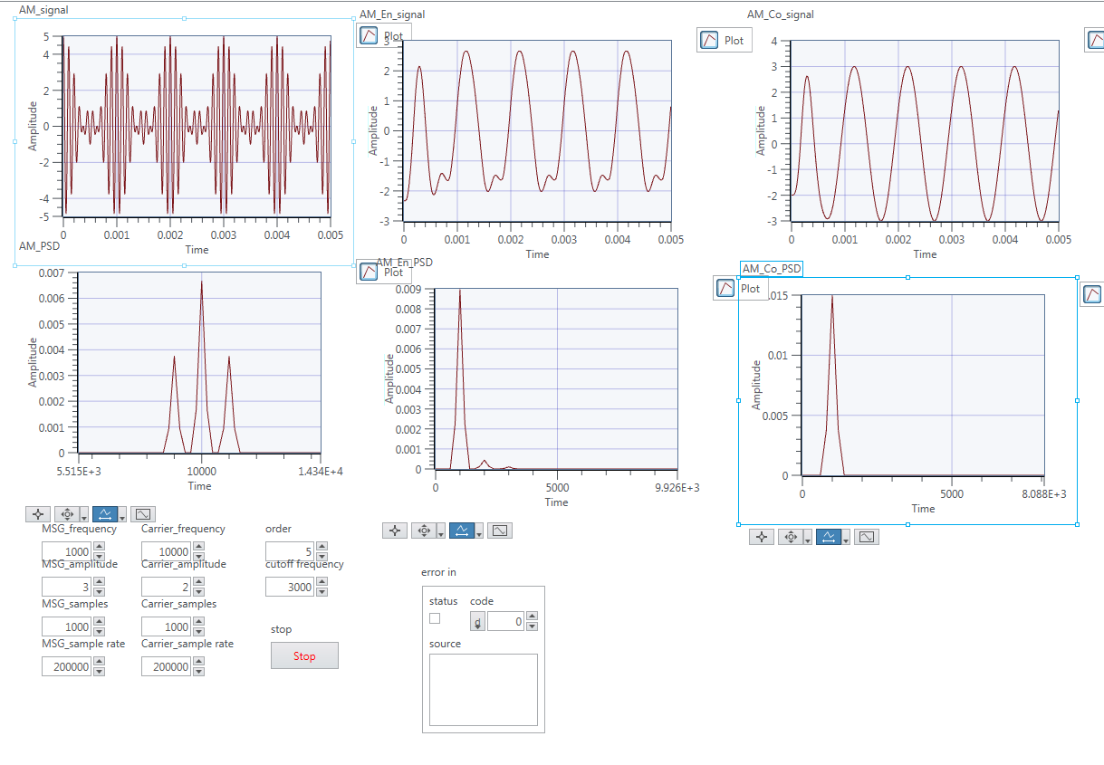

Figure 40 Amp = 3

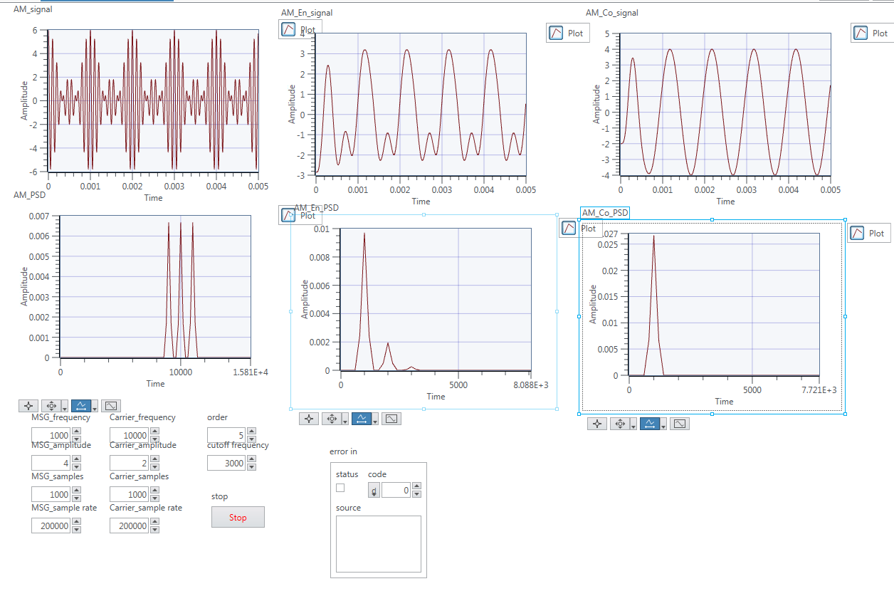

Figure 41 Amp = 4

Compare the figure 38 to 41, we can see the PSD of the AM signal increase as the amplitude of the message signal increase. The reason of this change is due to the modulation index increase, the over modulation happened. So part of the signal is lost due to over modulation; so after the demodulation, the signal changed.

# Ex 4: AM Communications via USRP

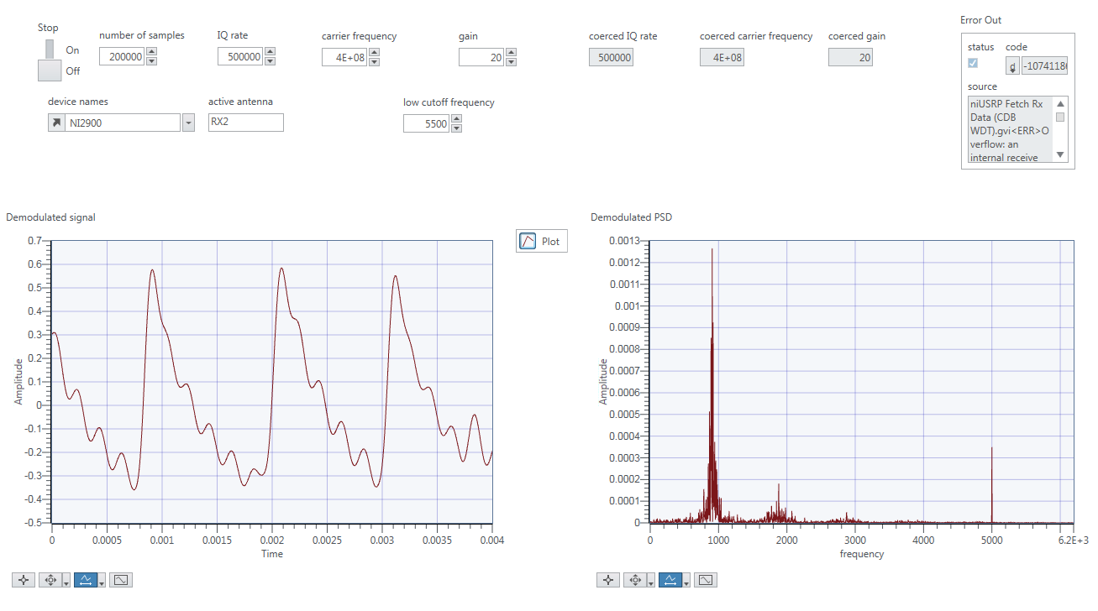

Figure 42 20dB\_mi0.1

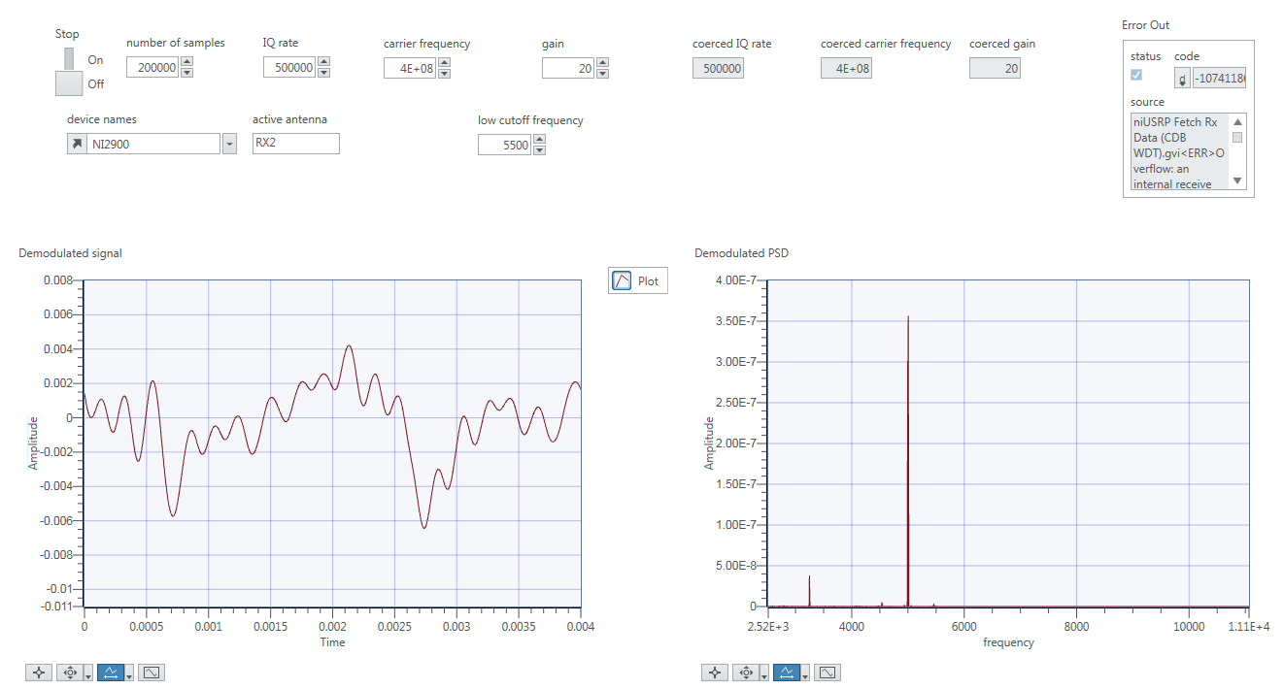

Figure 43 mi 0.4

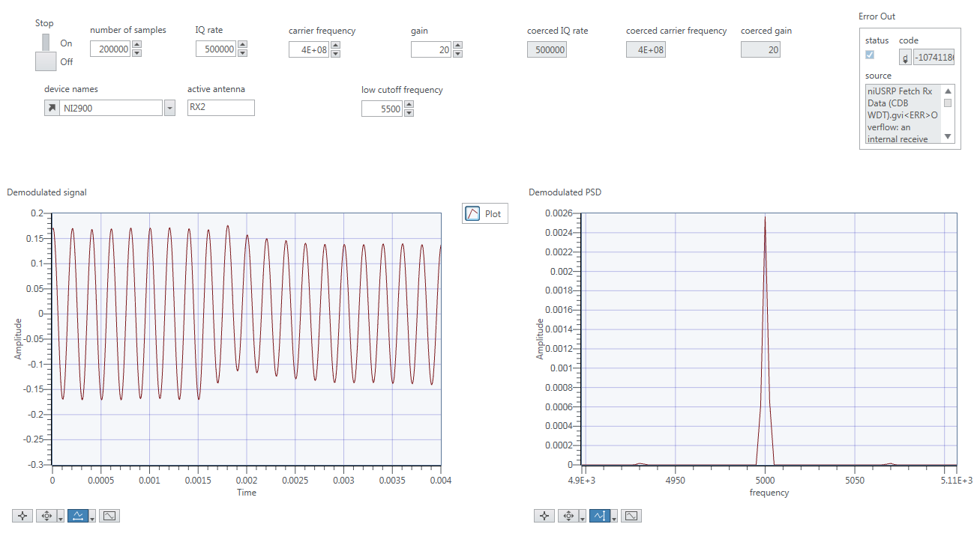

Figure 44 mi1.0

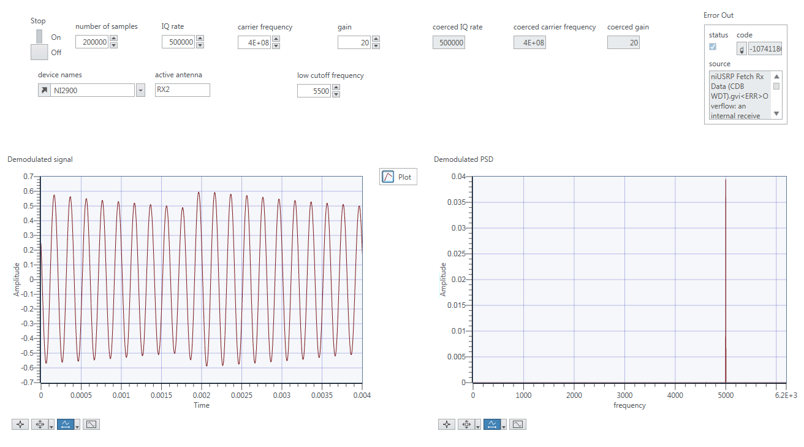

Figure 45 mi 10

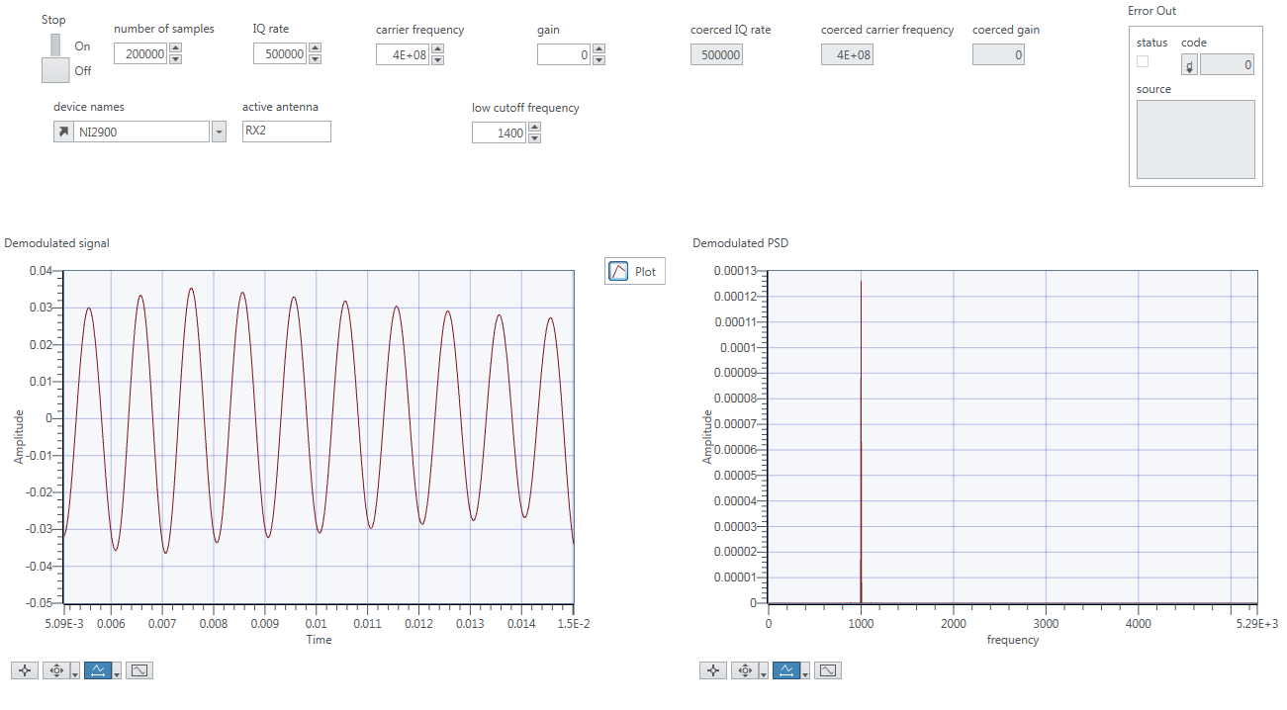

Figure 46 panel rx

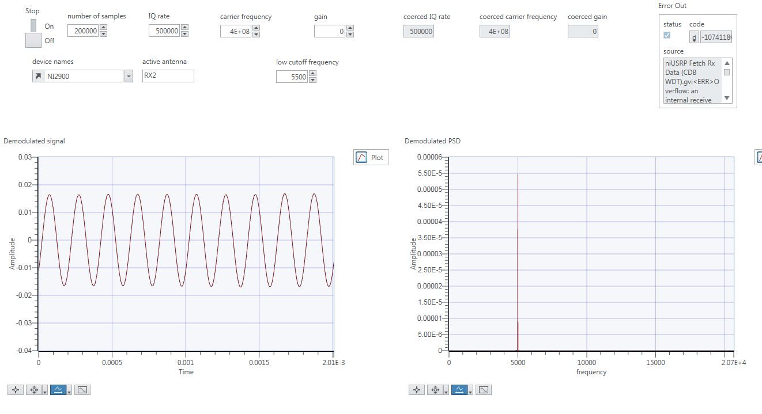

Figure 47 panel rx 5k

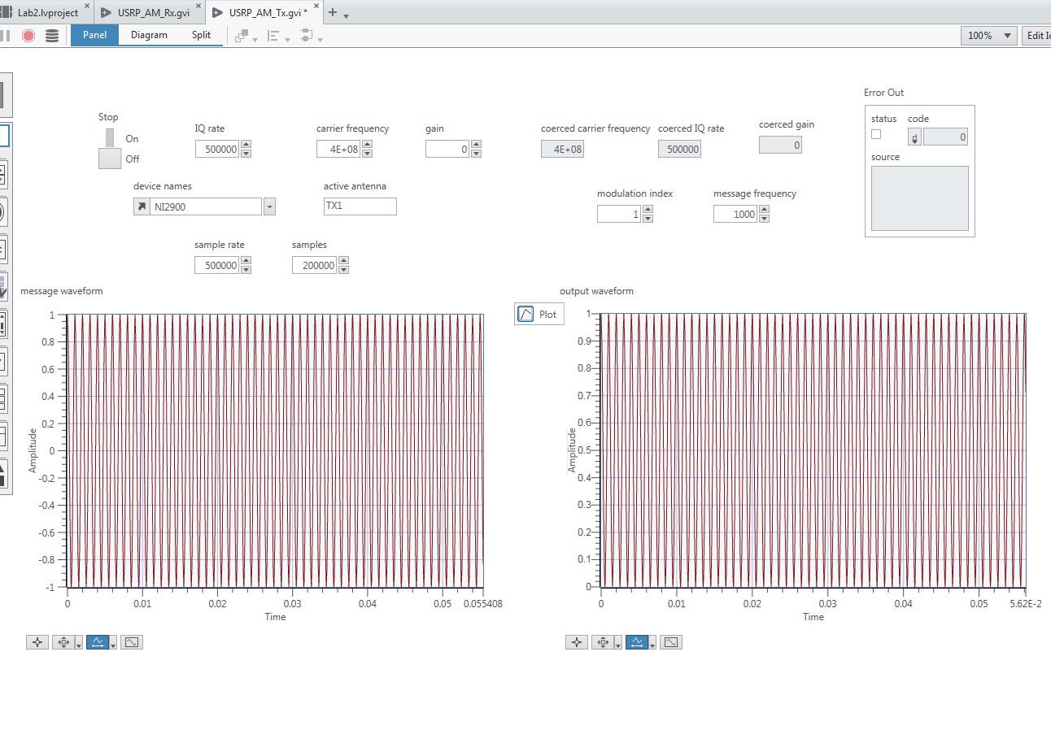

Figure 48 panel tx

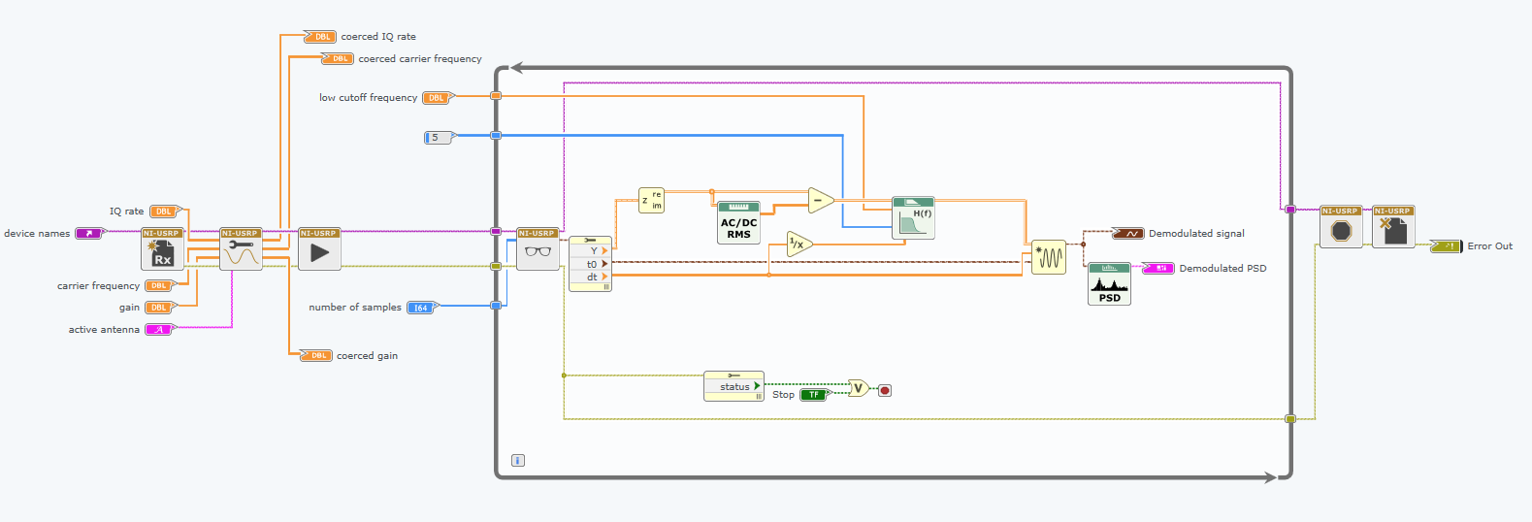

Figure 49 diagram rx

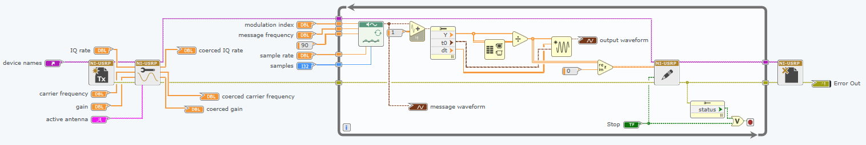

Figure 50 diagram tx

Ex 5: Listening to AM Music

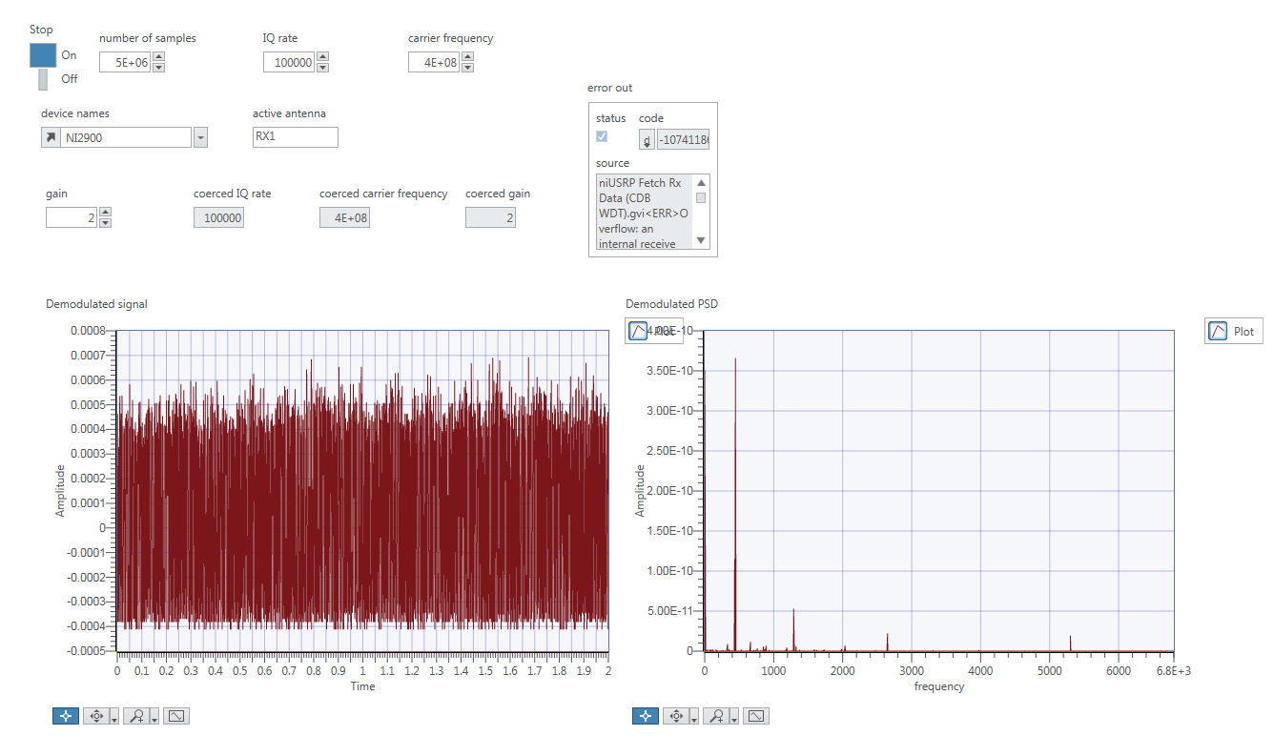

# Lab 3: FM Simulation and USRP

Ex 1: FM Modulator

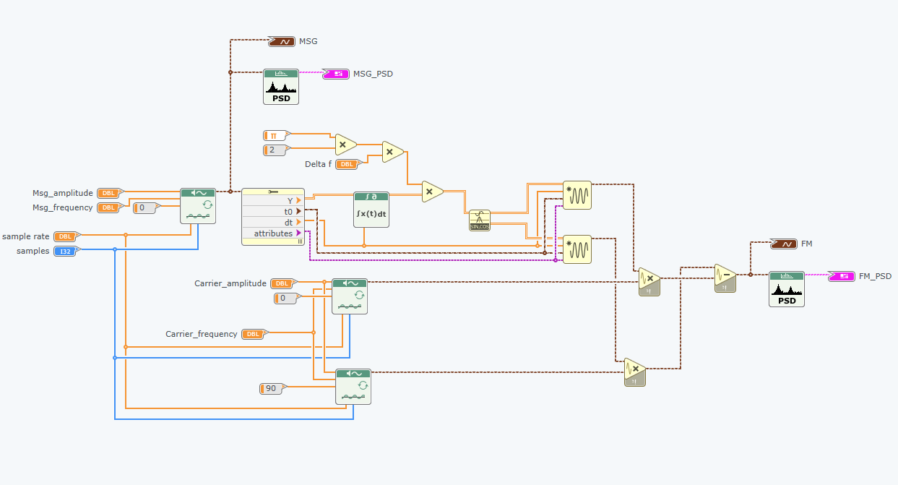

Figure 51 Wrong design

Figure 51 is the wrong design during this exercise. The reason is there a 𝟐𝝅 in θ(t), so we wondered that we should multiply 𝟐𝝅. But in fact, multiply 𝟐𝝅 here will decrease the value of the θ.

