Ministry of Education and Science of the Republic of Kazakhstan

“International Information Technology University”

Department of computer engineering and information security

Laboratory work #5

Enterprise Cybersecurity

Made by: Baktygulova A.

SIS-1701K

Checked by: Sagymbekova A.O

Almaty, 2020

Part1

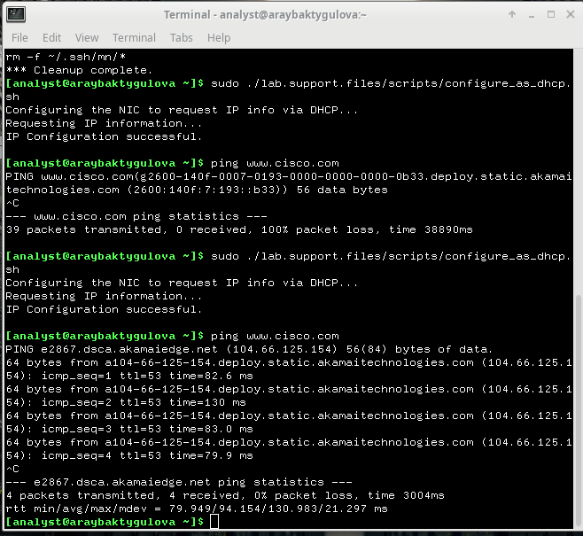

Part2 Step1

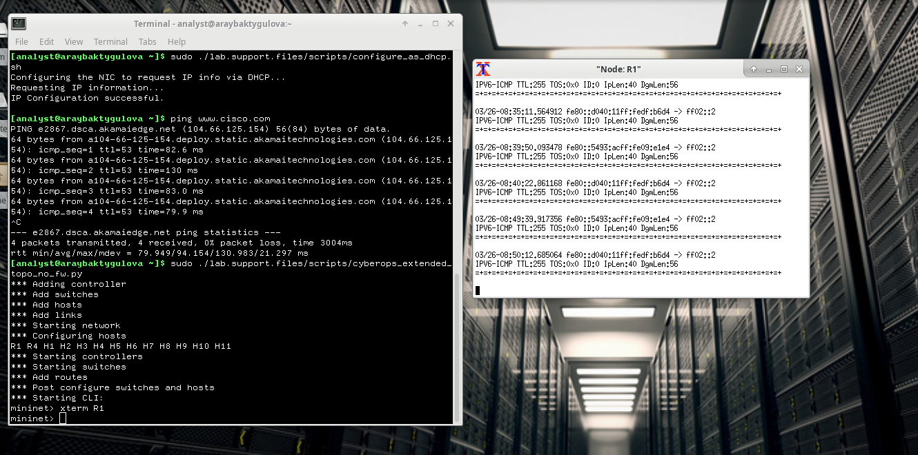

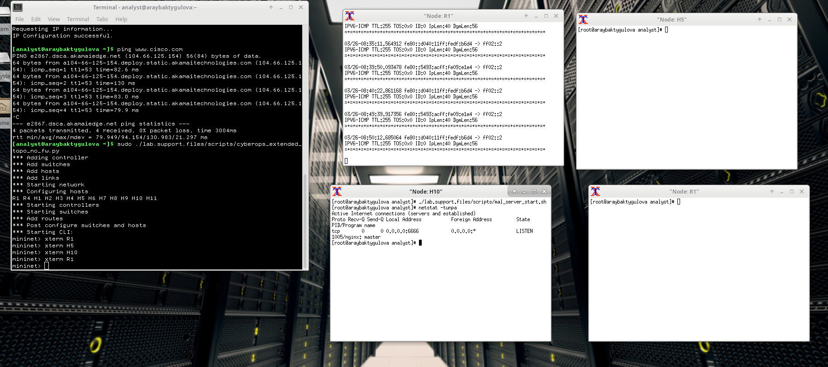

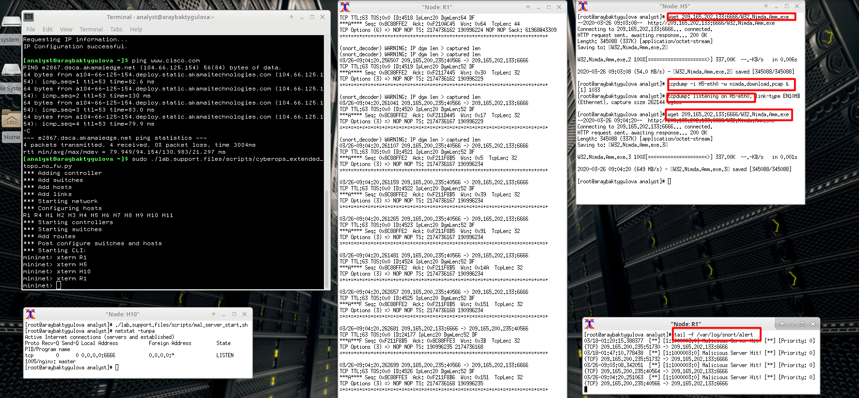

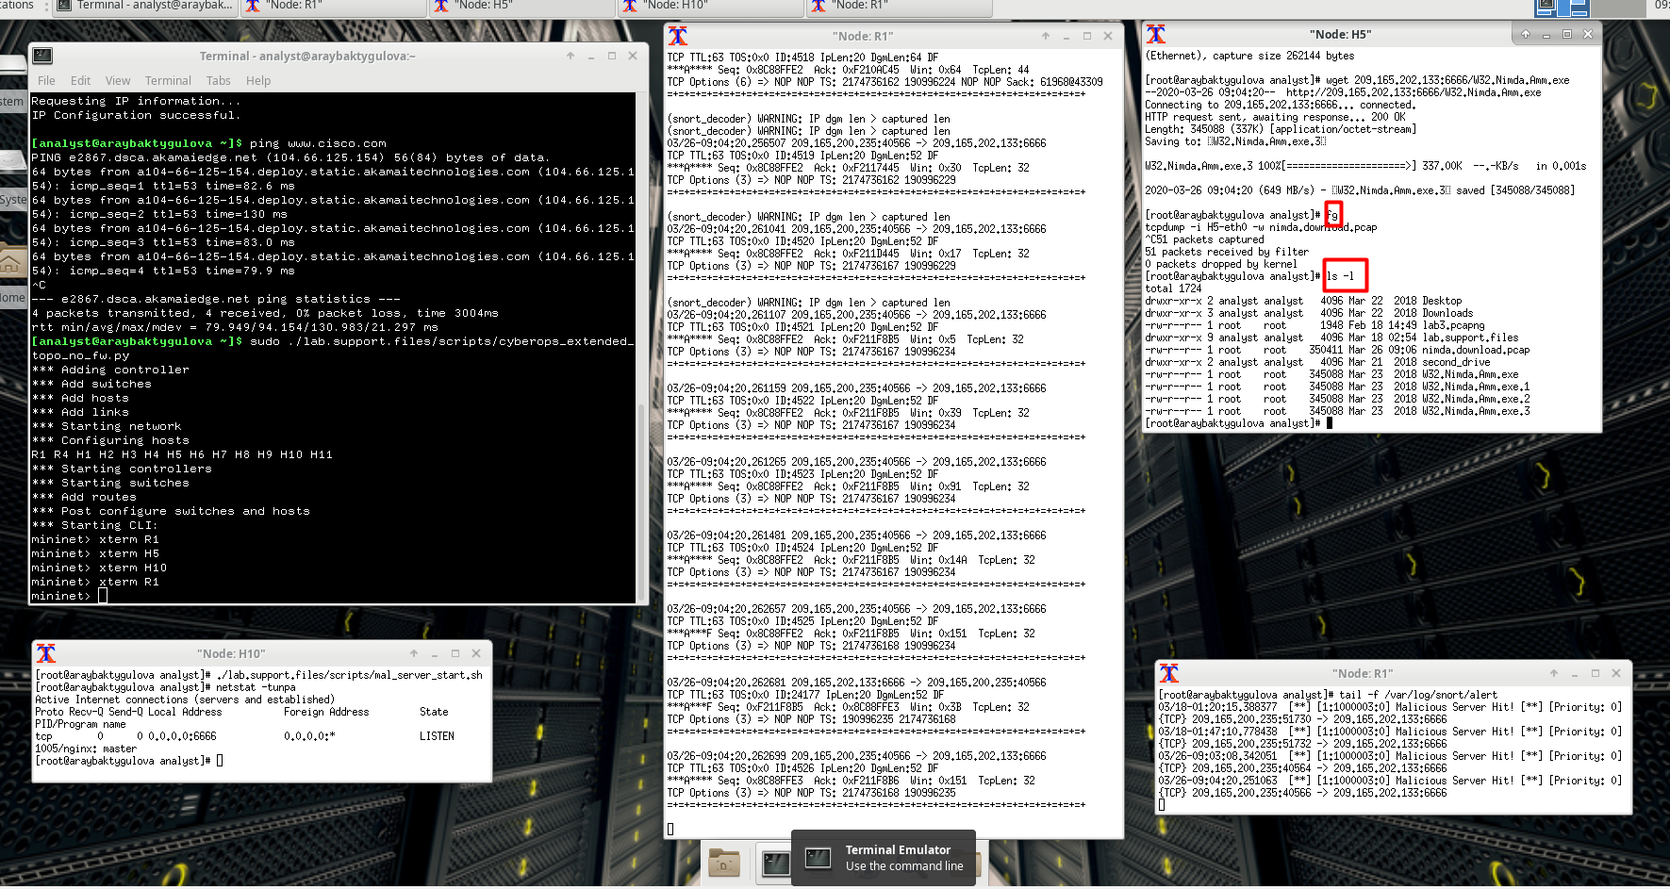

Step2

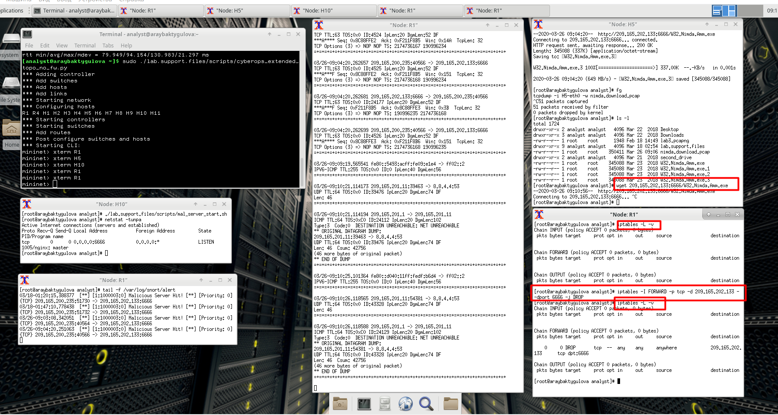

Part3

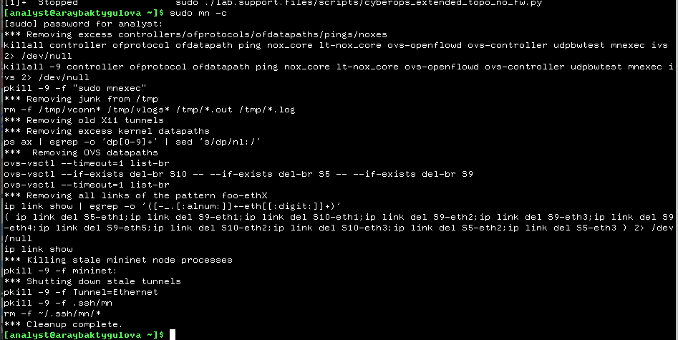

Additional tasks

FIREWALL RULES –

FORWARD for S10 to H18

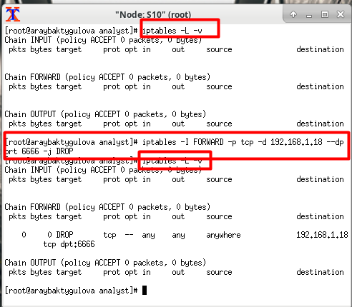

FORWARD for R4 to H11

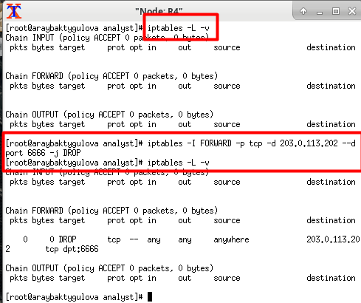

INPUT S5 to H6

