Name: Phuong Nguyen

Date: 5/28/2025

Course: Foundations Of Programming: Python

GitHub: https://github.com/tnyen102/IntroToProg-Python-Mod06

Assignment 06 – Functions

# Introduction

This week, I learned about functions and how it will help me reuse my code so I don’t have to write it over and over again. I also learned about local vs global variables. Local is just specific to that block of code while global can be used anywhere in the script. A better alternative is using parameters because it is more flexible and reusable. I also learned about classes which is use to group functions, variables and constants together. Lastly I learned that Separation of Concerns will enhance maintainability and scalability.

# Writing the Script

This week’s assignment is similar to Assignment 05 except we have to add functions, classes, and using the separation of concerns pattern. The basic information was already given with the starter file, so I copied over the header, the constants and variables over and updated it with what is required for this assignment. In addition I have import the json file over and used the Enrollments.json that was already given (Figure 1).

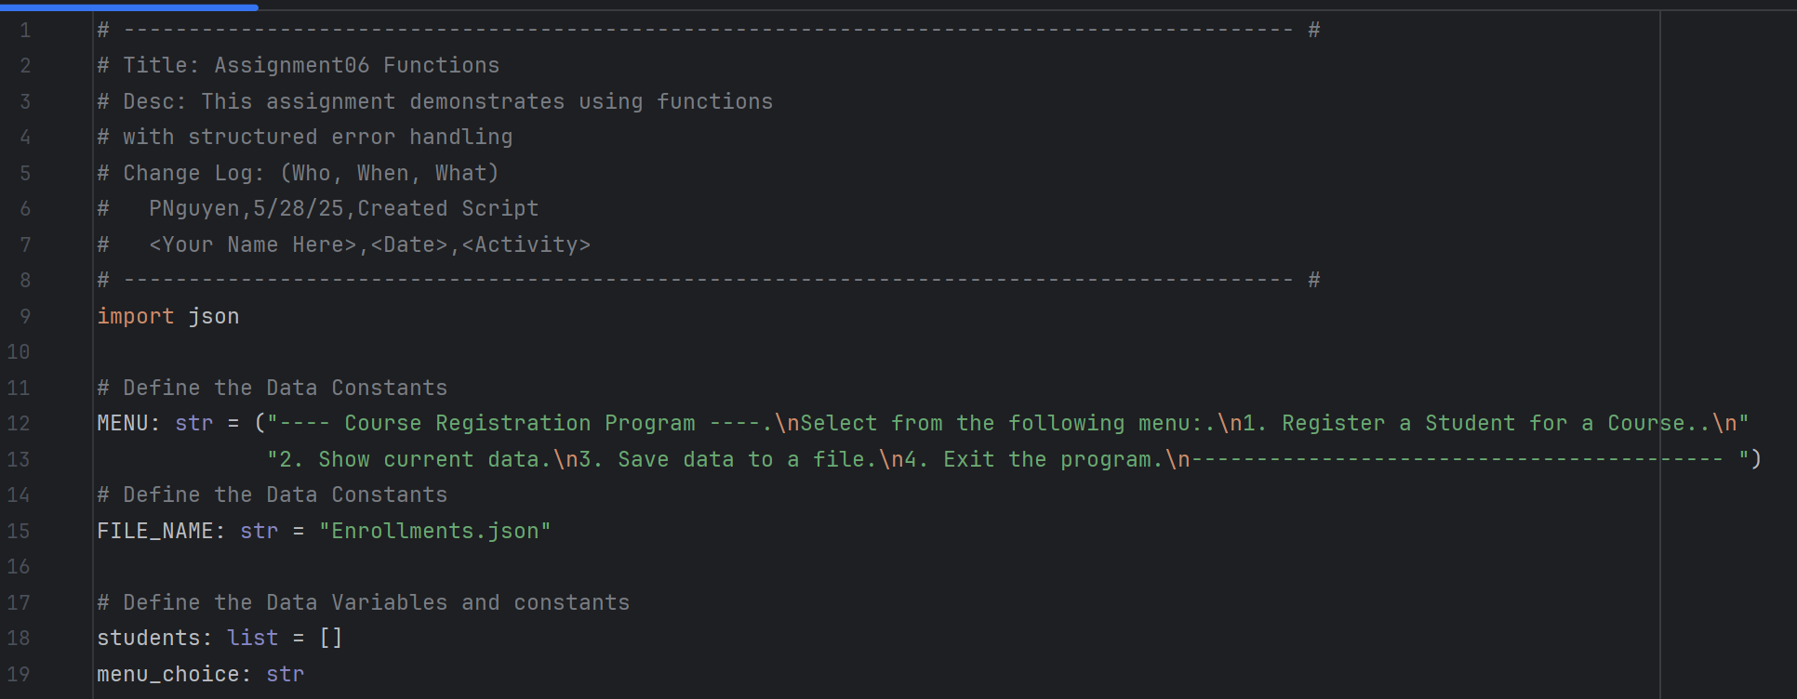

Figure 1: Basic Information

My next task is similar to create a class to process the required data. Under the class I will have different functions for different purposes. Two functions that are required are to read the data from the json file and load it into a list as dictionary rows and to write the data to the json files (Figure 2).

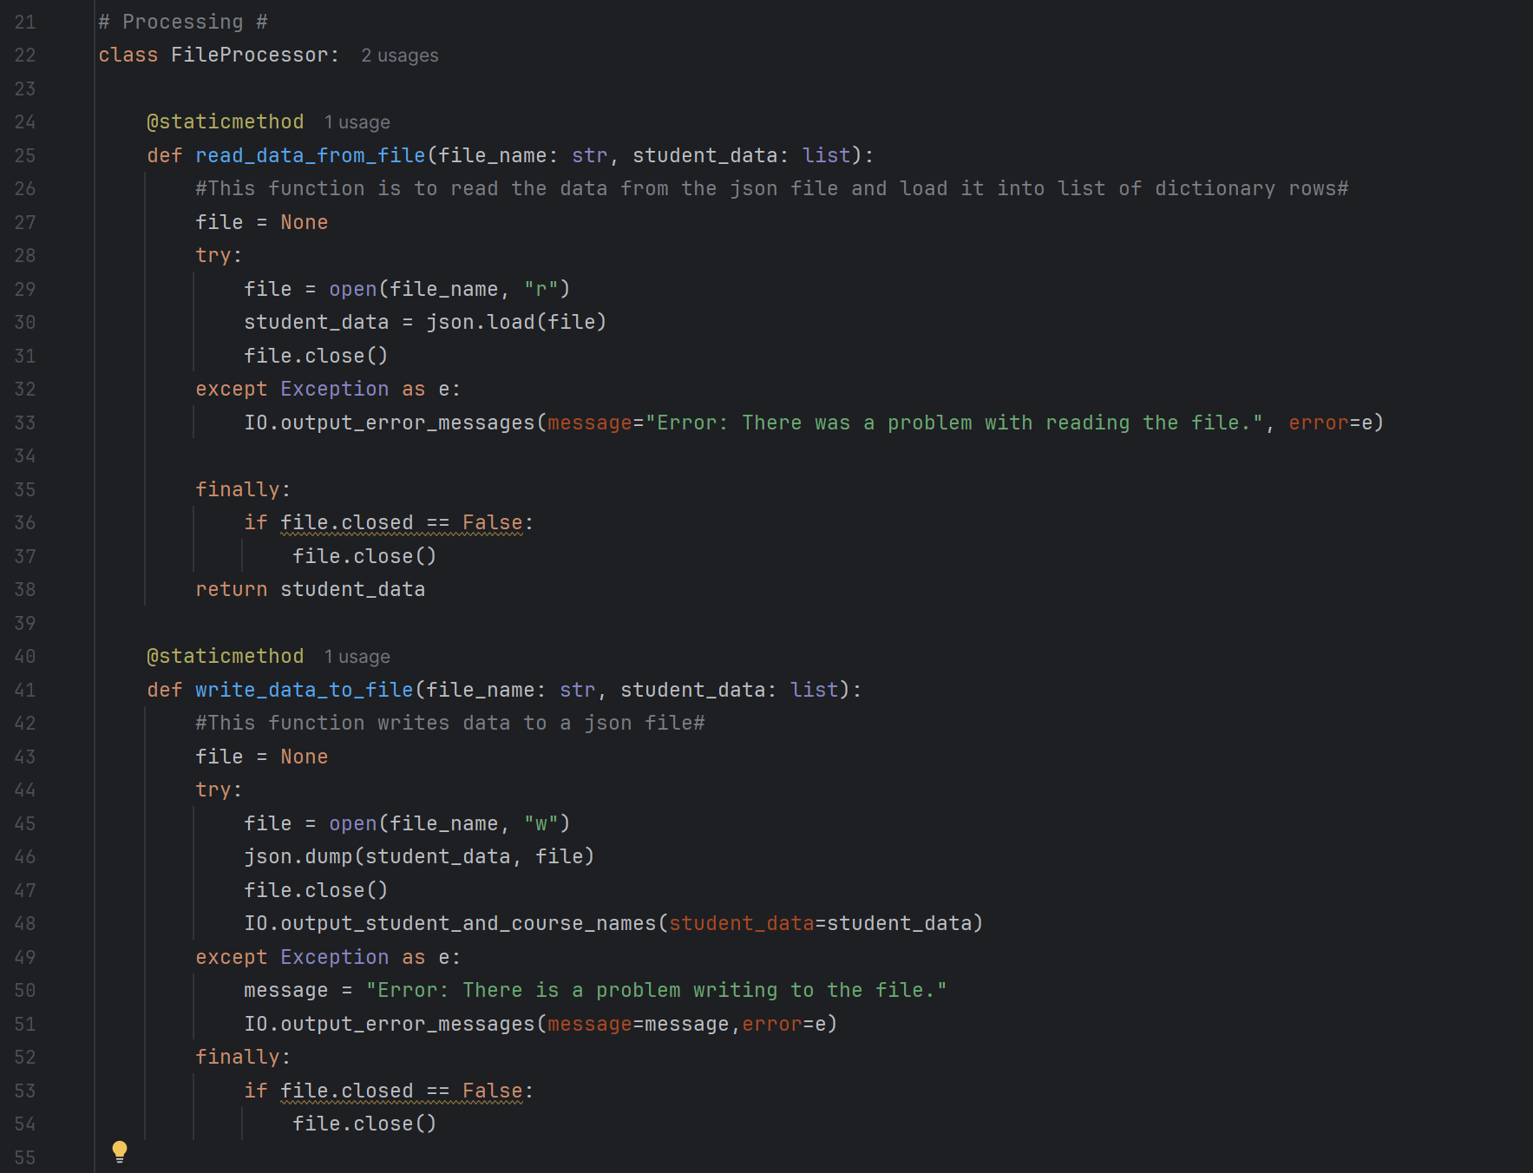

Figure 2: Processing class and functions

The next class is to present the data to the users to get their inputs as well as displaying it back to them. The first function is about getting an error message if the users enter something that is not part of the menu. The next function is simply to display the menu choice to the user. The third function is to get the users to enter their choice from the menu. The fourth function is to display the information back to the user. The last function prompts the users for inputs. (Figure 3).

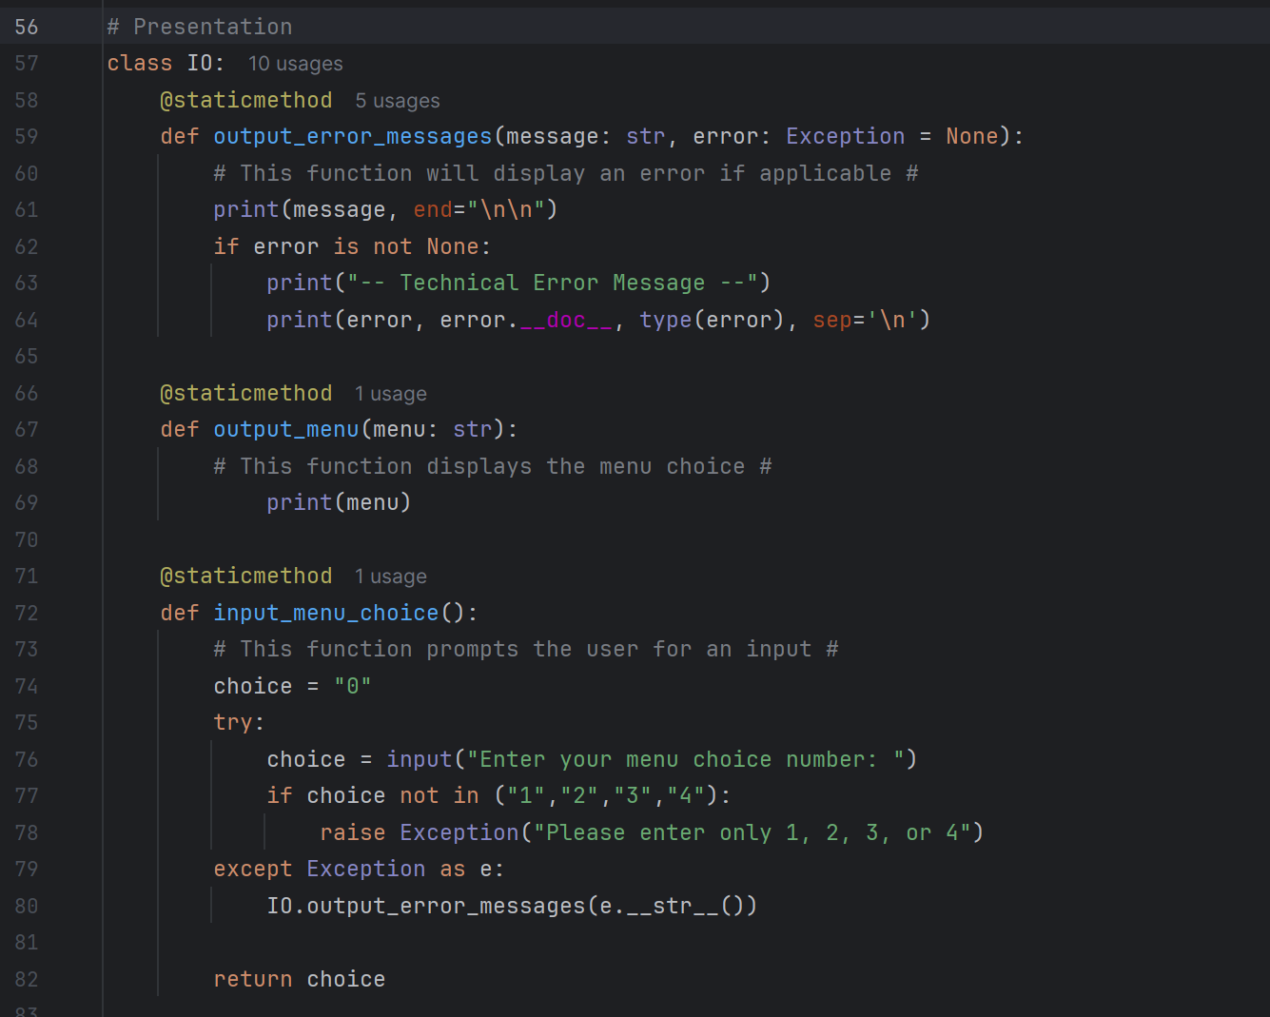

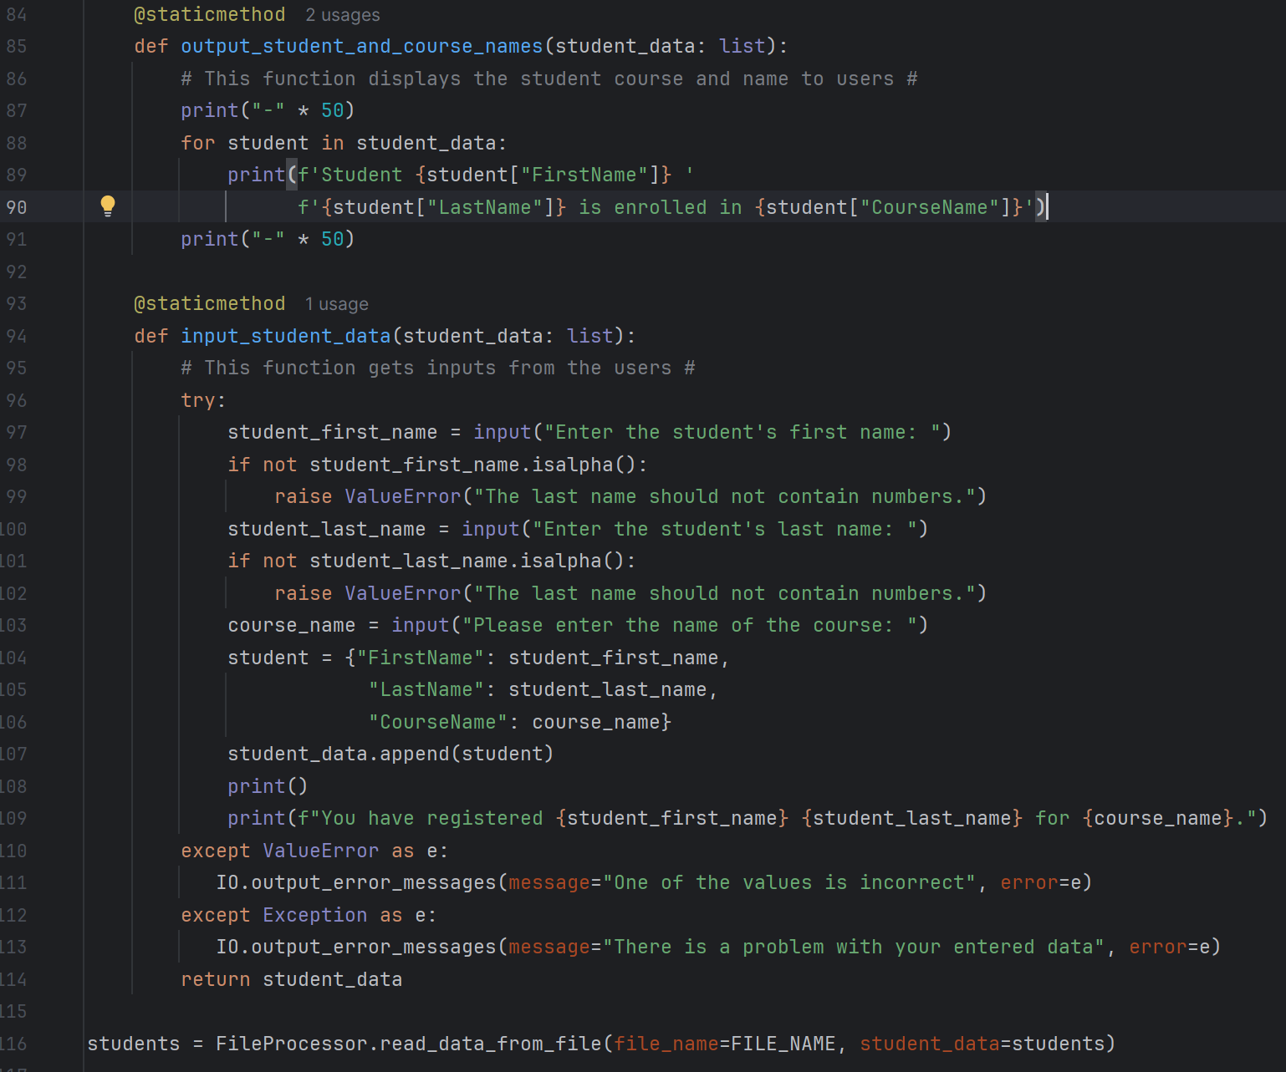

Figure 3: Presentation class and functions

The last script is similar to what we have learned and that is the while loop which allows the users to make the selection and the output will be what is selected. The main difference is that we are now using our functions that was defined earlier, this is a much cleaner code to look at compare to before. (Figure 4).

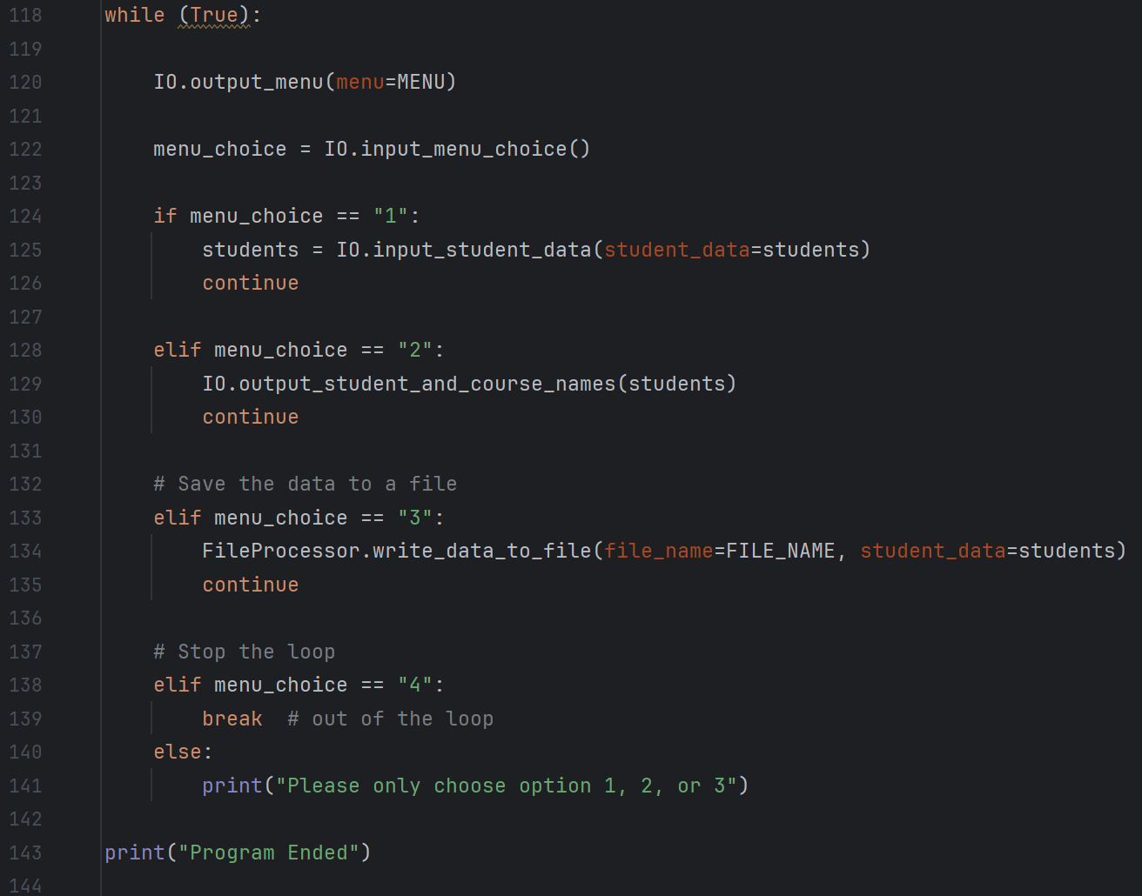

Figure 4 While Loop with the functions

# Testing the Script

With my script in place, it is time for me to test and make sure it works in both PyCharm and the Command Prompt. After some trial and error, I was able to successfully get my script to work in PyCharm, it also opened and saved the json file as intended (Figure 5). It also worked in the command prompt, as you can see the json file was updated and saved to a later time when I ran it (Figure 6). The error message also works as intended (Figure 7).

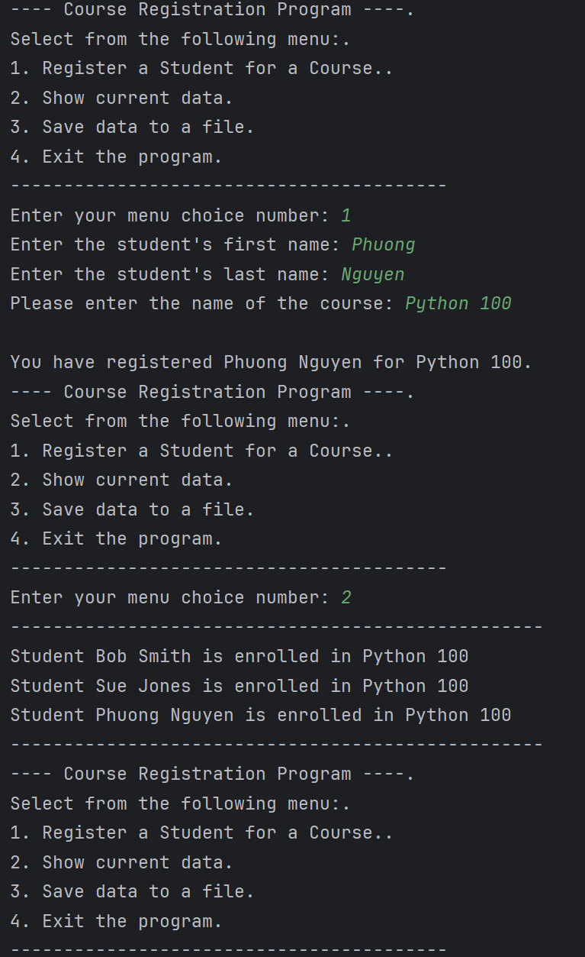

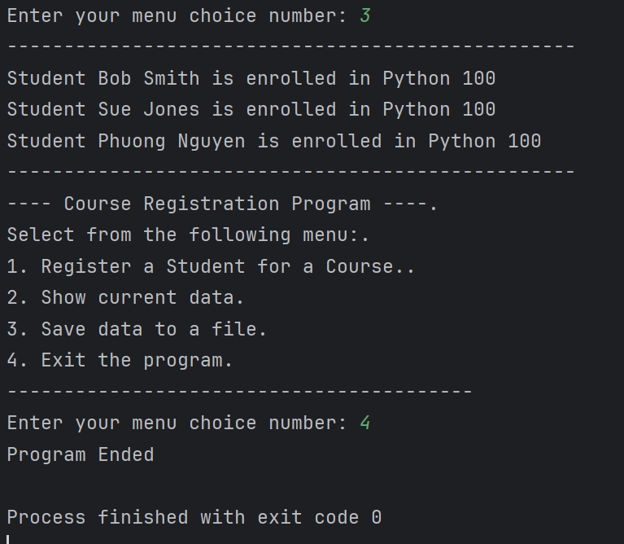



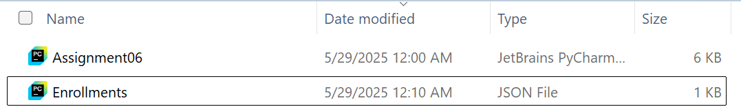

Figure 5: Test in PyCharm

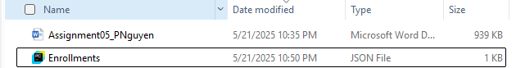

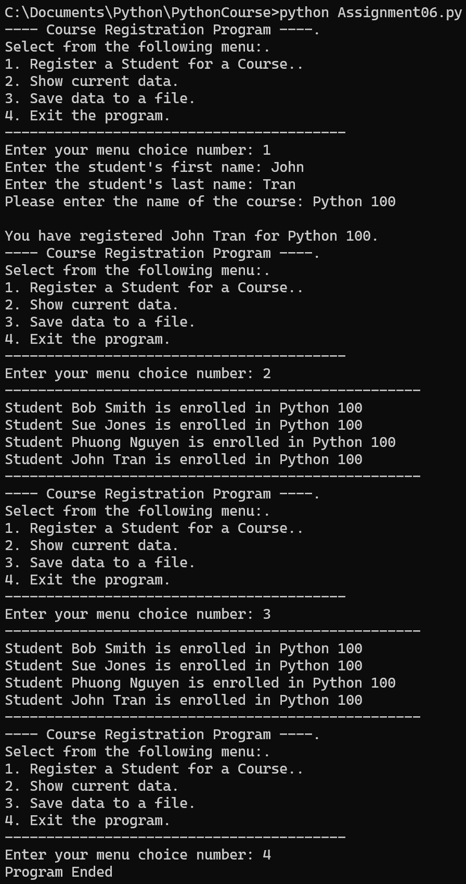

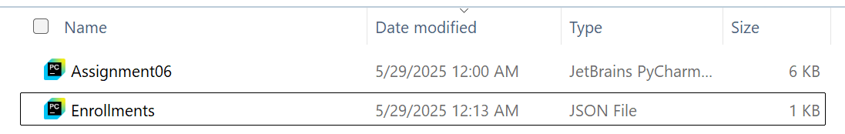

Figure 6: Test in Command Prompt

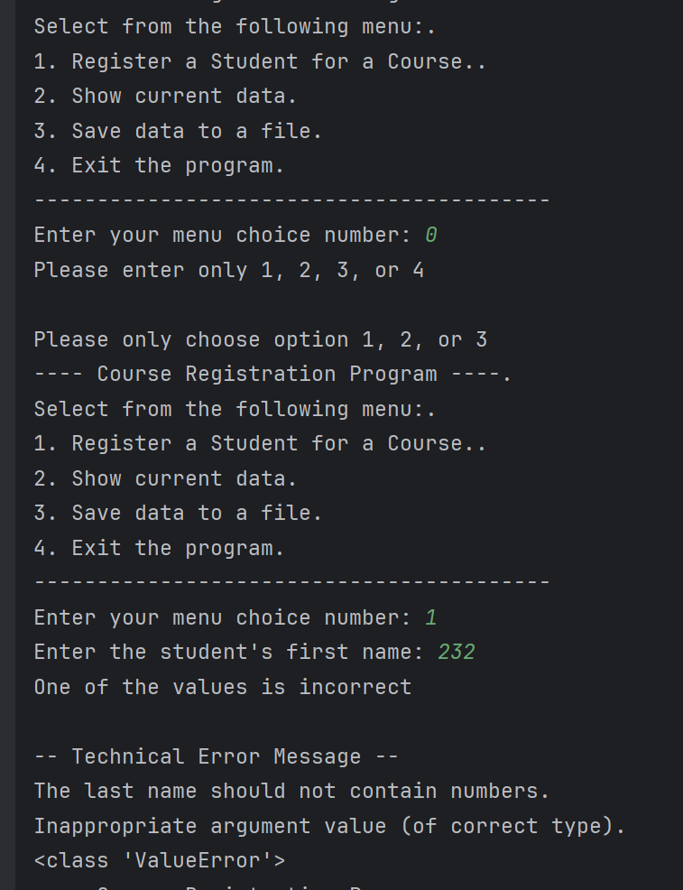

Figure 7: Error Message

# Summary

This week’s assignment was even more challenging then last week’s especially the class, functions and SOC. I had to watch the instructor session this week to get my code to work. This module taught me about class and functions and how it can help streamline my code and make it more easy to read and follow.