THE OPEN SOURCE AUDIT
A Capstone Project for OSS NGMC Course
Chosen Software: Python

Course: Open Source Software | Unit Coverage: 1 – 5
Max Marks: 100

Field | Details
Student Name | Kavya Chaudhary
Registration Number | 24BCE11433
Slot | A13
Date of Submission | 31/03/2026

1. Introduction
Python is one of the most widely used programming languages in the world today — a tool that powers scientific research, machine learning systems, web applications, automation scripts, and beginner education alike. Yet Python did not emerge from a corporation with a product roadmap or a commercial motive. It was born from one person's frustration with the limitations of existing tools, released freely to the world, and shaped over three decades by a community that believed software should be open, readable, and accessible to everyone.

This report conducts a structured audit of Python as an open-source software project. It examines why Python was created, what its PSF (Python Software Foundation) license actually grants its users, what ethical questions open-source development raises, how Python lives inside a Linux system, what ecosystem surrounds it, and how it compares to proprietary alternatives. Alongside this report, five shell scripts demonstrate practical Linux skills that connect directly to the philosophy of open-source tools.

Python is not just a language. It is a philosophy made executable.

Part A — Origin and Philosophy (Units 1 & 2)

A1. The Problem Python Was Created to Solve
The World Before Python
In the late 1980s, if you wanted to write a program, your options were constrained in frustrating ways. Low-level languages like C and C++ gave you power but demanded that you manage memory manually, write verbose code, and fight the language as much as the problem. High-level languages like BASIC were simple but too limited for serious work. FORTRAN and Pascal existed for scientific use but were rigid and not designed for interactive or exploratory programming.

There was a gap — a missing tool for the programmer who needed something more powerful than a shell script but more flexible and human-readable than C. Someone who wanted to prototype quickly, experiment interactively, and write code that communicated its intent clearly to another human being.

Guido van Rossum and the ABC Language
Guido van Rossum was a Dutch programmer working at Centrum Wiskunde & Informatica (CWI) in Amsterdam in the late 1980s. He had been part of the team that developed a language called ABC — an educational language designed to be clean, readable, and beginner-friendly. ABC had genuinely good ideas: indentation as syntax, powerful built-in data types, and a philosophy of reducing programmer burden. But it had a fatal weakness: it was closed and inflexible. You could not extend ABC, could not add new libraries, and could not interact with the operating system effectively. It was a beautiful cage.

Van Rossum took what was best about ABC — the clean syntax, the philosophy of readability — and set out to fix what was broken. During the Christmas holiday of 1989, working in his spare time, he began writing a new language interpreter. He named it Python, after Monty Python's Flying Circus, the British comedy group — a deliberate signal that programming did not have to be solemn and corporate.

Why He Shared It
Python 0.9.0 was released to the Usenet newsgroup alt.sources in February 1991. Van Rossum did not need permission from a corporation to do this. He had written it himself, and he chose to release it openly because he believed the tool would improve if others could read it, use it, and contribute to it. This was not a naive act of charity — it was a deliberate alignment with the emerging culture of open, collaborative software development that was defining the early internet era.

The problem Python solved was not just technical. It solved the problem of inaccessibility: inaccessibility to programming for beginners, inaccessibility to rapid prototyping for researchers, and inaccessibility to a language that respected the programmer's time and intelligence. It solved all of this for free.

A2. The License — What It Actually Says
The PSF License
Python is released under the Python Software Foundation License (PSF License), currently version 2. The PSF License is a permissive open-source license — meaning it places very few restrictions on what you can do with Python's source code. It is broadly compatible with the GPL and has been approved by both the Open Source Initiative (OSI) and the Free Software Foundation (FSF).

The PSF License grants you the right to use, copy, modify, and distribute Python for any purpose, including commercial use, provided you retain the original copyright notice and the license text. That is essentially the full extent of the restriction. There is no requirement to share your modifications. There is no obligation to release derivative works as open source. A company can take CPython (the reference implementation of Python), modify it, ship it in a product, and never release those changes.

The Four Freedoms of Free Software
The Free Software Foundation defines four fundamental freedoms that a free software license must grant:
- Freedom 0 — The freedom to run the program for any purpose.
- Freedom 1 — The freedom to study how the program works and change it.
- Freedom 2 — The freedom to redistribute copies to help others.
- Freedom 3 — The freedom to distribute copies of your modified versions.

The PSF License grants all four freedoms. You can run Python for any purpose — commercial, educational, personal, governmental. You can read CPython's source code on GitHub. You can redistribute Python binaries. You can fork Python, modify it, and distribute your modified version. Python is therefore free software in the philosophical sense, not merely the economic sense.

GPL vs MIT vs PSF
The GNU General Public License (GPL) is a copyleft license. If you take GPL-licensed code, modify it, and distribute it, you must release your modifications under the GPL as well. This is called the 'viral' property of GPL — freedom propagates. The GPL protects users of software by ensuring that the source code remains accessible down the chain of distribution.

The MIT License is a permissive license. It allows you to do almost anything with the code — including incorporating it into proprietary software — as long as you include the original license text. There is no requirement to share modifications.

The PSF License behaves similarly to MIT: it is permissive, commercially friendly, and places no copyleft obligation on derivative works. This was a deliberate choice. Python's creators wanted adoption above all else. A copyleft license might have made companies hesitant to build products using Python.

If I were to build something and release it, I would choose the MIT License for a utility library I want widely adopted without friction, and GPL v3 for a full application where I care about ensuring users always have access to the source code. The choice depends on whether maximising adoption or maximising user freedom is the primary goal.

Free as in Beer vs Free as in Freedom
Richard Stallman's famous distinction: 'free as in free speech, not free beer.' Free beer costs you nothing monetarily. Free speech means you have the right to use it, study it, modify it, and share it. Python is both: it costs nothing to download, and the PSF License grants you genuine freedom over the software.

An example: Python itself can be downloaded and used at zero cost (free beer). But more importantly, you can read exactly how the CPython interpreter evaluates your code, find a bug in the standard library, fix it, and submit that fix back to the project (free as in freedom). A proprietary language like MATLAB costs thousands of dollars and you cannot inspect or fix its internal workings.

A3. The Ethics of Open Source
Should All Software Be Open Source?
The argument for: software is fundamentally different from physical goods. A program can be copied infinitely at zero marginal cost. Keeping source code closed imposes an artificial scarcity that serves the vendor's commercial interests but harms the broader ecosystem. Open source creates collective wealth — every developer who uses Python benefits from decades of contributed work, and contributes back to a shared resource. Security researchers can audit open-source code and find vulnerabilities. Users can trust what they are running because they can verify it.

The argument against: not all software is created equal. Building a novel algorithm or a product that represents years of investment requires a business model. Open sourcing everything could reduce the incentive to invest in expensive, difficult problems. Some domains — medical devices, financial systems, defence — may require proprietary control for liability and security reasons. And open-source software is not automatically more secure; OpenSSL's Heartbleed vulnerability existed in widely used code for two years before it was discovered.

My position: open source is the right default for foundational infrastructure — languages, operating systems, compilers, protocols. These become more valuable when they are shared, auditable, and not controlled by any single entity. Proprietary software has legitimate space for novel applications and products built on top of that open foundation.

Is It Ethical for Companies to Profit from Free Community Labor?
Google uses Python extensively across its infrastructure. Meta uses it. Amazon Web Services runs Python-powered services. None of these companies are obligated by the PSF License to contribute back. The question of ethics here is genuine and uncomfortable.

Red Hat built an entire billion-dollar business on Linux — a product created mostly by unpaid contributors and then acquired by IBM for $34 billion. Is this exploitation? The counterargument is that Red Hat contributed significantly back to Linux, that their commercial success funded further development, and that the GPL's copyleft provisions ensured their modifications stayed open. Python's permissive license does not offer even that protection.

There is a difference between companies that take without giving — sometimes called 'open source parasites' — and companies that contribute meaningfully back: code, documentation, infrastructure, paid developer time. Google, for instance, employs core Python developers. The ethical obligation exists even where the legal one does not. The community notices, and companies that only take tend to find the community less welcoming when they need help.

Standing on the Shoulders of Giants
Isaac Newton's phrase, now a cliche, has particular weight in software. Every Python program ever written runs on top of CPython, which runs on top of the Linux kernel, which runs on top of hardware abstraction layers, which communicates through TCP/IP protocols developed with public funding in the 1970s. The entire edifice of modern software is built on accumulated open contributions.

Open source enables innovation precisely by removing the need to rebuild the foundation every time. A researcher building a machine learning model does not need to write their own matrix multiplication library — NumPy exists. A web developer does not need to write an HTTP parser — the standard library provides one. This is not the undermining of original innovation; it is the precondition for it. The original innovation happens at the frontier, built on the open ground below.

Part B — Linux Footprint (Unit 2)

Installation Method
Python is available through package managers on all major Linux distributions. On Debian/Ubuntu-based systems, the primary method is apt. On Red Hat/Fedora/CentOS systems, it is dnf or yum. Python can also be compiled from source, which is necessary when requiring a specific version not packaged for your distribution.

Install via apt (Ubuntu/Debian):
sudo apt update && sudo apt install python3 python3-pip

Install via dnf (Fedora/RHEL):
sudo dnf install python3 python3-pip

Key Directories
Path | Purpose
/usr/bin/python3 | Main interpreter binary — the executable you call from the command line
/usr/lib/python3.x/ | Standard library modules — the batteries included with every Python install
/usr/lib/python3/dist-packages/ | System-wide third-party packages installed via apt
/usr/local/lib/python3.x/dist-packages/ | User/pip-installed third-party packages
~/.local/lib/python3.x/ | Per-user packages installed with pip install --user
/etc/python3/ | System-level Python configuration (if present)
/var/log/ | Logs from Python applications and services running on the system

User and Group
Python itself does not run as a dedicated system user — it runs as whatever user invokes the interpreter. A Python web application running under Apache will run as the www-data user. A Python system maintenance script running as root will run as root. A user script will run as that user.

This matters for security because Python is a general-purpose interpreter: it can execute arbitrary code, read files, make network connections, and spawn processes. Running a Python application with excessive privilege — as root, for instance — means that any vulnerability in the application code can be exploited to take complete control of the system. Best practice is to create a dedicated, low-privilege system user for any Python service.

Service Management
Python applications can be managed as systemd services. A typical Flask or Django web application would be deployed with a WSGI server like gunicorn, and a systemd unit file would manage the process lifecycle.

Example systemd commands for a Python service:
sudo systemctl start myapp sudo systemctl stop myapp sudo systemctl restart myapp sudo systemctl status myapp sudo systemctl enable myapp # start on boot

Update Model
Security patches for the Python interpreter itself are pushed through the distribution's package manager. Running apt upgrade or dnf upgrade will update CPython when patches are released by the Python Security Response Team. Critical vulnerabilities in Python's standard library or interpreter are disclosed via the Python security mailing list and CVE database, and patches are typically backported to supported LTS distribution versions by the distribution maintainers.

Third-party packages installed via pip are updated separately using pip install --upgrade <package>. Tools like pip-audit and safety check installed packages against known vulnerability databases.

Part C — The FOSS Ecosystem (Units 3 & 4)

Dependencies
CPython, the reference implementation, depends on a set of C libraries and system components. Key dependencies include libffi (foreign function interface, used for ctypes), OpenSSL (for ssl and hashlib modules), zlib and libbz2 (compression modules), readline (interactive interpreter line editing), sqlite3 (built-in database module), and the system C library (glibc on most Linux systems).

Python also depends on a C compiler (GCC or Clang) when building from source, which illustrates the layered nature of open-source tooling: Python depends on GCC, which is itself an open-source project from the GNU Project.

What Python Has Enabled
Project / Tool | Relationship to Python | License
NumPy | Scientific computing array library — the numerical foundation of data science | BSD
Django | Full-stack web framework — powers Instagram, Pinterest, Disqus | BSD
Flask | Lightweight web microframework built on Python | BSD
TensorFlow / PyTorch | Machine learning frameworks with Python as primary interface | Apache / BSD
Ansible | IT automation tool written entirely in Python | GPL v3
Jupyter Notebook | Interactive computing environment — transformed research publishing | BSD
pip | Package installer for Python — the tool that distributes the ecosystem | MIT
Conda | Cross-platform package manager originating from scientific Python community | BSD

Python in the LAMP Stack and Beyond
Python does not fit neatly into the classic LAMP stack (Linux, Apache, MySQL, PHP) because it is not PHP. However, it has its own equivalent: the LLAP stack — Linux, Linux (kernel), Apache or Nginx, Python. Web applications are commonly deployed as Linux services running Django or Flask behind an Nginx reverse proxy, with PostgreSQL or MySQL as the database backend.

Python has also become the dominant language in data science and machine learning infrastructure, replacing R and MATLAB in many research contexts. In the context of DevOps and cloud infrastructure, Python is the language of tools like Ansible, AWS Boto3 (the AWS SDK), Google Cloud client libraries, and Azure SDK — meaning that the largest commercial cloud platforms chose Python as their primary automation interface.

Community and Governance
Python is governed by the Python Software Foundation (PSF), a non-profit organisation registered in the United States. The PSF holds the intellectual property rights to CPython, manages the Python trademark, and funds PyCon — the annual Python conference which is one of the largest open-source conferences in the world.

Technical governance follows a 'Steering Council' model introduced in PEP 13 after Guido van Rossum resigned as Benevolent Dictator for Life (BDFL) in 2018. A five-member elected Steering Council makes final decisions on language evolution. Language changes are proposed via Python Enhancement Proposals (PEPs), which are public documents debated openly on the python-dev mailing list and the Python Discourse forum.

Community channels include the python-dev and python-ideas mailing lists, the official Python Discourse (discuss.python.org), the #python IRC channel on Libera.Chat, and regional PyCon events held on every continent.

Part D — Open Source vs Proprietary (Critical Analysis)

Comparison: Python vs MATLAB
The most direct proprietary alternative to Python in scientific and engineering computing is MATLAB, developed by MathWorks. The comparison below is specific and honest — open source is not always the obvious winner in every dimension.

Dimension | Python (Open Source) | MATLAB (Proprietary)
Cost | Free. Zero cost for individuals, businesses, governments, students. | Individual licence: ~$1,000/year. University bundle: negotiated. Runtime deployment licence required per machine.
Security — Code Audit | Full CPython source on GitHub. Any researcher can audit the interpreter, standard library, and dependencies. | Closed source. MathWorks audits internally. Users cannot verify behaviour or inspect for backdoors.
Support & Reliability | Community support via Stack Overflow, Discourse, GitHub Issues. No guaranteed SLA. Commercial support from third parties (e.g. Anaconda, ActiveState). | Official MathWorks support with SLA. Extensive documentation. Toolbox guarantees. Preferred in regulated industries.
Freedom to Modify | Full freedom under PSF License. Fork CPython, modify interpreter, redistribute. Anaconda, PyPy, MicroPython are examples. | No modification rights. Cannot fork. Cannot redistribute. No access to source.
Community vs Corporate Control | PSF governance + elected Steering Council. Language evolution driven by community PEPs. No single corporate entity can change direction unilaterally. | MathWorks has complete unilateral control over roadmap, licensing, pricing, and discontinuation.
Ecosystem Breadth | Over 500,000 packages on PyPI. ML/AI ecosystem (TensorFlow, PyTorch) is overwhelmingly Python-native. Web, automation, scripting all native. | Rich toolboxes in signal processing, control systems, simulink. But ecosystem is gated by licence cost per toolbox.
Performance | Interpreted. Slower than compiled languages for CPU-bound tasks. Mitigated by NumPy (C underneath), Cython, PyPy. | JIT-compiled matrix operations. Highly optimised for numerical linear algebra. Faster for pure matrix work.

Verdict and Recommendation
Python is the correct choice for the overwhelming majority of real-world deployments. Its zero cost removes a significant barrier for startups, research institutions in developing countries, and individual developers. Its open ecosystem means that the best machine learning tools in the world — PyTorch, TensorFlow, Hugging Face Transformers — are built in Python and available to anyone. The ability to audit the source code is not merely philosophical: it is practically important for security-critical applications.

MATLAB retains a legitimate edge in two narrow contexts: first, highly regulated engineering environments (aerospace, medical devices) where MathWorks provides certification and warranty that no open-source project can match; second, legacy systems where decades of MATLAB code exist and migration cost is prohibitive. For any new project, any educational context, and any domain touching web development, data science, automation, or AI, Python is the rational choice.

Would I contribute to Python? Yes. The Python project accepts contributions at multiple levels — bug reports, documentation improvements, and core patches. The contributor guide is public, the issue tracker is open, and the culture of the CPython core developers, while demanding about code quality, is welcoming to new contributors. The PSF's developer-in-residence program shows a maturing model of funding open-source work sustainably. Contributing to Python is contributing to infrastructure that millions of people depend on. That is worth doing.

Shell Script Documentation (Units 2 & 5)
Each of the five shell scripts is documented below with its purpose, the shell concepts used, and the full commented source code. All scripts are written for bash and designed to run on any Linux system with Python 3 installed.

Script 1 — System Identity Report
Purpose: Displays a formatted welcome screen showing Linux system information: distribution name, kernel version, current user and home directory, system uptime, current date/time, and a note about the open-source licenses covering the OS and the audited software (Python).
Shell Concepts Used: Variables, echo, command substitution $(), /etc/os-release, uname, whoami, uptime, date, formatted output with printf.
File: script1_system_identity.sh
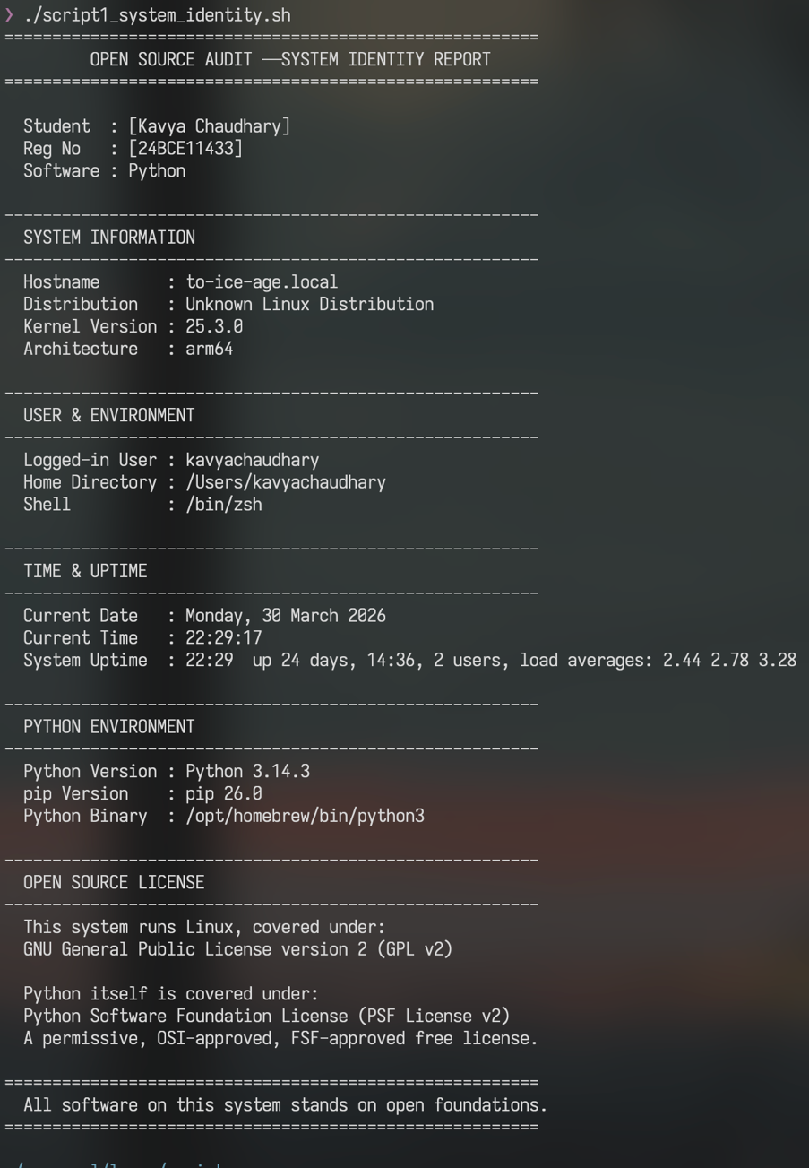

Script 2 — FOSS Package Inspector
Purpose: Checks whether a given open-source package (default: python3) is installed on the system, displays its version/license/summary from package manager metadata, and uses a case statement to print an open-source philosophy note about the package.
Shell Concepts Used: if-then-else, case statement, command -v for availability check, rpm -qi and dpkg -l for package queries, pipe with grep, command-line arguments $1.
File: script2_package_inspector.sh
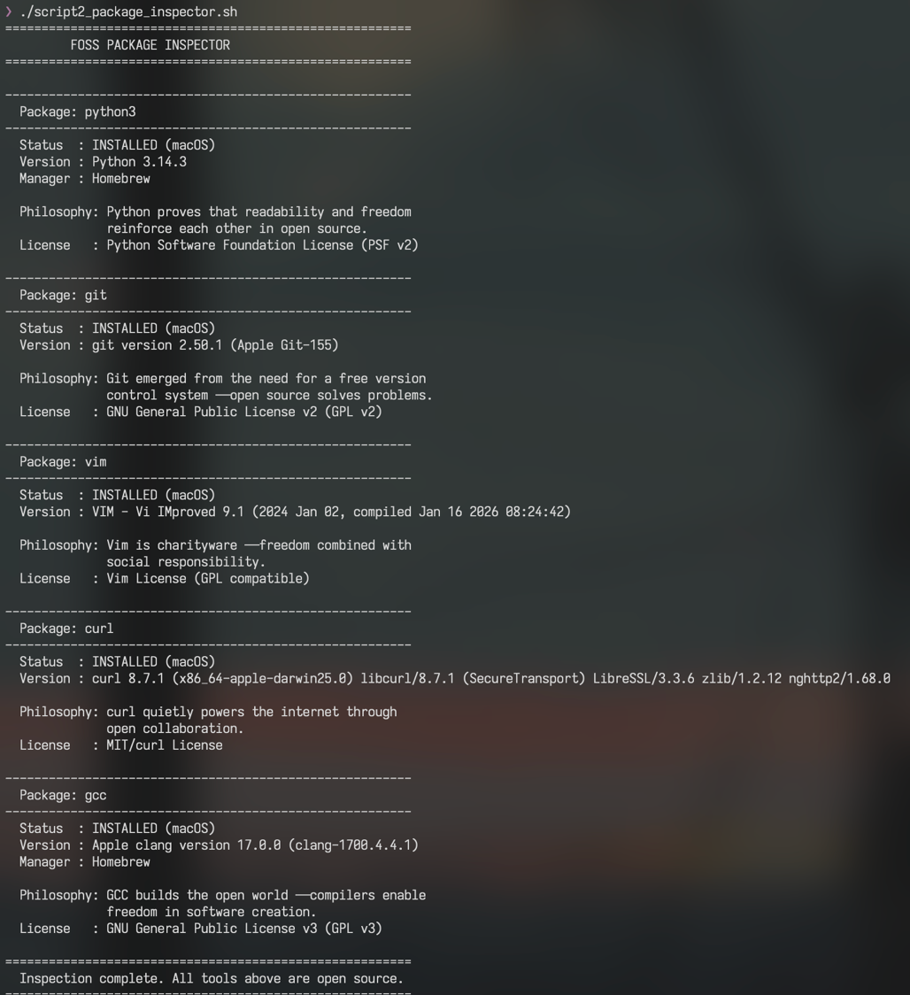

Script 3 — Disk and Permission Auditor
Purpose: Loops through key Linux system directories and Python-specific installation paths, reporting each location's size, permissions, owner, and type. Detects the installed Python version automatically.
Shell Concepts Used: for loop with arrays, ls -ld for permissions, du -sh for disk usage, awk for field extraction, cut for string parsing, printf for aligned tabular output, if [ -d ] and if [ -f ] for type checking.
File: script3_disk_permission_auditor.sh
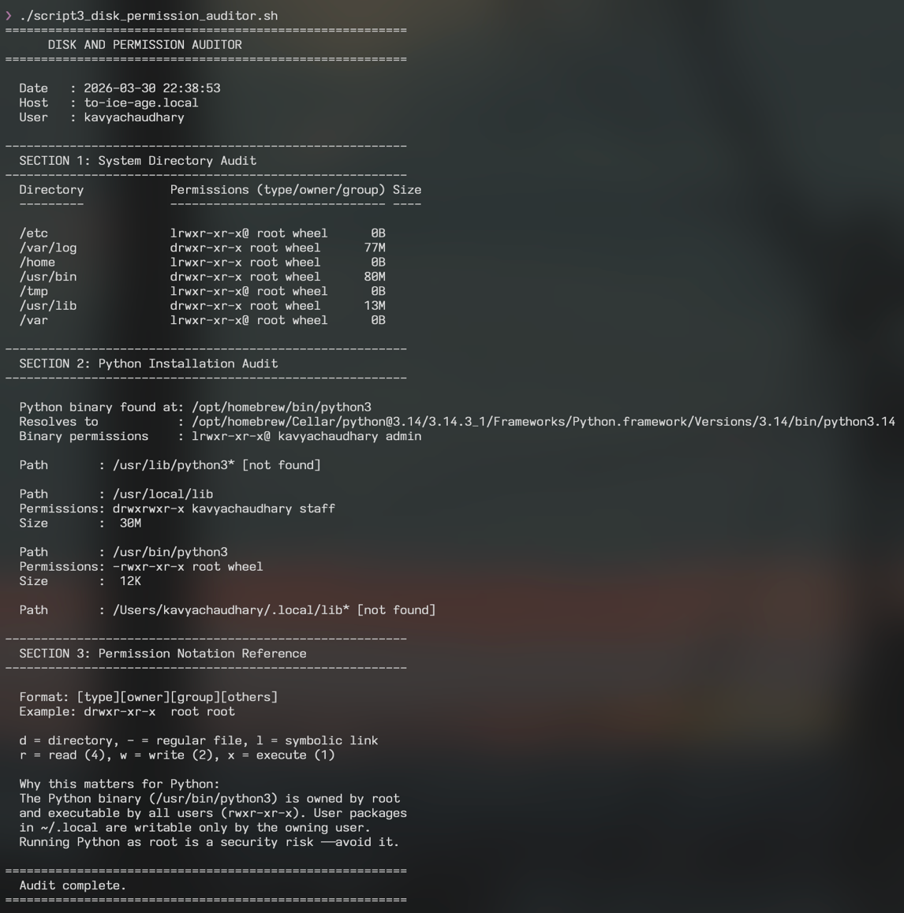

Script 4 — Log File Analyzer
Purpose: Reads a log file line by line, counts occurrences of a keyword (default: 'error'), prints a summary with the last 5 matching lines. Includes retry logic for empty files and generates a sample log if none is provided.
Shell Concepts Used: while IFS= read -r loop, if-then inside loop, counter variables $(( )), grep -iq for case-insensitive search, tail -5, mktemp for temporary files, do-while style retry logic, command-line arguments $1 and $2.
File: script4_log_analyzer.sh
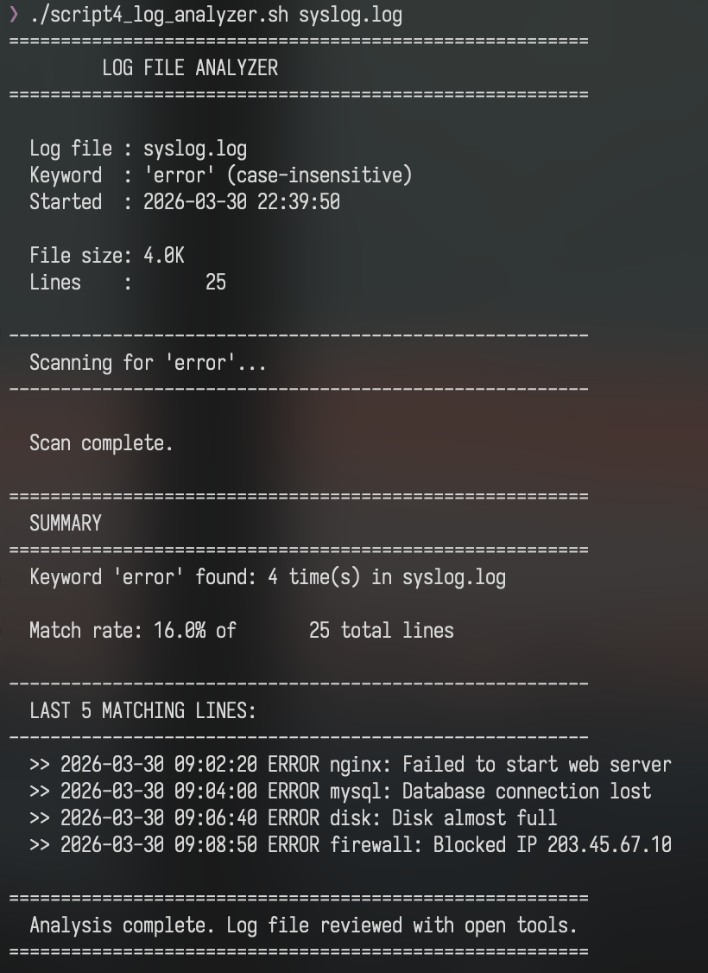

Script 5 — Open Source Manifesto Generator
Purpose: Interactively asks the user three questions and composes a personalised open-source philosophy manifesto using their answers. Saves the result to a .txt file named after the current user and displays it on screen.
Shell Concepts Used: read -p for interactive input, string concatenation, here-doc (<<EOF), writing to file with > and >>, date command formatting, functions as aliases (print_separator), cat to display output.
File: script5_manifesto_generator.sh
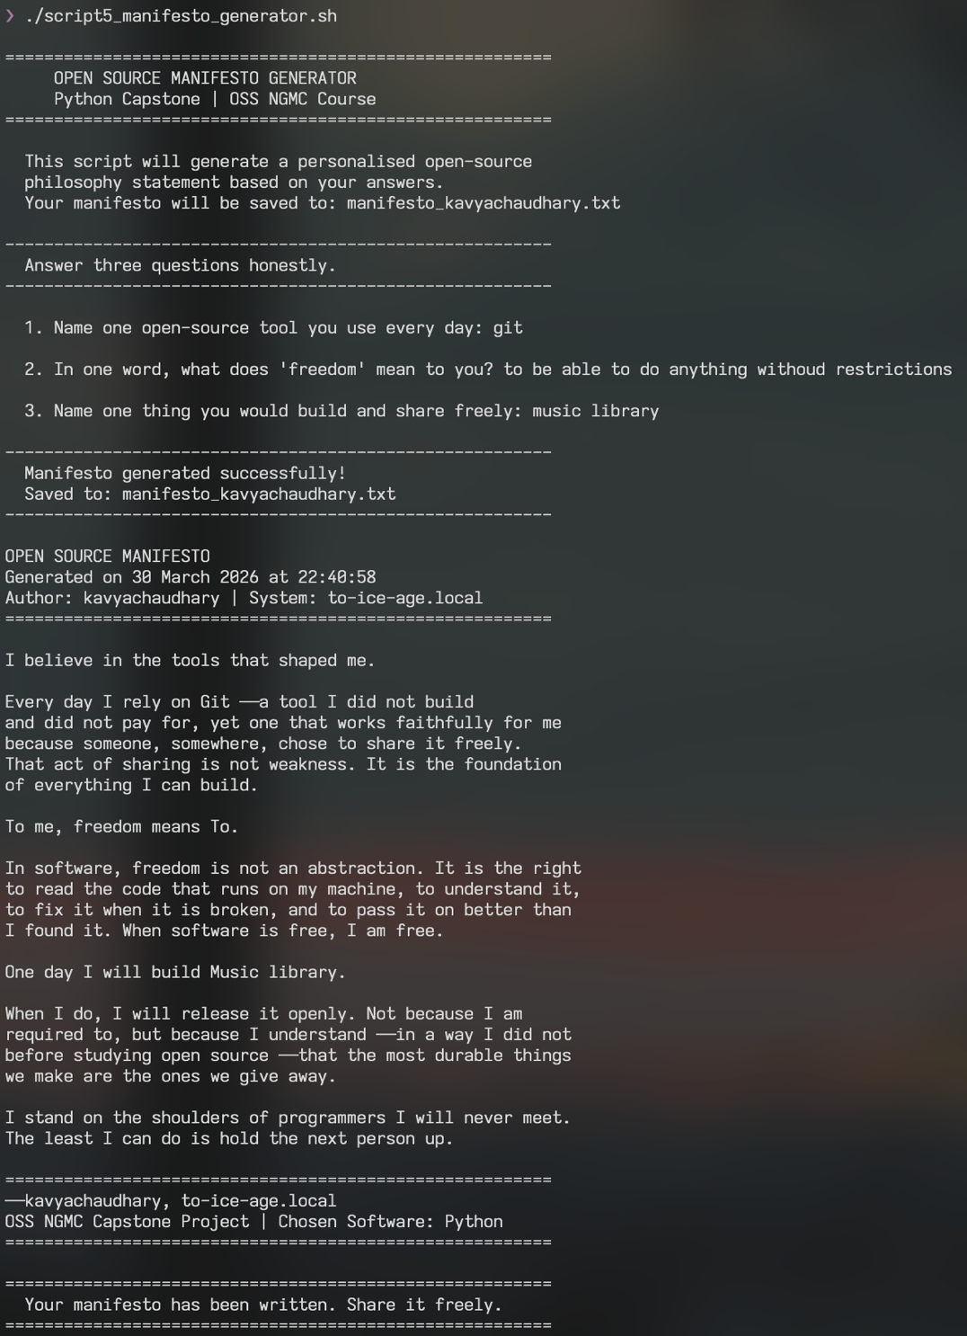

References
- van Rossum, G. (1991). Python 0.9.0 release post. alt.sources Usenet newsgroup. February 1991.
- Python Software Foundation. PSF License Version 2. python.org/psf/license
- Free Software Foundation. The Free Software Definition. gnu.org/philosophy/free-sw.html
- Open Source Initiative. The Open Source Definition. opensource.org/osd
- Python Enhancement Proposals Index. peps.python.org
- CPython Source Repository. github.com/python/cpython
- Raymond, E. S. (1999). The Cathedral and the Bazaar. catb.org/~esr/writings/cathedral-bazaar
- Python Steering Council. PEP 13 — Python Language Governance. peps.python.org/pep-0013
- SPDX License List — PSF-2.0. spdx.org/licenses/PSF-2.0.html
- The Linux Command Line, W. Shotts. linuxcommand.org

