**BATANGAS CITY MEDICAL EMERGENCY RESPONSE APP: SAVING LIVES THROUGH TECHNOLOGY**

A Project   
Presented to  
The Faculty of STI College Batangas

In Partial Fulfillment  
for the Requirements in  
Inquiries, Investigation, and Immersion

by

Acob, Aaron Jhay G.

Aguilar, Keith Dexter B.

Bajio, Frank Vincent R.

Capio, John Cyrelle S.

Catibog, Jeric Vincent B.

De Josef, Yeoj Neil C.

Falogme, Mark Kenneth A.

Fonte, Dan Nicole Lyton G.

Sajo, Coleen Jill F.

TVL – Information Technology

March 2019

# ACKNOWLEDGEMENT

We would like to sincerely thank the following individuals, who have helped us in the completion of this project:

To Ms. Liezel P. Tiñedo, our subject teacher, who has been patient and helpful to us throughout the entire process of this research paper;

To Mr. Jayson D. Abratique, our mobile application instructor, who has always assisted us and guided us throughout the process of developing the project;

To Ms. Christine P. Villena, our adviser, who has always been understanding, and supportive to us;

To our beloved parents, teachers, classmates, and friends for their never-ending encouragement, empathy, and support to us;

And lastly, to the Lord Almighty, for giving us wisdom, strength, love, happiness, and guidance throughout the entire year.

* **The Proponents**

TABLE OF CONTENTS

[**ACKNOWLEDGEMENT ii**](#_Toc3145139)

[**APPROVAL SHEET ii**](#_Toc3145140)

[**Chapter I: THE PROBLEM AND ITS BACKGROUND 1-1**](#_Toc3145141)

[**Introduction 1-1**](#_Toc3145142)

[**Statement of the Problem 1-2**](#_Toc3145143)

[**Conceptual Framework 1-2**](#_Toc3145144)

[**Significance of the Project 1-4**](#_Toc3145145)

[**Scope, Delimitation, and Limitation 1-4**](#_Toc3145146)

[**Definition of Terms 1-5**](#_Toc3145147)

[**Chapter II: REVIEW OF RELATED LITERATURE AND STUDIES 2-1**](#_Toc3145148)

[**Research Literature 2-1**](#_Toc3145149)

[**Research Studies 2-2**](#_Toc3145150)

[**Synthesis 2-3**](#_Toc3145151)

[**Chapter III: PROPOSED MOBILE APPLICATION 3-1**](#_Toc3145152)

[**Chapter IV: PRESENTATION AND DISCUSSION OF   
MOBILE APPLICATION SCREENSHOTS 4-1**](#_Toc3145154)

[**First Screenshot 4-1**](#_Toc3145155)

[**Second Screenshot 4-2**](#_Toc3145156)

[**Third Screenshot 4-3**](#_Toc3145157)

[**Fourth Screenshot 4-4**](#_Toc3145158)

[**Fifth Screenshot 4-5**](#_Toc3145159)

[**Sixth Screenshot 4-6**](#_Toc3145160)

[**Seventh Screenshot 4-7**](#_Toc3145161)

[**Eighth Screenshot 4-8**](#_Toc3145162)

[**Chapter V 5-1**](#_Toc3145163)

[**Summary 5-1**](#_Toc3145164)

[**Recommendations 5-3**](#_Toc3145165)

[**BIBLIOGRAPHY**](#_Toc3145166)

**APPENDIX: GANTT CHART**

[**CURRICULUM VITAE**](#_Toc3145167)

**TABLE OF FIGURES**

**Figure**

**1**

**2**

**3**

**4**

**5**

**6**

**7**

**8**

**9**

**10**

**Name**

Project Paradigm

Main Menu

Log In Screen

Start-Up Screen

Patient’s Information Menu

Guardian Contact List

Known Conditions List

Food Supplements List

Insurance Holder Screen

Change Password Menu

**Pages**

1-3

3-1

4-1

4-2

4-3

4-4

4-5

4-6

4-7

4-8

# APPROVAL SHEET

The project entitled “**BATANGAS CITY MEDICAL EMERGENCY RESPONSE APP: SAVING LIVES THROUGH TECHNOLOGY”** prepared and submitted by **ACOB, AARON JHAY, AGUILAR, KEITH DEXTER, BAJIO, FRANK VINCENT, CAPIO, JOHN CYRELLE, CATIBOG, JERIC VINCENT, DE JOSEF, YEOJ NIEL, FALOGME, MARK KENNETH, FONTE, DAN NICOLE LYTON G.** and **SAJO, COLEEN JILL F.** in partial fulfillment of the requirements for Technical Vocational Track, major in Information Technology has been evaluated and approved with a grade of \_\_\_\_\_\_\_\_\_\_\_\_\_\_\_\_\_\_\_\_\_\_\_\_\_\_ (passed or failed)

\_\_\_\_\_\_\_\_\_\_\_\_\_\_\_\_\_\_\_\_\_\_\_\_\_\_  
**Mr. Jayson D. Abratique**

Mobile Application Instructor

\_\_\_\_\_\_\_\_\_\_\_\_\_\_\_\_\_\_\_\_\_\_\_\_\_\_  
**Ms. Christine P. Villena**

Computer Programming 6 Instructor

\_\_\_\_\_\_\_\_\_\_\_\_\_\_\_\_\_\_\_\_\_\_\_\_\_\_  
**Ms. Liezel P. Tiñedo**

Research Adviser

\_\_\_\_\_\_\_\_\_\_\_\_\_\_\_\_\_\_\_\_\_\_\_\_\_\_  
**Ms. Mary Rose Macatangay**

Work Immersion Instructor

\_\_\_\_\_\_\_\_\_\_\_\_\_\_\_\_\_\_\_\_\_\_\_\_\_\_  
**Dr. Jennifer B. Chen**

SCHOOL PRINCIPAL

# Chapter I

**THE PROBLEM AND ITS BACKGROUND**

## Introduction

Accidents happen all the time, and they can be very fatal at times. In a news article by TOPTEN.PH (2018), road accidents are the most common type of accident to happen, followed by drowning, and work-related accidents. As such, there is a need to reduce the number of people involved in accidents. In order to do so, citizens must be able to simultaneously contact the authorities, as well as their families and relatives, in case of emergencies.

In the age where technology has become prominent and has continuously developed through the years, owning a mobile phone is considered as a necessity by most people. Many things can be done with only a few taps on the screen, thanks to mobile applications. There are various types of mobile applications that showcase varied functions. Anyone can benefit from using such applications: from sending an e-mail to their co-worker during a traffic jam, to saving a person’s life by instantly contacting authorities. As developers, the researchers aim to provide opportunity to people by creating an application that could save lives. With this, Batangas City Medical Emergency Response App was developed.

Batangas City Medical Emergency Response App is an emergency response application used to alert nearby fire stations, police stations, and hospitals about any particular life-threatening situation that happens to its user. It is used to alert the user’s family and/or relatives about the user’s condition, situation, and whereabouts. The application implements cross-platforming therefore, it can be accessed in different platforms such as personal computers.

The application is originally made for Oriental Mindoro Medical Emergency Response Services. However, the location was eventually set to Batangas City. Regardless, the main purpose of the mobile application has not changed since then. It aims to help users who are in danger, and to assist a person who needs rescuing, as soon as possible, by giving them quick access to immediate response from authorities.

## Statement of the Problem

This research aims to answer the following questions:

1. What is the main purpose of developing Batangas City Medical Emergency Response App?
2. How did the proponents design and develop the mobile application?
3. What are the effects of the mobile application to the proponents’ target users?
4. How does the mobile application function?

## Conceptual Framework

This section presents the input, process, and output which the researchers use in determining the operations in programming the mobile application. This presents the processes that the research used in conducting the study. This also helps the researchers in identifying the differences and relationships of the variables.

**Output**

Batangas City Emergency Response App

**Process**

* Implementation of cross platform
* Developing with the use of C#, SQL and Javascript
* Integration of APIs for SMS and Google Maps

**Input**

* Main purpose of the mobile application
* Methods for developing the mobile application
* Effects of the mobile application to its target users
* Functions of the mobile application

***Figure 1.*** *A project paradigm on Batangas City Medical Emergency Response App.*

Figure 1 discusses the relationship of the tables and highlights its connection in order to construct the course of action. The first table shows the input of the study such as the main purpose of the mobile application, reasons for developing the application, and the benefits of the mobile application.

The second table shows the processes used in the study which are the implementation of cross-platform, programming with the use of three programming languages, and integration and incorporation of Google Maps Application Programming Interface (API).

The last table shows the output, which is the mobile application itself.

## Significance of the Project

Batangas City Emergency Response App is beneficial to the following:

**To STI College Batangas**, the project can be used by anyone—from students to faculty—when an emergency occurs.

**To the residents of Batangas City,** the project gives immediate response to those who are in need of help.

**To the fire stations, police stations, and hospitals**, the project serves as a promotion, as well as an aid in preventing possible danger that may occur.

**To the researchers,** the thorough process in developing the project helps them in becoming more familiar with the application’s features, and in utilizing their skills as developers.

**To the future researchers,** the project can be used as basis for those who aim to develop a similar mobile application that can benefit the community.

## Scope, Delimitation, and Limitation

The study focuses on the mobile application, Batangas City Emergency Response App. The scope intends to examine the profile of the respondents according to the age, gender, and year level.

The mobile application is delimited in terms of respondents and location, since the application can only be used by residents of Batangas City. Anyone who lives outside Batangas City will not be able to access the application. Moreover, the mobile application is currently available for the students of STI College Batangas.

The evaluation is limited within Batangas City. This includes the fire stations, police stations, and hospitals that are found within that specific area. In addition, the application is only used for emergency purposes.

## Definition of Terms

To understand the project, terms used are defined conceptually and operationally as follows:

**Application Program Interface (API).** This term refers to the part of the server that receives requests and sends responses to clients through an application (Gazarov, 2016). In this study, API refers to the Google Maps API which the researchers incorporated in the project to embed Google Maps on the mobile application.

**Global Positioning System (GPS).** This term is defined as a “constellation” of approximately 30 well-spaced satellites that orbit the Earth, and make it possible for people with ground receivers to pinpoint their geographic location (Rouse, 2016). In this study, GPS refers as one of the mobile application’s features, which tracks the user’s current location.

**SOS.** This term is an internationally recognized distress signal based on Morse Code, built on the work of the British Marconi International Marine Communication Company and the German company Telefunken (Harris, 2018). In this study, SOS refers to the most commonly message used by most people to indicate an emergency.

**Short Message Service (SMS).** This term refers to the technology used to send short, text-only messages from one phone to another over a cellular data network (Costello, 2018). In this study, SMS refers to one of the project’s features where in case of emergency, the user can instantly send an automated text message to anyone in their contact list.

# Chapter II

**REVIEW OF RELATED LITERATURE AND STUDIES**

## Research Literature

Sposaro and Tyson (2009) created an Android application called “iFall”. It is an alert system for fall detection using common commercially available electronic devices to both detect the fall and alert authorities. If a fall is suspected, a notification is raised requiring the user’s response. If the user does not respond, the system alerts pre-specified social contacts with an information message via SMS. If a contact responds, the system commits an audible notification, automatically connects, and enables the speaker phone. If a social contact confirms a fall, an appropriate emergency service is alerted (Sposaro, et. al., 2009).

Jadhav, et. al. (2014) developed Emergency Management System (EMS), which enables smart phone based ad-hoc communications at disaster times over Wi-Fi. The system works on the principles of client-server system, wherein the server responds to the request of clients (Jadhav et. al., 2014). The researches implemented two Android applications for EMS Client and Rescue respectively, and a server that is implemented as a web-based Java application.

The MotorolaAlert developed by Motorola (March 2016) and EmergencyAlert developed by the Government of the Province of Alberta in Canada. Applications are also limited to notifying just friends and family with a current GPS position. The main difference between them is about the user interface. The former adopts an interface with a few options and buttons associated with representative icons. The latter consists of a textual menu with several options that can make users confused.

ELERTS and My112 developed by the local government of Madrid applications allow users to contact directly with an official emergency center, but they are limited to predefined locations. The ELERTS app is valid just for hospitals or colleges to notify the security department about a problem. Consequently, it can be used just for small-scale events that do not require an immediate and urgent solution.

## Research Studies

 Schoning (2013) explained that users are generally annoyed by long tasks and do not pay enough attention, much less during emergency situations. Therefore, designers should elaborate a direct and short navigation through the application otherwise users will prefer traditional calls. Language is also deemed important since users can be confused and upset with the displayed instructions. For this reason, short, easy, and understandable labels and descriptions are needed. Finally, feedback is a critical factor for an emergency application. During a traditional call, users are reassured by the voice of an operator. The mobile application must be able to provide a similar response with, for example, a confirmation message about the success of the procedure.

Similar to My112 application, several 112 Operation Centers across Europe as well as other emergency numbers have been developing their own applications as alternatives for improving the traditional emergency call. All of them offer a similar service such as making calls enriched by geo-localization. In particular, they had the possibility to test in real situations the one developed by the local government of Madrid for the Spanish 112 Operation Center and called My112. With this, they decided to include it among the analyzed applications.

Meanwhile, Ado, de Guzman J., and de Guzman R. (July 2014) developed a mobile emergency response application using geolocation. The project is a combination of a mobile and web application for responding to emergency requests for ambulances, fire trucks, and police from people in a certain area or city. Using geolocation, the mobile application would detect the user’s current location, whereas the web application that is deployed in a command center would receive the name, age, mobile number, and location of the user for dispatching emergency units easily.

## Synthesis

Ado, et. al.’s project uses geolocation in order to track down the user’s current location. The method of geolocation is similar to how the GPS tracking works, which is used by MotorolaAlert (Motorola, 2016) and EmergencyAlert. It is also noted that their respective projects are also able to contact authorities.

However, MotororalAlert and EmergencyAlert are both limited to notifying the friends and family of the user. In the other hand, the project created by Ado and his fellow researchers is capable of sending the user’s information to a particular command center in order to dispatch emergency units necessary.

Jadhev, et. al.’s EMS is a client-server system-based application, where their mobile application receives the client’s request, while the web-based server receives the request. Similar to this, Ado, et. al.’s project also uses a mobile application that can receive the user’s information and send it through a web application that can receive the said information. Both applications are also capable in responding different emergencies such as fire and medical emergencies. In addition, they both use GPS tracking in order to detect the user’s current location.

The difference between the two is that Jadhev, et. al.’s application is only applicable for places where Wi-fi is available, since the client is only capable of communicating during emergencies through Wi-fi. Meanwhile, Ado, et. al.’s project is an offline-based application, and therefore it can be used anywhere even if Wi-fi is unavailable in a certain area.

Batangas City Response App can be considered as a mixture of the different applications previously mentioned in this study. Like the other projects mentioned, Batangas City Response App uses GPS tracking to detect the user’s current location. Similar to iFall, the application implements the usage of SMS in order for the user to send messages. Like MotorolaAlert and EmergencyAlert, the user is able to contact his/her family, friends, and relatives in their contact list through the application. The application can respond to alert authorities to respond in different emergencies, similar to the projects developed by Jadhev, et. al.’s and Ado, et. al.

Ultimately, the researchers rely on Ado, et. al.’s project, for it has the most similarities in terms of the application’s features: from the implementation of geolocation in detecting the user’s location, to the ability of responding to emergency requests for ambulances, fire trucks, and police.

The only difference is that Batangas City Response App uses the SMS API to contact authorities and the people listed in the user’s contact list, whereas Ado, et. al.’s application does not use any sort of messaging system.

# Chapter III

# PROPOSED MOBILE APPLICATION

# 53423821_578462035992443_5800456575671861248_n

# *Figure 2.Main Menu*

**Home Button.**This shows the user’s current location according to the latitude and longitude coordinates provided through GPS tracking.

# Profile Button. This section presents the information of the user: Patient Information, Current Medications, Guardians, Insurance, Food Supplements, and Known Conditions.

**Setting Button.** When the user clicks this button, another screen pops up and shows the password textbox.

# Chapter IV

**PRESENTATION AND DISCUSSION OF MOBILE APPLICATION SCREENSHOTS**

This section includes the screenshotsof the activities on the proponents’ mobile application: Batangas City Medical Emergency Response App.

# First Screenshot

**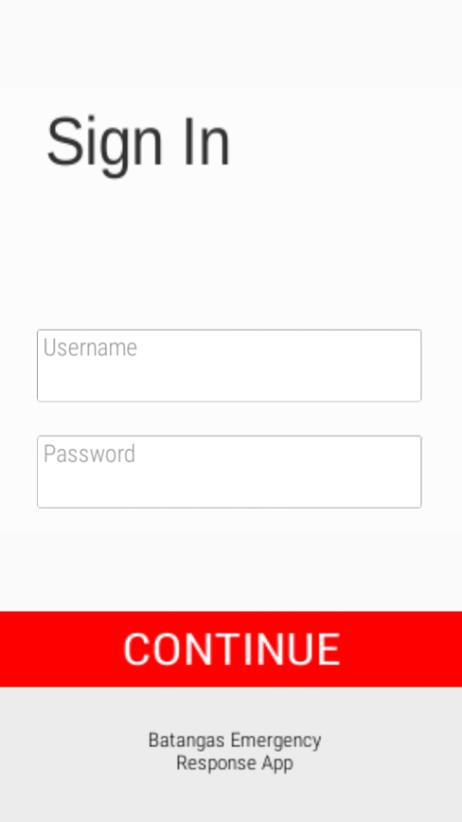**

***Figure 3.****Sign In Screen*

The Login Screen is the first screen that appears upon opening the mobile application. It prompts the user to enter his/her username and password before he/she continues using the mobile application.

**Username Textbox.** This is where the user enters his/her username.

**Password Textbox.** This is where the user enters his/her password.

**Continue Button.** Upon clicking, the button leads the user to the start-up screen of the mobile application once the user successfully inputs the correct username and password.

# Second Screenshot

**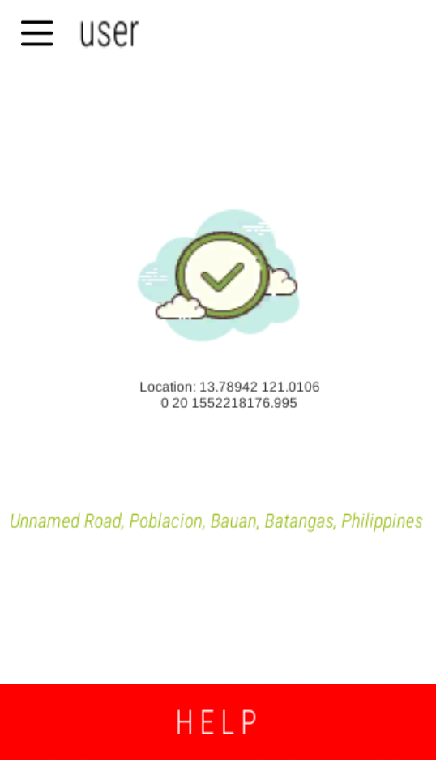**

***Figure 4.****Start-Up Screen*

Once the user enters the correct username and password from the *Sign In* screen and clicks the Continue button, the start-up screen loads. This shows the user’s current location according to the latitude and longitude coordinates provided through the GPS tracking.

**Help Button.** Clicking this button automatically sends a notification to the web-based server, signaling an emergency situation that occurred to the user.

# Third Screenshot

**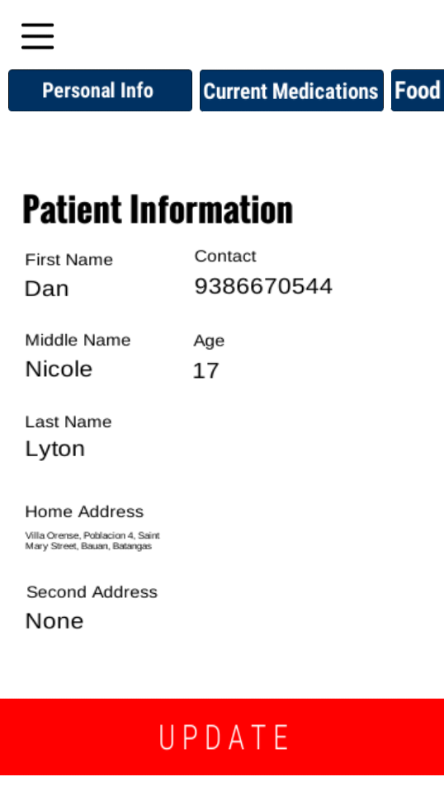**

***Figure 5.****Patient Information Menu*

This shows the patient’s/user’s personal information, which includes the patient’s/user’s full name, contact number, age, home address, and second address.

**Update Button.** The user updates his/her personal information by clicking this button.

# Fourth Screenshot

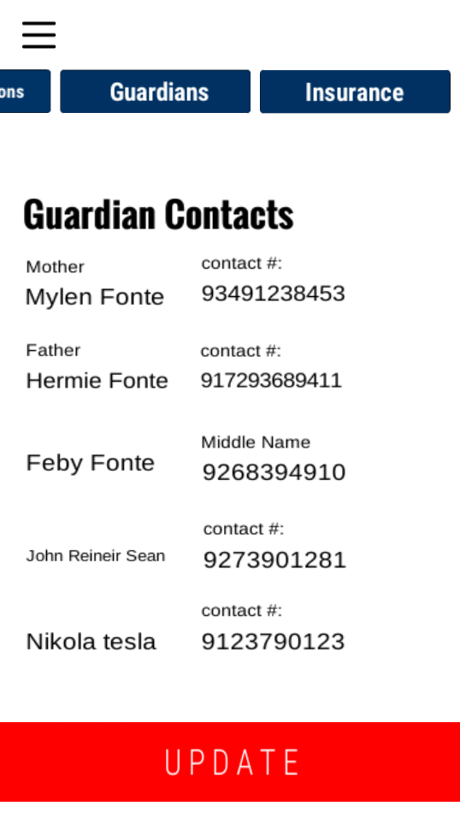

***Figure 6.****Guardian Contacts List*

This screen shows the user’s contact list of his/her guardians. The information includes the guardian’s name, relationship to the user, and contact number.

**Update Button.** The user updates the information in the contact list, as well as adds another person in his/her contact list.

**Fifth Screenshot**

**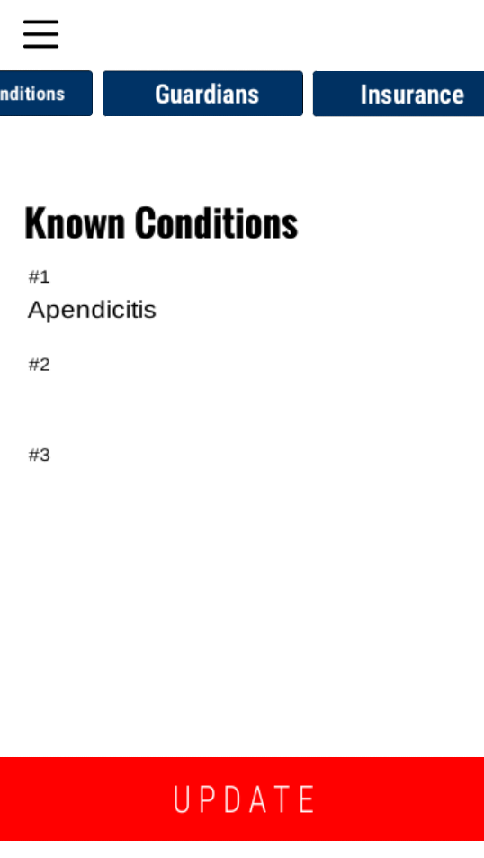**

***Figure 7.****Known Conditions List*

This particular menu shows the user’s currently known conditions. The user can have at most three conditions listed.

**Update Button.** The button allows the user to update information, and even add when applicable.

# Sixth Screenshot

**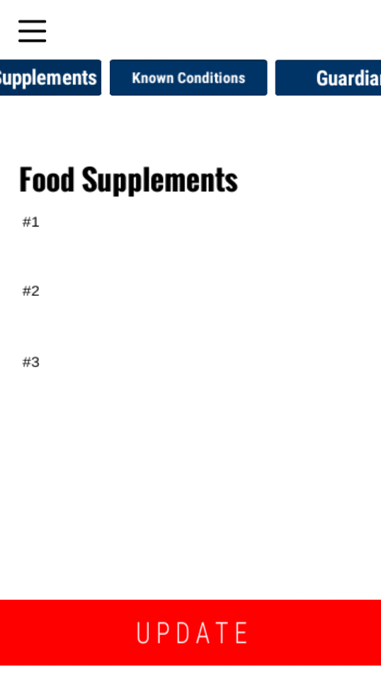**

***Figure 8.****Food Supplements List*

This list features the kinds of food supplements the user takes for his/her medication or diet. Similar to the *Known Conditions List,* the user can only have up to three food supplements listed.

**Update Button.** The button allows the user to update the information in the list, and also add more information when necessary.

# Seventh Screenshot

**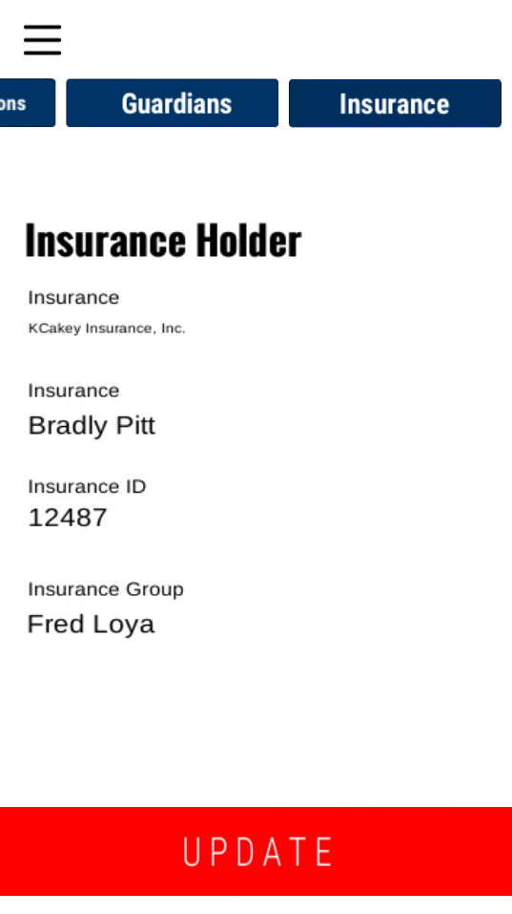**

***Figure 9.****Insurance Holder Screen*

This screen shows the information about the user’s current insurance holder. Listed in the information are the insurance company’s name, the key person insurance, the insurance ID, and the insurance group.

**Update Button.** This is used by the user to update any information necessary by clicking it.

# Eighth Screenshot

**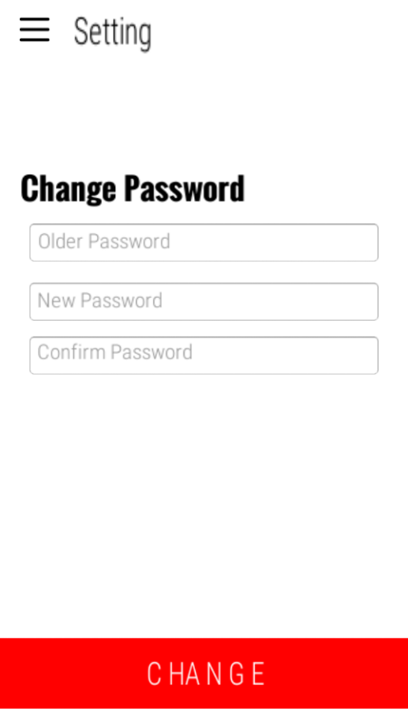**

***Figure 10.****Change Password Menu*

In this menu, the user can change the password whenever he/she it is necessary.

**Older Password Textbox.**This is where the user enters his/her previous password.

**New Password Textbox.**This is where the user enters his/her new password.

**Confirm Password Textbox.** This prompts the user to re-enter the same exact password he/she enters from the New Password Textbox.

**Change Button.** Clicking this button automatically changes the user’s password to the new one if it is entered correctly.

## Chapter V

**SUMMARY AND RECOMMENDATIONS**

## Summary

Like any other emergency response mobile application, Batangas City Medical Emergency Mobile Application serves as an easier and faster way of contacting hospitals to give immediate response on emergencies. The application has several features that help in fulfilling its purpose, such as GPS tracking and sending an automatic message through the SMS system to the user’s contacts list.

The backbone of the application is its web-based server, which is used by the administrator to receive notifications of emergencies from the mobile application.

Throughout the study, the proponents aimed to answer the following questions:

1. What is the main purpose of developing Batangas City Medical Emergency Response App?
2. How did the proponents design and develop the mobile application?
3. What are the effects of the mobile application to the proponents’ target users?
4. How does the mobile application function?

The main purpose of developing the mobile application is to give immediate medical response to the citizens of Batangas City in times of emergency. In addition, the project is developed to prevent any further casualties that could occur during an emergency situation.

The proponents designed and developed the project using their knowledge in mobile application development, as well as implementing the suggestions given to them by the panelists from the previous semester. The integration of the APIs for SMS and Google Maps was necessary throughout the process.

With the project’s main purpose in mind, the target users for the mobile application are to become more aware in responding to emergency situations. They would also be familiar with the hospitals within the vicinity of Batangas City, as well as to their respective emergency hotlines.

Since the project functions more as a utility application, users can utilize the project’s several features aforementioned in the previous chapters for their benefit. The application has various functionalities, such as tracking the user’s current location via GPS tracking. Its main function is to notify the emergency to the administrator through the web-based server, so that the administrator can directly contact the nearest hospital for a medical emergency response unit.

## Recommendations

Due to the limited amount of time given to the proponents, certain aspects of the mobile application are recommended to be improved or changed.

The following are the recommendations the proponents suggest:

1. Thorough research on the emergency units in the hospitals of Batangas City
2. Improving the design of both the mobile application and the web-based server
3. A wider scope of target users
4. Additional features that can both fulfill the purpose of the project and benefit the users

# BIBLIOGRAPHY

* *Accidents that kill pinoys the most.* (2018, January 02). Retrieved from http://tucp.org.ph/2018/01/accidents-kill-pinoys/
* Ado, R. G., de Guzman, J. B., & de Guzman, R. C., (2014). Mobile Emergency Response Application Using Geolocation for Command Centers. *International Journal of Computer and Communication Engineering,3*(4), 235-238. doi:10.7763/ijcce.2014.v3.327
* Costello, S. (2019, January 11). What is SMS and MMS on the iPhone? Find Out Here. Retrieved from https://www.lifewire.com/what-is-sms-mms-iphone-2000247
* Gazarov, P. (2016, August 13). What is an API? In English, please. Retrieved from https://medium.freecodecamp.org/what-is-an-api-in-english-please-b880a3214a82
* Harris, J. (2018, October 3). What does SOS stand for? (It's not what you think). Retrieved from http://home.bt.com/tech-gadgets/internet/broadband/what-does-sos-stand-for-history-facts-distress-signals-11364102599687
* Jadhav, R., Jain, D., Patel, J., & Phadhtare, S. (2014). Emergency Management System Using Android Application. *International Journal of Computer Science and Information Technologies,5*(3). Retrieved December 16, 2018.
* Rouse, M. (2016). What is Global Positioning System (GPS)? - Definition from WhatIs.com. Retrieved from https://searchmobilecomputing.techtarget.com/definition/Global-Positioning-System
* Sposaro, F., & Tyson, G. (2009). IFall: An android application for fall monitoring and response. *2009 Annual International Conference of the IEEE Engineering in Medicine and Biology Society*. doi:10.1109/iembs.2009.5334912

**APPENDIX:**

**GANTT CHART**

# CURRICULUM VITAE

**Name :** Acob, Aaron Jhay G.

**Address :** Bilongo, Taysan, Batangas

**Date of Birth :** January 3, 2000

**Place of Birth :** Bilongo, Taysan, Batangas

**Citizenship :**  Filipino

**Sex :** Male

**Civil Status :** Single

**Education Background**

**Senior High School :** STI College Batangas

Kumintang Ibaba, Batangas City

TVL - Information Technology

S.Y. 2017-2019

**Junior High School :** BilongoNational High School

Bilongo, Taysan, Batangas

SY 2013 - 2017

**Elementary School :** BilongoElementary School

Bilongo, Taysan, Batangas

SY 2006 - 2013

**CURRICULUM VITAE**

**Name :** Aguilar, Keith Dexter B.

**Address :** Pinamucan Ibaba, Batangas City

**Date of Birth :** September 25, 2001

**Place of Birth :** Mayao Castillo, Lucena City

**Citizenship :**  Filipino

**Sex :** Male

**Civil Status :** Single

**Education Background**

**Senior High School :** STI College Batangas

Kumintang Ibaba, Batangas City

TVL - Information Technology

S.Y. 2017-2019

**Junior High School :** Pinamucan National High School

Pinamucan, Batangas City

SY 2013 - 2017

**Elementary School :** Pinamucan Ibaba Elementary School

Pinamucan Ibaba, Batangas City

SY 2006 - 2013

**CURRICULUM VITAE**

**Name :** Bajio, Frank Vincent R.

**Address :** Tabangao Dao, Batangas City

**Date of Birth :** May 22, 2001

**Place of Birth :** Quezon City

**Citizenship :**  Filipino

**Sex :** Male

**Civil Status :** Single

**Education Background**

**Senior High School :** STI College Batangas

Kumintang Ibaba, Batangas City

TVL - Information Technology

S.Y. 2017-2019

**Junior High School :** TabangaoNational High School

TabangaoApalaya, Batangas City

SY 2013 - 2017

**Elementary School :** Tabangao Elementary School

Tabangao Dao, Batangas City

SY 2006 - 2013

**CURRICULUM VITAE**

**Name :** Capio, John Cyrelle S.

**Address :** Pinamucan Ibaba, Batangas City

**Date of Birth :** June 2, 2001

**Place of Birth :** PinamucanIbaba, Batangas City

**Citizenship :**  Filipino

**Sex :** Male

**Civil Status :** Single

**Education Background**

**Senior High School :** STI College Batangas

Kumintang Ibaba, Batangas City

TVL - Information Technology

S.Y. 2017-2019

**Junior High School :** Pinamucan National High School

Pinamucan Proper, Batangas City

SY 2013 - 2017

**Elementary School :** Pinamucan Ibaba Elementary School

Pinamucan Ibaba, Batangas City

SY 2006 - 2013

**CURRICULUM VITAE**

**Name :** Catibog, Jeric Vincent B..

**Address :** Soro-soroIlaya, Batangas City

**Date of Birth :** November15, 2001

**Place of Birth :** Lipa City

**Citizenship :**  Filipino

**Sex :** Male

**Civil Status :** Single

**Education Background**

**Senior High School :** STI College Batangas

Kumintang Ibaba, Batangas City

TVL - Information Technology

S.Y. 2017-2019

**Junior High School :** LibjoNational High School

Libjo, Batangas City

SY 2013 - 2017

**Elementary School :** Libjo Elementary School

Libjo, Batangas City

SY 2007 - 2013

**CURRICULUM VITAE**

**Name :** De Josef, Yeoj Neil C..

**Address :** Marikaban, Tingloy, Batangas

**Date of Birth :** August 20, 2001

**Place of Birth :** Marikaban, Tingloy, Batangas

**Citizenship :**  Filipino

**Sex :** Male

**Civil Status :** Single

**Education Background**

**Senior High School :** STI College Batangas

Kumintang Ibaba, Batangas City

TVL - Information Technology

S.Y. 2017-2019

**Junior High School :** TingloyNational High School

Poblacion 14, Tingloy, Batangas

SY 2013 - 2017

**Elementary School :** Marikaban Elementary School

Marikaban, Tingloy, Batangas

SY 2007 - 2013

**CURRICULUM VITAE**

**Name :** Falogme, Mark Kenneth A.

**Address :** Coliat, Ibaan, Batangas

**Date of Birth :** December 11, 1998

**Place of Birth :** Ibaan, Batangas

**Citizenship :**  Filipino

**Sex :** Male

**Civil Status :** Married

**Education Background**

**Senior High School :** STI College Batangas

Kumintang Ibaba, Batangas City

TVL - Information Technology

S.Y. 2017-2019

**Junior High School :** Dr. Juan A. Pastor Memorial   
 National High School

Talaibon, Ibaan, Batangas

SY 2011 - 2015

**Elementary School :** Coliat Elementary School

Coliat, Ibaan, Batangas

SY 2004 - 2011

**CURRICULUM VITAE**

**Name :** Fonte, Dan Nicole Lyton G.

**Address :** Villa Orense, Bauan, Batangas City

**Date of Birth :** July 18, 2001

**Place of Birth :** Paranas, Samar

**Citizenship :**  Filipino

**Sex :** Male

**Civil Status :** Single

**Education Background**

**Senior High School :** STI College Batangas

Kumintang Ibaba, Batangas City

TVL - Information Technology

S.Y. 2017-2019

**Junior High School :** Bauan Colleges Incorporated

KapitanPunso, Bauan ,Batangas

SY 2013 - 2017

**Elementary School :** Bauan East Central School

KapitanPunso, BauanBatangas

SY 2011 - 2013

West Bauan Central School

Apalaya, Bauan, Batangas

SY 2007 - 2011

**CURRICULUM VITAE**

**Name :** Sajo, Coleen Jill F.

**Address :** Balagtas, Batangas City

**Date of Birth :** March 10, 2001

**Place of Birth :** Batangas City

**Citizenship :**  Filipino

**Sex :** Female

**Civil Status :** Single

**Education Background**

**Senior High School :** STI College Batangas

Kumintang Ibaba, Batangas City

TVL - Information Technology

S.Y. 2017-2019

**Junior High School :** Casa del Bambino Emmanuel Montessori

Alangilan, Batangas City

SY 2013 - 2017

**Elementary School :** Balagtas Elementary School

Balagtas, Batangas City

SY 2006 – 2013