*Please save as Word document, not PDF.
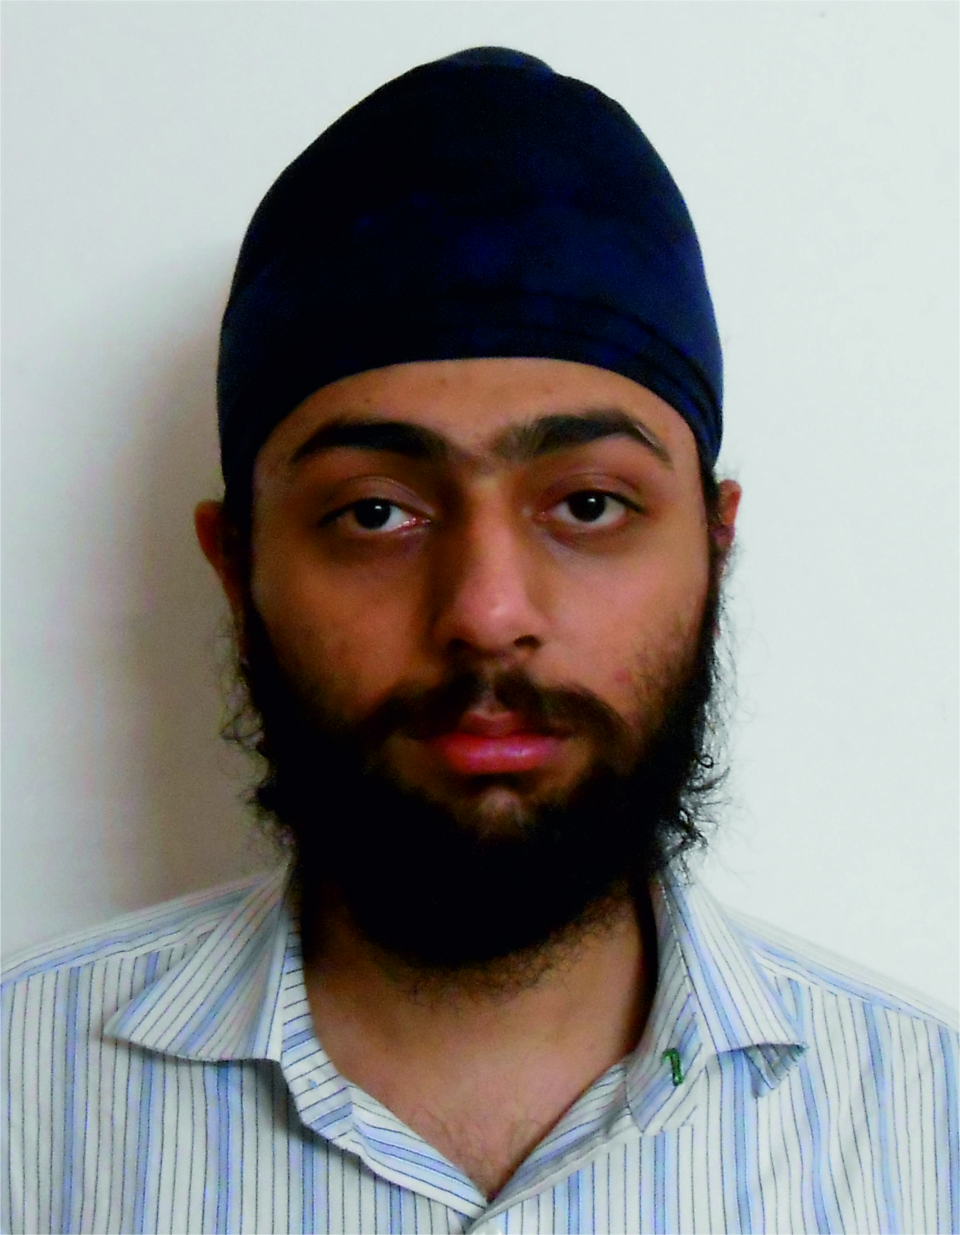
Name (LAST, First, Other): Arora Atul Singh
Contact Information
Address: 4317/3 Ansari Road, Darya Ganj, New Delhi-110002, India
Tel: 011 43542019
Cell: +91 8699413350
E-Mail: toAtulArora@gmail.com
Research Intern Period Requested at OIST: May 10 to July 26, 2015
PERSONAL DETAILS
Date of Birth: 1991/11/20
Citizenship: Indian
Gender: Male

EDUCATION *tertiary level only, don’t include high school level of education
Education and Training
2011-present | Indian Institute of Science Education and Research, Mohali  Pursuing Masters of Science (integrated) | Mohali, India
Summer, 2014 | Indian Institute of Science Education and Research, Mohali  Worked on “ways of using a universal quantum computer to perform simulations of quantum phenomena itself” | Mohali, India
Monsoon, 2013 | National Centre for Biological Sciences  Attended a monsoon school on Physics of Life | Bangalore, India
Summer, 2013 | National Physical Laboratory  Intern, studied dynamics of a two dimensional magnetic dipo... | New Delhi, India
Winter, 2013 | Indian Institute of Science Education and Research, Mohali  Intern, studied Quantum Mechanics | Mohali, India
Summer, 2012 | Indian Institute of Science Education and Research, Mohali  Intern, studied group theory and linear algebra for understa… | Mohali, India
Summer, 2011 | Indian Institute of Technology, Bombay  Intern, worked on image recognition techniques using OpenCV | Mumbai, India
Projects (description truncated brevity):
Summer 2013, Nazar Band, A face recognition system built using OpenCV with the aim ...
Sem III 2012, Opportunity Cell Website, Team Project, A centralized web portal for the ...
Sem III 2012, Fly Count Assister, For easing the task of counting flies (Biology experiment)...
Sem III 2012, NaveenTantra, Team Project, An Online Election system, based on a novel...
Summer 2012, Telescope, Team Project, Newtonian Reflection Telescope for observing ...
Sem II 2012, Capacitive Touch Sensor, Sensitive enough to measure changes in PicoFarads..
2010-11, Chatur Chaalak, Developed with the aim of application in robotics, this project was ...
2010, Live GSM, This was an attempt at controlling a phone using a microcontroller, to be ...
Class XII 2010, 3D Modelling and Animation, Imitated the '21st Century FOX' animation and ...
Class XI-XII 2009-10, Space Race, This game was developed using OpenGL to ensure ...
Class XI 2009, Robotic Rescue Vehicle (RRV), It was designed using auto-mobile parts such...
Class X 2008, Math Project, A calculator built using micro-controllers, to verify the property...
Class IX 2006, ALive City 2 - DirectX 9.0, My second attempt at game making; this was...
Class VIII 2005, Motion Detection - Image Processing, This program was developed to save...
Class VIII 2005, ALive City - DirectX 8.0, My first computer graphics 3D project, a simple...
Class VII 2004, Edge Detecting Robot, Built using stepper motors and a microprocessor,...
Class VII 2004, AT Keyboard Interface, Built using the 8051 series of Microcontrollers and...
Class VII 2004, School Bell Scheduler 2, This application was re-written in Visual Basic.NET...
Class VI 2003, School Bell Scheduler, A program, written in Visual Basic 6, for automating ...
EMPLOYMENT HISTORY
List in chronological order, including position details and dates (YYYY/MM)
OTHER QUALIFICATIONS
Computer Skills: Basic, C, C++, C#, Python, Javascript, SQL, HTML, PHP, LaTeX | Visual Studio, Sublime Text, Microsoft Office (Word, Powerpoint, Outlook, OneNote, Excel), CorelDraw, Git, Vegas, Maya, GNU plot, SolidWorks, FL Studio, Sound Forge
Language: English

INTERESTS
Physics, Playing the Guitar, Programming and Electronics, Debating, Playing the Tabla

