**Queue**

# Queue

A queue is an abstract data type or collection in which the entities in the collection are kept in order and the principle (or only) operations on the collection are the addition of entities to the rear terminal position (enqueue), and removal of entities from the front terminal position (dequeue). This makes the queue a First-In-First-Out **(FIFO) data structure**.

# Types of Queue

1. Queue
2. Double-ended queue (Deque)
3. Circular Queue
4. Priority Queue

# Time Complexity

|  |  |  |
| --- | --- | --- |
| Algorithm | Average | Worst case |
| Space | O(*n*) | O(*n*) |
| Search | O(*n*) | O(*n*) |
| Insert | O(1) | O(1) |
| Delete | O(1) | O(1) |

# Operations

Queue operations may involve initializing or defining the queue, utilizing it, and then completely erasing it from the memory.

Queues maintain two data pointers, front and rear. Therefore, its operations are comparatively difficult to implement than that of stacks.

## Primary Operations

### enqueue()

add (store) an item to the queue

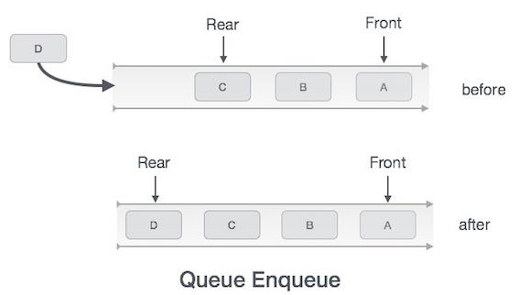

|  |  |
| --- | --- |
| Algorithm | Example |
| procedure enqueue(data)  if queue is full  return overflow  endif    rear ← rear + 1    queue[rear] ← data  return true  end procedure | int enqueue(int data)  if(isfull())  return 0;    rear = rear + 1;    queue[rear] = data;  return 1;    end procedure |

### dequeue()

remove (access) an item from the queue

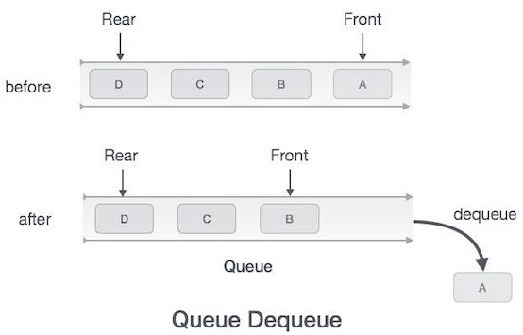

|  |  |
| --- | --- |
| Algorithm | Example |
| procedure dequeue  if queue is empty  return underflow  end if    data = queue[front]  front ← front + 1  return true  end procedure | int dequeue() {  if(isempty())  return 0;    int data = queue[front];  front = front + 1;    return data;  } |

## Additional Operations

### peek()

Gets the element at the front of the queue without removing it

|  |  |
| --- | --- |
| Algorithm | Example |
| begin procedure peek  return queue[front]  end procedure | int peek() {  return queue[front];  } |

### isfull()

Checks if the queue is full

|  |  |
| --- | --- |
| Algorithm | Example |
| begin procedure isfull    if rear equals to MAXSIZE  return true  else  return false  endif  end procedure | bool isfull() {  if(rear == MAXSIZE - 1)  return true;  else  return false;  } |

### isempty()

Checks if the queue is empty

|  |  |
| --- | --- |
| Algorithm | Example |
| begin procedure isempty  if front is less than MIN OR front is greater than rear  return true  else  return false  endif    end procedure | bool isempty() {  if(front < 0 || front > rear)  return true;  else  return false;  } |

# Applications

1. When a resource is shared among multiple consumers, like a printer, CPU task scheduling etc.
2. **Asynchronous Data Transfer**: When data is transferred asynchronously (data not necessarily received at same rate as sent) between two processes. Examples include IO Buffers, pipes, file IO, etc.
3. In real life scenario, Call Center phone systems uses Queues to hold people calling them in an order, until a service representative is free
4. Handling of interrupts in real-time systems. The interrupts are handled in the same order as they arrive i.e. First come first served
5. **M/M/1 queue**: One of the most important queueing models is known as an M/M/1 queue, which has been shown to accurately model many real-world situations. It is characterized by three properties:
6. There is one server—a FIFO queue.
7. Interarrival times to the queue obey an exponential distribution with rate λ per minute.
8. Service times from a nonempty queue obey an exponential distribution with rate μ per minute.

# Queue Implementations

## Using Array

#include <stdio.h>

#include <stdlib.h>

#include <limits.h>

// A structure to represent a queue

struct Queue {

int front, rear, size;

unsigned capacity;

int* array;

};

// function to create a queue of given capacity. It initializes size of queue as 0

struct Queue* createQueue(unsigned capacity) {

struct Queue* queue = (struct Queue*) malloc(sizeof(struct Queue));

queue->capacity = capacity;

queue->front = queue->size = 0;

queue->rear = capacity - 1; // This is important, see the enqueue

queue->array = (int*) malloc(queue->capacity * sizeof(int));

return queue;

}

// Queue is full when size becomes equal to the capacity

int isFull(struct Queue* queue) {

return (queue->size == queue->capacity);

}

// Queue is empty when size is 0

int isEmpty(struct Queue* queue) {

return (queue->size == 0);

}

// Function to add an item to the queue. It changes rear and size

void enqueue(struct Queue* queue, int item) {

if (isFull(queue))

return;

queue->rear = (queue->rear + 1) % queue->capacity;

queue->array[queue->rear] = item;

queue->size = queue->size + 1;

printf("%d enqueued to queue\n", item);

}

// Function to remove an item from queue. It changes front and size

int dequeue(struct Queue* queue) {

if (isEmpty(queue))

return INT_MIN;

int item = queue->array[queue->front];

queue->front = (queue->front + 1) % queue->capacity;

queue->size = queue->size - 1;

return item;

}

// Function to get front of queue

int front(struct Queue* queue) {

if (isEmpty(queue))

return INT_MIN;

return queue->array[queue->front];

}

// Function to get rear of queue

int rear(struct Queue* queue) {

if (isEmpty(queue))

return INT_MIN;

return queue->array[queue->rear];

}

// Driver program to test above functions./

int main() {

struct Queue* queue = createQueue(1000);

enqueue(queue, 10);

enqueue(queue, 20);

enqueue(queue, 30);

enqueue(queue, 40);

printf("%d dequeued from queue\n", dequeue(queue));

printf("Front item is %d\n", front(queue));

printf("Rear item is %d\n", rear(queue));

return 0;

}

Output:

10 enqueued to queue

20 enqueued to queue

30 enqueued to queue

40 enqueued to queue

10 dequeued from queue

Front item is 20

Rear item is 40

## Using Linked List

// A C program to demonstrate linked list based implementation of queue

#include <stdlib.h>

#include <stdio.h>

// A linked list (LL) node to store a queue entry

struct QNode {

int key;

struct QNode *next;

};

// The queue, front stores the front node of LL and rear stores the last node of LL

struct Queue {

struct QNode *front, *rear;

};

// A utility function to create a new linked list node.

struct QNode* newNode(int k) {

struct QNode *temp = (struct QNode*)malloc(sizeof(struct QNode));

temp->key = k;

temp->next = NULL;

return temp;

}

// A utility function to create an empty queue

struct Queue *createQueue() {

struct Queue *q = (struct Queue*)malloc(sizeof(struct Queue));

q->front = q->rear = NULL;

return q;

}

// The function to add a key k to q

void enQueue(struct Queue *q, int k) {

// Create a new LL node

struct QNode *temp = newNode(k);

// If queue is empty, then new node is front and rear both

if (q->rear == NULL) {

q->front = q->rear = temp;

return;

}

// Add the new node at the end of queue and change rear

q->rear->next = temp;

q->rear = temp;

}

// Function to remove a key from given queue q

struct QNode *deQueue(struct Queue *q) {

// If queue is empty, return NULL.

if (q->front == NULL)

return NULL;

// Store previous front and move front one node ahead

struct QNode *temp = q->front;

q->front = q->front->next;

// If front becomes NULL, then change rear also as NULL

if (q->front == NULL)

q->rear = NULL;

return temp;

}

// Driver Program to test anove functions

int main() {

struct Queue *q = createQueue();

enQueue(q, 10);

enQueue(q, 20);

deQueue(q);

deQueue(q);

enQueue(q, 30);

enQueue(q, 40);

enQueue(q, 50);

struct QNode *n = deQueue(q);

if (n != NULL)

printf("Dequeued item is %d", n->key);

return 0;

}

Output:

Dequeued item is 30

## Implement Queue using Stacks

A queue can be implemented using two stacks. Let queue to be implemented be q and stacks used to implement q be stack1 and stack2. q can be implemented in two ways:

### Making enqueue operation costly

In this method oldest entered element is always at the top of stack 1, so that dequeue operation just pops from stack1. To put the element at top of stack1, stack2 is used.

**enQueue(q, x)**

1. While stack1 is not empty, push everything from satck1 to stack2
2. Push x to stack1 (assuming size of stacks is unlimited)
3. Push everything back to stack1

**dnQueue(q)**

1. If stack1 is empty, then error
2. Pop an item from stack1 and return it

### Making dequeue operation costly

In this method, in en-queue operation, the new element is entered at the top of stack1. In de-queue operation, if stack2 is empty then all the elements are moved to stack2 and finally top of stack2 is returned.

**enQueue(q, x)**

1. Push x to stack1 (assuming size of stacks is unlimited).

**deQueue(q)**

1. If both stacks are empty, then error.
2. If stack2 is empty

While stack1 is not empty, push everything from stack1 to stack2

1. Pop the element from stack2 and return it

Method 2 is definitely better than method 1.

Method 1 moves all the elements twice in enqueue operation, while method 2 (in dequeue operation) moves the elements once and moves elements only if stack2 empty.

/* Program to implement a queue using two stacks */

#include <stdio.h>

#include <stdlib.h>

/* structure of a stack node */

struct sNode {

int data;

struct sNode *next;

};

/* Function to push an item to stack*/

void push(struct sNode** top_ref, int new_data);

/* Function to pop an item from stack*/

int pop(struct sNode** top_ref);

/* structure of queue having two stacks */

struct queue {

struct sNode *stack1;

struct sNode *stack2;

};

/* Function to enqueue an item to queue */

void enQueue(struct queue *q, int x) {

push(&q->stack1, x);

}

/* Function to dequeue an item from queue */

int deQueue(struct queue *q) {

int x;

/* If both stacks are empty then error */

if(q->stack1 == NULL && q->stack2 == NULL) {

printf("Q is empty");

getchar();

exit(0);

}

/* Move elements from satck1 to stack 2 only if stack2 is empty */

if(q->stack2 == NULL) {

while(q->stack1 != NULL) {

x = pop(&q->stack1);

push(&q->stack2, x);

}

}

x = pop(&q->stack2);

return x;

}

/* Function to push an item to stack*/

void push(struct sNode** top_ref, int new_data) {

/* allocate node */

struct sNode* new_node = (struct sNode*) malloc(sizeof(struct sNode));

if(new_node == NULL) {

printf("Stack overflow \n");

getchar();

exit(0);

}

/* put in the data */

new_node->data = new_data;

/* link the old list off the new node */

new_node->next = (*top_ref);

/* move the head to point to the new node */

(*top_ref) = new_node;

}

/* Function to pop an item from stack*/

int pop(struct sNode** top_ref) {

int res;

struct sNode *top;

/*If stack is empty then error */

if(*top_ref == NULL) {

printf("Stack overflow \n");

getchar();

exit(0);

}

else {

top = *top_ref;

res = top->data;

*top_ref = top->next;

free(top);

return res;

}

}

/* Driver function to test anove functions */

int main() {

/* Create a queue with items 1 2 3*/

struct queue *q = (struct queue*)malloc(sizeof(struct queue));

q->stack1 = NULL;

q->stack2 = NULL;

enQueue(q, 1);

enQueue(q, 2);

enQueue(q, 3);

/* Dequeue items */

printf("%d ", deQueue(q));

printf("%d ", deQueue(q));

printf("%d ", deQueue(q));

return 0;

}

Output:

1 2 3

# References

<https://www.geeksforgeeks.org/queue-data-structure/>