**Tree**

# Tree

A tree is a widely used abstract data type (ADT)—or data structure implementing this ADT—that simulates a hierarchical data structure.

**Definition**:

A tree is a data structure made up of nodes or vertices and edges without having any cycle.

The tree with no nodes is called the null or empty tree. A tree that is not empty consists of a root node and potentially many levels of additional nodes that form a hierarchy.

A tree data structure can be defined recursively (locally) as a collection of nodes (starting at a root node), where each node is a data structure consisting of a value, together with a list of references to nodes (the "children"), with the constraints that no reference is duplicated, and none points to the root.

Alternatively, a tree can be defined abstractly as a whole (globally) as an ordered tree, with a value assigned to each node.

# Basic Terms

**Root**: The top node in a tree.

**Child**: A node directly connected to another node when moving away from the Root.

**Parent**: The converse notion of a child.

**Siblings**: A group of nodes with the same parent.

**Descendant**: A node reachable by repeated proceeding from parent to child.

**Ancestor**: A node reachable by repeated proceeding from child to parent.

**Leaf (External node):** A node with no children.

**Branch (Internal node):** A node with at least one child.

**Degree**: The number of subtrees of a node.

**Edge**: The connection between one node and another.

**Path**: A sequence of nodes and edges connecting a node with a descendant.

**Level**: The level of a node is defined by 1 + (the number of connections between the node and the root).

**Height of node**: The height of a node is the number of edges on the longest path between that node and a leaf.

**Height of tree**: The height of a tree is the height of its root node.

**Depth**: The depth of a node is the number of edges from the tree's root node to the node.

**Subtree**: Subtree represents the descendants of a node.

**Visiting**: Visiting refers to checking the value of a node when control is on the node.

**Traversing**: Traversing means passing through nodes in a specific order.

**Keys**: Key represents a value of a node based on which a search operation is to be carried out for a node.

**Forest**: A forest is a set of n ≥ 0 disjoint trees.

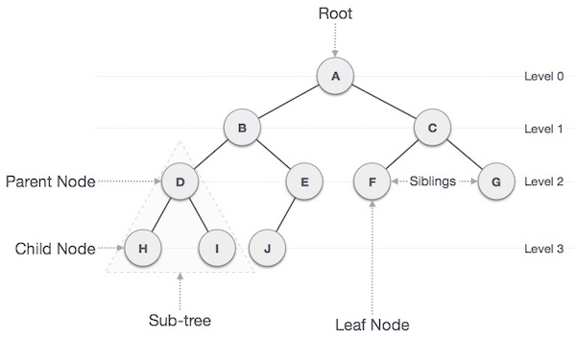

# Common operations

1. Enumerating all the items
2. Enumerating a section of a tree
3. Searching for an item
4. Adding a new item at a certain position on the tree
5. Deleting an item
6. Pruning: Removing a whole section of a tree
7. Grafting: Adding a whole section to a tree
8. Finding the root for any node
9. Finding the lowest common ancestor of two nodes

# Common uses

1. Representing hierarchical data
2. Storing data in a way that makes it efficiently searchable (see binary search tree and tree traversal)
3. Representing sorted lists of data
4. As a workflow for compositing digital images for visual effects
5. Router algorithms
6. Form of a multi-stage decision-making

# Why Trees?

1. One reason to use trees might be because you want to store information that naturally forms a hierarchy. For example, the file system on a computer.
2. Trees (with some ordering e.g., BST) provide moderate access/search (quicker than Linked List and slower than arrays).
3. Trees provide moderate insertion/deletion (quicker than Arrays and slower than Unordered Linked Lists).
4. Like Linked Lists and unlike Arrays, Trees don’t have an upper limit on number of nodes as nodes are linked using pointers.

# Advantages of trees

* Trees reflect structural relationships in the data
* Trees are used to represent hierarchies
* Trees provide an efficient insertion and searching
* Trees are very flexible data, allowing to move subtrees around with minimum effort

# References

<https://www.geeksforgeeks.org/tree-data-structure/>