create temporary table mac165076457953(mac char(20), station char(64), aim_capture_time char(20), capture_time char(20), imsi char(16), rssi char(8), rpt_time char(20), phone_num char(16))default charset=utf8;

select * from mac165076457953;
select capture_time,phone_num from imsi_D05F64CF0440 where capture_time>='2022-04-17 09:40:42' and capture_time<'2022-04-24 09:40:42' and imsi='4601101429900000';

insert into mac165076457953(mac, station, aim_capture_time, imsi, capture_time, rssi, rpt_time, phone_num) (select distinct 'D05F64CF0440' as mac, 'old_device_1' as station, '2022-04-19 09:40:00' as aim_capture_time, imsi, capture_time,rssi, rpt_time, phone_num from imsi_D05F64CF0440 where capture_time>='2022-04-19 09:32:30' and capture_time<'2022-04-19 09:47:30' and imsi!='4601101429900000');

select capture_time,phone_num from imsi_D05F64CF0441 where capture_time>='2022-04-17 09:40:42' and capture_time<'2022-04-24 09:40:42' and imsi='4601101429900000';
insert into mac165076457953(mac, station, aim_capture_time, imsi, capture_time, rssi, rpt_time, phone_num) (select distinct 'D05F64CF0441' as mac, 'old_device_2' as station, '2022-04-19 09:30:00' as aim_capture_time, imsi, capture_time,rssi, rpt_time, phone_num from imsi_D05F64CF0441 where capture_time>='2022-04-19 09:22:30' and capture_time<'2022-04-19 09:37:30' and imsi!='4601101429900000');
select imsi,count(imsi) as imsi_count from mac165076457953 group by imsi order by imsi_count desc limit 100;

select phone_num, address, type as operator from imsiaddr where phone_num=(select phone_num from mac165076457953 where imsi='4601101429900002' limit 1);

select mac, station, aim_capture_time, capture_time, rssi, rpt_time from mac165076457953 where imsi='4601101429900002' limit 500;

常驻人口Test ctrl+鼠标左键 即可定位

临时表查看？？

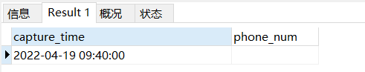
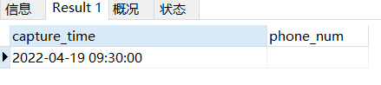
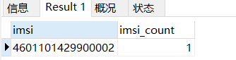
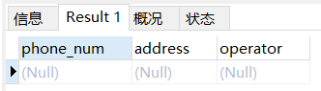
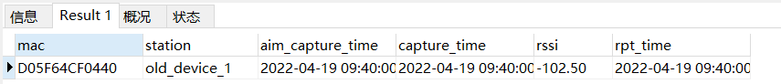

SQL INSERT INTO SELECT 语句
INSERT INTO table2
(column_name(s))
SELECT column_name(s)
FROM table1;

sql_info=[]
if station_list:
for each_station in station_list:
sqlcmd="select site_name as station,mac from devices where site_name='%s';"(each_station)
res_dict=sqlcmd_excute(sqlcmd,dict)
if res_dict:
device_list_new.append(res_dict)
# mac = search_mac_list_by_station(i)[0]
# device_list.append({"station": i, "mac": mac}) # 将搜索结果添加到原列表中每项(字典)中去

else: # 若未指定站点列表，则默认所有的站点进行查询
device_list = station_mac_dict_list_get()

for i in station_list:
mac = search_mac_list_by_station(i)[0]
device_list_old.append({"station": i, "mac": mac}) # 将搜索结果添加到原列表中每项(字典)中去
str1 = "select site_name as station,mac from devices where site_name='%s';"%(i)
sql_info.append(str1)

2022_04_27_09_28 常驻人口Test
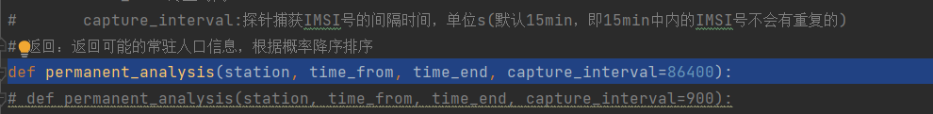
为测试数据方便 设置86400s =24h 相当于一天

old_device_1
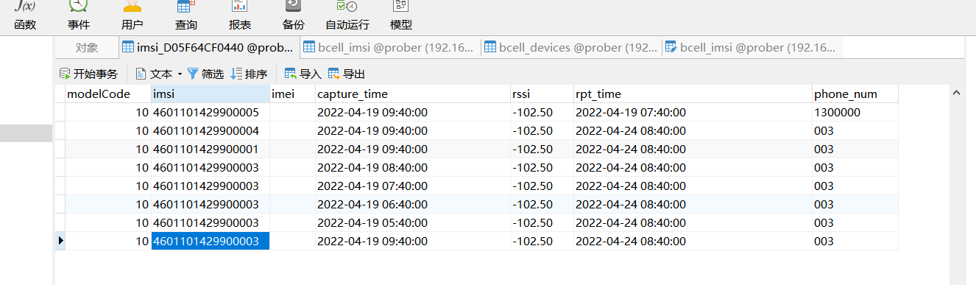
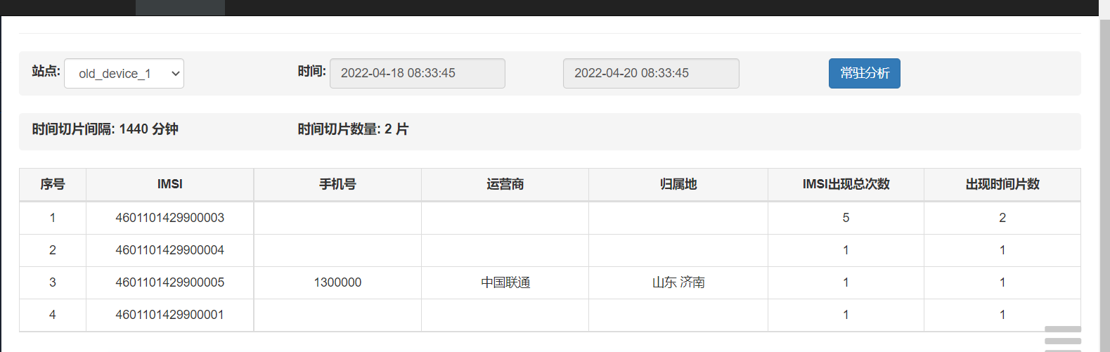

old_device_2
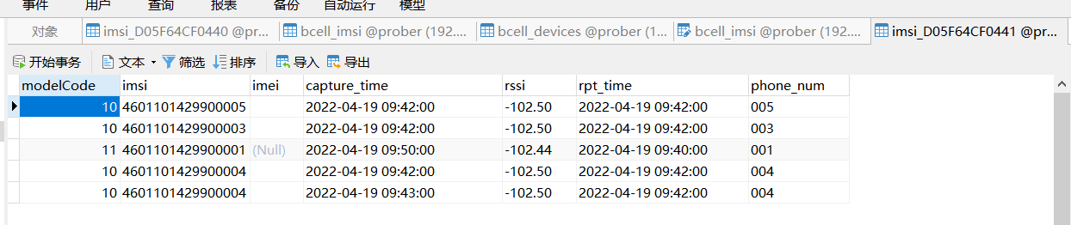
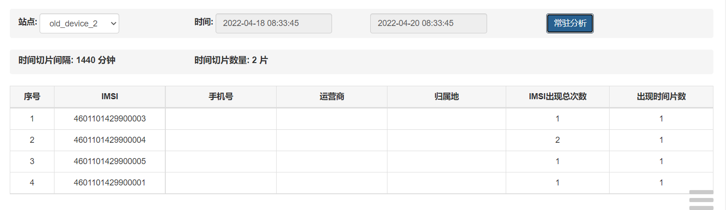

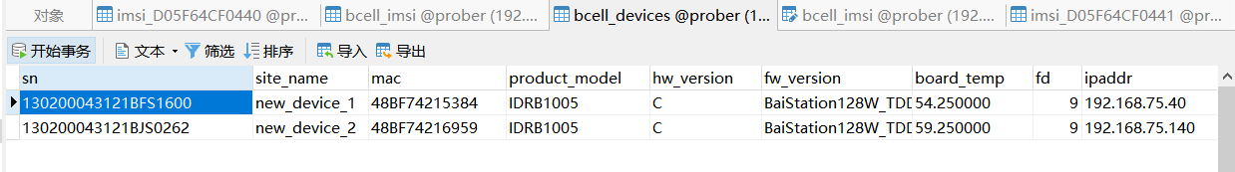

new_device_1
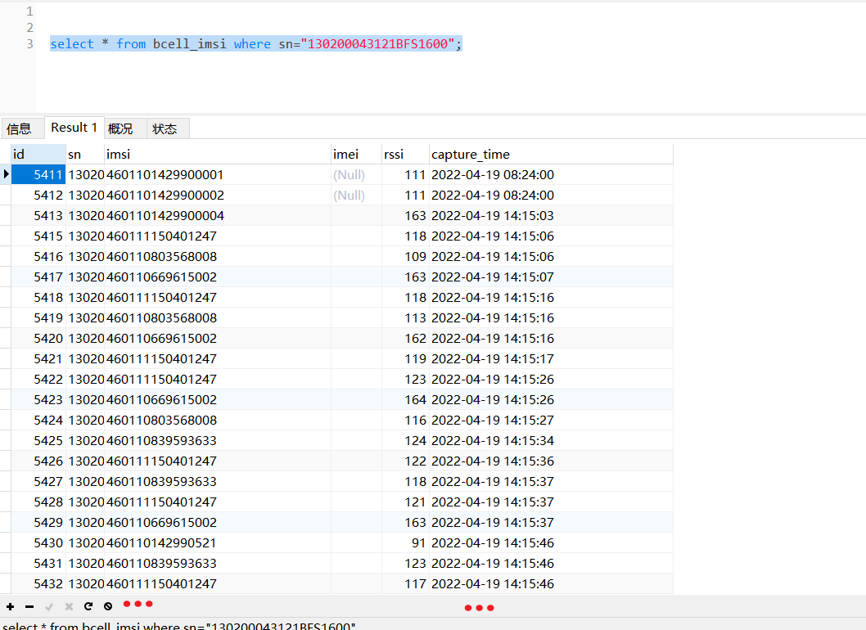
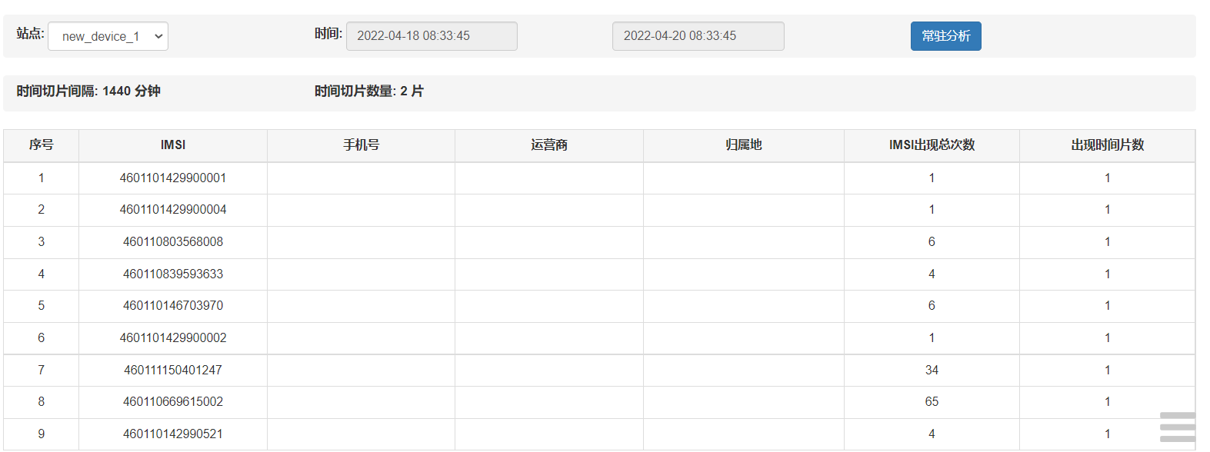
select count(1) from bcell_imsi where sn="130200043121BFS1600" and imsi="460110669615002";
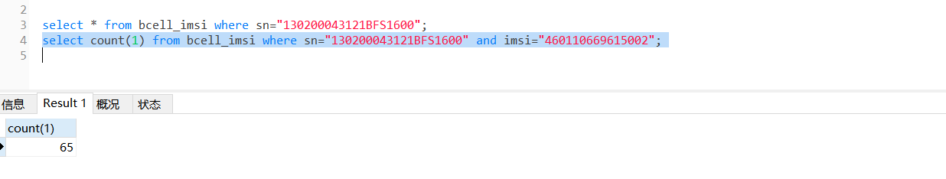

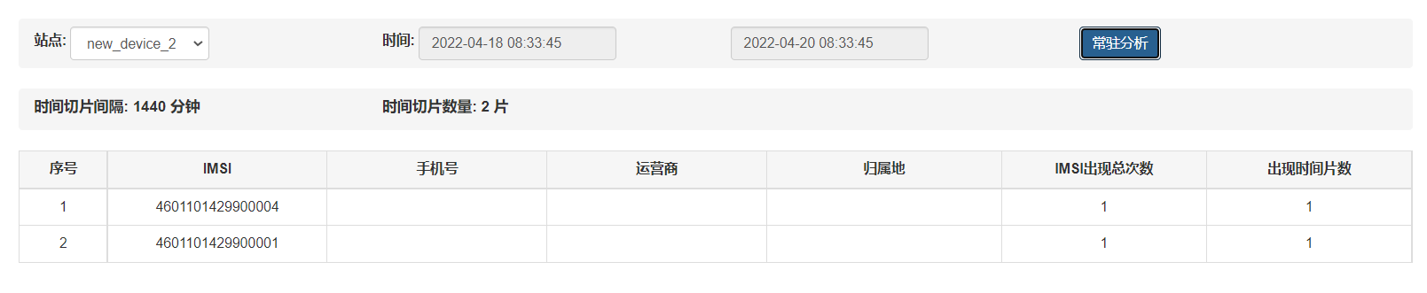

new_device_2

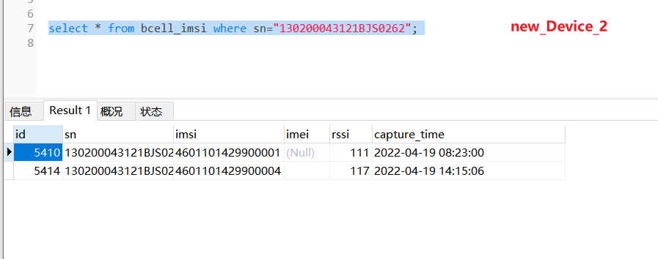

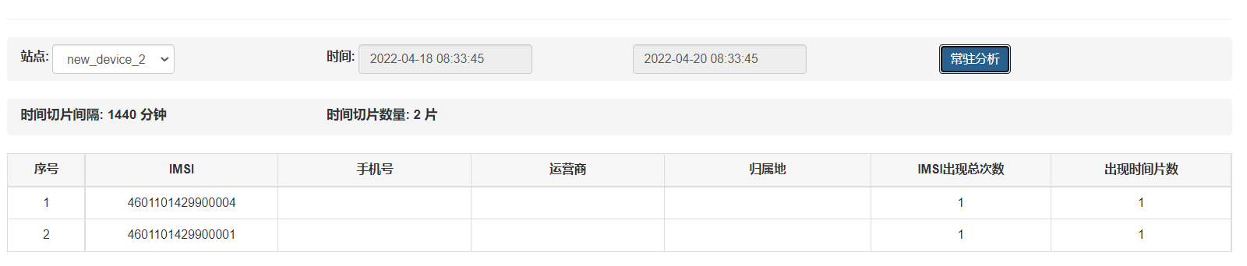

2022_04_27_09_42 伴随分析

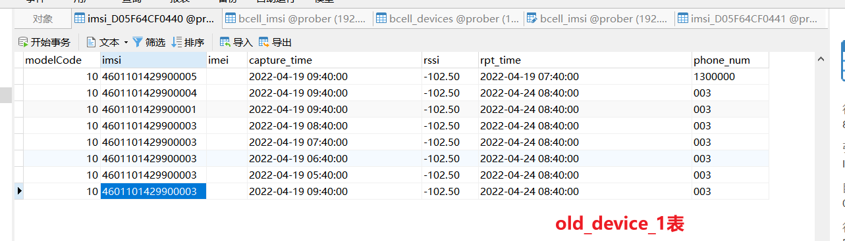
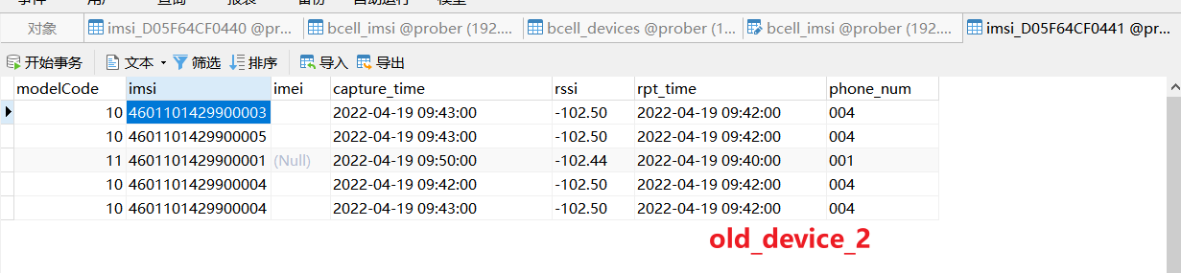
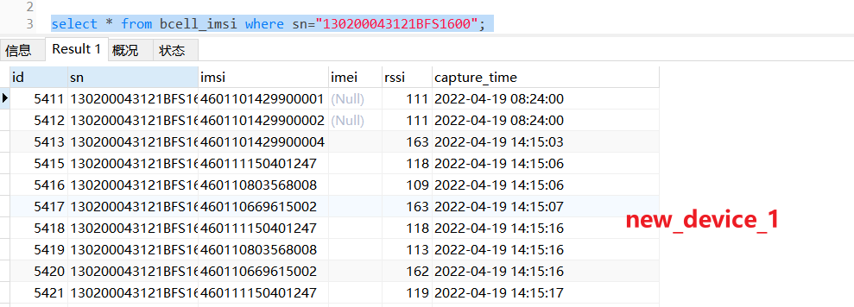
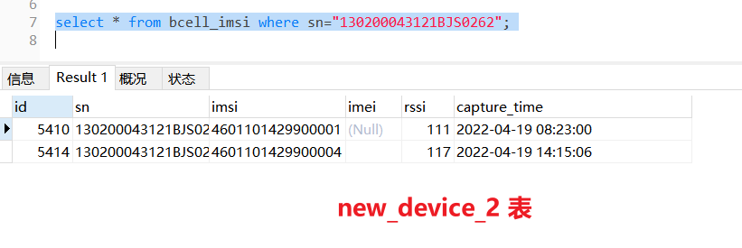

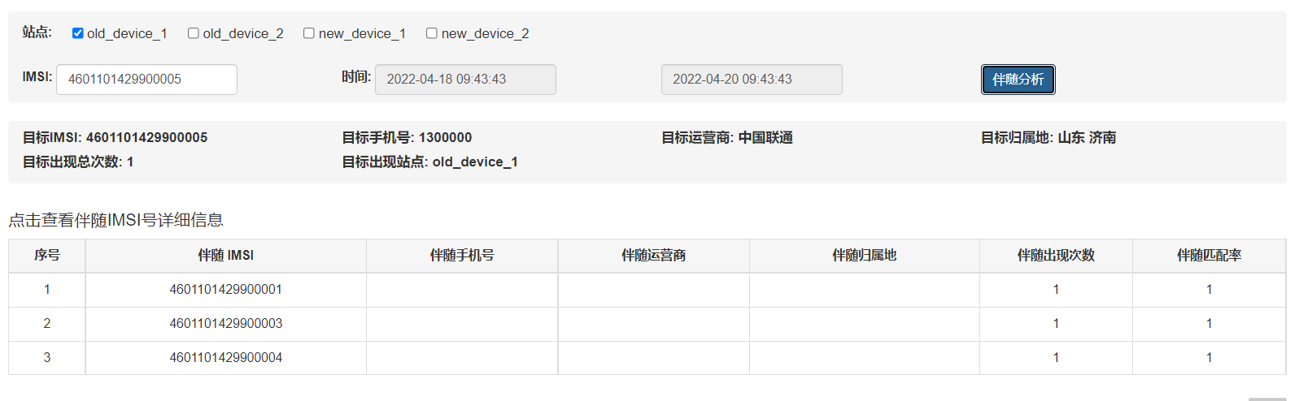
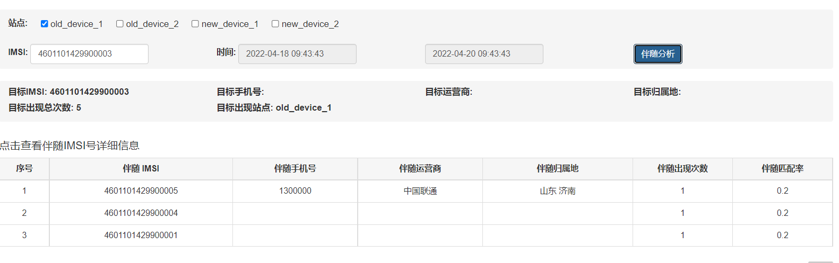

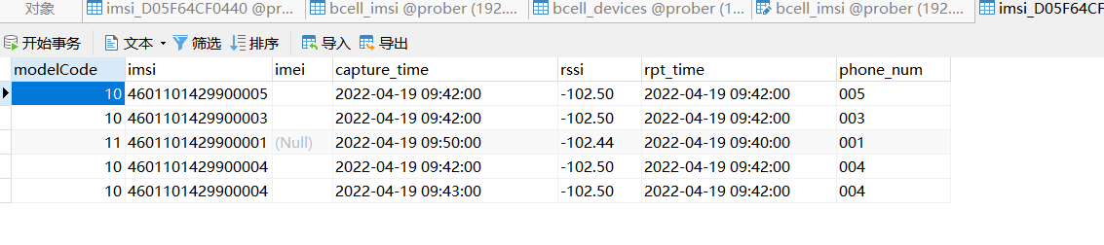

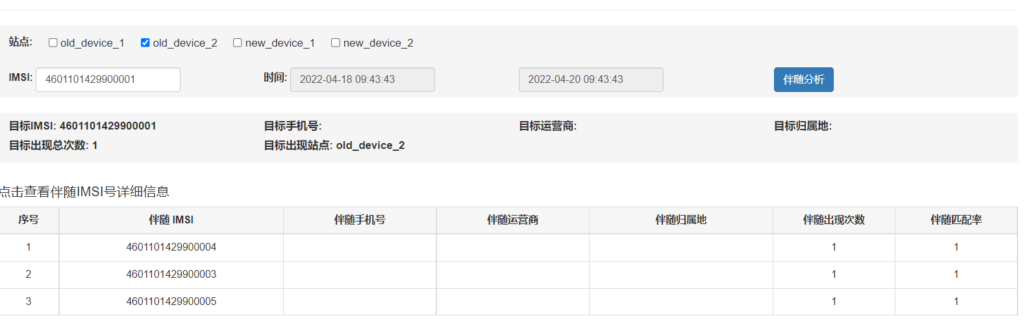
xxx 单独查询新设备错误，修改
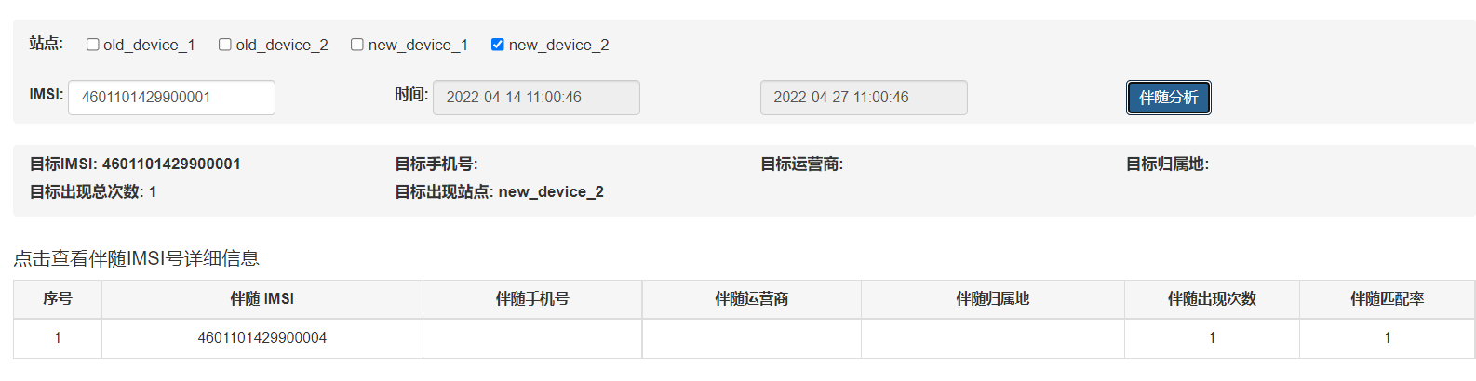

时间差？？
