个人重复性高的git 使用语法 ctrl+鼠标左键即可定位

旧设备
# 获取地图IMSI搜索数据数组
# 参数：
# imsi:需要查询的IMSI号
# time_from:起始时间
# time_end:终止时间
# pagefrom:分页的起始页
# recordsLimt:每页的记录数量(默认每页30)
# orderby:根据指定选项排序
# orderdir:排序方向(递增:"asc",默认)(递减:"desc")
# 返回：
# station_list: 站点信息列表
# info_list:当前显示的查询信息列表
# total_records:符合条件的记录总数

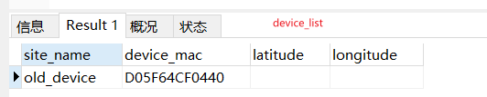

新设备 bcell_device_list sql查找test
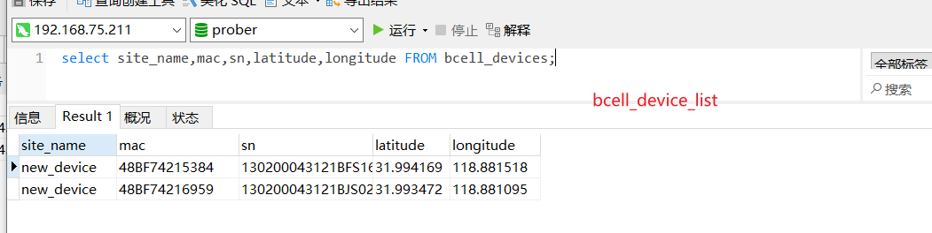

total_records
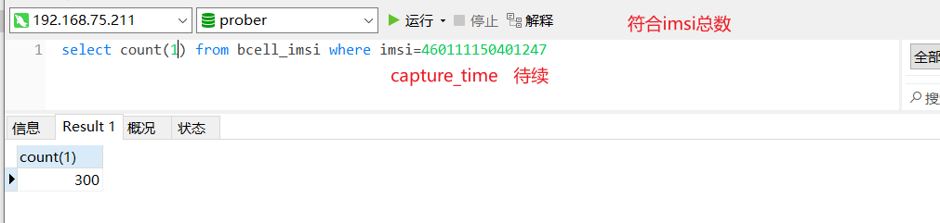

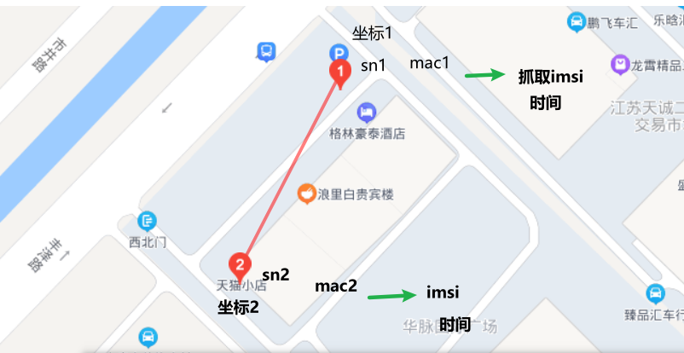
,

查找 imsi+符合时间段（+页数） >>
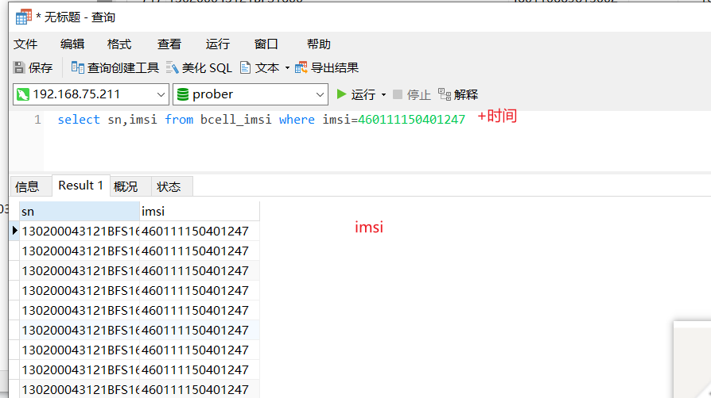
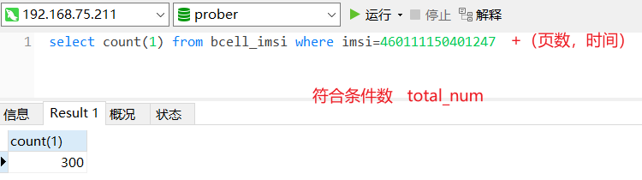

bcell_device

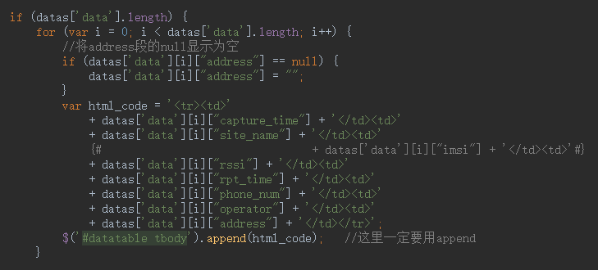
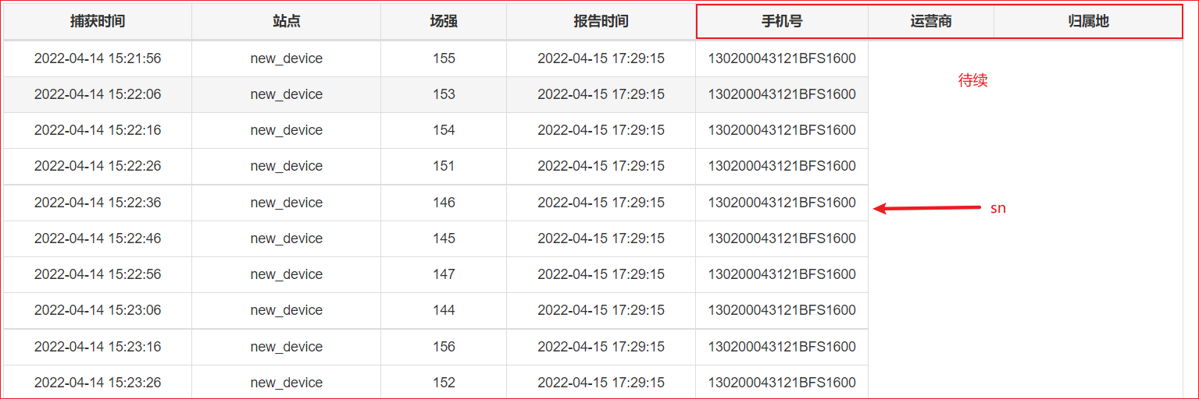

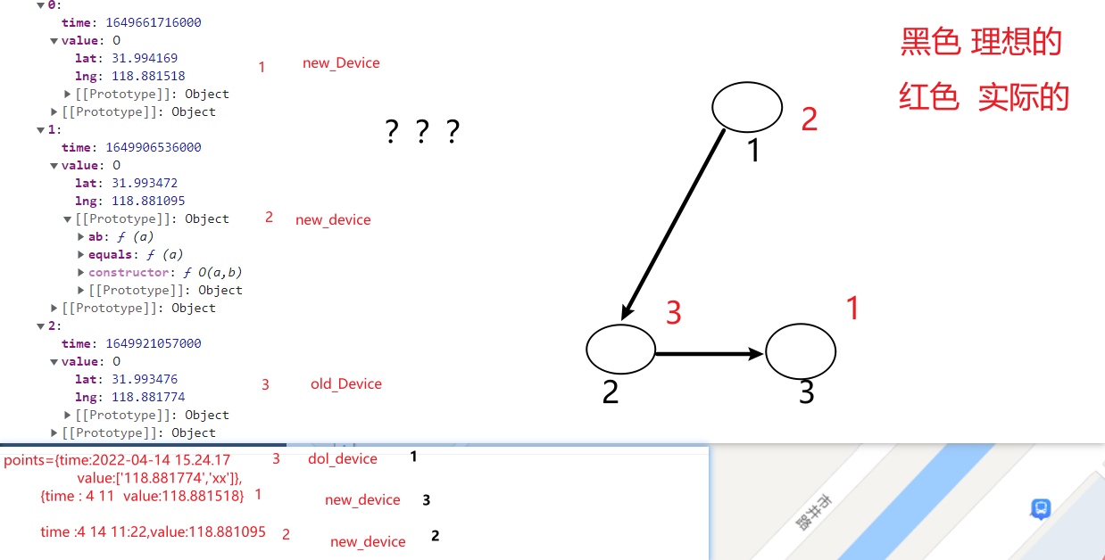

+++++++++++++++++++++++++++++++++++++++++++++++++++++

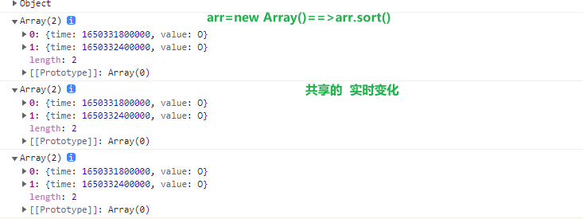
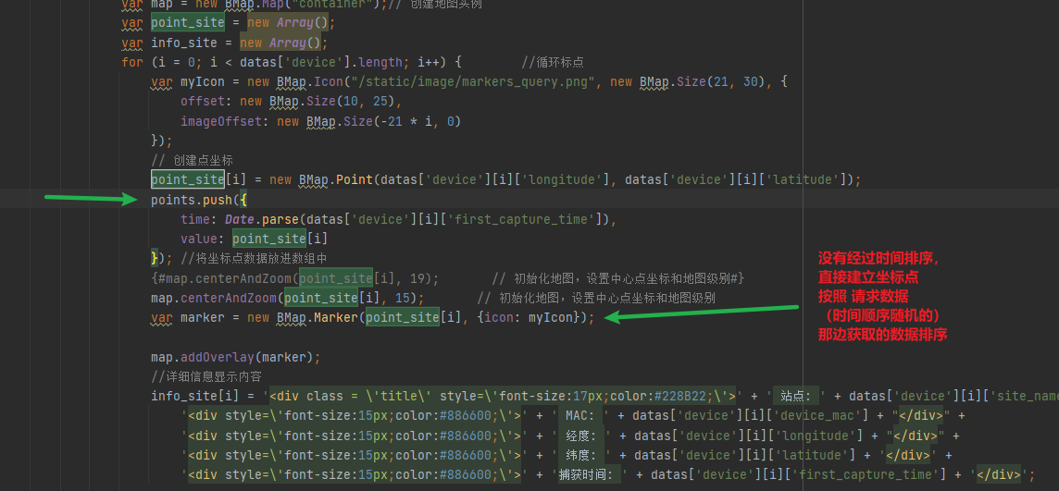

func test 属性时间字符串 按时间排序 asc 递增
<script>
var arr = new Array();
arr.push({
latitude: "32.00125",
first_capture_time: "2022-04-19 09:40:00",
device_mac: "D05F64CF0440",
longitude: "118.802776",
site_name: "old_device_1",
});
arr.push({
latitude: "31.851143",
first_capture_time: "2022-04-19 09:30:00",
device_mac: "D05F64CF0441",
longitude: "118.813915",
site_name: "old_device_2",
});
arr.push({
latitude: "31.851143",
first_capture_time: "2022-04-19 08:24:00",
device_mac: "D05F64CF0441",
longitude: "118.813915",
site_name: "old_device_2",
});
arr.push({
latitude: "31.851143",
first_capture_time: "2022-04-19 08:23:00",
device_mac: "D05F64CF0441",
longitude: "118.813915",
site_name: "old_device_2",
});
// function compare(property) {
// return function (a, b) {
// var value1 = a[property];
// var value2 = b[property];
// return value1 - value2;
// };
// }
console.log(
arr.sort(function (a, b) {
return a.first_capture_time > b.first_capture_time ? 1 : -1;
})
);
console.log(arr)
</script>

测试 2022_04_19_15_30
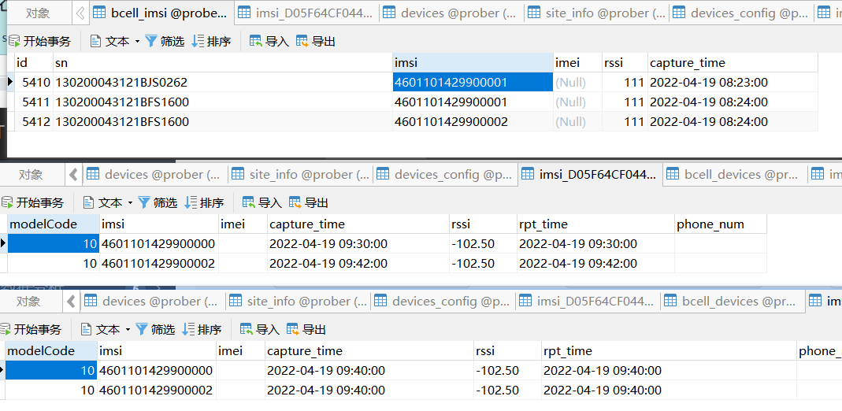

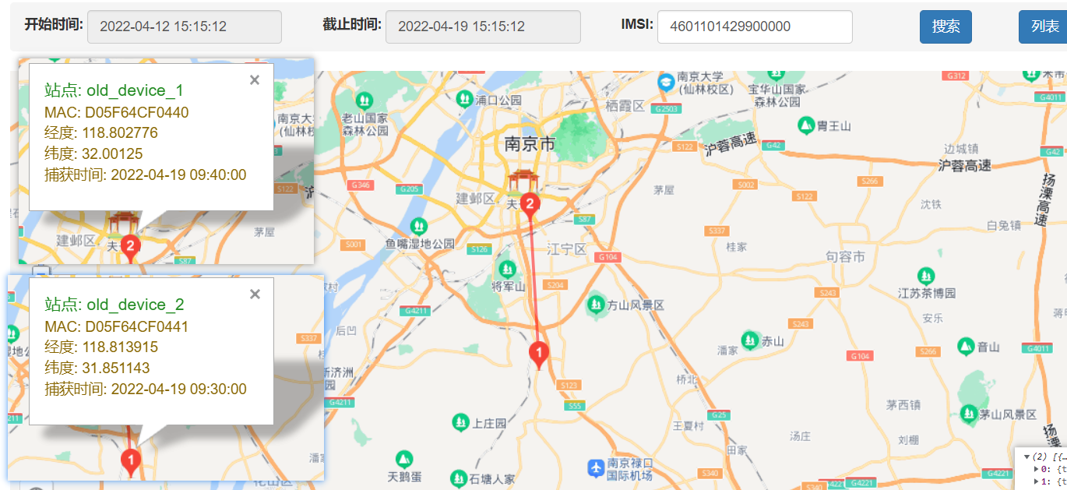
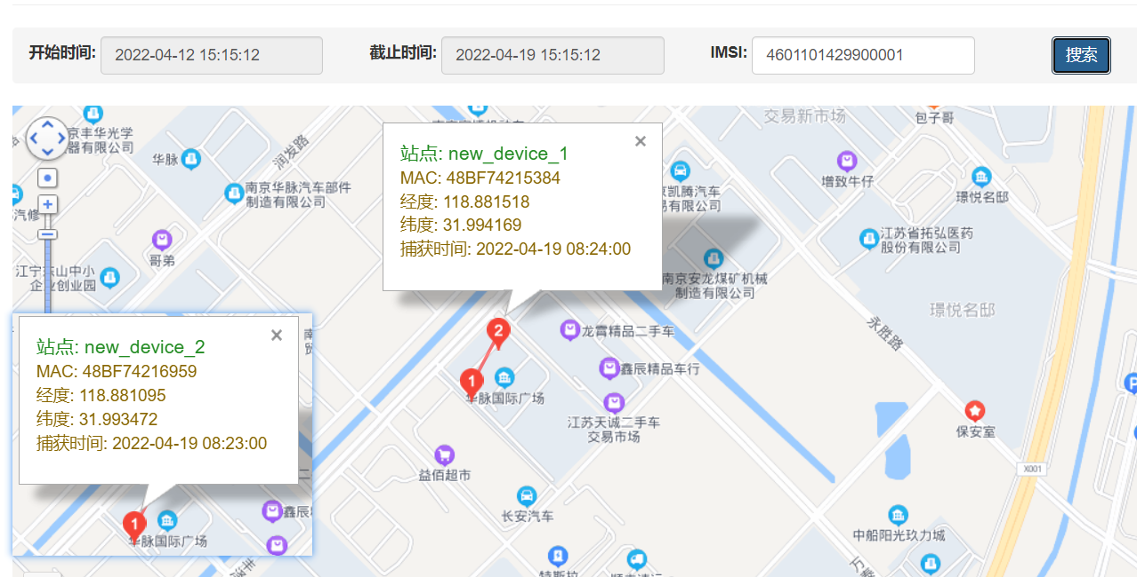
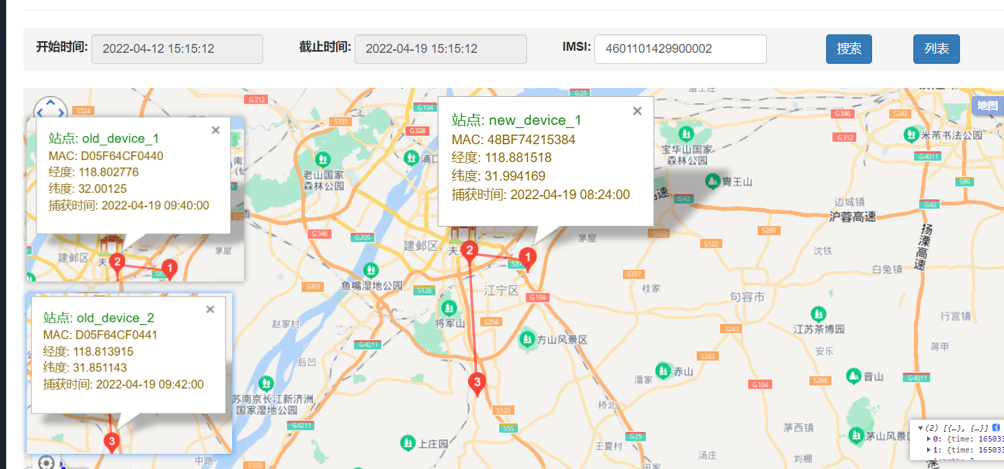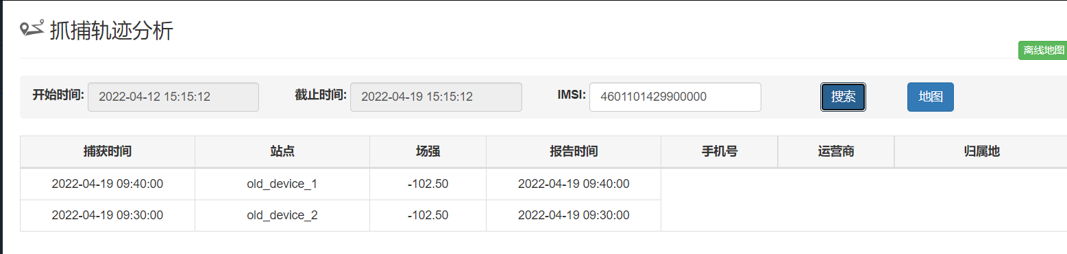
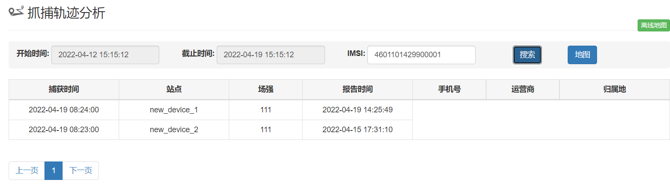
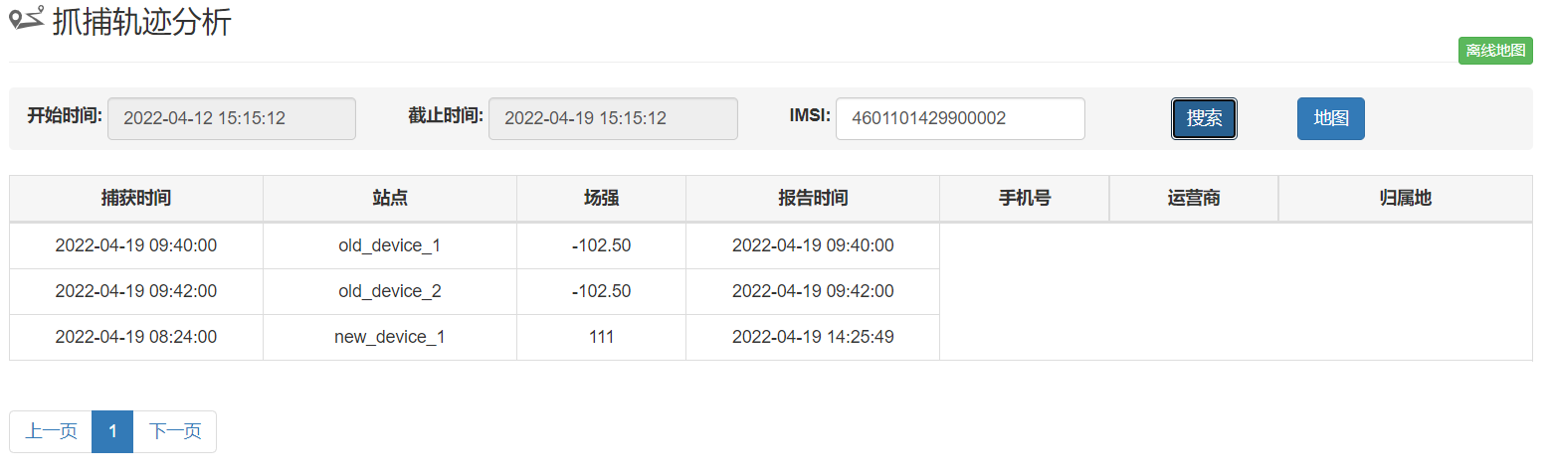

*******************************************************************************
***************************个人重复性高的git语法**************************
************************************************************************TOP
2022_04_19_20_52

git fetch +git merge ≠ git push

git fetch 本地原有的不变+远程仓库上获取的代码 merge 合并
使用git fetch更新代码，本地的库中master的commitID不变，还是等于1。但是与git上面关联的那个orign/master的commit ID变成了2。这时候我们本地相当于存储了两个代码的版本号，我们还要通过merge去合并这两个不同的代码版本，如果这两个版本都修改了同一处的代码，这时候merge就会出现冲突，然后我们解决冲突之后就生成了一个新的代码版本。
这时候本地的代码版本可能就变成了commit ID=3，即生成了一个新的代码版本。
相当于fetch的时候本地的master没有变化，但是与远程仓关联的那个版本号被更新了，我们接下来就是在本地合并这两个版本号的代码。
git push (强制把远程上的代码覆盖本地代码)

https://zhidao.baidu.com/question/1500397357157284459.html

git clone
git remote -v
git reflog
git reset (git reflog 上查看的id 或者git log --reverse --oneline 上常看的id)

执行 git add xx,git commit -m “” 后
删掉git add xx ，git commit -m “”的内容 用 git reset ( git reflog 上查看的id 选择最近merge那个版本的ID)

git commit -a -m “”
git commit -m “”
git push
git commit --amend -m “”
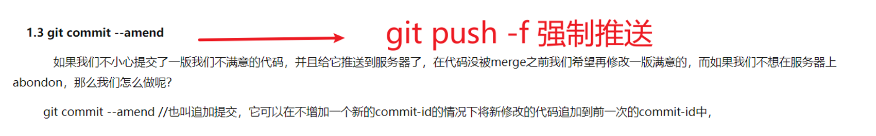
git push -f 强制覆盖 慎用
git fetch
git fetch >> git log - p fetch_head
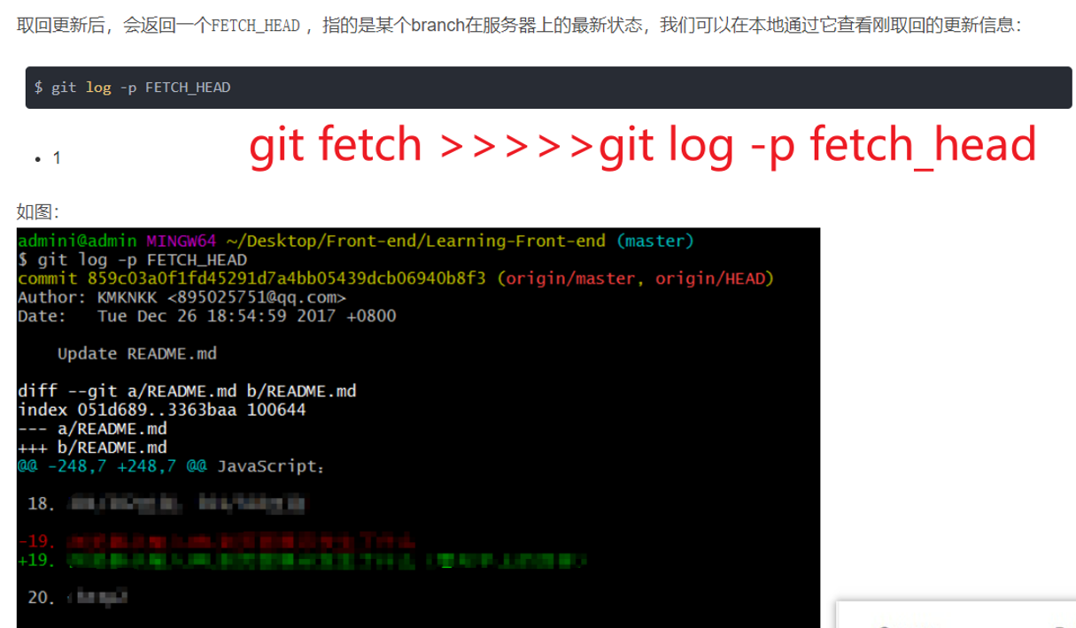
git merge 查看git fetch +git merge ≠ git push

*******************************************************************************
*******************************************************************************
*******************************************************************************

mysql中的日期格式问题
在Mysql中，关于日期的格式有三种类型：Data、Datatime、Timestamp
 | Data | Datatime | Timestamp
存储数据格式 | YYYY-MM-DD | YYYY-MM-DD hh:mm:ss | yyyymmddhhmmss
支持的范围 | 1000-01-01 到 9999-12-31 | 1000-01-01 00:00:00 到  9999-12-31 23:59:59 | 1770-01-01到2037年
特殊说明 | 允许使用字符串或者数字来赋值。例如，12331212和‘1233-12-12’的存储结果为：1233-12-12 | 允许使用字符串或者数字来赋值。例如，12331212121212和‘1233-12-12 12:12:12’的存储结果都为：1233-12-12 12:12:12 | 给该类型字段赋值时，值必须大于19700101000000，否则会抛异常。
注意：对于datatime类型：
1、自动识别时间字符串：
当写入其他时间字符串时，只有数据库识别成功才能够写入成功，且是想要的数据；如果识别不了的时间值，会显示为：‘000-00-00 00:00:00’
2、查询时智能补全模式：
假设要查询某天的全部数据，当在where条件后写入where dt = ‘2021-12-01’时，想要查出一天的数据时。若dt的类型是date时，则可以查出；若dt的类型是datetime时或者其他类型，则无法查出。因为在MySQL中，会对时间类型进行自动补零。上面的实际语句为where dt = ‘2021-12-01 00:00:00’。
要想解决上面的问题有两种思路：
1、在service层中对传进来的时间进行拼接（next_day + " (一定要在这个位置加一个空格)00:00:00")
2、使用MySQL中的to_days(next_day)函数，使用between and

sql all test

select * from bcell_imsi where imsi=460111150401247;
select count(*) from bcell_imsi where imsi=460111150401247;
select capture_time,sn,imsi from bcell_imsi where capture_time>="2022-04-09 15:54:43" and capture_time<"2022-04-15 15:54:23" and imsi=460015972114883;
select capture_time,sn,imsi from bcell_imsi where capture_time>=DATE_FORMAT('2022-04-15 15:54:23','%Y-%m-%d') and capture_time<DATE_FORMAT('2022-04-15 15:55:23','%Y-%m-%d') and imsi="460015972114883";

select count(*) from bcell_imsi;

select capture_time,sn,imsi from bcell_imsi where capture_time>="2022-04-08 16:50:45"
and capture_time< "2022-04-15 16:50:45" and imsi="460015972114883" ORDER BY true desc limit 0,10;

select capture_time,sn,imsi from bcell_imsi where capture_time>="2022-04-08 16:50:45"
and capture_time< "2022-04-15 16:50:45" and imsi="460015972114883" ORDER BY true asc limit 0,10;

select count(*) from bcell_imsi where capture_time>="2022-04-08 16:50:45"
and capture_time< "2022-04-15 16:50:45" and imsi="460015972114883";

select capture_time,sn,imsi from bcell_imsi where capture_time>='2022-04-10 10:13:10' and capture_time<'2022-04-17 10:13:10' and imsi='460015972114883'; limit 0,30;

select capture_time,sn,imsi from bcell_imsi where capture_time>='2022-04-10 10:41:19' and capture_time<'2022-04-17 10:41:19' and imsi='460015972114883' limit 0,2;

2022_04_19_15_52

select sn,site_name,mac as device_mac,longitude,latitude from bcell_devices;

select count(1) from bcell_imsi where sn='130200043121BFS1600' and capture_time>='2022-04-07 08:44:41' and capture_time<'2022-04-16 12:44:41' and imsi='460015972114883';

select count(1) from bcell_imsi where sn='130200043121BFS1600' and capture_time>='2022-04-07 08:44:41' and capture_time<'2022-04-16 12:44:41' and imsi='460015972114883';

select capture_time,site_name,rpt_time,rssi,bcell_imsi.sn from bcell_imsi LEFT join bcell_devices on bcell_imsi.sn=bcell_devices.sn ;

select * from bcell_imsi LEFT join bcell_devices on bcell_imsi.sn=bcell_devices.sn ;

*******************************************************************************

select * from bcell_imsi where imsi=460111150401247;
select count(*) from bcell_imsi where imsi=460111150401247;
select capture_time,sn,imsi from bcell_imsi where capture_time>="2022-04-09 15:54:43" and capture_time<"2022-04-15 15:54:23" and imsi=460015972114883;
select capture_time,sn,imsi from bcell_imsi where capture_time>=DATE_FORMAT('2022-04-15 15:54:23','%Y-%m-%d') and capture_time<DATE_FORMAT('2022-04-15 15:55:23','%Y-%m-%d') and imsi="460015972114883";

select count(*) from bcell_imsi;

select capture_time,sn,imsi from bcell_imsi where capture_time>="2022-04-08 16:50:45"
and capture_time< "2022-04-15 16:50:45" and imsi="460015972114883" ORDER BY true desc limit 0,10;

select capture_time,sn,imsi from bcell_imsi where capture_time>="2022-04-08 16:50:45"
and capture_time< "2022-04-15 16:50:45" and imsi="460015972114883" ORDER BY true asc limit 0,10;

select count(*) from bcell_imsi where capture_time>="2022-04-08 16:50:45"
and capture_time< "2022-04-15 16:50:45" and imsi="460015972114883";

select capture_time,sn,imsi from bcell_imsi where capture_time>='2022-04-10 10:13:10' and capture_time<'2022-04-17 10:13:10' and imsi='460015972114883'; limit 0,30;

select capture_time,sn,imsi from bcell_imsi where capture_time>='2022-04-10 10:41:19' and capture_time<'2022-04-17 10:41:19' and imsi='460015972114883' limit 0,2;

select sn,longitude,latitude from bcell_devices;

select count(1) from bcell_imsi where sn='130200043121BFS1600' and capture_time>='2022-04-08 16:50:45' and capture_time<'2022-04-15 16:50:45' and imsi='460015972114883';
select count(1) from bcell_imsi where sn='130200043121BJS0262' and capture_time>='2022-04-08 16:50:45' and capture_time<'2022-04-15 16:50:45' and imsi='460015972114883';

select count(1) from bcell_imsi where sn='130200043121BFS1600' and capture_time>='2022-04-08 16:50:45' and capture_time<'2022-04-15 16:50:45' and imsi='460015972114883';
select DISTINCT sn ,imsi from bcell_imsi;

select capture_time as first_capture_time from bcell_imsi where imsi='460015972114883' and sn='130200043121BFS1600' and capture_time>='2022-04-10 13:00:12' and capture_time<'2022-04-17 13:00:12' limit 1;

select capture_time,site_name,rpt_time,rssi,bcell_imsi.sn from bcell_imsi LEFT join bcell_devices on bcell_imsi.sn=bcell_devices.sn where capture_time>='2022-04-08 16:50:45' and capture_time<'2022-04-15 16:50:45' and imsi='460015972114883' order by TRUE DESC LIMIT 1,2;
select capture_time,site_name,rpt_time,rssi,bcell_imsi.sn from bcell_imsi LEFT join bcell_devices on bcell_imsi.sn=bcell_devices.sn where capture_time>='2022-04-09 09:20:27' and capture_time<'2022-04-18 09:20:27' and imsi='460015972114883';
select capture_time,site_name,rpt_time,rssi,bcell_imsi.sn from bcell_imsi LEFT join bcell_devices on bcell_imsi.sn=bcell_devices.sn where capture_time>='2022-04-06 09:20:27' and capture_time<'2022-04-18 09:20:27' and imsi='460015972114883' order by true desc limit 0,30;

select sn,longitude,latitude from bcell_devices;

select devices.site_name,site_info.device_mac,site_info.latitude,site_info.longitude from devices left join site_info on devices.mac=site_info.device_mac where devices.site_name is not null ;

select count(*) from bcell_imsi where imsi="460015972114883";

(select imsi_D05F64CF0440.*, 'old_device' as site_name, imsiaddr.address, imsiaddr.type as operator from imsi_D05F64CF0440 left join imsiaddr on imsi_D05F64CF0440.phone_num=imsiaddr.phone_num where imsi_D05F64CF0440.capture_time>='2022-04-11 16:11:09' and imsi_D05F64CF0440.capture_time<'2022-04-16 16:11:09' and imsi_D05F64CF0440.imsi='460015972114883' ) limit 1;

******************************************************************************

