**Create dashboards:**

Create Dashboards to visualize the sensor data using the node-red-dashboard nodes added from Lab 4

* Go to the Node-Red editor of your Bluemix app.
* Copy and past this flow into your node-red window. To do this, click on the navigation menu on the top right, click on import, click on clipboard, paste the flow from below into the window, click import and drop the flow into the center panel of the Node-red editor.

[{"id":"3e77d543.c1882a","type":"ibmiot in","z":"610762ad.802074","authentication":"quickstart","apiKey":"","inputType":"evt","deviceId":"96135de8ca84","applicationId":"","deviceType":"+","eventType":"+","commandType":"","format":"json","name":"IBM IoT App In","service":"quickstart","allDevices":false,"allApplications":false,"allDeviceTypes":true,"allEvents":true,"allCommands":false,"allFormats":false,"x":100,"y":400,"wires":[["ae0082ac.51ff8","c0c482df.3f3b8"]]},{"id":"ae0082ac.51ff8","type":"function","z":"610762ad.802074","name":"temp","func":"return {payload:msg.payload.d.temp};","outputs":1,"x":290,"y":400,"wires":[["ff6ad0d9.00953","e388fdd2.c52d08"]]},{"id":"ff6ad0d9.00953","type":"switch","z":"610762ad.802074","name":"temp thresh","property":"payload","rules":[{"t":"lte","v":40,"v2":null},{"t":"gt","v":40,"v2":null}],"checkall":"true","outputs":2,"x":450,"y":400,"wires":[["80621eff.7f9de"],["8e1706a.f71e8f8"]]},{"id":"5dad02b7.a252fc","type":"debug","z":"610762ad.802074","name":"cpu status","active":true,"complete":"false","x":790,"y":400,"wires":[]},{"id":"c0c482df.3f3b8","type":"debug","z":"610762ad.802074","name":"device data","active":true,"console":"false","complete":"true","x":310,"y":480,"wires":[]},{"id":"80621eff.7f9de","type":"template","z":"610762ad.802074","name":"safe","template":"Temperature ({{payload}}) within safe limits","x":610,"y":380,"wires":[["5dad02b7.a252fc"]]},{"id":"8e1706a.f71e8f8","type":"template","z":"610762ad.802074","name":"danger","template":"Temperature ({{payload}}) critical","x":620,"y":420,"wires":[["5dad02b7.a252fc"]]},{"id":"7926c7b2.86d938","type":"comment","z":"610762ad.802074","name":"Temperature Monitor","info":"","x":110,"y":300,"wires":[]},{"id":"188a5e87.e775a1","type":"comment","z":"610762ad.802074","name":"Configure source","info":"","x":100,"y":360,"wires":[]},{"id":"e388fdd2.c52d08","type":"ui_gauge","z":"610762ad.802074","name":"","group":"2514bb7e.085e3c","order":0,"width":"3","height":"3","gtype":"gage","title":"Gauge","label":"units","format":"{{value}}","min":0,"max":10,"colors":["#00b500","#e6e600","#ca3838"],"seg1":"","seg2":"","x":445.83333333333326,"y":311.66666666666663,"wires":[]},{"id":"2514bb7e.085e3c","type":"ui_group","z":"","name":"Default","tab":"7cdbf1bd.089bc","disp":true,"width":"6"},{"id":"7cdbf1bd.089bc","type":"ui_tab","z":"","name":"Home","icon":"dashboard"}]

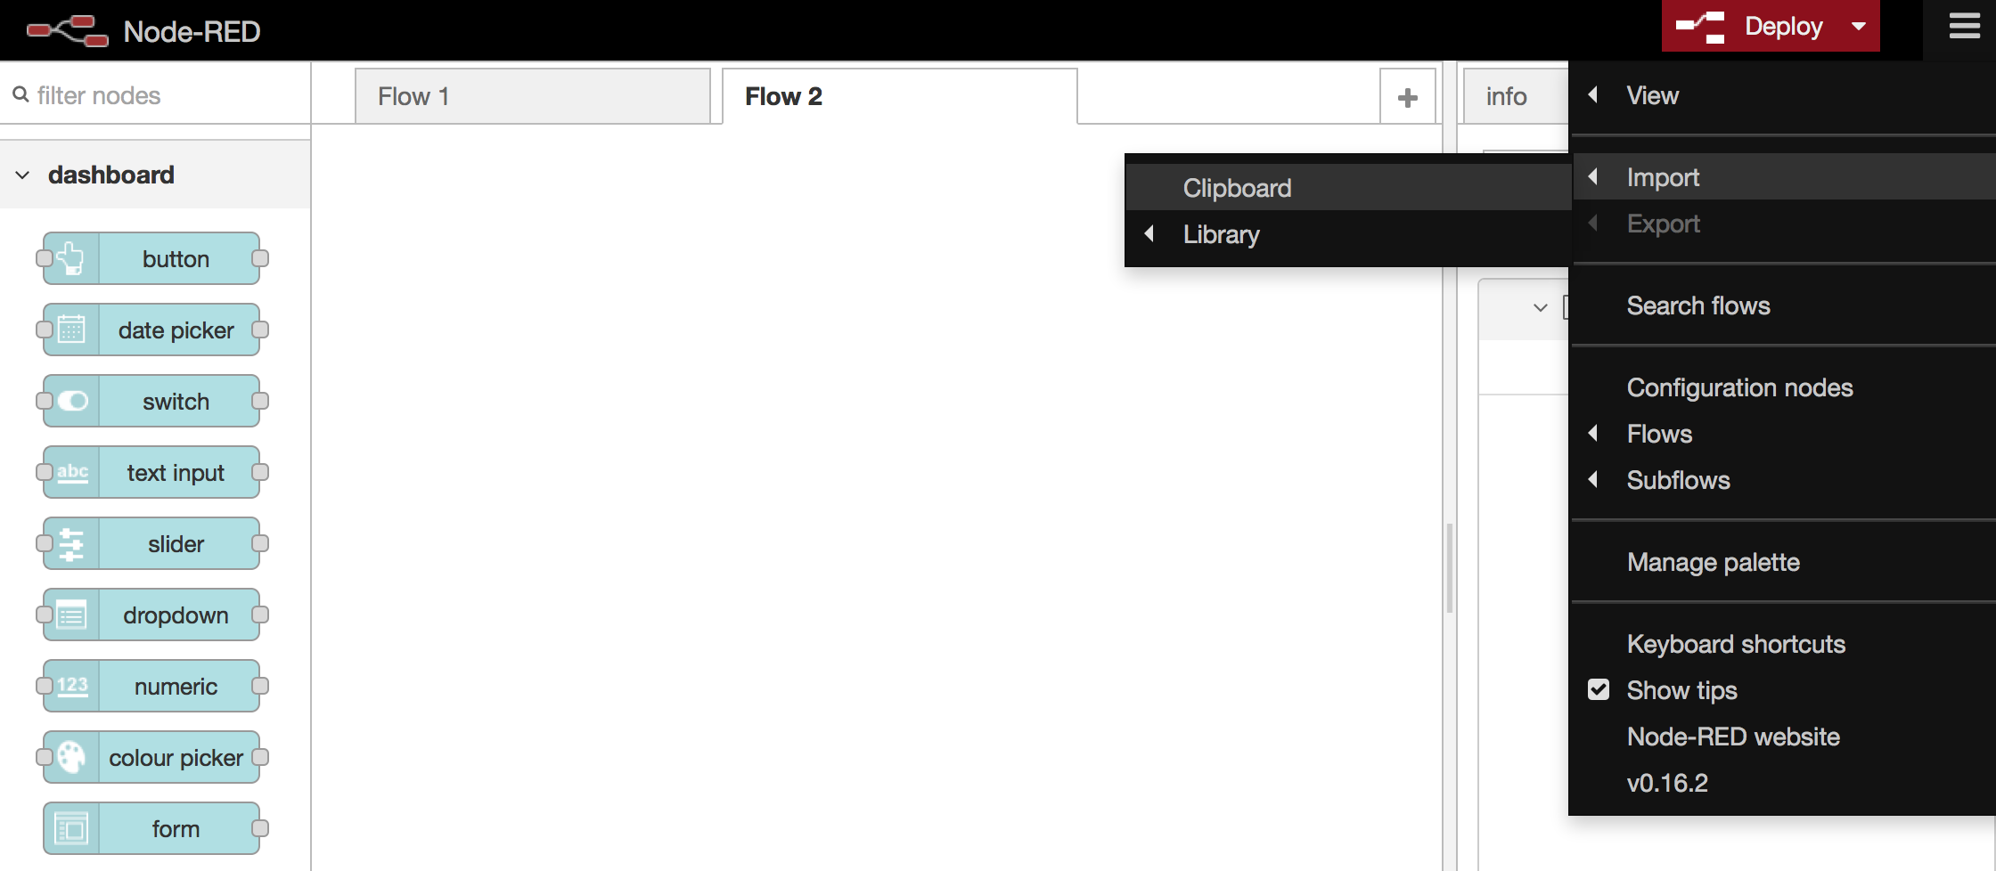

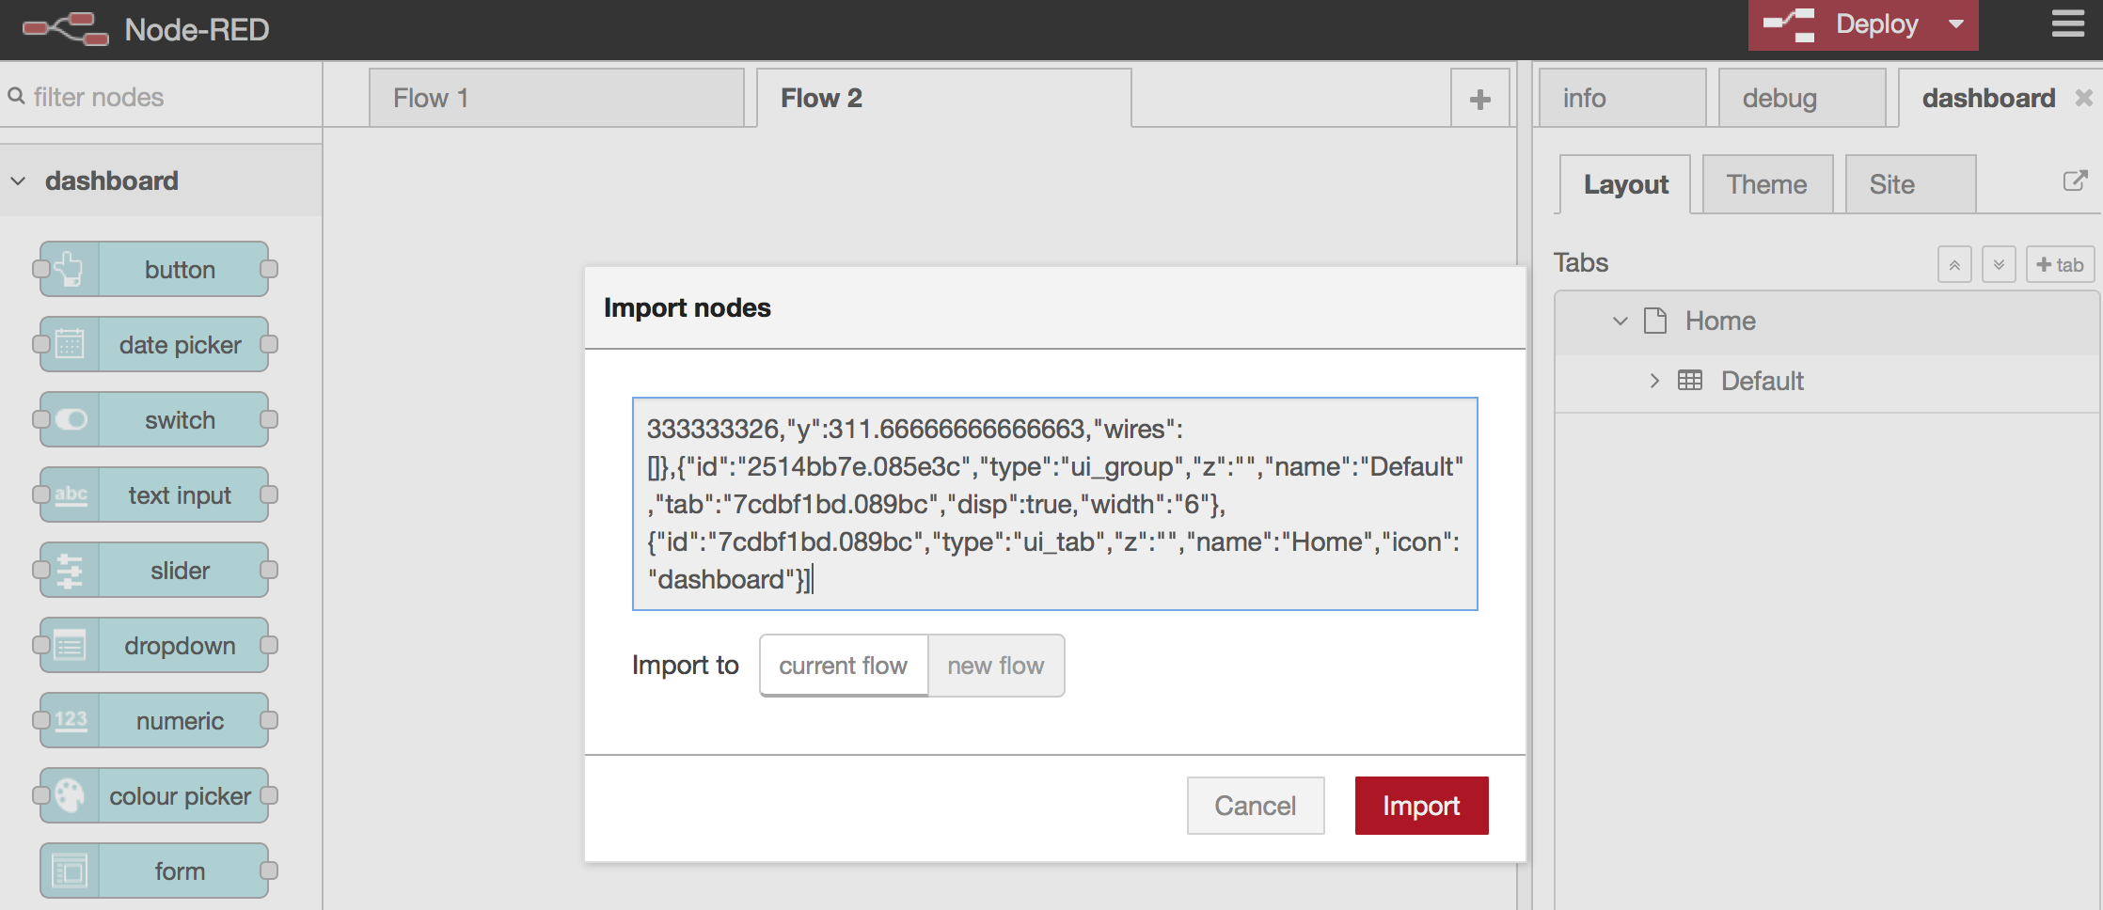

* You should now have a have a flow like this.

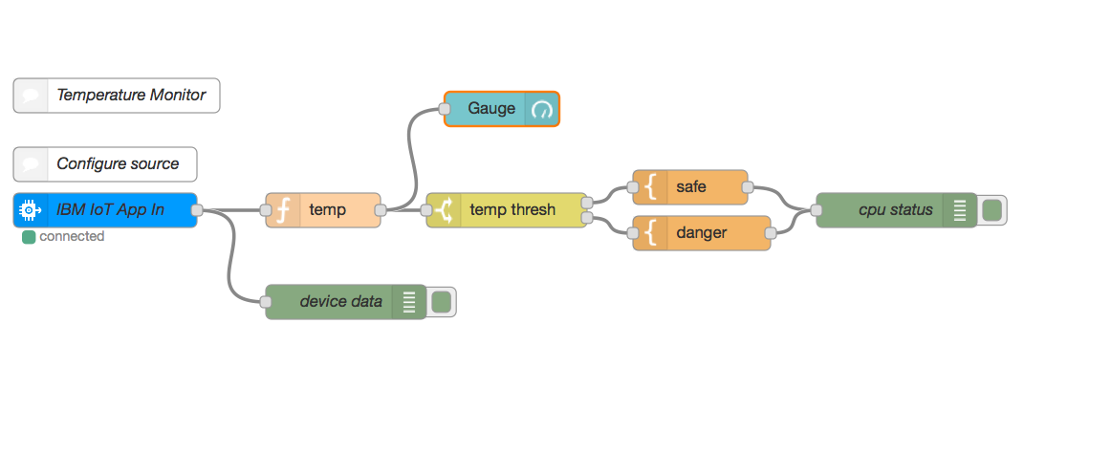

* Open a new browser tab. Go to <http://ibm.biz/iotsensor> and this will take you to the web simulated device.

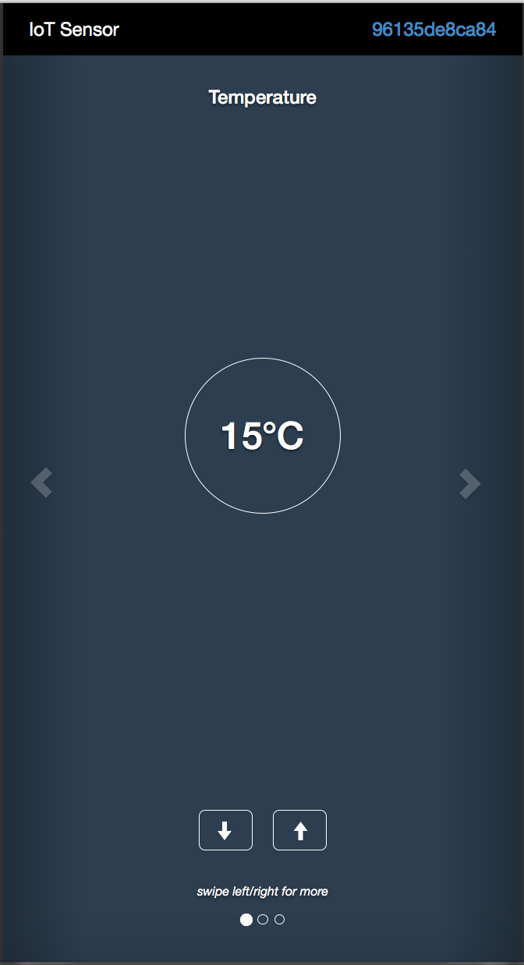

* Copy the “Device ID” from the top right corner. It is n alphanumeric string. This is unique to each instance of the simulated device. Refreshing the browser tab will generate a new device ID.
* Switch back to the Node-Red editor tab. Double click the “IBM IoT App In” node. Paste the copied Device ID into the Device ID field.

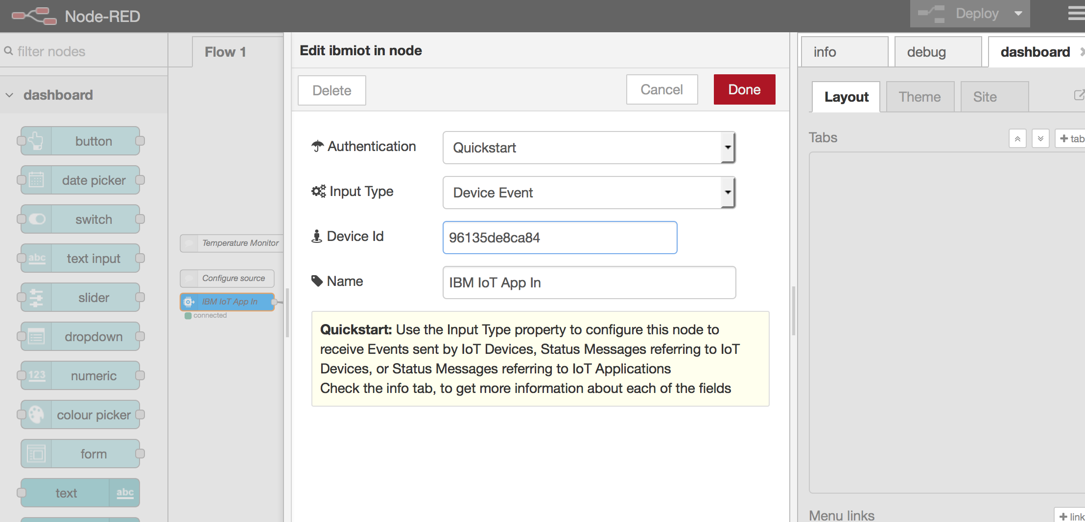

* Click “Done” and “Deploy”
* To see the temperate gauge, go to http://<YourAppName>.mybluemix.net/ui
* Play with the flow to create humidity and object temperature gauge to the dashboard as well.