**Use Watson Language Translator and Watson Text to Speech capabilities**

Now that you have added the Watson Language Translator and Watson Text to Speech, you can use them in your application

* Go to your application’s node-red editor
* Copy and import this flow into the editor. (Follow the steps described in the previous lab to import from the clipboard)

[{"id":"4ce623d6.c0d104","type":"ibmiot in","z":"5b951349.5f9094","authentication":"quickstart","apiKey":"","inputType":"evt","deviceId":"8bf9b82ad2fd","applicationId":"","deviceType":"+","eventType":"+","commandType":"","format":"json","name":"IBM IoT App In","service":"quickstart","allDevices":false,"allApplications":false,"allDeviceTypes":true,"allEvents":true,"allCommands":false,"allFormats":false,"x":196.66665649414062,"y":250,"wires":[["b3ad3ec8.deffc8","56fb2f69.10482","6e03d7b1.10c248","1869b46f.f26c54"]]},{"id":"acf5a0d4.9b4c18","type":"function","z":"5b951349.5f9094","name":"temp","func":"return {payload:msg.payload.d.temp};","outputs":1,"x":386.6666564941406,"y":250,"wires":[["4d3ffedc.cca1d","8c307eb4.e2309"]]},{"id":"4d3ffedc.cca1d","type":"switch","z":"5b951349.5f9094","name":"temp thresh","property":"payload","rules":[{"t":"lte","v":40,"v2":null},{"t":"gt","v":40,"v2":null}],"checkall":"true","outputs":2,"x":546.6666564941406,"y":250,"wires":[["e2527562.915778"],["8b4a8e30.d73348"]]},{"id":"c9c52810.f7e22","type":"debug","z":"5b951349.5f9094","name":"cpu status","active":true,"complete":"false","x":950,"y":226.66668701171875,"wires":[]},{"id":"b3ad3ec8.deffc8","type":"debug","z":"5b951349.5f9094","name":"device data","active":false,"console":"false","complete":"true","x":202.6666259765625,"y":340,"wires":[]},{"id":"e2527562.915778","type":"template","z":"5b951349.5f9094","name":"safe","fieldType":"msg","syntax":"mustache","template":"Temperature ({{payload}}) within safe limits","x":706.6666564941406,"y":230,"wires":[["abfa2eb7.344af8"]]},{"id":"8b4a8e30.d73348","type":"template","z":"5b951349.5f9094","name":"danger","template":"Temperature ({{payload}}) critical","x":715,"y":303.3333435058594,"wires":[["abfa2eb7.344af8"]]},{"id":"5b3ba89f.b4ada","type":"comment","z":"5b951349.5f9094","name":"Temperature Monitor","info":"","x":206.66665649414062,"y":150,"wires":[]},{"id":"b7ffa894.0ed42","type":"comment","z":"5b951349.5f9094","name":"Configure source","info":"","x":196.66665649414062,"y":210,"wires":[]},{"id":"8c307eb4.e2309","type":"ui_gauge","z":"5b951349.5f9094","name":"Temperature","group":"2514bb7e.085e3c","order":0,"width":"3","height":"3","gtype":"gage","title":"Gauge","label":"units","format":"{{value}}","min":0,"max":"100","colors":["#00b500","#e6e600","#ca3838"],"seg1":"","seg2":"","x":622.4999389648438,"y":149.99996948242188,"wires":[]},{"id":"56fb2f69.10482","type":"function","z":"5b951349.5f9094","name":"Humidity","func":"return {payload:msg.payload.d.humidity};","outputs":1,"noerr":0,"x":381.6666259765625,"y":186.66665649414062,"wires":[["2495eca0.e56034"]]},{"id":"6e03d7b1.10c248","type":"function","z":"5b951349.5f9094","name":"Object Temperature","func":"return {payload:msg.payload.d.objectTemp};","outputs":1,"noerr":0,"x":390,"y":109.99999237060547,"wires":[["7abd05e1.5e624c"]]},{"id":"7abd05e1.5e624c","type":"ui_gauge","z":"5b951349.5f9094","name":"Object Temperature","group":"2514bb7e.085e3c","order":0,"width":"3","height":"3","gtype":"gage","title":"Gauge","label":"°C","format":"{{value}}","min":0,"max":"100","colors":["#00b500","#e6e600","#ca3838"],"seg1":"","seg2":"","x":641.6666259765625,"y":54.99999237060547,"wires":[]},{"id":"2495eca0.e56034","type":"ui_gauge","z":"5b951349.5f9094","name":"Humidity","group":"2514bb7e.085e3c","order":0,"width":"3","height":"3","gtype":"gage","title":"Gauge","label":"%","format":"{{value}}","min":0,"max":"100","colors":["#00b500","#e6e600","#ca3838"],"seg1":"","seg2":"","x":608.3333129882812,"y":103.33333587646484,"wires":[]},{"id":"abfa2eb7.344af8","type":"watson-translator","z":"5b951349.5f9094","name":"","action":"translate","basemodel":"ar-en","domain":"conversational","srclang":"en","destlang":"es","password":"","custom":"","domainhidden":"conversational","srclanghidden":"en","destlanghidden":"es","basemodelhidden":"","customhidden":"","filetype":"forcedglossary","trainid":"","lgparams2":true,"ldparamshidden2":"true","x":884.1666259765625,"y":278.3333435058594,"wires":[["c9c52810.f7e22","e11a4b79.a300c"]]},{"id":"f7ad6cb1.9f9e7","type":"http in","z":"5b951349.5f9094","name":"","url":"/audio","method":"get","swaggerDoc":"","x":173.33331298828125,"y":498.00000762939453,"wires":[["caac0040.7c6538"]]},{"id":"b7e5914.2cbe8f","type":"http response","z":"5b951349.5f9094","name":"","x":593.8788013458252,"y":496.2726936340332,"wires":[]},{"id":"caac0040.7c6538","type":"template","z":"5b951349.5f9094","name":"","field":"payload","fieldType":"msg","syntax":"mustache","template":"<!DOCTYPE html>\n<html>\n<head>\n <title>IBM Watson - Text To Speech</title>\n <script src=\"https://ajax.googleapis.com/ajax/libs/jquery/2.1.4/jquery.min.js\"></script>\n \n <script type=\"text/javascript\">\n var socketaddy = \"ws://\" + window.location.host + \"/ws/audio\";\n\n $(document).ready(function(){\n var output = document.getElementById('output')\n $('#output').on('playing', function () {\n $('#text').text('Playing audio.')\n \n });\n $('#output').on('ended', function () {\n $('#text').text('Waiting for audio...')\n \n });\n sock = new WebSocket(socketaddy);\n sock.onopen = function(){\n $('#text').text('Waiting for audio...');\n console.log(\"Connected websocket\");\n };\n sock.onerror = function(){ \n console.log(\"Websocket error\"); \n };\n sock.onclose = function () {\n $('#text').text('Not connected. Refresh the page?')\n }\n sock.onmessage = function(evt){\n console.log(\"Websocket message\", evt); \n output.src = window.URL.createObjectURL(evt.data);\n output.play();\n };\n });\n </script>\n \n</head>\n<body style=\"font-size: 56px; font-family: helvetica; text-align: center; margin-top: 100px;\">\n <div id=\"text\">Connecting...</div>\n <audio id=\"output\"></audio>\n</body>\n</html>","x":388.33331298828125,"y":494.9999771118164,"wires":[["b7e5914.2cbe8f"]]},{"id":"e11a4b79.a300c","type":"watson-text-to-speech","z":"5b951349.5f9094","name":"","lang":"es-ES","langhidden":"es-ES","voice":"es-ES_LauraVoice","voicehidden":"","format":"audio/wav","password":"","x":806.6666259765625,"y":375,"wires":[["2acd737f.e5f534"]]},{"id":"52ee8814.45042","type":"websocket out","z":"5b951349.5f9094","name":"","server":"b1117a4b.d507d","client":"","x":1060.757568359375,"y":367.72723388671875,"wires":[]},{"id":"2acd737f.e5f534","type":"function","z":"5b951349.5f9094","name":"Transform Text to Speech","func":"msg.payload = msg.speech;\nreturn msg;","outputs":1,"noerr":0,"x":949.48486328125,"y":439.54534912109375,"wires":[["52ee8814.45042"]]},{"id":"1869b46f.f26c54","type":"delay","z":"5b951349.5f9094","name":"","pauseType":"rate","timeout":"5","timeoutUnits":"seconds","rate":"1","nbRateUnits":"10","rateUnits":"second","randomFirst":"1","randomLast":"5","randomUnits":"seconds","drop":true,"x":369,"y":319.5,"wires":[["acf5a0d4.9b4c18"]]},{"id":"2514bb7e.085e3c","type":"ui_group","z":"","name":"Simulated Sensor Readings","tab":"7cdbf1bd.089bc","disp":true,"width":"6"},{"id":"b1117a4b.d507d","type":"websocket-listener","path":"/ws/audio","wholemsg":"false"},{"id":"7cdbf1bd.089bc","type":"ui_tab","z":"","name":"Home","icon":"dashboard"}]

* Go to ibm.biz/iotsensor on a separate browser tab. Copy the device ID.
* Switch back to the Node-Red editor
* Double click the “IBM IoT App in” node. Paste the device ID.
* Double click the “language translator” node. Make changes as in the screenshot to translate from English to Spanish. Click “Done”.

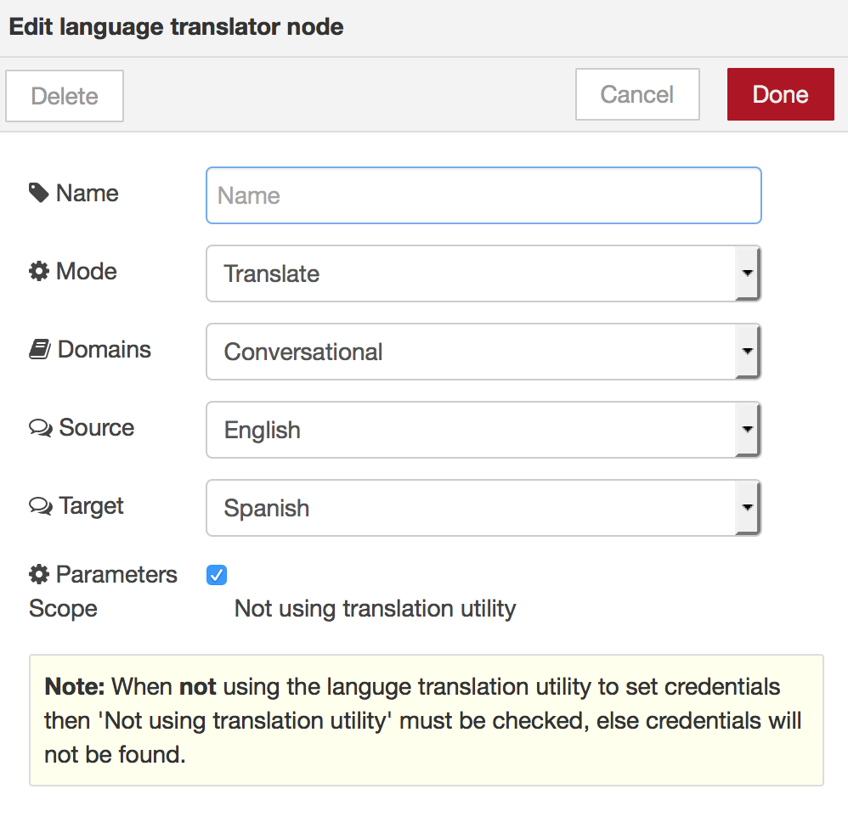

* Click Deploy.
* You should now see the debug panel containing messages in Spanish every 10 seconds.
* Set your laptop speaker volume up. Go to <YourAppName>.mybluemix.net/audio
* You should now here the message spoken to you in Spanish every 10 seconds.