Connect your iPhone and retrieve weather information for your location:

* Go to your Node-Red editor
* Copy and import this flow

[{"id":"172f4a5b.bdbd2e","type":"http in","z":"5b951349.5f9094","name":"","url":"/audio","method":"get","swaggerDoc":"","x":194,"y":174,"wires":[["692af5f6.110364"]]},{"id":"55b7a502.c568d4","type":"http response","z":"5b951349.5f9094","name":"","x":614.545488357544,"y":172.27268600463867,"wires":[]},{"id":"692af5f6.110364","type":"template","z":"5b951349.5f9094","name":"","field":"payload","fieldType":"msg","syntax":"mustache","template":"<!DOCTYPE html>\n<html>\n<head>\n <title>IBM Watson - Text To Speech</title>\n <script src=\"https://ajax.googleapis.com/ajax/libs/jquery/2.1.4/jquery.min.js\"></script>\n \n <script type=\"text/javascript\">\n var socketaddy = \"ws://\" + window.location.host + \"/ws/audio\";\n\n $(document).ready(function(){\n var output = document.getElementById('output')\n $('#output').on('playing', function () {\n $('#text').text('Playing audio.')\n \n });\n $('#output').on('ended', function () {\n $('#text').text('Waiting for audio...')\n \n });\n sock = new WebSocket(socketaddy);\n sock.onopen = function(){\n $('#text').text('Waiting for audio...');\n console.log(\"Connected websocket\");\n };\n sock.onerror = function(){ \n console.log(\"Websocket error\"); \n };\n sock.onclose = function () {\n $('#text').text('Not connected. Refresh the page?')\n }\n sock.onmessage = function(evt){\n console.log(\"Websocket message\", evt); \n output.src = window.URL.createObjectURL(evt.data);\n output.play();\n };\n });\n </script>\n \n</head>\n<body style=\"font-size: 56px; font-family: helvetica; text-align: center; margin-top: 100px;\">\n <div id=\"text\">Connecting...</div>\n <audio id=\"output\"></audio>\n</body>\n</html>","x":409,"y":170.99996948242188,"wires":[["55b7a502.c568d4"]]},{"id":"933aee50.5b30e8","type":"find-my-iphone","z":"5b951349.5f9094","x":168.8487548828125,"y":444.63641357421875,"wires":[["bcdb6ed3.c05868","9e14790b.6d5c3"]]},{"id":"282a4157.87e596","type":"inject","z":"5b951349.5f9094","name":"Check weather every 3hrs","topic":"","payload":"","payloadType":"date","repeat":"","crontab":"","once":false,"x":179.01540120442723,"y":343.46978759765625,"wires":[["933aee50.5b30e8"]]},{"id":"bcdb6ed3.c05868","type":"function","z":"5b951349.5f9094","name":"Weather API URL","func":"if (msg.payload.modelDisplayName.valueOf() === \"iPhone\".valueOf())\n{\n var url = \"https://twcservice.mybluemix.net/api/weather/v1/geocode/\"+msg.payload.location.latitude+\"/\"+msg.payload.location.longitude+\"/observations.json?language=en-US\";\n msg.url = url;\n return msg;\n}","outputs":1,"noerr":0,"x":447.848876953125,"y":374.13653564453125,"wires":[["c64a9273.753cc","b923b76b.83f8d"]]},{"id":"ef541c70.388fb8","type":"debug","z":"5b951349.5f9094","name":"Display current weather for your location","active":false,"console":"false","complete":"payload","x":811.1822509765625,"y":334.9699401855469,"wires":[]},{"id":"c64a9273.753cc","type":"http request","z":"5b951349.5f9094","name":"Get Current Weather","method":"GET","ret":"obj","url":"","tls":"","x":458.68206787109375,"y":447.05303955078125,"wires":[["ef541c70.388fb8","ee444fc7.96e588","2399de35.93311a","21b6ebf0.8c523c","ad9f2826.c8f5b8"]]},{"id":"8d6728a6.0ea1a8","type":"template","z":"5b951349.5f9094","name":"Weather Channel Temperature in Fahrenheit","field":"payload","fieldType":"msg","format":"text","syntax":"mustache","template":"Temperature now from Weather Channel: {{payload}} degree Fahrenheit!","x":1223.7293701171875,"y":445.291259765625,"wires":[["9fd1d443.93d8d"]]},{"id":"ee444fc7.96e588","type":"function","z":"5b951349.5f9094","name":"Get Temperature data from Weather rest api","func":"return {payload:msg.payload.observation.temp};","outputs":1,"noerr":0,"x":819.705322265625,"y":447.17236328125,"wires":[["8d6728a6.0ea1a8","eb6d9029.022988"]]},{"id":"eb6d9029.022988","type":"switch","z":"5b951349.5f9094","name":"Set temp threshold (cold, pleasant, hot)","property":"payload","propertyType":"msg","rules":[{"t":"lt","v":"45","vt":"str"},{"t":"gt","v":"75","vt":"str"},{"t":"btwn","v":"45","vt":"num","v2":"75","v2t":"num"}],"checkall":"true","outputs":3,"x":235.9674072265625,"y":693.2196655273438,"wires":[["204a53c9.4fd3d4"],["2267cfed.d2fc58"],["de55ead2.503c08"]]},{"id":"204a53c9.4fd3d4","type":"template","z":"5b951349.5f9094","name":"Cold day warning","field":"payload","fieldType":"msg","syntax":"mustache","template":"Extremely cold day. Don't forget your jacket, hat and gloves.","x":559.5387573242188,"y":628.7909545898438,"wires":[["8d75b2f1.21aff","33757042.4d902"]]},{"id":"2267cfed.d2fc58","type":"template","z":"5b951349.5f9094","name":"Heat alert","field":"payload","fieldType":"msg","syntax":"mustache","template":"Hot day! Wear something light and go for cotton. Drink plenty of water. Don't forget your sunscreen,","x":526.5864868164062,"y":691.6124877929688,"wires":[["8d75b2f1.21aff","33757042.4d902","f8410b8a.d48c18"]]},{"id":"de55ead2.503c08","type":"template","z":"5b951349.5f9094","name":"Pleasant day message","field":"payload","fieldType":"msg","syntax":"mustache","template":"Beautiful, pleasant day. Enjoy the outdoors.","x":562.1580200195312,"y":763.8626098632812,"wires":[["8d75b2f1.21aff","33757042.4d902","f8410b8a.d48c18"]]},{"id":"d1547f19.b05e28","type":"watson-text-to-speech","z":"5b951349.5f9094","name":"","lang":"es-ES","langhidden":"es-ES","voice":"es-ES_LauraVoice","voicehidden":"","format":"audio/wav","password":"","x":1246.3245849609375,"y":633.7554931640625,"wires":[["474b841a.b72384"]]},{"id":"6c8b3c9b.a11edc","type":"websocket out","z":"5b951349.5f9094","name":"","server":"438b3693.e926b","client":"","x":1466.41552734375,"y":682.4827270507812,"wires":[]},{"id":"474b841a.b72384","type":"function","z":"5b951349.5f9094","name":"Transform Text to Speech","func":"msg.payload = msg.speech;\nreturn msg;","outputs":1,"noerr":0,"x":1279.1427815755214,"y":742.3008422851562,"wires":[["6c8b3c9b.a11edc"]]},{"id":"8d75b2f1.21aff","type":"twilio out","z":"5b951349.5f9094","service":"_ext_","twilio":"97beeeb6.6c642","from":"","number":"","name":"Send text message on current temperature","x":976.3245849609375,"y":683.3386840820312,"wires":[]},{"id":"1b152d4e.5f29b3","type":"debug","z":"5b951349.5f9094","name":"Display payload from your iphone","active":false,"console":"false","complete":"payload","x":430.3487548828125,"y":533.1364135742188,"wires":[]},{"id":"2399de35.93311a","type":"ibmiot out","z":"5b951349.5f9094","authentication":"boundService","apiKey":"","outputType":"evt","deviceId":"Weather1","deviceType":"WeatherDevice","eventCommandType":"update","format":"json","data":"temp:10","qos":0,"name":"Send to IBM IoT","service":"registered","x":735.68212890625,"y":267.4696350097656,"wires":[]},{"id":"9e14790b.6d5c3","type":"function","z":"5b951349.5f9094","name":"Get Only iPhone","func":"if (msg.payload.modelDisplayName.valueOf() === \"iPhone\".valueOf())\n{\n return msg;\n}","outputs":1,"noerr":0,"x":157.68206787109375,"y":533.1362915039062,"wires":[["1b152d4e.5f29b3"]]},{"id":"9fd1d443.93d8d","type":"debug","z":"5b951349.5f9094","name":"Display current temperature","active":true,"console":"false","complete":"payload","x":1574.0155029296875,"y":445.80291748046875,"wires":[]},{"id":"b923b76b.83f8d","type":"debug","z":"5b951349.5f9094","name":"","active":false,"console":"false","complete":"false","x":461.25,"y":267.75,"wires":[]},{"id":"33757042.4d902","type":"watson-translator","z":"5b951349.5f9094","name":"","action":"translate","basemodel":"ar-en","domain":"conversational","srclang":"en","destlang":"es","password":"","custom":"","domainhidden":"conversational","srclanghidden":"en","destlanghidden":"es","basemodelhidden":"","customhidden":"","filetype":"forcedglossary","trainid":"","lgparams2":true,"ldparamshidden2":"true","x":973.75,"y":632.125,"wires":[["d1547f19.b05e28","30a27ace.bd760e"]]},{"id":"30a27ace.bd760e","type":"debug","z":"5b951349.5f9094","name":"Display message in local language","active":true,"console":"false","complete":"payload","x":1313.75,"y":547.75,"wires":[]},{"id":"21b6ebf0.8c523c","type":"function","z":"5b951349.5f9094","name":"","func":"msg.payload = msg.payload.observation;\nreturn msg;","outputs":1,"noerr":0,"x":562,"y":494,"wires":[["d8e36047.9efcf"]]},{"id":"d8e36047.9efcf","type":"debug","z":"5b951349.5f9094","name":"device data","active":false,"console":"false","complete":"payload","x":716,"y":494,"wires":[]},{"id":"ad9f2826.c8f5b8","type":"cloudant out","z":"5b951349.5f9094","name":"","cloudant":"","database":"weather","service":"iPhoneWeatherWatsonDemo-cloudantNoSQLDB","payonly":false,"operation":"insert","x":715,"y":223.64285714285688,"wires":[]},{"id":"f8410b8a.d48c18","type":"debug","z":"5b951349.5f9094","name":"","active":true,"console":"false","complete":"false","x":950.9999999999998,"y":854.0999755859373,"wires":[]},{"id":"438b3693.e926b","type":"websocket-listener","path":"/ws/audio","wholemsg":"false"},{"id":"97beeeb6.6c642","type":"twilio-api","z":"5b951349.5f9094","sid":"","from":"","name":"SMS"}]

* You should now have a flow like this.

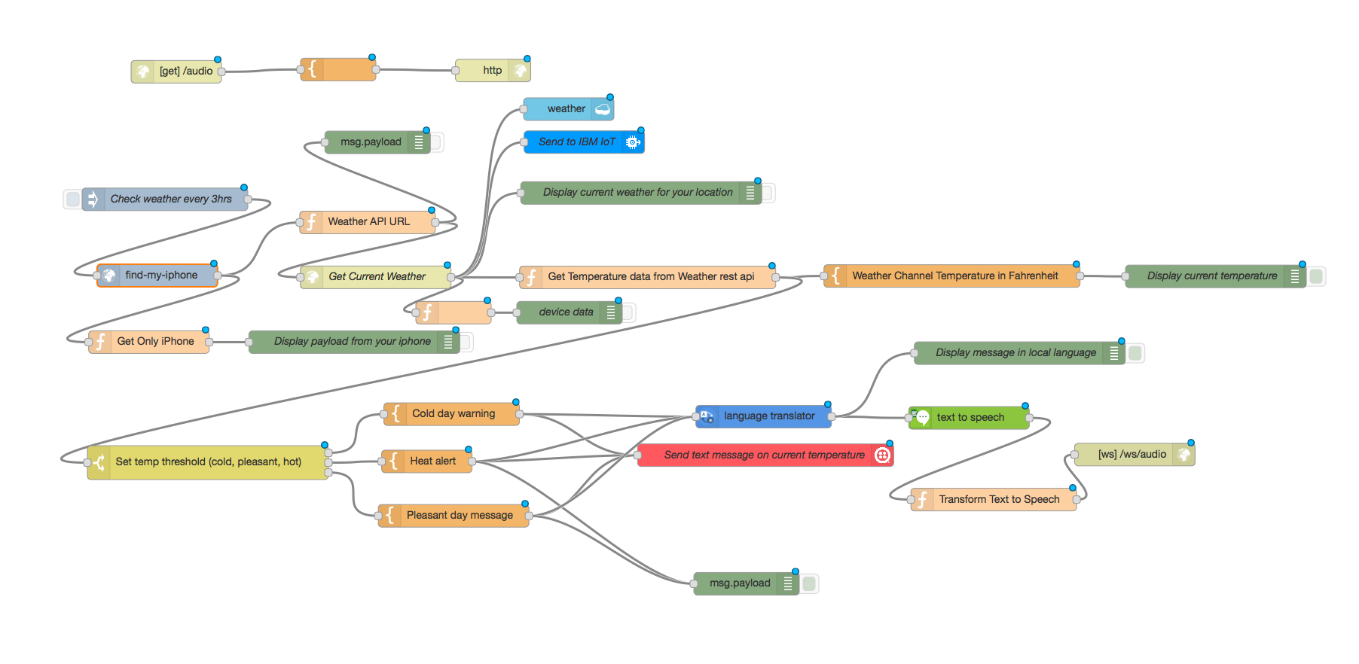

* Double click the “find-my-iphone” node. Provide your apple credentials. Click “Done”
* 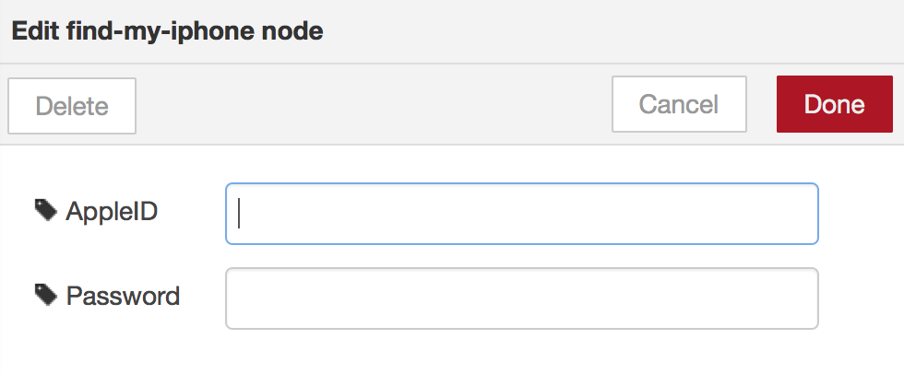
* Double click the “Get Current Weather” node. Check “Use basic authentication” box and update the Weather Services username and password. You can obtain the weather services credentials from the Bluemix app console page. See screenshots below.

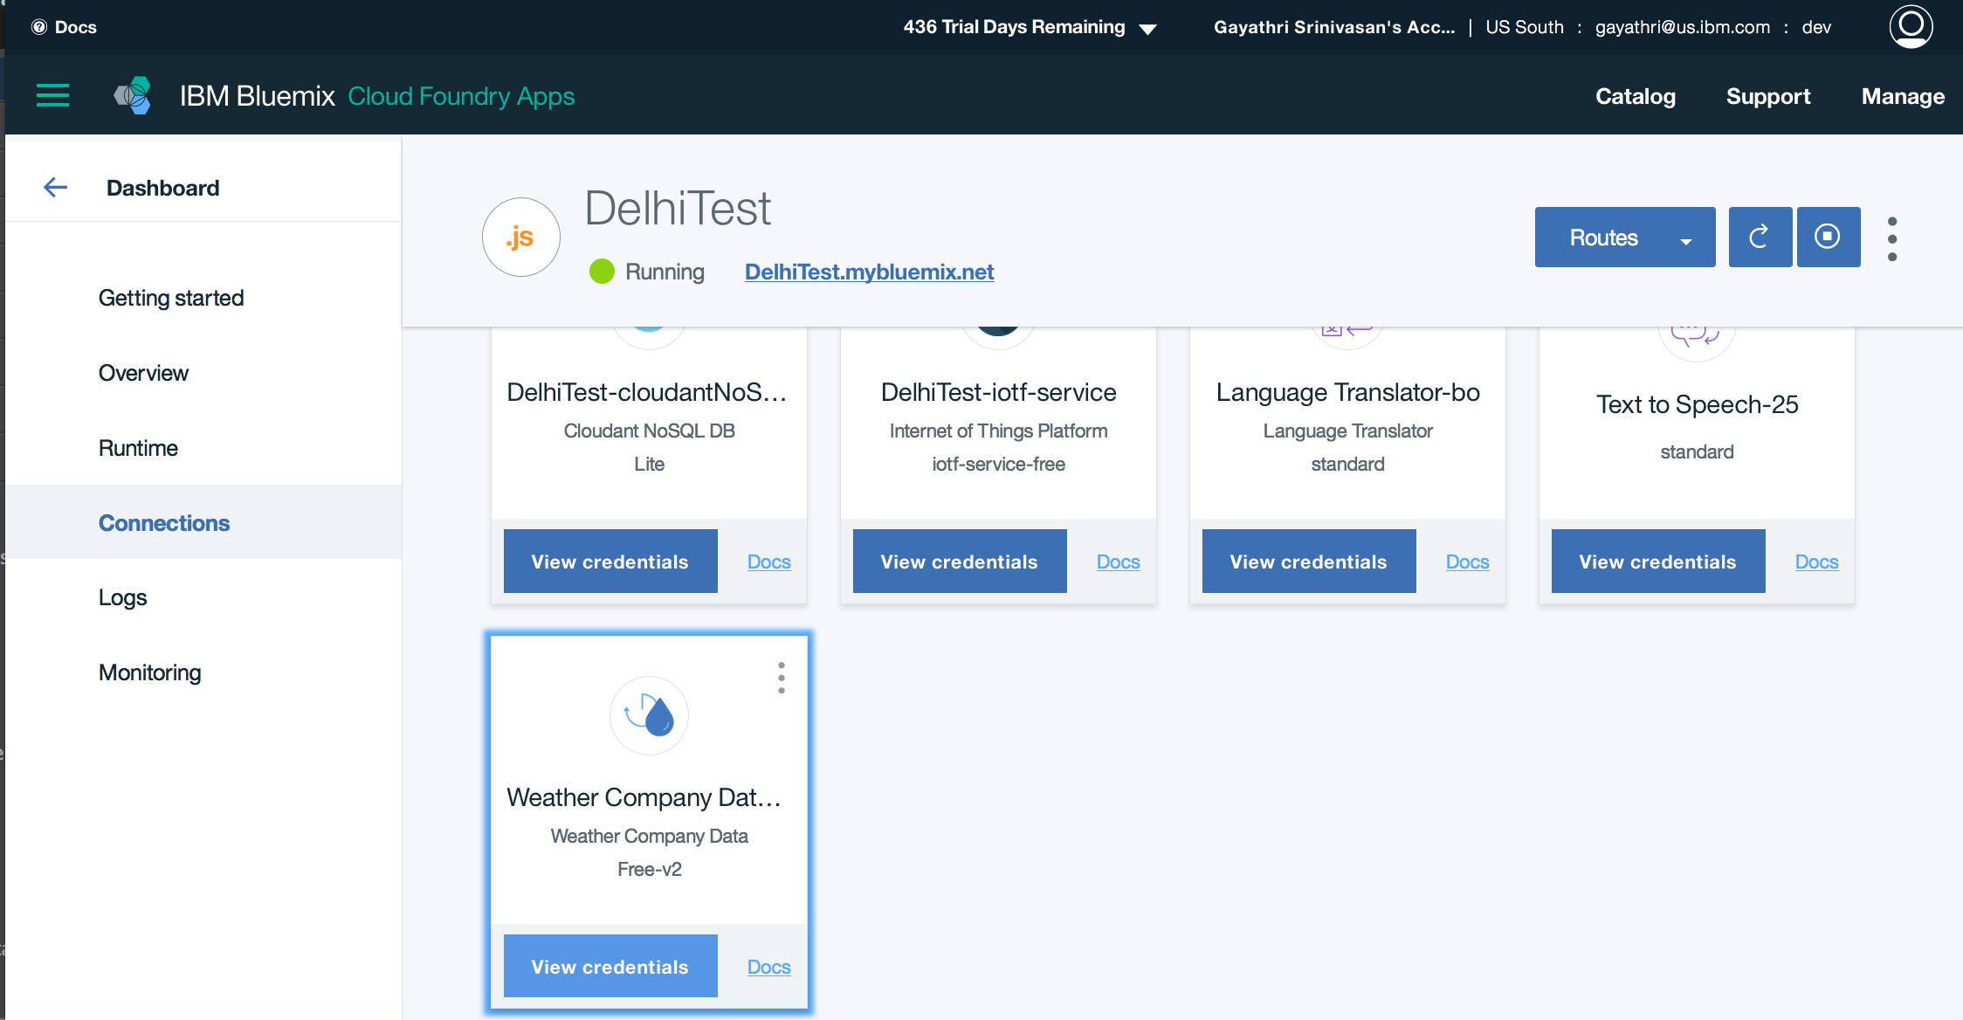

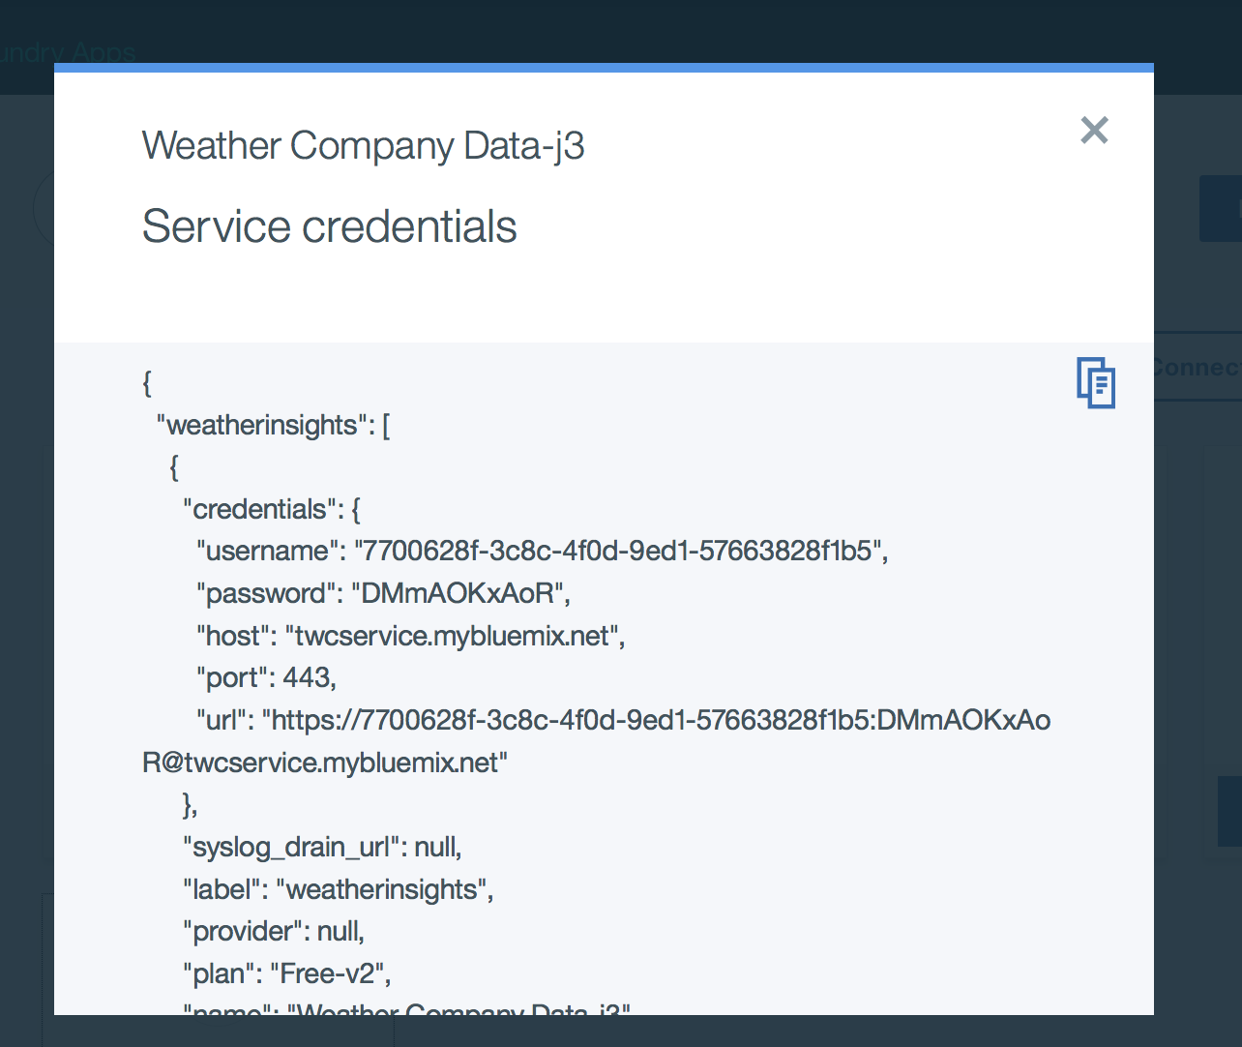

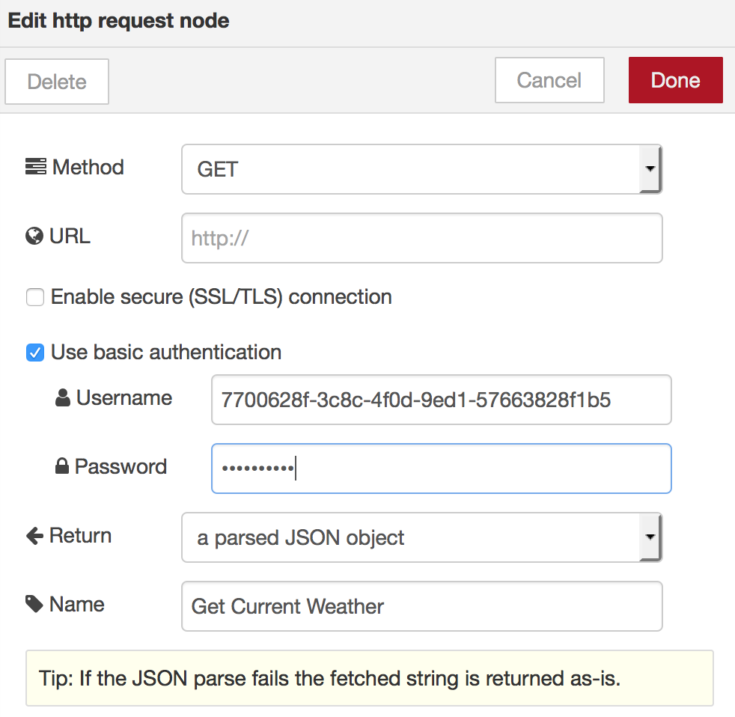

* Click “Done”
* Double click the “Send text message on current temperature” node and update it with your Twilio details as in the previous lab.
* Click Done
* Click Deploy
* Click the box to the left of the “Check weather every 3hrs” node to trigger the flow. You should get a text message and also see relevant details on your debug panel.

