**Send Text Alerts:**

* Go to twilio.com and setup a free account.
* Go to your Node-Red editor and copy and import this flow

[{"id":"38cfd08e.95f438","type":"ibmiot in","z":"5b951349.5f9094","authentication":"quickstart","apiKey":"","inputType":"evt","deviceId":"65bd0a4b6347","applicationId":"","deviceType":"+","eventType":"+","commandType":"","format":"json","name":"IBM IoT App In","service":"quickstart","allDevices":false,"allApplications":false,"allDeviceTypes":true,"allEvents":true,"allCommands":false,"allFormats":false,"x":154,"y":318,"wires":[["3cf76202.0aed76","319d5184.15b5a6","287381e3.1bcb86","24ad7d8c.df16d2"]]},{"id":"56e99b44.79351c","type":"function","z":"5b951349.5f9094","name":"temp","func":"return {payload:msg.payload.d.temp};","outputs":1,"x":344,"y":318,"wires":[["83d2859e.a03928","320a44b9.0af7b4"]]},{"id":"83d2859e.a03928","type":"switch","z":"5b951349.5f9094","name":"temp thresh","property":"payload","rules":[{"t":"lte","v":40,"v2":null},{"t":"gt","v":40,"v2":null}],"checkall":"true","outputs":2,"x":504,"y":318,"wires":[["7fa05d4d.926c64"],["3fd4241a.c964ec"]]},{"id":"512f0fd8.92fc68","type":"debug","z":"5b951349.5f9094","name":"cpu status","active":true,"complete":"false","x":907.3333435058594,"y":294.66668701171875,"wires":[]},{"id":"3cf76202.0aed76","type":"debug","z":"5b951349.5f9094","name":"device data","active":false,"console":"false","complete":"true","x":159.99996948242188,"y":408,"wires":[]},{"id":"7fa05d4d.926c64","type":"template","z":"5b951349.5f9094","name":"safe","fieldType":"msg","syntax":"mustache","template":"Temperature ({{payload}}) within safe limits","x":664,"y":298,"wires":[["d49219a5.f848f8"]]},{"id":"3fd4241a.c964ec","type":"template","z":"5b951349.5f9094","name":"danger","template":"Temperature ({{payload}}) critical","x":672.3333435058594,"y":371.3333435058594,"wires":[["d49219a5.f848f8","f6d57244.d72ff"]]},{"id":"968a7336.c541","type":"comment","z":"5b951349.5f9094","name":"Temperature Monitor","info":"","x":164,"y":218,"wires":[]},{"id":"2674deb2.ce461a","type":"comment","z":"5b951349.5f9094","name":"Configure source","info":"","x":154,"y":278,"wires":[]},{"id":"320a44b9.0af7b4","type":"ui_gauge","z":"5b951349.5f9094","name":"Temperature","group":"2514bb7e.085e3c","order":0,"width":"3","height":"3","gtype":"gage","title":"Gauge","label":"units","format":"{{value}}","min":0,"max":"100","colors":["#00b500","#e6e600","#ca3838"],"seg1":"","seg2":"","x":579.8332824707031,"y":217.99996948242188,"wires":[]},{"id":"319d5184.15b5a6","type":"function","z":"5b951349.5f9094","name":"Humidity","func":"return {payload:msg.payload.d.humidity};","outputs":1,"noerr":0,"x":338.9999694824219,"y":254.66665649414062,"wires":[["862e84a4.77fc68"]]},{"id":"287381e3.1bcb86","type":"function","z":"5b951349.5f9094","name":"Object Temperature","func":"return {payload:msg.payload.d.objectTemp};","outputs":1,"noerr":0,"x":347.3333435058594,"y":177.99999237060547,"wires":[["bc452ff8.e34768"]]},{"id":"bc452ff8.e34768","type":"ui_gauge","z":"5b951349.5f9094","name":"Object Temperature","group":"2514bb7e.085e3c","order":0,"width":"3","height":"3","gtype":"gage","title":"Gauge","label":"°C","format":"{{value}}","min":0,"max":"100","colors":["#00b500","#e6e600","#ca3838"],"seg1":"","seg2":"","x":598.9999694824219,"y":122.99999237060547,"wires":[]},{"id":"862e84a4.77fc68","type":"ui_gauge","z":"5b951349.5f9094","name":"Humidity","group":"2514bb7e.085e3c","order":0,"width":"3","height":"3","gtype":"gage","title":"Gauge","label":"%","format":"{{value}}","min":0,"max":"100","colors":["#00b500","#e6e600","#ca3838"],"seg1":"","seg2":"","x":565.6666564941406,"y":171.33333587646484,"wires":[]},{"id":"d49219a5.f848f8","type":"watson-translator","z":"5b951349.5f9094","name":"","action":"translate","basemodel":"ar-en","domain":"conversational","srclang":"en","destlang":"es","password":"","custom":"","domainhidden":"conversational","srclanghidden":"en","destlanghidden":"es","basemodelhidden":"","customhidden":"","filetype":"forcedglossary","trainid":"","lgparams2":true,"ldparamshidden2":"true","x":841.4999694824219,"y":346.3333435058594,"wires":[["512f0fd8.92fc68","daa74092.35547"]]},{"id":"a1b060b4.c21588","type":"http in","z":"5b951349.5f9094","name":"","url":"/audio","method":"get","swaggerDoc":"","x":130.66665649414062,"y":566.0000076293945,"wires":[["fce91864.a82b18"]]},{"id":"fab4d431.aa5ac8","type":"http response","z":"5b951349.5f9094","name":"","x":551.2121448516846,"y":564.2726936340332,"wires":[]},{"id":"fce91864.a82b18","type":"template","z":"5b951349.5f9094","name":"","field":"payload","fieldType":"msg","syntax":"mustache","template":"<!DOCTYPE html>\n<html>\n<head>\n <title>IBM Watson - Text To Speech</title>\n <script src=\"https://ajax.googleapis.com/ajax/libs/jquery/2.1.4/jquery.min.js\"></script>\n \n <script type=\"text/javascript\">\n var socketaddy = \"ws://\" + window.location.host + \"/ws/audio\";\n\n $(document).ready(function(){\n var output = document.getElementById('output')\n $('#output').on('playing', function () {\n $('#text').text('Playing audio.')\n \n });\n $('#output').on('ended', function () {\n $('#text').text('Waiting for audio...')\n \n });\n sock = new WebSocket(socketaddy);\n sock.onopen = function(){\n $('#text').text('Waiting for audio...');\n console.log(\"Connected websocket\");\n };\n sock.onerror = function(){ \n console.log(\"Websocket error\"); \n };\n sock.onclose = function () {\n $('#text').text('Not connected. Refresh the page?')\n }\n sock.onmessage = function(evt){\n console.log(\"Websocket message\", evt); \n output.src = window.URL.createObjectURL(evt.data);\n output.play();\n };\n });\n </script>\n \n</head>\n<body style=\"font-size: 56px; font-family: helvetica; text-align: center; margin-top: 100px;\">\n <div id=\"text\">Connecting...</div>\n <audio id=\"output\"></audio>\n</body>\n</html>","x":345.6666564941406,"y":562.9999771118164,"wires":[["fab4d431.aa5ac8"]]},{"id":"daa74092.35547","type":"watson-text-to-speech","z":"5b951349.5f9094","name":"","lang":"es-ES","langhidden":"es-ES","voice":"es-ES_LauraVoice","voicehidden":"","format":"audio/wav","password":"","x":864,"y":410.99999237060547,"wires":[["cd8323bd.a800a8"]]},{"id":"f01069ab.fa62a","type":"websocket out","z":"5b951349.5f9094","name":"","server":"b1117a4b.d507d","client":"","x":1068.0909423828125,"y":383.7272262573242,"wires":[]},{"id":"cd8323bd.a800a8","type":"function","z":"5b951349.5f9094","name":"Transform Text to Speech","func":"msg.payload = msg.speech;\nreturn msg;","outputs":1,"noerr":0,"x":968.8182373046875,"y":485.5453414916992,"wires":[["f01069ab.fa62a"]]},{"id":"24ad7d8c.df16d2","type":"delay","z":"5b951349.5f9094","name":"","pauseType":"rate","timeout":"5","timeoutUnits":"seconds","rate":"1","nbRateUnits":"10","rateUnits":"second","randomFirst":"1","randomLast":"5","randomUnits":"seconds","drop":true,"x":326.3333435058594,"y":387.5,"wires":[["56e99b44.79351c"]]},{"id":"f6d57244.d72ff","type":"twilio out","z":"5b951349.5f9094","service":"_ext_","twilio":"6223a815.16ee4","from":"","number":"","name":"Send Text Alert","x":697,"y":477.99999237060547,"wires":[]},{"id":"2514bb7e.085e3c","type":"ui_group","z":"","name":"Simulated Sensor Readings","tab":"7cdbf1bd.089bc","disp":true,"width":"6"},{"id":"b1117a4b.d507d","type":"websocket-listener","path":"/ws/audio","wholemsg":"false"},{"id":"6223a815.16ee4","type":"twilio-api","z":"","sid":"","from":"","name":"Send Text Alert"},{"id":"7cdbf1bd.089bc","type":"ui_tab","z":"","name":"Home","icon":"dashboard"}]

* Go to ibm.biz/iotsensor on a separate browser tab. Copy the device ID.
* Switch back to the Node-Red editor
* Double click the “IBM IoT App in” node. Paste the device ID.
* Double click the “Send Text Alert” node. Update the “Service” as an “External Service” from the drop down menu. Provide your phone number to receive text alert in the “SMS to” field.

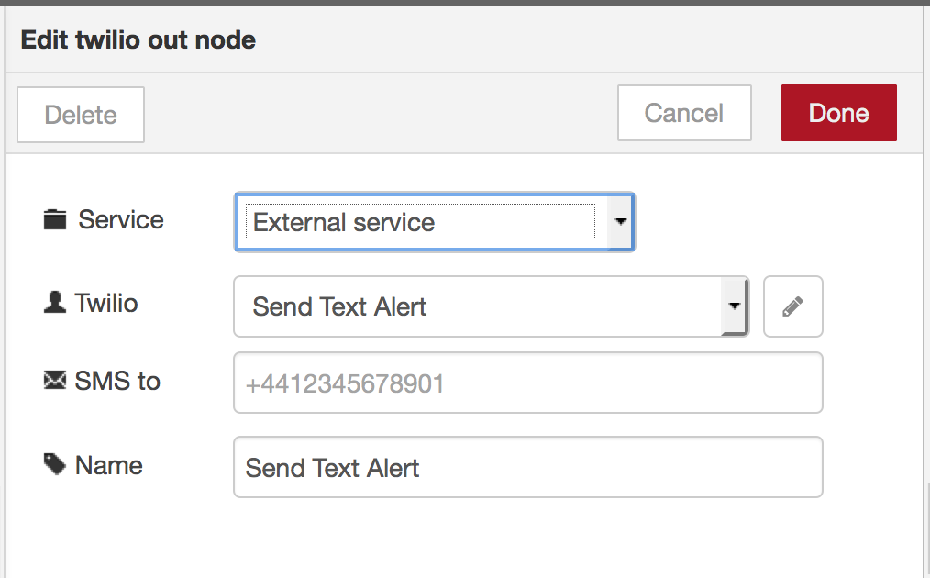

* Clock on the edit button next to the Twilio field. It should take you to this popup.

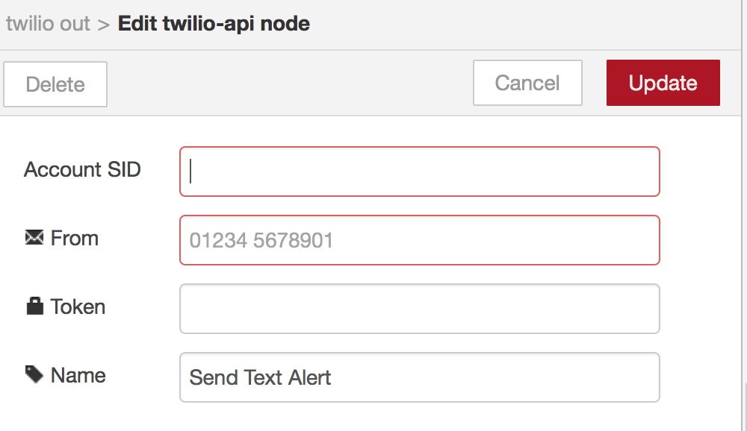

* Provide your Twilio account SID, Token and Phone number.
* Click “Update” and “Done” and “Deploy”
* If your temperature goes to the danger level, you should now get a text message.