PROJECT REPORT
on

Employee Turnover Prediction

SUBMITTED IN THE PARTIAL FULFILMENT OF THE REQUIREMENT FOR THE AWARD OF THE DEGREE OF
BACHELOR OF TECHNOLOGY
IN

COMPUTER SCIENCE & ARTIFICIAL INTELLIGENCE



SUBMITTED TO:- SUBMITTED BY:-
Dr .Ridhi Kappor Himanshu vyas
Associate Professor 12201159
Department of CSE B.Tech( Cs&Ai)

DEPARTMENT OF COMPUTER SCIENCE AND ENGINEERING
DAV UNIVERSITY
JALANDHAR-PATHANKOT NATIONAL HIGHWAY, NH 44,

ABSTRACT
Employee turnover is a major concern for organizations, as the loss of skilled employees leads to increased recruitment costs, reduced productivity, and disruptions in workflow. Predicting employee turnover in advance can help organizations take preventive actions, design better retention strategies, and improve overall workforce stability. This project focuses on developing a Machine Learning–based Employee Turnover Prediction System that analyzes historical HR data to identify employees who are likely to leave the organization.
The system uses key employee attributes such as satisfaction level, last evaluation score, number of projects, average monthly working hours, time spent in the company, promotion history, and work-related factors to train predictive models. Multiple machine learning algorithms—including Logistic Regression, Decision Tree, Random Forest, and others—are applied and evaluated to identify the most accurate model for classification. The dataset is preprocessed using techniques like feature scaling, encoding, and exploratory data analysis to ensure high-quality model performance.

ACKNOWEDGEMENT
I would like to express my sincere gratitude to my project guide, Dr Ridhi Kapoor, for their valuable guidance, constructive feedback, and continuous support throughout the duration of this project. I am also thankful to Dr Rahul Hans and the Department of Engineering for providing the necessary resources and an encouraging academic environment.

My appreciation extends to all faculty members and classmates whose suggestions and cooperation helped strengthen the quality of this work. Lastly, I am deeply grateful to my family for their constant encouragement and support, which motivated me to complete this project successfully.

TABLE OF CONTENT

Sr.No | Content | Page No
1 | CHAPTER 1: INTRODUCTION | 6-9
 | 1.1 Problem Definition
 | 1.2 Introduction to Employee Turnover Prediction
 | 1.3 Scope and Objectives
 | 1.4 Existing System
 | 1.5Proposed System
 | 1.6 Feasibility Analysis
2 | CHAPTER 2: SYSTEM REQUIREMENTS & ANALYSIS | 10-13
 | 2.1 System Requirements (Hardware & Software)
 | 2.2 System Analysis
 | 2.3 Functional Requirements
 | 2.4 About the Current System
3 | CHAPTER 3: TECHNOLOGIES & TOOLS USED | 21-26
 | 3.1 HTML
 | 3.2 Tailwind CSS
 | 3.3 JavaScript
 | 3.4 ReactJS with Vite
 | 3.5 SQL (Authentication & Realtime/ Database)
 | 3.6 Python
 | 3.7 Additional Tools (Git, VS Code etc.
4 | CHAPTER 4: SYSTEM DESIGN | 27-30
 | 4.1 Introduction to System Design
 | 4.2 Objectives of System Design
 | 4.3 Initial Design / System Architecture Diagram
 | 4.4 Data Flow Diagrams (DFD)
 | 4.5 ER Diagram / Database Structure
 | 4.6 Use Case Diagram
5 | CHAPTER 5: MODULE DESCRIPTION | 8-10
 | 5.1 Home Module
 | 5.2 About Module
 | 5.3 Dashboard Module
 | 5.4 Department Module
 | CHAPTER 6: IMPLEMENTATION & TESTING
6 | 6.1 Steps to Achieve Objectives | 31-36
 | 6.2 Frontend Implementation
 | 6.3 Backend & Database Implementation
 | 6.4 Dataset Training
 | 6.5 Testing (Unit, Integration, UI Testing)
 | CHAPTER 7: FUTURE SCOPE
7 | 7.1 Future Scope of Employee Turnover prediction | 37-38
 | CHAPTER 8: CONCLUSION & REFERENCES
8 | 8.1 Conclusion | 39-40
 | 8.2 References

CHAPTER 1: INTRODUCTION
  - Introduction:

Employee turnover has become one of the most significant challenges faced by organizations globally, especially in today’s competitive and dynamic business environment. Every company invests considerable time, effort, and financial resources to hire, train, and develop skilled employees. When these employees leave the organization, either voluntarily or involuntarily, the company not only loses talent but also incurs substantial replacement costs, productivity disruptions, and operational inefficiencies. As a result, predicting employee turnover in advance has emerged as an essential requirement for organizations seeking to maintain workforce stability, improve job satisfaction, and enhance overall performance. With the growth of Artificial Intelligence (AI) and Machine Learning (ML), data-driven predictive models have proven highly effective in identifying patterns and factors that influence employees’ decisions to stay or leave.
Employee turnover prediction refers to the use of statistical and machine learning techniques to analyze historical HR data and forecast which employees are most likely to leave the organization in the near future. Traditionally, HR managers relied on manual observations, surveys, or interviews to understand employee dissatisfaction. However, these methods were subjective, time-consuming, and often inaccurate. Modern companies generate large amounts of structured data such as satisfaction levels, performance evaluations, number of projects, working hours, length of service, and salary details. These datasets can be analyzed using machine learning algorithms to uncover hidden trends and correlations that are not easily noticeable through traditional methods. By leveraging these insights, organizations can take proactive measures such as improving workplace conditions, revising compensation, optimizing workloads, or offering training and career development programs to retain valuable employees.
The rapid rise of data-driven HR analytics has transformed employee turnover prediction into a crucial decision-support tool. Machine learning models such as Logistic Regression, Decision Trees, Random Forest, Support Vector Machines (SVM), and Artificial Neural Networks (ANN) are commonly applied to classify employees into categories like "likely to stay" or "likely to leave." These models evaluate multiple parameters simultaneously and produce accurate predictions based on learned patterns. Among these, ensemble methods like Random Forest and Gradient Boosting are widely preferred due to their high accuracy, ability to handle large datasets, and resistance to overfitting. The use of deep learning models has further improved prediction capability, especially when dealing with complex, nonlinear employee behavior.
- Moreover, employee turnover prediction plays a strategic role in organizational planning. High turnover not only affects productivity but also impacts team morale, customer satisfaction, and long-term organizational growth. For industries such as IT, healthcare, retail, and manufacturing, where skilled labor is crucial, unexpected turnover can delay projects, reduce service quality, and damage company reputation. Predictive analytics helps organizations identify at-risk employees early, allowing HR teams to conduct timely interventions. For example, if the model identifies that employees with high workload and low satisfaction are more likely to leave, the organization can redesign roles, balance workloads, or initiate employee-friendly policies. Thus, predictive modeling becomes a vital tool for achieving sustainability, stability, and employee well-being.
- This project aims to develop a robust Employee Turnover Prediction system using machine learning algorithms to accurately classify employees’ turnover intentions. The model is trained using a dataset that includes important attributes such as satisfaction level, last evaluation score, number of projects handled, average monthly working hours, time spent at the company, work accidents, promotion history, and other relevant factors. By preprocessing the data, selecting significant features, visualizing patterns, and training multiple ML models, the project seeks to identify the best algorithm that offers maximum accuracy in predicting turnover.
- In addition, the project not only focuses on building a predictive model but also emphasizes the interpretation of data patterns. Understanding why employees leave is equally important as predicting who might leave. Therefore, the project includes exploratory data analysis (EDA), correlation studies, and interpretation of feature importance to provide actionable insights for HR managers and organizations.
- In conclusion, employee turnover prediction is a modern and highly valuable application of machine learning in the domain of Human Resource Management (HRM). By integrating AI-based prediction models with HR decision-making, organizations can improve employee retention, reduce hiring costs, and create a more stable and productive workforce. This project contributes to this goal by designing an accurate, efficient, and scalable machine learning system capable of forecasting employee turnover with significant precision.

1.2 PROBLEM DEFINITION:
Employee turnover has become a critical issue for organizations, especially in industries where skilled and experienced employees are essential for maintaining productivity and achieving business goals. High turnover not only leads to increased recruitment and training costs but also negatively impacts team performance, organizational stability, and long-term growth. Traditional HR practices rely heavily on manual methods such as surveys, interviews, and general observations to identify employees who may leave the company. These methods are often inaccurate, subjective, and incapable of analyzing large volumes of employee-related data. As a result, organizations struggle to take timely and effective action to retain valuable employees.
The main problem addressed in this project is the lack of an accurate and automated system to predict employee turnover using data-driven approaches. Companies generate extensive HR data, but without analytical tools, this data remains underutilized. There is a need for a machine learning-based solution that can analyze multiple factors such as satisfaction level, performance evaluation, workload, promotions, working hours, and other relevant attributes to accurately predict whether an employee is likely to leave the organization.
Therefore, the problem can be formally defined as:
“To develop an intelligent machine learning model that can analyze historical employee data and accurately predict the likelihood of employee turnover, enabling organizations to take proactive measures to retain employees and improve workforce management.”
The system must address the following challenges:
- Identifying key factors that influence employee turnover from a multidimensional dataset.
- Handling diverse and complex data, including numerical, categorical, and potentially imbalanced classes.
- Building a robust classification model that can predict employee turnover with high accuracy and minimal error.
- Providing interpretable insights so HR managers can understand the reasons behind predicted turnover risk.
- Ensuring scalability, so the model can be applied to different organizations or datasets.
By solving this problem, organizations will be able to reduce turnover rates, optimize HR strategies, improve employee satisfaction, and minimize financial losses associated with unexpected employee exits.

1.3 SCOPE AND OBJECTIVE:
The primary objective of this project is to design and develop a machine learning-based predictive system capable of accurately forecasting employee turnover. This system aims to support organizations in making data-driven decisions to improve employee retention and overall workforce stability. The major objectives include:
- To analyze historical HR data and identify key factors that contribute to employee turnover, such as satisfaction level, performance evaluation, working hours, promotions, and workload.
- To preprocess and prepare the dataset by handling missing values, encoding categorical features, normalizing data, and addressing class imbalance to ensure high-quality model training.
- To apply and compare multiple machine learning algorithms such as Logistic Regression, Decision Trees, Random Forest, Support Vector Machine (SVM), and Neural Networks to determine the most accurate model.
- To build a predictive classification model that can accurately determine whether an employee is likely to stay or leave the organization.
- To evaluate the performance of models using metrics like accuracy, precision, recall, F1-score, and confusion matrix to ensure reliability and robustness.
- To interpret and visualize feature importance, correlations, and data patterns to help HR professionals understand critical turnover drivers.
- To develop an easy-to-use system interface (if included) that can allow HR managers to input employee data and obtain turnover predictions in real-time.
- To provide actionable insights that can assist organizations in designing effective retention strategies and improving employee satisfaction

The scope of this project covers the design, development, analysis, and evaluation of a predictive model for employee turnover using machine learning techniques. The project focuses on how data-driven HR analytics can help organizations retain their workforce and minimize operational losses caused by high turnover. The scope includes the following key areas:
- Data Collection & Exploration:
The project uses a structured employee dataset containing attributes such as satisfaction level, last evaluation score, number of projects, average monthly hours, time at company, accidents, promotions, and department details. It includes thorough data understanding and exploratory data analysis (EDA).
- Data Preprocessing & Feature Engineering:
Cleaning the dataset, handling missing or inconsistent data, converting categorical attributes into numerical form, scaling features, and selecting significant variables that impact turnover prediction.
- Machine Learning Model Development:
Implementing various ML algorithms and selecting the most effective model. The focus remains on classification models best suited for employee turnover prediction.
- Model Training, Testing, and Validation:
The dataset is divided into training and testing sets. The model’s performance is evaluated using standard metrics, ensuring accuracy and reliability.
- Visualization & Insights:
Generating visual representations such as histograms, heatmaps, bar charts, and correlation matrices to clearly understand patterns and relationships in the data.
- Prediction & Decision Support:
The system predicts whether an employee is at a high risk of leaving. HR departments can use these predictions to take preventive actions like counseling, workload adjustment, promotions, or policy changes.
- Model Deployment (Optional):
If included, the model may be integrated into a web interface or dashboard built using Flask, React, or similar technologies to allow real-time predictions.
- Limitations:
The project focuses on structured datasets and does not include text-based employee feedback, emails, or unstructured data. Predictions are probabilistic and depend heavily on dataset quality.
- Future Scope:
The system can be extended to include deep learning models, real-time HR analytics dashboards, sentiment analysis from employee reviews, and integration with HR management software.

1.4 Existing System:
In most organizations, the existing system used to monitor and manage employee turnover is largely manual, reactive, and based on intuition rather than data-driven insights. Human Resource (HR) departments traditionally rely on periodic performance reviews, exit interviews, employee surveys, and supervisors’ observations to understand the reasons behind employee dissatisfaction and resignations. While these methods provide some insights, they are subjective, time-consuming, and often fail to detect early warning signs of employees intending to leave the organization.
The existing system primarily suffers from the following limitations:

1. Manual HR Monitoring
HR managers typically identify potential turnover risks through personal interactions, face-to-face discussions, or feedback forms. This approach depends heavily on the experience and judgment of HR personnel, which makes the process inconsistent and prone to human error. Employees often avoid openly explaining dissatisfaction, making manual detection difficult.

2. Lack of Predictive Capability
The traditional approach is reactive—organizations realize the turnover problem only after an employee has already resigned. There is no mechanism to predict turnover in advance. As a result, organizations fail to take timely preventive measures such as modifying workloads, improving work environment, or offering career growth opportunities.

3. Limited Use of HR Data
Although companies collect large amounts of employee data such as attendance, performance evaluations, project workloads, and salaries, this data is underutilized. Organizations rarely analyze these datasets to identify patterns or trends related to employee behavior. Most decisions rely on intuition instead of data-driven analysis.

4. Inefficient Communication Loop
Exit interviews, satisfaction surveys, and feedback sessions are often conducted infrequently or after the problem has occurred. The feedback is sometimes stored but not analyzed systematically. This results in delayed or ineffective decision-making, leading to repeated turnover issues.

5. No Centralized System
Most organizations lack a centralized digital platform that monitors employee satisfaction, performance trends, and workload distribution in real-time. Without such a system, it becomes difficult for the HR team to track high-risk employees and take corrective action.

6. High Cost of Turnover
The failure of the existing system to predict or prevent turnover leads to increased costs associated with recruitment, training, onboarding, productivity loss, and project delays. This financial impact is substantial, especially in industries with a high demand for skilled professionals.

7. Limited Scalability
Manual processes cannot scale well as the organization grows. More employees mean more data, more performance issues, and more HR interventions, making the system inefficient and unsustainable in the long run.

1.5 PROPOSED SYSTEM:

Key Features of the Proposed System

1. Automated Data Analysis
The system automatically processes and analyzes employee datasets, identifying important variables that influence turnover. This eliminates human subjectivity and ensures consistent, data-driven insights.

2. Machine Learning-Based Prediction
The core of the proposed system is a machine learning classification model. Algorithms such as Logistic Regression, Random Forest, Decision Tree, SVM, and Neural Networks are tested and compared to select the most accurate model. The chosen model predicts whether an employee is likely to stay or leave.

3. Feature Importance & Pattern Detection
The system highlights the contribution of each factor—like satisfaction level, average monthly working hours, and last evaluation score—towards turnover prediction. These insights help HR teams understand the root causes of employee exit trends.

4. Real-Time Prediction (Optional)
The system can be deployed as a web application using Flask/React, enabling HR managers to input an employee’s data and instantly receive a turnover prediction output.

5. Visualization Dashboard
Graphs, heatmaps, and charts are used to visualize relationships between variables and employee behavior. This makes the system more interactive and easy to understand for non-technical HR staff.

6. Data-Driven Decision Support
The system provides actionable insights that can assist organizations in developing effective retention strategies such as modifying workload, scheduling training programs, improving work culture, or adjusting compensation.

1.6 Feasibility Analysis

Feasibility analysis evaluates whether a proposed project is practical, achievable, and beneficial from various perspectives. For the Employee Turnover Prediction System, the feasibility analysis ensures that the system can be successfully developed, implemented, and maintained within the available resources and constraints. The feasibility study is conducted under three major categories: Technical Feasibility, Operational Feasibility, and Economic Feasibility.

1. Technical Feasibility
Technical feasibility examines whether the technology, tools, and technical resources required to develop the system are available and capable of supporting the proposed solution.

Availability of Tools and Technologies
The entire system can be developed using widely available technologies such as:
- Python programming language
- Machine learning libraries like Scikit-Learn, NumPy, Pandas, Matplotlib, Seaborn
- Jupyter Notebook or VS Code for model development
- Flask/React (optional) for deployment
These tools are open-source and do not require high investment.

Hardware Requirements
The project requires only a standard computer or laptop with:
- Minimum 8GB RAM
- Multi-core processor
- Sufficient storage for datasets and model files
These specifications are easily available in typical academic or organizational settings.

Dataset Availability
HR datasets required for employee turnover prediction are widely available, and synthetic or public datasets like the IBM HR Analytics Dataset can be used for development and testing.

Technical Expertise
Developers require knowledge of:
- Machine learning algorithms
- Data preprocessing
- Python programming
- Basic statistics and visualization
- Web development (for deployment)
These skills are common among CS & AI students, making the project technically feasible.

Conclusion (Technical Feasibility)
All the technologies and resources needed for the project are accessible, cost-effective, and easy to use. Hence, the project is technically feasible.

2. Operational Feasibility
Operational feasibility evaluates whether the proposed system will operate effectively within the existing organizational environment and whether users will accept and benefit from it.

User Acceptance
HR managers and organizational leaders will find the system highly beneficial because it provides:
- Early identification of employees likely to leave
- Better workforce planning
- Data-driven insights for decision-making
Since organizations are actively adopting data analytics, the system will be readily accepted.

Ease of Use
The system can be designed with a simple interface allowing HR staff to:
- Input employee details
- Get instant predictions
- View graphical insights
Minimal training is required, making it user-friendly.

Integration with Existing HR Processes
The system can seamlessly integrate with:
- Performance evaluation procedures
- Attendance tracking
- Employee satisfaction surveys
It complements existing HR practices rather than replacing them.

Operational Benefits
- Enhances employee retention strategies
- Reduces turnover rate
- Improves workplace satisfaction and productivity
- Saves time and manual effort

Conclusion (Operational Feasibility)
The system aligns well with HR workflows and offers significant operational advantages. Therefore, it is operationally feasible.

3. Economic Feasibility
Economic feasibility determines whether the project is financially viable and whether the benefits outweigh the costs.

Development Costs
The development cost is minimal because:
- Tools and software used (Python, ML libraries) are open-source
- No licensing fees or expensive software is required
- Only standard hardware is needed
This makes the project budget-friendly.

Implementation Costs
Implementation costs are also low:
- Deployment can be done on local servers or lightweight cloud platforms
- Maintenance costs are minimal
- No additional infrastructure investment is required

Cost-Benefit Analysis
Benefits include:
- Significant reduction in turnover-related costs
- Improved employee retention
- Enhanced productivity
- Better HR decision-making
- Reduced hiring and training expenses
These benefits significantly outweigh the low implementation costs.

Return on Investment (ROI)
Organizations will experience long-term savings by preventing unexpected resignations and ensuring workforce stability. Thus, the project provides high ROI.

CHAPTER 2: SYSTEM REQUIREMENTS & ANALYSIS
2.1 System Requirements (Hardware & Software):
The Employee Salary prediction is a web-based application designed to allow Admins to upload Salary prediction categories and detailed Salary predictions and allow Users to browse, share, rate, comment, and interact with the content. To develop and run such a system effectively, certain hardware and software requirements must be met. These requirements help ensure smooth performance, efficient processing, secure database operations, and responsive display across devices.
The system requires a stable internet connection along with a device capable of running modern browsers to access the platform. Since the project is built using ReactJS and Vite, supported by SQL and Cloudinary, the environment must be able to run updated software versions and modern JavaScript frameworks. Both development and deployment require dependable tools, libraries, and computing environments to ensure the platform performs reliably for both Admin and Users.
Hardware Requirements
Development Device: A computer with at least an Intel i3 processor and 8 GB RAM to efficiently run ReactJS and development tools.
User Devices: Any smartphone, tablet, or computer capable of running modern browsers, ensuring accessibility for all users.
Internet Connectivity: A stable connection is needed for loading Salary predictions, uploading images, and performing real-time database operations
Software Requirements
Operating System: Windows, Linux, or macOS to support development and deployment tasks.
Node.js & npm: Required for running ReactJS, installing dependencies, and building the project.
ReactJS with Vite: Used for creating a fast and interactive user interface with optimized performance.
SQL: Handles authentication, database operations, and real-time updates for user interaction.
Cloudinary: Stores and delivers Salary prediction images with high performance and automatic
optimization.
Tailwind CSS: Provides a responsive, utility-first design system for modern UI development.

2.2 System Analysis
System analysis focuses on understanding how the Employee Salary prediction functions, what problems it solves, how data flows between components, and how users interact with the system. Since the platform has two distinct roles—Admin and User—it is essential to analyse how each part of the system works and how they communicate with the database.
The analysis begins by identifying the main problems: difficulty in sharing Salary predictions systematically, inability to categorize information manually, and the absence of a digital platform where users can view, interact, and engage with Salary predictions in real-time. The system solves these by providing a structured platform with categories, image-supported Salary prediction uploads, ratings, and comments. Using modern technologies such as ReactJS and SQL ensures real-time operations and dynamic user experiences.
This platform incorporates a centralized data model where the Admin is the only person who can upload or add content, ensuring data accuracy and security. Users can interact with the content but cannot modify core data. The analysis also includes understanding performance needs, security requirements, access restrictions, and workflows.
System Structure
Admin Workflow: Admin adds categories and uploads related Salary predictions, ensuring accurate and controlled content.
User Workflow: Users can view, share, rate, and comment on Salary predictions, providing engagement and feedback.
Data Flow
Salary prediction Data Flow: Admin inputs Salary prediction details, stored in SQL, and displayed dynamically on the user interface.
Image Data Flow: Images are uploaded to Cloudinary, and the generated URL is linked with Salary prediction data.
Role Management
Admin Access Control: Only admin has the authority to add, edit, or delete Salary predictions, maintaining system integrity.
User Access Control: Users interact with Salary predictions but cannot modify the core content, ensuring data security.
Technology Analysis
Frontend Performance: ReactJS ensures fast navigation and dynamic content rendering.
Backend Reliability: SQL offers secure real-time data updates without manual server management.

2.3 Functional Requirements
Functional requirements describe what the system must do. They define the essential features and capabilities that the platform provides for both Admin and Users. Since this platform focuses on Salary prediction sharing, the requirement list is divided into two main role categories.
Admin Functional Requirements
Add Categories: Admin can create structured categories to organize Salary predictions efficiently.
Add Salary predictions: Admin uploads Salary predictions under specific categories along with images and details.
Edit & Delete Salary predictions: Admin can update or remove Salary predictions to maintain accuracy and relevancy.

2.4 About the Current System
The current system for managing and understanding employee turnover in most organizations is largely manual, experience-based, and reactive. HR departments rely on traditional methods such as employee surveys, performance reviews, face-to-face interviews, and exit interviews to evaluate employee satisfaction and detect turnover risks. Although these methods provide some information, they lack accuracy, consistency, and the ability to analyze large volumes of employee data.

1. Manual Monitoring Processes
HR managers typically observe employee behavior, collect feedback, and conduct meetings to identify dissatisfaction. This approach depends heavily on human judgment and varies from one HR professional to another, leading to inconsistent insights.

2. Reactive Problem Handling
In the existing system, issues are addressed after an employee decides to resign. Organizations do not have an effective mechanism to predict turnover in advance. As a result:
- Valuable employees leave unexpectedly
- Project schedules get disrupted
- Recruitment and training costs increase
The system reacts to problems instead of preventing them.

3. Underutilization of HR Data
Organizations collect large amounts of data such as:
- Performance scores
- Attendance
- Working hours
- Promotions
- Employee satisfaction surveys
However, most companies do not analyze this data systematically. Instead, decisions are made based on intuition rather than data-driven insights.

4. Limited Analytical Tools
The current system does not use machine learning or data analytics to understand hidden patterns behind turnover. Without analytical tools:
- Early warning signs are missed
- Correlations between factors (like workload and satisfaction) remain unknown
- HR teams cannot identify which employees are at high risk

5. Time-Consuming Processes
Traditional HR methods such as manual surveys, long interviews, and paperwork make turnover analysis slow and inefficient. This delays decision-making and prevents timely action.

6. Lack of Predictive Capability
The biggest limitation of the current system is its inability to predict future turnover. HR teams can only analyze past events or employee complaints. They do not have the capability to forecast:
- Who is likely to resign
- When an employee becomes dissatisfied
- What factors increase turnover probability

7. No Centralized Platform
Most organizations do not have a centralized platform connecting all employee-related data. Information is scattered across spreadsheets, attendance software, email records, and paper files. This makes it difficult to generate meaningful insights.

8. High Cost of Turnover
Because the current system cannot identify risks early, organizations face:
- Increased hiring costs
- Training and onboarding expenses
- Loss of skilled talent
- Reduced productivity
- Project delays
These issues show that the current system is inefficient and financially burdensome.

CHAPTER 3: TECHNOLOGIES & TOOLS USED


3.1 Tailwind CSS
Tailwind CSS is a modern utility-first CSS framework used to style theEmployee Salary prediction. Instead of writing lengthy custom CSS files, Tailwind offers pre-defined utility classes that allow developers to design user interfaces directly within the HTML or JSX structure. This makes styling faster, more consistent, and highly customizable.
The primary advantage of Tailwind CSS in this project is the ability to maintain a clean and responsive interface without the need for complex stylesheet management. Because the platform heavily relies on visually appealing Salary prediction presentations, Tailwind CSS plays a crucial role in shaping card layouts, spacing, typography, shadows, borders, and responsive design.
In traditional CSS, developers must write custom classes for margins, padding, colors, and spacing. Tailwind eliminates this overhead by providing ready-made classes like p-4, mt-6, rounded-xl, shadowlg, and grid-cols-3. This approach significantly speeds up development while ensuring visual consistency throughout the application.
For theEmployee Salary prediction, Tailwind CSS enhances the user experience by providing clean and aesthetically pleasing components. Salary prediction cards, navigation bars, rating indicators, and comment sections are styled using Tailwind classes. The framework’s grid and flexbox utilities enable smooth layout management, allowing multiple Salary prediction cards to adjust automatically depending on screen size.
Furthermore, Tailwind’s responsive utilities ensure that the platform works seamlessly across all devices. Classes such as md:grid-cols-2 or sm:text-lg allow content to adapt dynamically, ensuring readability and user-friendliness on smartphones and tablets.
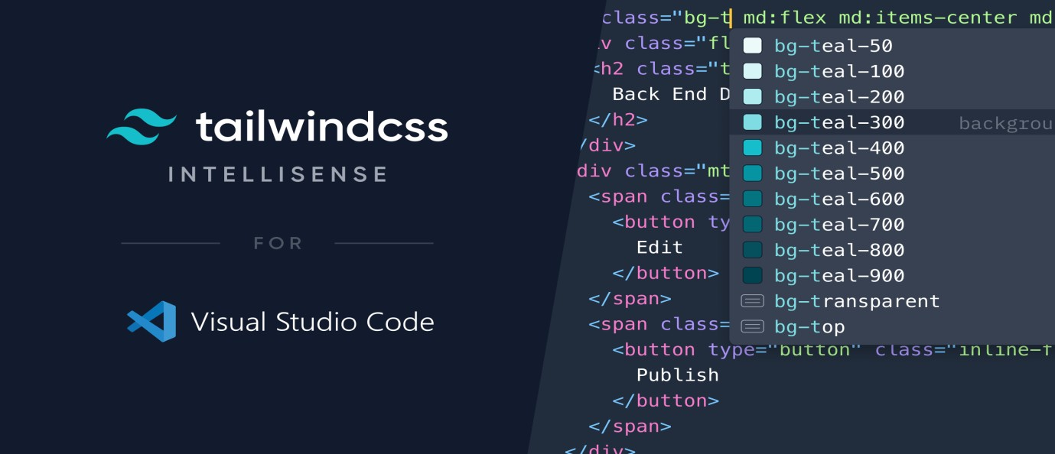

3.2 JavaScript
JavaScript is the core programming language powering the interactivity of theEmployee Salary prediction. It enables dynamic functionality such as sharing Salary predictions, rating, commenting, rendering content, and communicating with SQL. JavaScript forms the basis of modern web applications because of its ability to manipulate the Document Object Model (DOM), handle events, and process asynchronous operations.
In this project, JavaScript is primarily used within ReactJS components, but its fundamental logic applies throughout the platform. For example, when a user clicks the “Share Salary prediction” button, JavaScript handles the function that generates the appropriate link for WhatsApp, Twitter, or Facebook. Similarly, when a user submits a comment or rating, JavaScript processes the user input and stores it in the SQL database.
JavaScript works in harmony with HTML and Tailwind CSS to build dynamic UI components such as Salary prediction modals, category filters, star-rating interactions, and comment forms. The asynchronous nature of JavaScript enables real-time updates through SQL, ensuring that new comments or ratings appear immediately without refreshing the page.
Error handling, form validation, input management, and data formatting are also achieved through JavaScript functions. For example, when a user attempts to submit an empty comment, JavaScript ensures that the system displays an error message instead of accepting incomplete data.
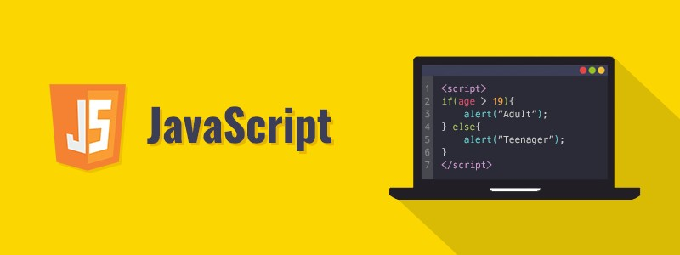

3.3 ReactJS with Vite
ReactJS is the primary frontend framework used to build theEmployee Salary prediction. It enables the creation of reusable components, efficient rendering, and smooth user interactions. Since Salary prediction platforms involve multiple UI elements such as Salary prediction lists, detail pages, comment sections, rating modules, and sharing options, ReactJS simplifies the development process by allowing each section to be built as a separate component.
React’s component-based architecture significantly improves maintainability and scalability. For instance, a Salary prediction card component can be reused throughout the platform—on the homepage, in categories, and on user profiles—without rewriting HTML or CSS. This reduces redundancy and ensures consistent design.
Vite is used as the development tool to bundle, build, and serve the application. Compared to traditional tools like Webpack, Vite offers much faster startup times and hot module replacement (HMR), which allows developers to instantly see changes in the browser. This enhances development efficiency and ensures a smoother workflow.
React’s use of Virtual DOM improves performance by minimizing unnecessary page reloads. When a user adds a comment or updates their rating, only the affected part of the interface updates. This creates a seamless and responsive experience.


VSCode(VisualStudioCode):
VS Code serves as the main code editor, offering extensions for React, Tailwind CSS, SQL, and debugging tools. Its integrated terminal allows developers to run npm commands, start the Vite server, and manage dependencies.
npm(NodePackageManager):
npm manages all project dependencies such as React, SQL, Tailwind CSS, and other libraries. It ensures proper installation, version control, and automatic updates.
BrowserDeveloperTools:
Chrome DevTools and Firefox developer tools assist in testing, debugging, and optimizing the interface. Developers can inspect UI elements, track network requests, and analyze performance issues.
These tools streamline the development process, support debugging, enable collaboration, and improve overall project quality.

CHAPTER 4: SYSTEM DESIGN

4.1 Introduction to System Design
System design is the process of translating project requirements into a structured blueprint that defines the architecture, components, data flow, and overall functioning of the system.
It ensures that the application is built in a systematic, maintainable, and scalable manner.
In this project, system design focuses on creating the internal structure of the Employee Salary prediction, where Admin manages categories and Salary predictions, while Users can view, share, comment, like, and rate Salary predictions.

4.2 Objectives of System Design
To define system architecture:Defines how the system’s frontend, backend, and database interact with each other.This ensures a proper structure for efficient communication between all components.
To improve system performance:Ensures the platform loads pages quickly, manages images smoothly, and handles a growing user base.Fast performance leads to a better user experience.
To reduce system complexity:Helps break the project into manageable modules like login, admin panel,Salary predictionview,andcomments.This makes development easier, cleaner, and less errorprone.
To ensure data accuracy and consistency:Defines how data will be stored and retrieved in SQLtoavoidduplicationormismatch.Accurate data makes the system reliable.
To enhance system security:Specifies methods like authentication, restricted admin access, and ensures protection from unauthorized access.
To support system scalability:Ensures the design can support more users, turnover predictions, and comments in future.A scalable system remains stable even as the platform grows.
To improve maintainability:Makes the platform easy to update, debug, and extend by organizing code properly.A maintainable system reduces future development cost.
To provide better user experience:Ensures the layout, flow, and interactions are simple and intuitive.Good design keeps users engaged with the platform.

4.3 Initial Design / System Architecture Diagram
Below is the explanation of the architecture for yourEmployee Salary prediction (SQL + React + Cloudinary).
Architecture Overview
The system follows a Client–Server Architecture where:
Frontend: React-based User Interface
Backend: Python +SqlLite
Dashboard: Accessible only by admin for managing categories and Salary predictions

Architecture Explanation Points
User Interface Layer (React JS): This layer contains all screens like Login, Home, Dashboard, Turnover prediction Details, about, etc.It interacts with flask using API calls.
Authentication Layer (SQL Lite): Handles user login, signup, session management, and admin rights.Ensures only authorized users enter the platform.
Database Layer (SQL Realtime Database): Stores category, Salary prediction details, comments, ratings, and user activities.Ensures fast reading and writing of real-time data.

CHAPTER 5: MODULE DESCRIPTION

5.1 Home Module
The Home Module provides users with an interactive landing page displaying featured Turnover predictions, categories, and recent uploads. It serves as the central navigation hub, guiding users toward all major functionalities of the platform.
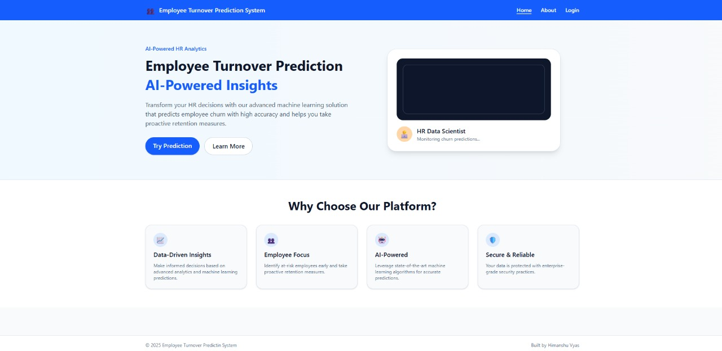

5.2 About Us Module
The About Us Module gives users an overview of the platform’s purpose, mission, and development background. It helps build trust by explaining the goal of creating a community-driven Salary prediction-sharing experience.

5.3 Turnover prediction Categories Module
The Salary prediction Categories Module displays all available food categories added by the admin. It allows users to explore Salary predictions more easily by browsing organized sections like breakfast, snacks, beverages, or desserts.
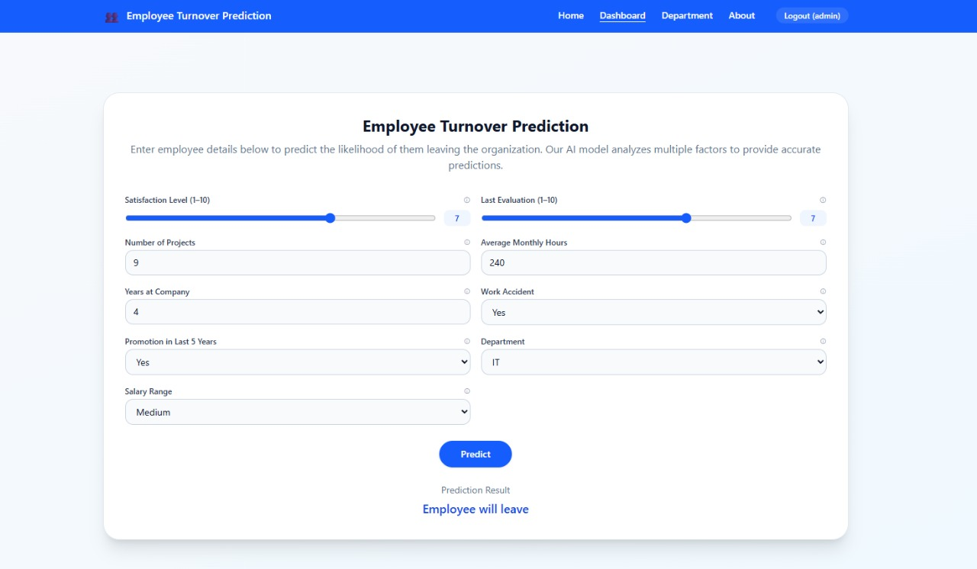

5.4 View Turnover prediction & Details Module
The View Salary prediction Module lets users open a specific Salary prediction and see complete details 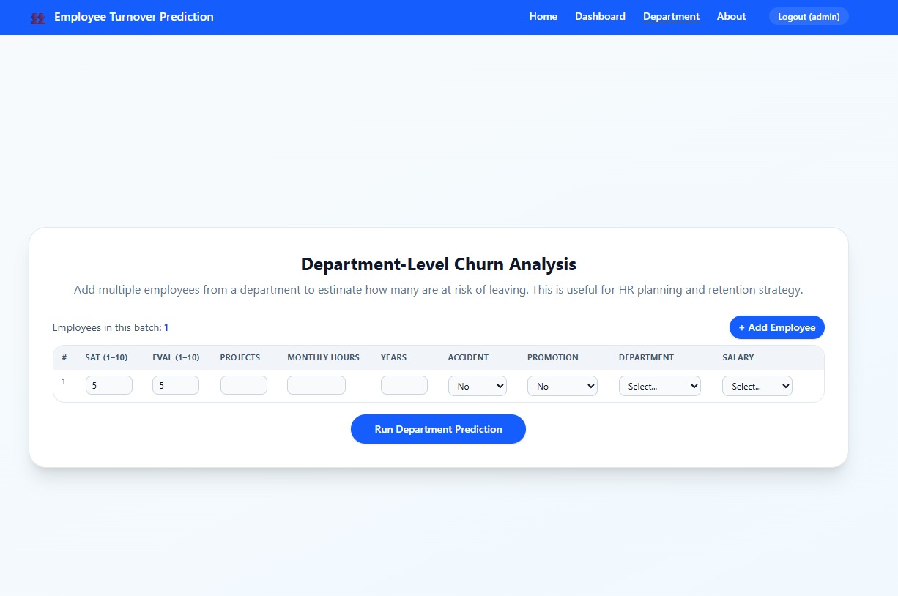

5.5 User Authentication Module (Login / Register)
The Authentication Module manages user registration and login using secure SQL authentication. It ensures that only legitimate users can share Salary predictions, comment, rate, and access personalized features.
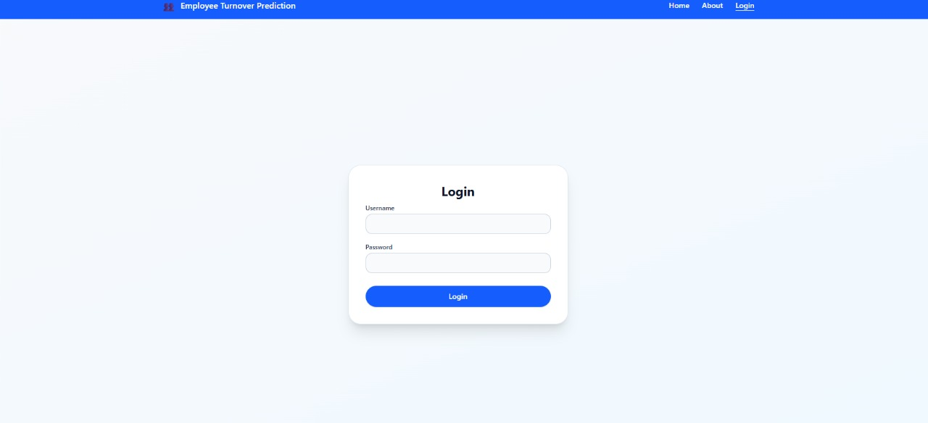

CHAPTER 6: IMPLEMENTATION & TESTING

6.1 Steps to Achieve Objectives
The implementation of the Turnover prediction System was carried out in a systematic manner to ensure the project objectives were successfully met. The primary goal was to develop a platform where users can browse, view, share, and interact with Turnover predictions .
Requirement Analysis:
The first phase involved gathering detailed functional and non-functional requirements. This helped in understanding the needs of both the admin and the users regarding Salary prediction viewing, sharing, rating, and authentication.
System Planning & Design:
This included creating system architecture, data flow diagrams, and ER diagrams. These diagrams provided a visual blueprint of how data flows between modules and how components interact within the system.
Frontend & Backend Setup:
After the design stage, frontend development using React and backend configuration using SQL Authentication and Database were initiated. The frontend ensured a smooth UI, while the backend maintained data integrity and secure login.
Module-wise Development:
Each module, such as category management, Turnover prediction display, rating system, and sharing, was implemented separately. This modular approach improved maintainability and debugging.
Testing & Debugging:
Continuous testing was done throughout development, focusing on unit testing of components and integration testing between modules. Errors were identified and resolved to create a stable system.

6.2 Frontend Implementation
The frontend of the Turnover prediction System was developed using React.js, chosen for its efficiency, modularity, and ability to build highly responsive user interfaces. React enabled the creation of reusable components that reduced development effort and made the system scalable for future enhancements. The goal of the frontend design was to provide a seamless experience where users could browse Salary predictions, view details, share content, rate dishes, and interact with the system effortlessly.
The user interface was carefully designed to ensure clarity, simplicity, and easy navigation. Clean color schemes, readable fonts, and clear layout structures were used to make the platform visually appealing. Special focus was placed on making the interface responsive so that users could access the system from desktops, tablets, or mobile devices without any display issues.
Navigation was managed using React Router, which allowed seamless transitions between different pages without reloading the entire website. The routing setup provided dedicated paths for major modules such as /login, /register, /categories, /Salary prediction, /add-Salary prediction, and /contact. This approach significantly improved user experience by ensuring quick transitions and allowing deep-linking, meaning users could directly open a specific Salary prediction page through a URL.
Dynamic data handling was one of the core strengths of the frontend. Turnover predictions, categories, comments, and user profile information were fetched in real time from SQL. Whenever a Salary prediction was added, updated, or deleted, the interface instantly reflected the changes without requiring manual refreshing. React Hooks such as useEffect and useState played an essential role in managing the data flow and updating the UI whenever new information was available from the database.
Form handling and validation were implemented thoroughly to maintain data quality and user security. All user input forms—including login, registration, add Salary prediction forms, comment submission, and contact forms—were built with controlled components to track real-time input changes.

Component-Based Structure:
Every screen, such as Home, Category List, Salary prediction Details, and Login, was built as an independent React component. This improved reusability and simplified updates or UI enhancements.
Routing and Navigation:
React Router was used for smooth page transitions without reloading the entire website. It provided specific routes for modules like /login, /category, /Salary prediction, and /contact.
Dynamic Rendering of Data:
Salary predictions, categories, and user details were fetched dynamically from SQL and rendered instantly. The frontend automatically updated the UI whenever new data was stored in the database.
Form Handling & Validation:
All user input forms—including login, registration, and comment forms—were equipped with proper validation rules to ensure accurate and safe data submission.

6.3 Backend & Database Implementation
The Employee Turnover Prediction System is developed using a modern full-stack architecture consisting of a machine learning backend and a user-friendly frontend interface. The system ensures fast prediction, smooth user interaction, and scalable deployment. The backend is deployed on Render, while the frontend is hosted on Vercel, allowing global accessibility and stable performance.

1. Backend Implementation
The backend of the system is built using Python and the Flask framework. It acts as the core engine of the project, performing data processing and generating machine learning predictions.

Key Backend Components
- Machine Learning Model
  - Trained using Scikit-Learn.
  - Saved using Pickle/Joblib.
  - Loaded during backend startup for fast prediction.
- REST API Endpoints
The main endpoint:
  - POST /predict
Accepts employee data in JSON format and returns turnover prediction.
- Data Processing Layer
  - Validates incoming data
  - Applies scaling/encoding (same as training phase)
  - Converts data to the format expected by the ML model
- Prediction Layer
  - Model predicts if the employee will stay or leave
  - Probability scores are also generated

Backend Deployment on Render
Render is used to deploy the backend server online for public access.

Backend Deployment Steps
- Push backend code to GitHub.
- Create a new Web Service on Render.
- Connect Render to the GitHub repository.
- Set environment settings (Python version, start command).
- Deploy the backend to generate a public API URL, for example:
- https://employee-turnover-backend.onrender.com/predict
- Use this URL in the frontend for API requests.

2. Frontend Implementation
The frontend is developed using React.js, providing a fast, clean, and interactive UI. It allows HR managers or users to enter employee details and view prediction results instantly.

Key Frontend Features
- Input Form
  - Fields like satisfaction level, evaluation score, number of projects, etc.
  - Validation to ensure correct data entry
- API Integration (Axios/Fetch)
  - Sends employee data to backend /predict API
  - Displays the returned prediction on UI
- User Interface
  - Built with React and TailwindCSS/Material UI
  - Simple, responsive, and professional design
- Output Section
  - Shows prediction: “Likely to Leave” or “Likely to Stay”
  - Displays probability score
  - Optional charts and data visualization

3. Frontend Deployment on Vercel
The frontend is deployed using Vercel, a fast hosting platform optimized for React applications.
- Configure build settings (usually auto-detected).
- Deploy the project to generate a public link, e.g.:
- https://employee-turnover-frontend.vercel.app
- Update the frontend .env or config to use the Render backend API URL.

4. Integration of Frontend and Backend
The frontend communicates with the backend through API calls:

Workflow
- User enters employee details
- Frontend creates a JSON request
- Sends to backend API using:
- axios.post("https://backend-onrender.com/predict", data)
- Backend processes input → applies ML model → generates prediction
- Response returned to the frontend
- UI displays the predicted result

.

6.5 Testing (Unit, Integration, UI Testing)
Unit Testing:
Individual components such as login, category display, and Turnover prediction card were tested separately to ensure they functioned correctly. This helped catch bugs early in the development process.
Integration Testing:
This testing verified how different modules worked together—for example, whether the Turnover prediction details page correctly fetched categories or whether user comments were stored and displayed properly.
User Interface Testing:
UI testing ensured that buttons, forms, navigation links, and input fields were fully functional on all devices. It also checked responsiveness on different screen sizes.
.
Overall System Stability:
Final testing showed that the system was secure, reliable, and ready for deployment. SQL authentication and security rules ensured data protection and controlled access.

CHAPTER 7: FUTURE SCOPE OF PROJECT
1.Expansion of Features:
More advanced Turnover prediction-sharing options can be added, such as private sharing, group sharing, and custom-Salary prediction-collections.
2.Mobile App Development:
A dedicated mobile app for Android and iOS can be created for faster Turnover prediction browsing .
Push notifications can alert users about newly added Salary predictions, comments, or trending data.

4.Social Media Integration Enhancement:
Additional platforms like Instagram, Pinterest, and Telegram can be integrated for wider sharing possibilities.
Users could directly import their Salary prediction photos or videos from social media into the platform.

8. Enhanced Admin Dashboard:
New analytics tools for admins can help track Turnover predictions .

9.Multi-Language Support:
The platform can support multiple languages to make Turnover predictions accessible to users
worldwide.

CHAPTER 8: CONCLUSION & REFERENCES

CONCLUSION
The Employee Turnover Prediction System successfully demonstrates the power of machine learning and data analytics in addressing one of the most critical challenges faced by modern organizations—employee retention. By analyzing historical HR data and identifying patterns in employee behavior, the system provides accurate predictions regarding whether an employee is likely to stay or leave. This enables HR departments to shift from traditional reactive approaches to a proactive strategy where turnover risks are identified early and preventive actions can be taken in time.
The project highlights how key factors such as satisfaction levels, performance evaluation scores, workload, promotions, and overall work environment can influence employee decisions. Using machine learning algorithms such as Logistic Regression, Random Forest, Decision Tree, and others, the model offers reliable results that support data-driven decision-making. The integration of data preprocessing, exploratory analysis, feature selection, and model evaluation ensures that the system is both robust and efficient.
The implementation of a user-friendly frontend, deployed on Vercel, combined with a scalable backend API hosted on Render, makes the system easily accessible and practical for real-world use. By providing instant predictions through a clean interface, the system bridges the gap between technical machine learning capabilities and everyday HR operations. The deployment architecture also ensures scalability, reliability, and effective handling of real-time prediction requests.
Overall, this project not only achieves its primary objective of predicting employee turnover but also demonstrates the practical application of artificial intelligence in Human Resource Management. It provides organizations with actionable insights that can significantly reduce turnover rates, minimize hiring and training costs, and improve workforce stability. The system forms a solid foundation for future enhancements such as incorporating deep learning techniques, sentiment analysis from employee feedback, real-time dashboards, and integration with HRMS platforms.
Thus, the project concludes that machine learning-driven turnover prediction is a powerful and essential tool for organizations aiming to enhance employee satisfaction, strengthen retention strategies, and improve overall organizational performance.

REFERENCES
1.React.js (Frontend Framework):
- React Official Website: https://react.dev
- React Documentation: https://react.dev/learn
2. JavaScript & Web Technologies:

