INSTRUCTIONS
Please read the instructions carefully before doing the questions.
- You can use materials in your computer, notebook and text book.
- You are NOT allowed to use any device to share data with others.
Beside the above conditions, students must follow the following requirements:
- The work must complete by using Visual Studio 2019
- The .NET Framework must be 3.5
- Create a folder named RollNo_Name_PRN292 (1) , e.g. 01245_LongNT_PRN292.
- THIS PART IS VERY IMPORTANT, PLEASE READ IT CAREFULLY AND FOLLOW THE INSTRUCTIONS.
- Create only one solution and three projects corresponding with three question below.
- You are given a database script (.sql file) in Zip file. Execute the script before doing these questions
- For Question related to webform, you have to create Web Application instead of Website.
- You are not allowed to use ObjectDataSource, SqlDataSource.
- Just one of above requirements is violated, your work will be considered as invalid.
On completion, submit the whole folder (1).

Question 1. (3 points)
You are asked to write a console application that includes a public Book class.
The Book class contains:
- Four private fields:
- string code
- string title
- DateTime year
- List<string> authors
and four public properties (Code, Title, Year, Authors) to get and set value for those private fields.
(1 point)
- The title of book must be cannot be blank.
So that, in setter of title, you must check the input value. If input value does not meet above condition, throw an exception.
(0.5 point)
- Define necessary constructors.
(0.5 point).
- Two public methods
string ToString() override the ToString() function of Object class and return the string contains Book’s information (include Code, Title, Year and list of the book’s authors) by the show in Figure below (0.5 point).
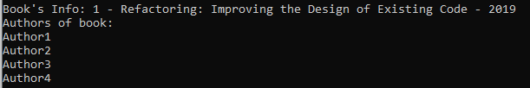
void AddAuthor(string AuthorName) to add AuthorName into list of string Authors. Note that, you must check that the AuthorName is present in Authors or not? If AuthorName already in Authors you need throw an exception and do not add AuthorName into Authors. (0.5 point)
Hint:
With the main function given, your code must have the same result as the Figure.
static void Main(string[] args)
{
try
{
Console.WriteLine("TC1:");
Book b1 = new Book(1, "", 2018);
Console.WriteLine(b1.ToString());
}
catch (Exception e)
{
Console.WriteLine(e.Message);
}

Console.WriteLine("\nTC2:");
Book b2 = new Book(1, "Refactoring: Improving the Design of Existing Code", 2019);
Console.WriteLine("Add Authors:");
while (true)
{
try
{
Console.WriteLine("Enter author's name (empty to stop):");
string s = Console.ReadLine();
if (s.Equals(string.Empty)) break;
b2.AddAuthor(s);
}
catch (Exception e)
{
Console.WriteLine(e.Message);
}
}

Console.WriteLine(b2.ToString());
Console.ReadLine();
}
The output should be the same as below
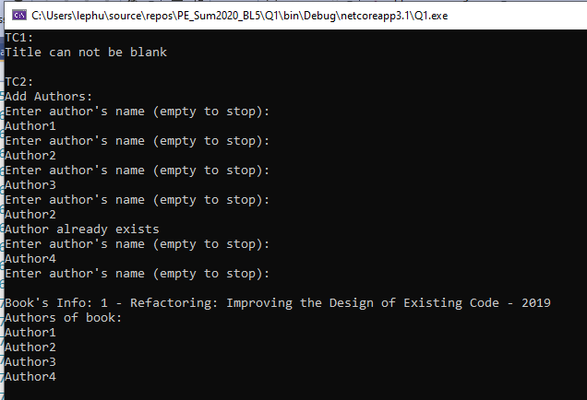

Question 2. (4 points)
You are asked to write a windows form application that allows users to show information of Book in given database.
(0 will be given to the work that not using database connection string in the file appsettings.json)
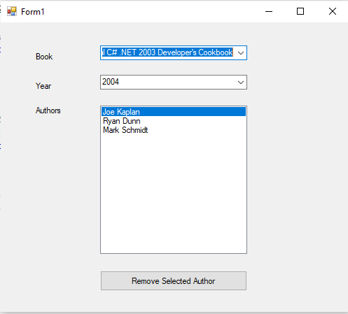

Figure 1 – Required form

- (0.5 point) The form is designed as shown in Figure 1, contains: three Labels, two ComboBox, one ListBox and one Button. The ComboBox must be set as DropdownList style.
- (1 point) List all book’s titles into the first ComboBox. The first item is selected by default.
List all integer from 2000 to 2010 into second ComboBox (these are static items).
- (1 point) Show information of selected book in the first ComboBox into the second ComboBox and ListBox below.
The year of selected book must be selected in second ComboBox.
List of authors of selected book must be loaded into the ListBox.
- (0.5 point) When user change the selected book in the first ComboBox, the data of second ComboBox and ListBox change accordingly.
- (1 point) User also can choose item in the ListBox and then click on the Button to remove this person from the book’s author list.
You must show the MessageBox to confirm the delete action like figure below.
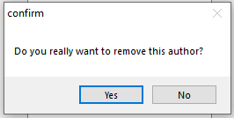

If user click on Yes, please change the data in database to perform this action.

Question 3. (3 points)
You are asked to write a Web application that show the list of Books in given database. (0 will be given to the work that not using database connection string in the file appsettings.json)
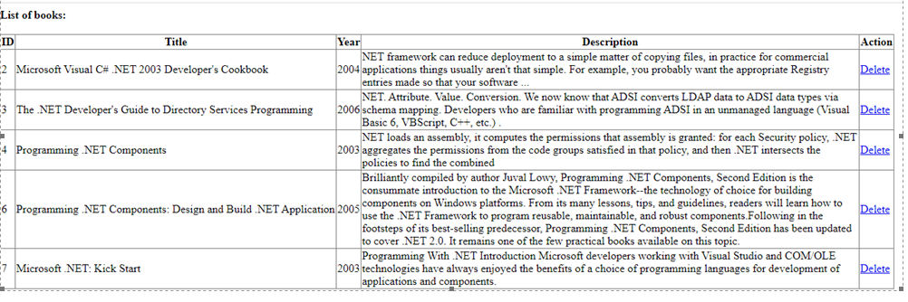

Figure 1 – “BookList” page
- The page has one page at url /Book/List and is designed as shown in Figure 1.
- (1 point) List of all books in database like Figure above.
- (1 point) Add the link “Delete” for each book.
- (1 point) When user click on link “Delete”, delete corresponding book from database and reload this page.

