**Assignment 4: Blocks World**

**Huy Nguyen, Toan Ly, Toan Nham (All contributed equally)**

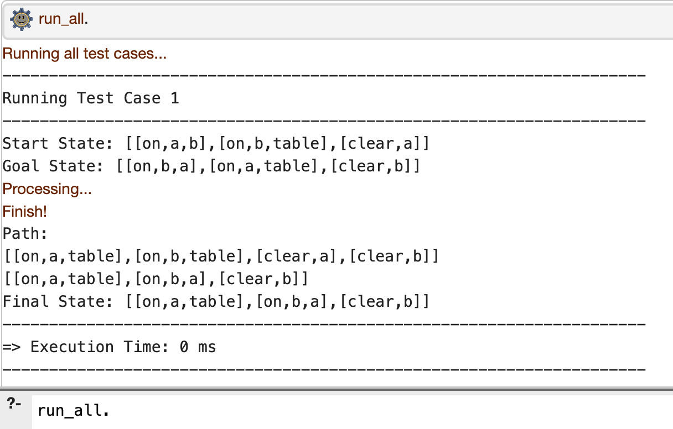

**Comment**: The states to the final solution are correct and optimal using minimal steps.

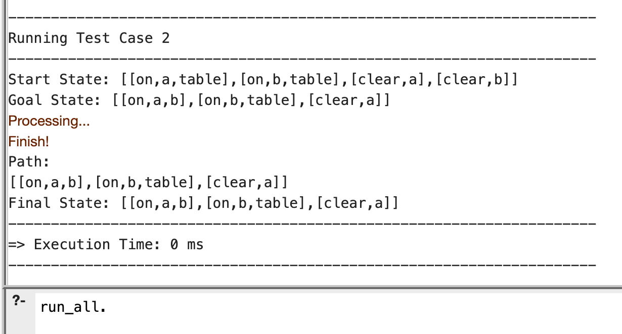

**Comment:** The path is straightforward and correct to reach to the final state

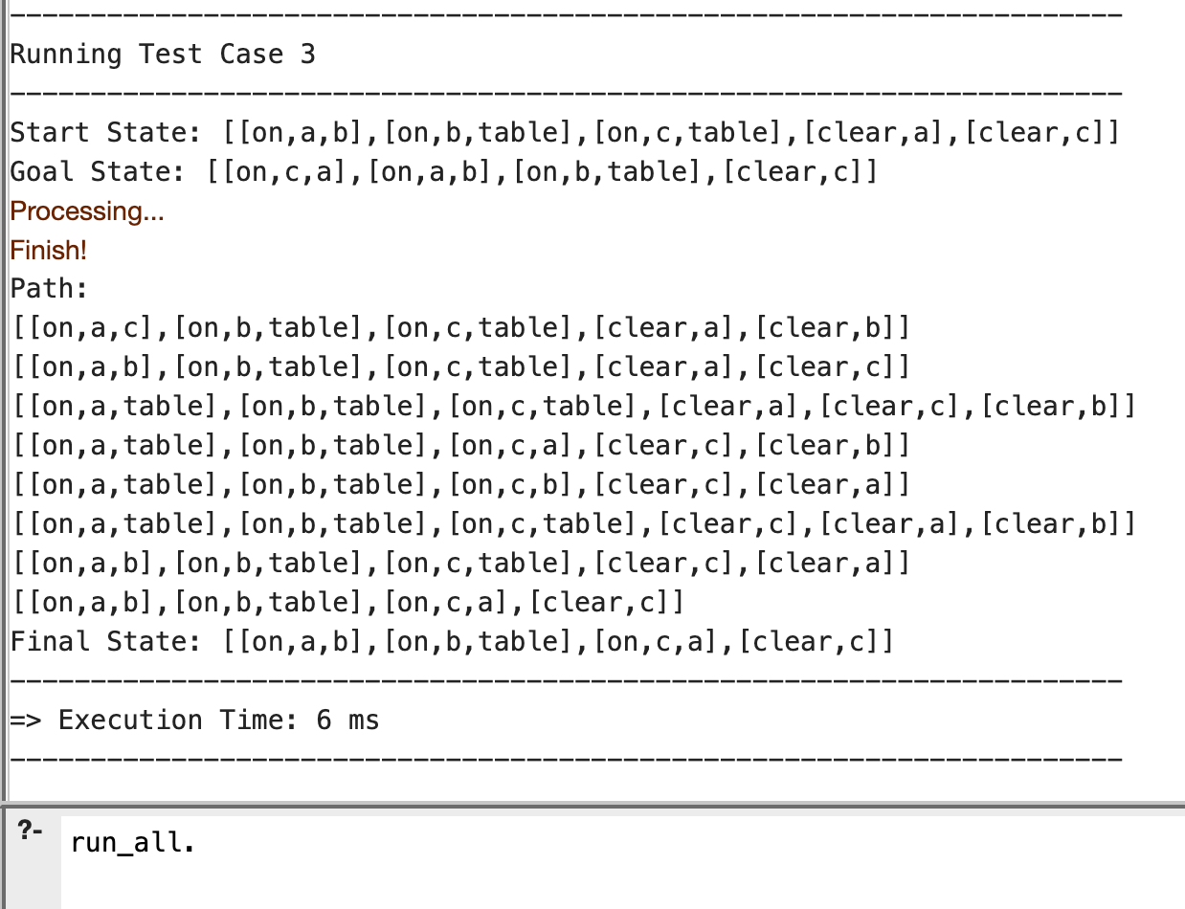

**Comment:** Although the solution is correct, the paths are not optimal as there should be only 1 step to reach the final solution. It may be because dfs starts with block a first and moves it around instead of just putting block c on top of a.

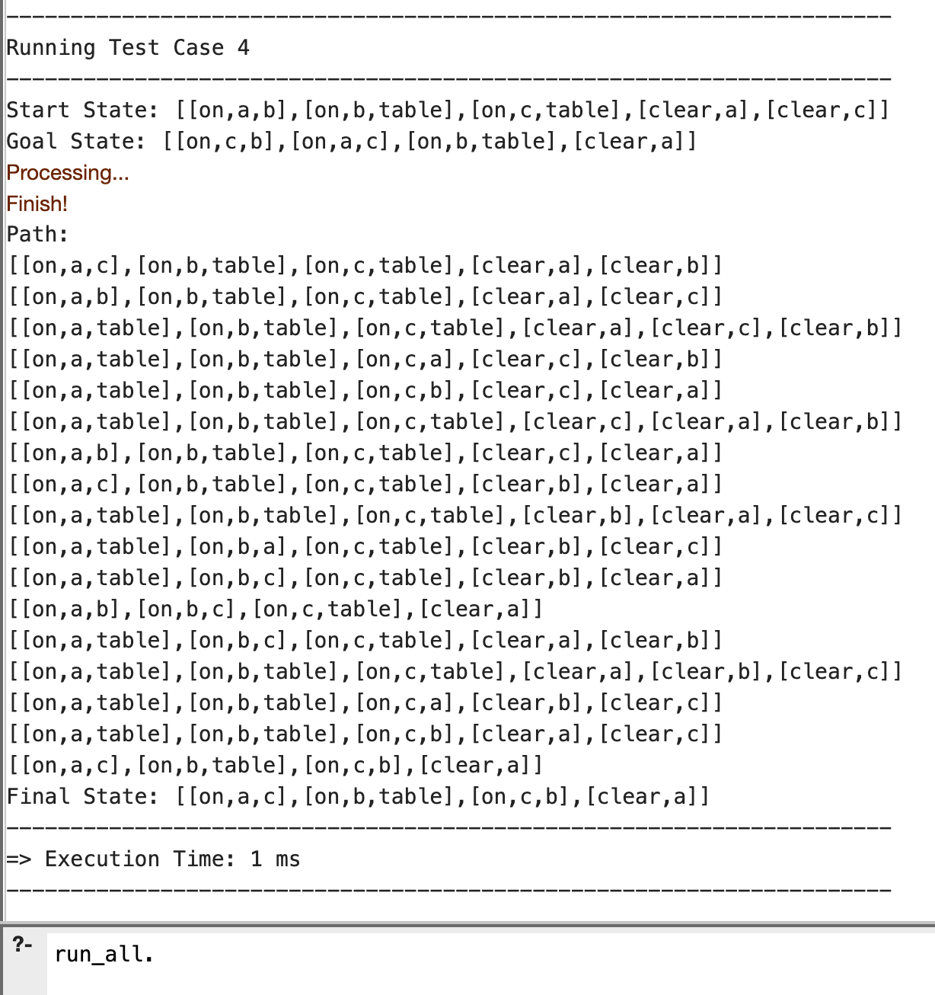

**Comment:** Similarly, although the final state is correct, the paths are not optimal since the algorithm starts putting block a on top of other blocks instead of on the table, which will reach the goal faster.

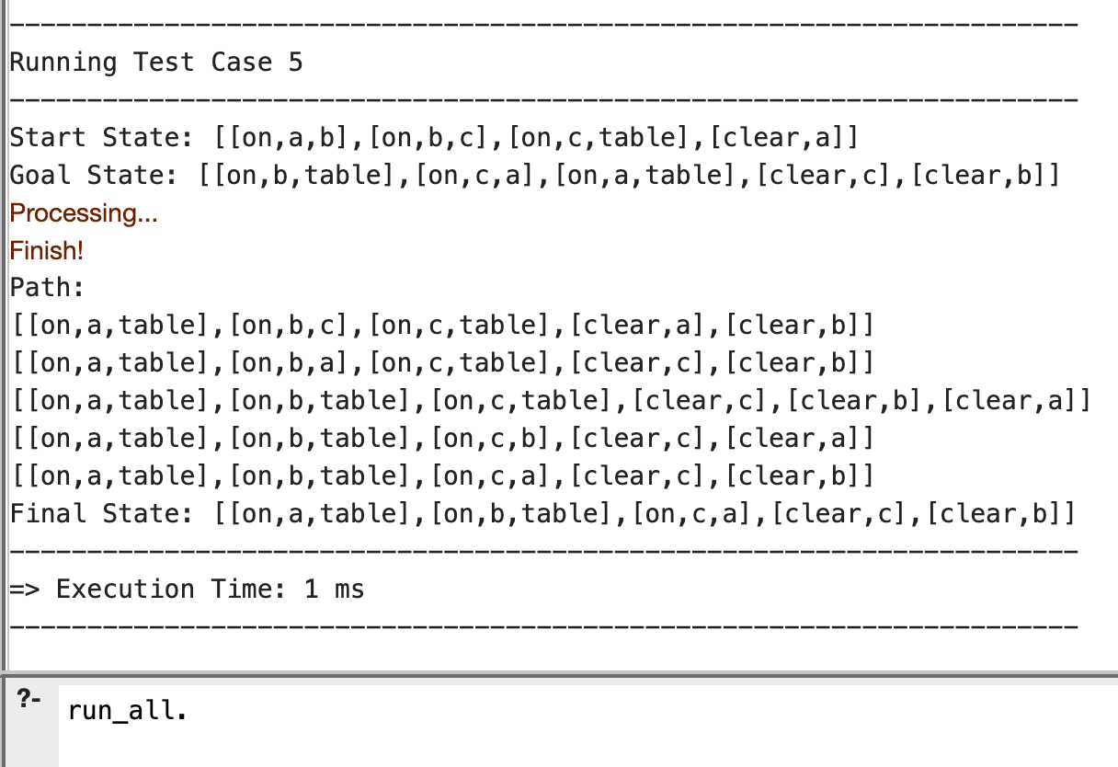

**Comment:** Similarly, the solution is correct but not optimal. It seems that the algorithm will only put a block onto the table if there’re no more blocks to be put onto.

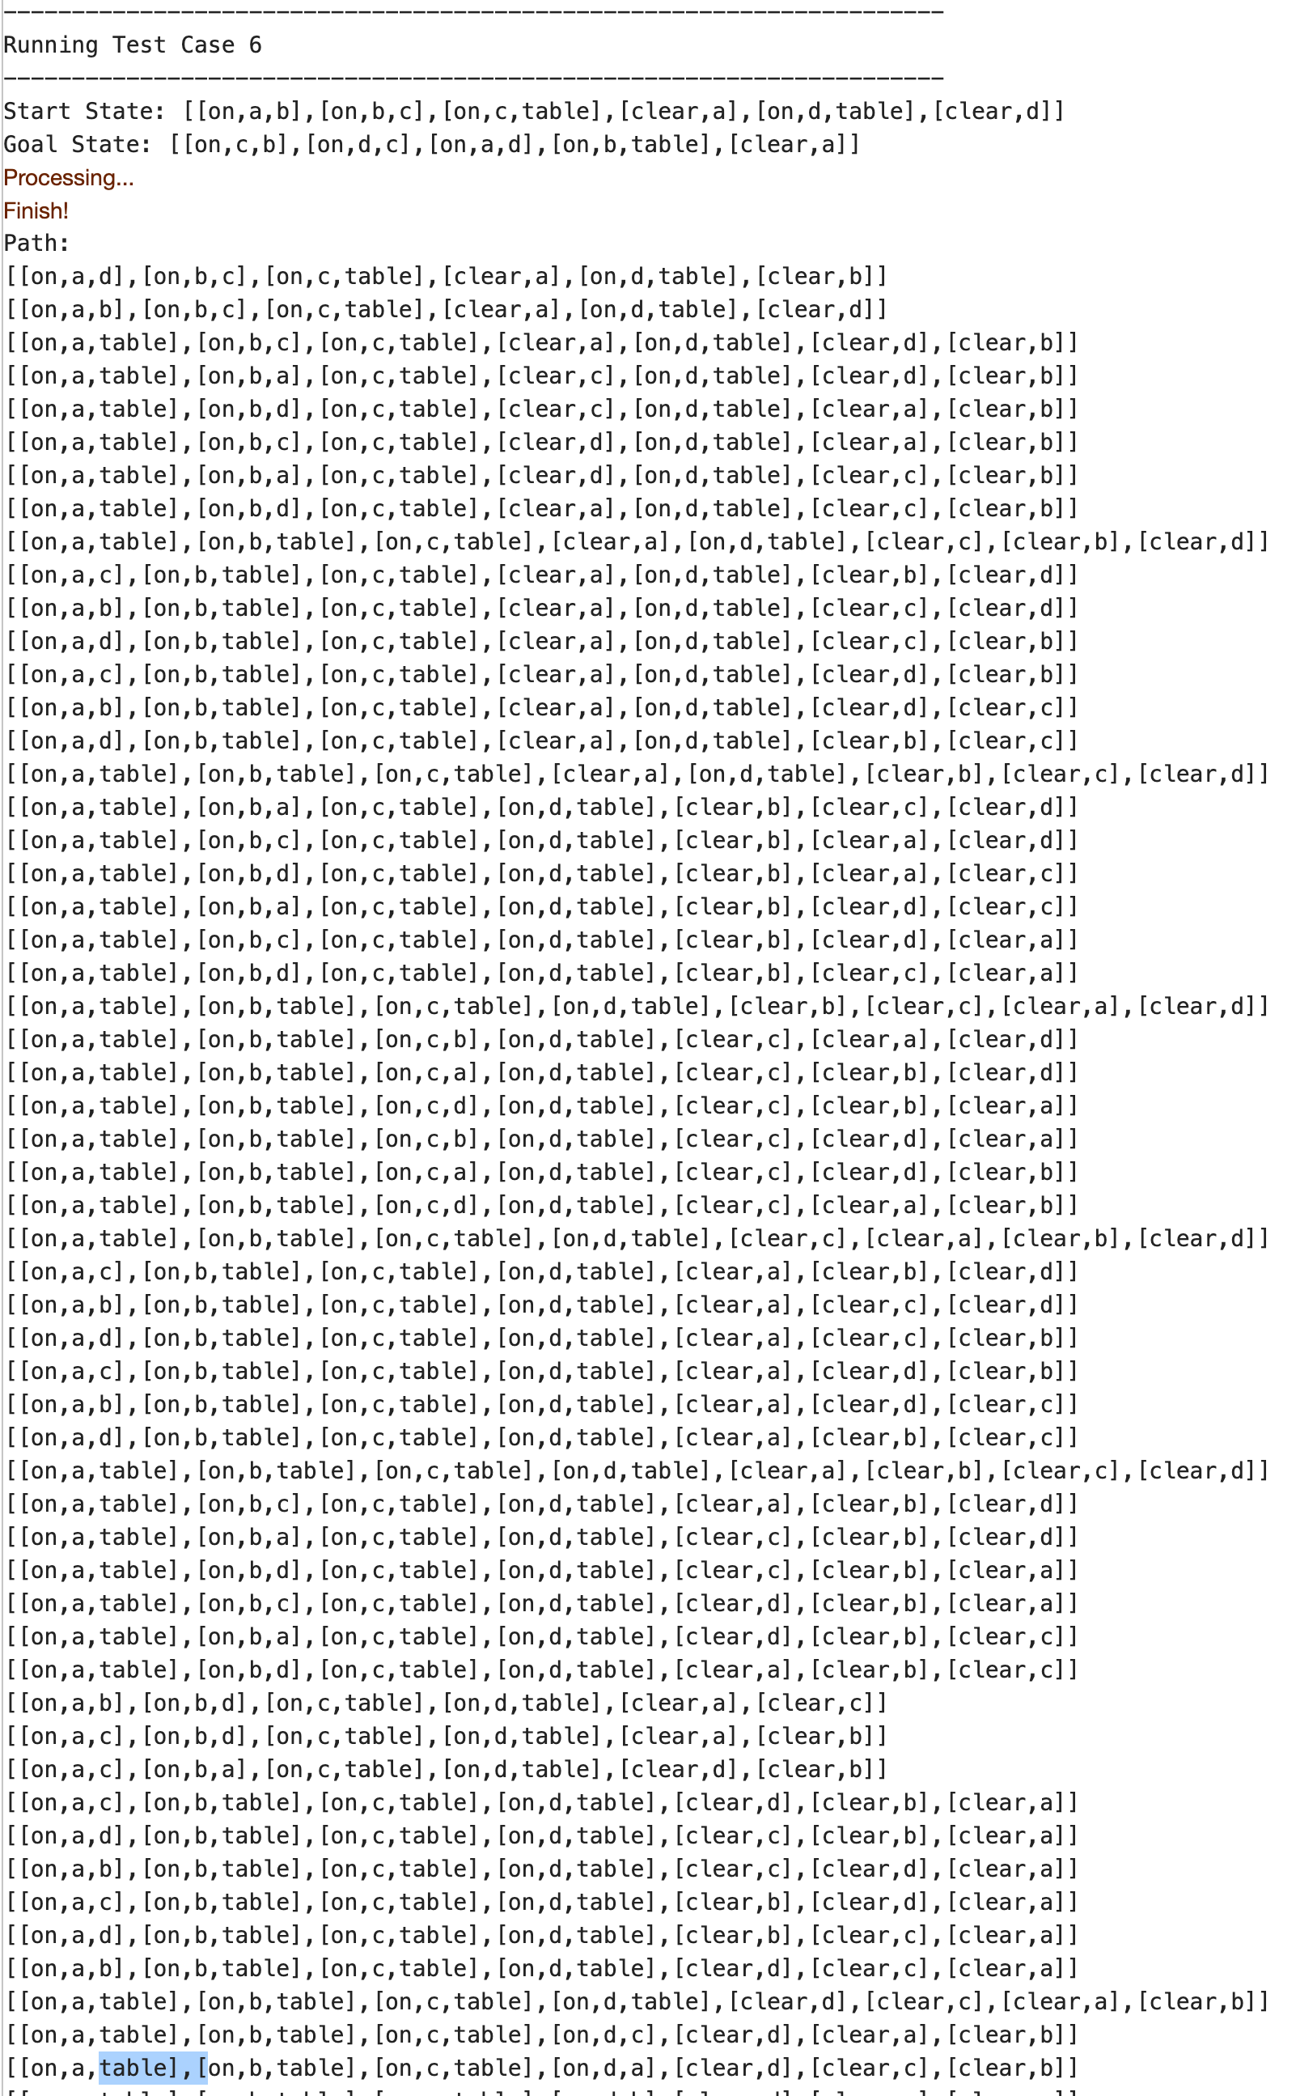

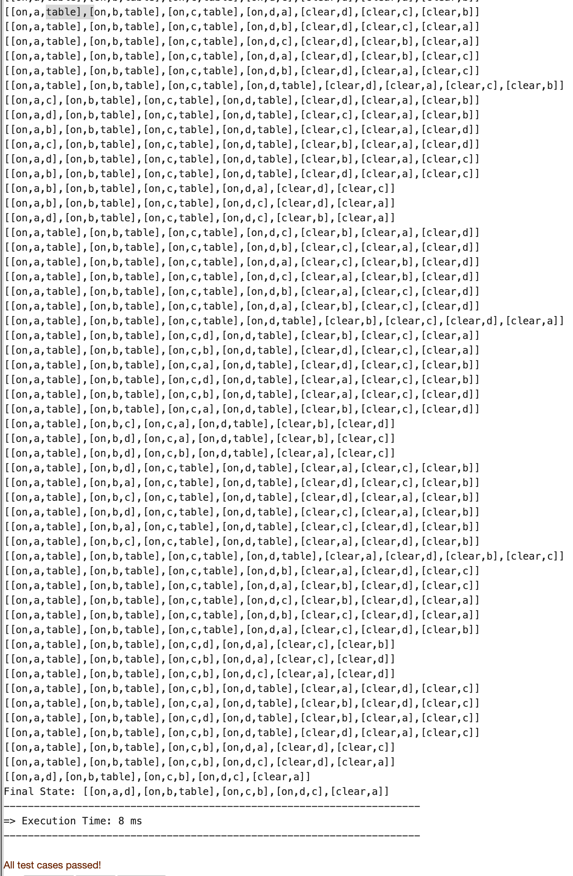

**Comment:** This is our last test case, the final state is correct, but the paths are not optimal because of similar reason explained above.