Toan Ly
CS 5137 - Deep Learning
Homework 1: Linear Regression and Neural Network Regression
Step 1. Data
- There are 3047 samples in this dataset
- Since the target label TARGET_deathRate is continuous, this is a regression problem. It’s trying to predict cancer mortality rates based on personal information related features such as education, income, age, race, as well as demographic features like population, poverty percentage and study per county, and several health related features such as average number of reported cases annually, average number of deaths per year.

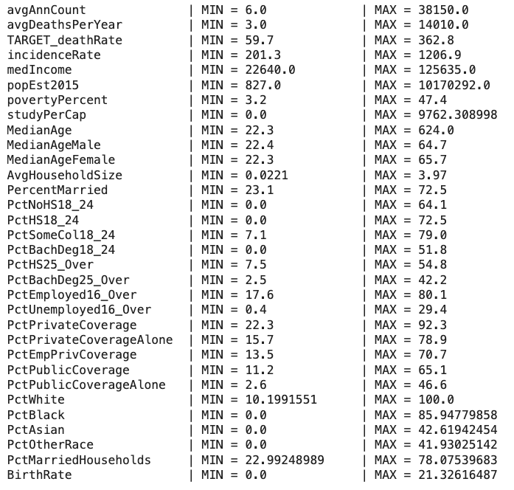
- There are 33 features (excluding target label), including 31 numerical features and 2 categorical features (Geography and binnedInc)
- Only 3 features have missing values, and it’s noticeable that PctSomeCol18_24 has roughly 75% missing values of the whole dataset.
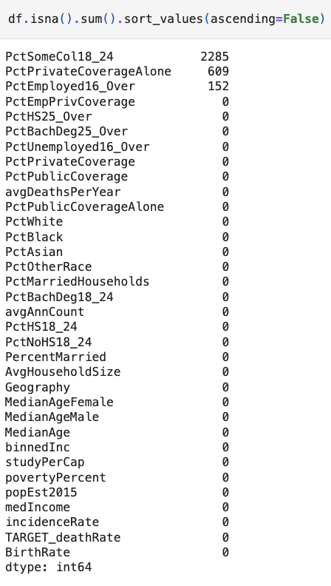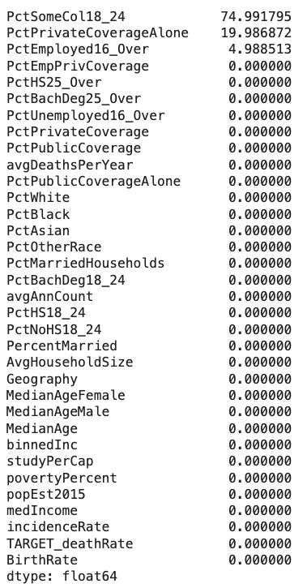

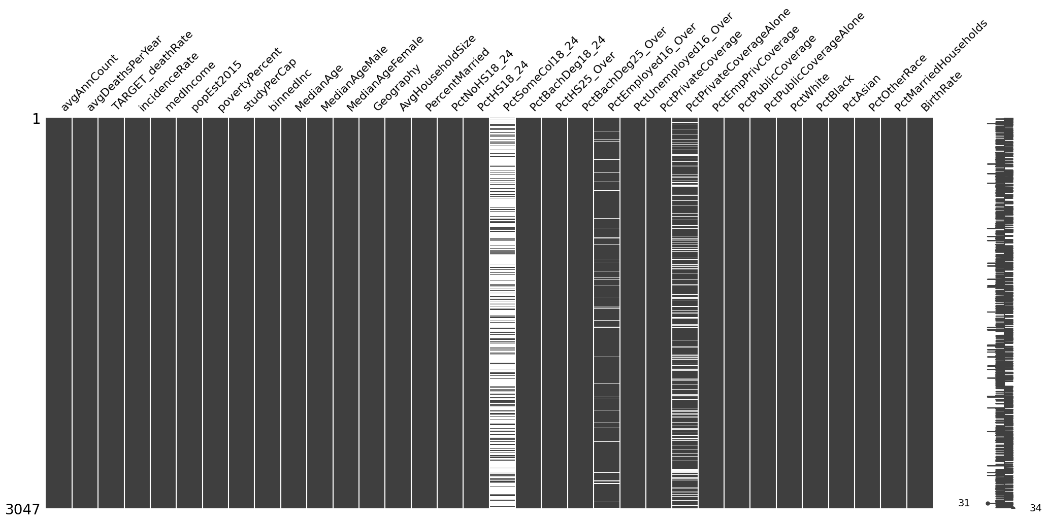
Below is nullity matrix to visualize where the missing values locate in each feature:

- The label of this dataset is TARGET_deathRate (cancer mortality rate)
- For this dataset, I used 80% for training data, 10% for validatation and 10% for the testset.
- For preprocessing, since PctSomeCo18_24 and PctPrivateCoverageAlone features contain ~75% and ~20% of missing values, it’s better to just drop the entire columns so that the model won’t try to learn noises during training. Trying to impute, on the other hand, will risk making those features contribute noises to the model or the model may be overfit to those fake patterns, which can cause poor generalization. Additionally, since PctEmployed16_Over feature only contains less than 5% missing values, it’s safe to impute with the median to preserve this feature’s information.
Next, while exploring the dataset, I realized an interesting part that MedianAge feature has a maximum value of 624, which is impossible. Investigating further, I saw some of the samples has MedianAge values over 120. My assumption was that the value may be mistakenly multiplied by 10 when collecting the dataset. Therefore, I modified those samples by dividing the MedianAge by 10.
For categorical features, since binnedInc contains the range of income, it would be useful to extract the mean income by calculating the average of the 2 values min and max from that feature so that the model can also learn from mean rather than just the median in medIncome. Moreover, for Geography, since all the values are unique, it won’t be helpful if we apply one hot encoding to this feature since it will create a giant sparse matrix. Therefore, my first approach was trying to extract the state from the feature and apply one hot encoding so that only 51 features (states) are added. However, it turned out that the model didn’t improve, so I also decided to drop Geography feature in the end.
Also in EDA, I observed that most of the feature distribution is skewed, such as PctBlack, PctAsian, which has few values having extremely large values while the majority has small values, so I applied log transformation to compress those large values and expand small ones, making the distribution closer to normal in order to help improve stability when training model. In this case, I only applied log transformation to features having skewness score > 1.
Below are the distributions after transformation:

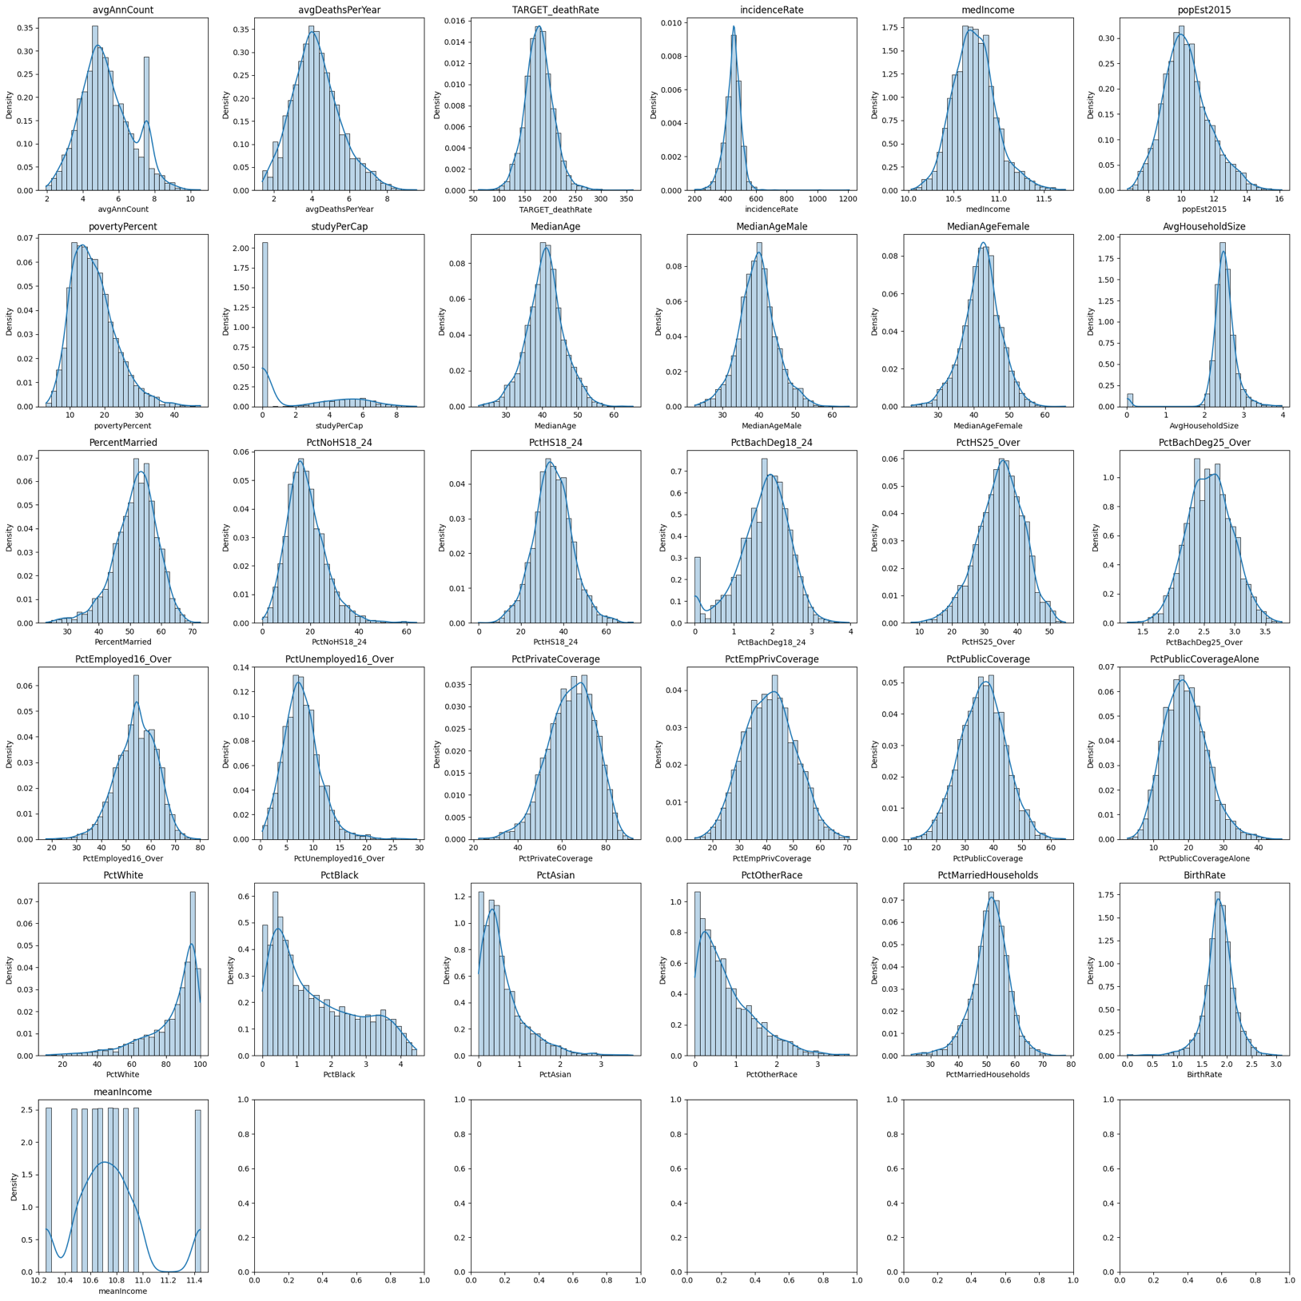

Finally, I splitted the dataset into 3 sets, training set (80%), validation set (10%) and test set (10%), and applied normalization to the datasets to scale the features down so the training phase can be more stable. Here, I used Robust Scaler (based on median and IQR) since it’s more robust to outliers in this dataset.

Step 2. Model
Here I trained linear regression and deep neural networks with these architectures. Below table is the model architecture choices with their corresponding best r2 scores:
Model | Test R-squared
Linear regression | 0.78
DNN-16 | 0.81
DNN-30-8 | 0.88
DNN-30-16-8 | 0.81
DNN-30-16-8-4 | 0.79
DNN-64-30-16-8 | 0.77
DNN-128-64-32 | 0.74

When training, I used batch size of 128, leaky relu activation, and I also applied batch normalization, gradient clipping, and early stopping techniques to help avoid gradient exploding, stable training and better generalization.
Additionally, I tried adding other techniques like L2 regularization, dropout, however, with this dataset, they didn’t seem to work, so I disabled them.
Step 3: Objective
Mean Squared Error (MSE) is the loss function I used to train the models
Step 4: Optimization
For optimization, I used SGD with momentum of 0.9 to help the model converge a little faster while training
Step 5: Model selection
Model | LR: 0.1 (R²) | LR: 0.01 (R²) | LR: 0.001 (R²) | LR: 0.0001 (R²)
Linear Regression | 0.78 | 0.78 | 0.78 | 0.78
DNN-16 | 0.73 | 0.79 | 0.81 | 0.68
DNN-30-8 | 0.80 | 0.84 | 0.88 | 0.55
DNN-30-16-8 | 0.39 | 0.81 | 0.80 | 0.57
DNN-30-16-8-4 | 0.59 | 0.79 | 0.51 | 0.52
DNN-64-30-16-8 | 0.69 | 0.77 | 0.40 | 0.47
DNN-128-64-32 | -0.07 | 0.74 | 0.66 | 0.57
* For linear regression, I used sklearn so it isn’t dependent on the learning rate. Therefore, r2 is the same for all learning rates
* I used green as the baseline for other models to compare, red for best r2 > linear regression, and blue otherwise
Step 6: Model performance
Below are MSE losses over epoch for each best model, noted that the losses are log transformed when visualizing:
- DNN-30-8 with learning rate 0.001 (r2 = 0.88)
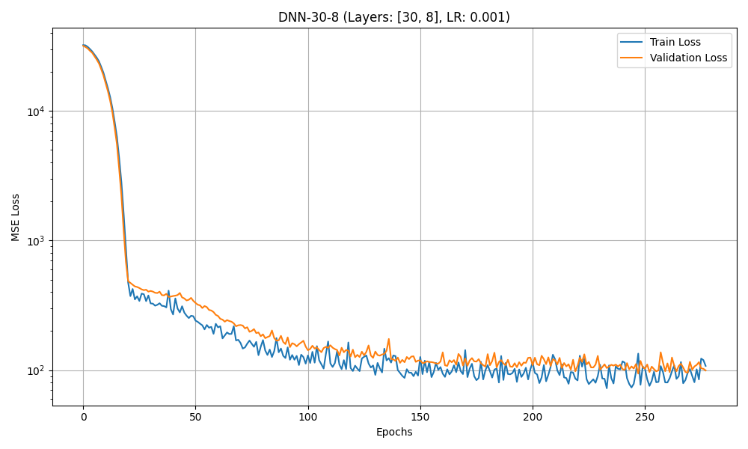

- DNN-30-8 with learning rate 0.01 (r2 = 0.84)
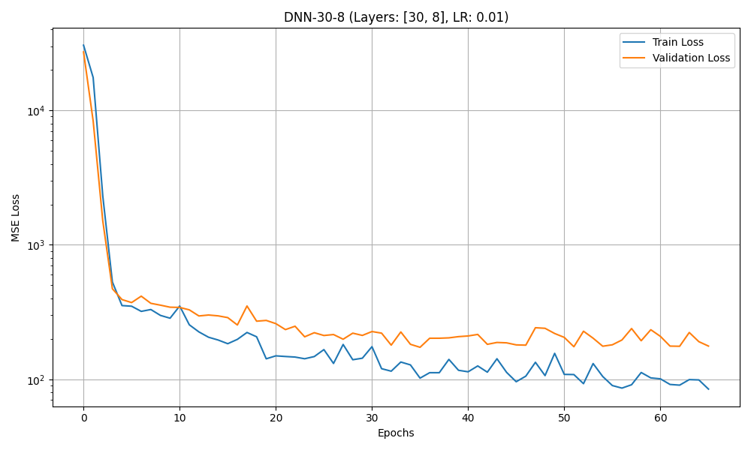
- DNN-16 with learning rate 0.001 (r2 = 0.81)
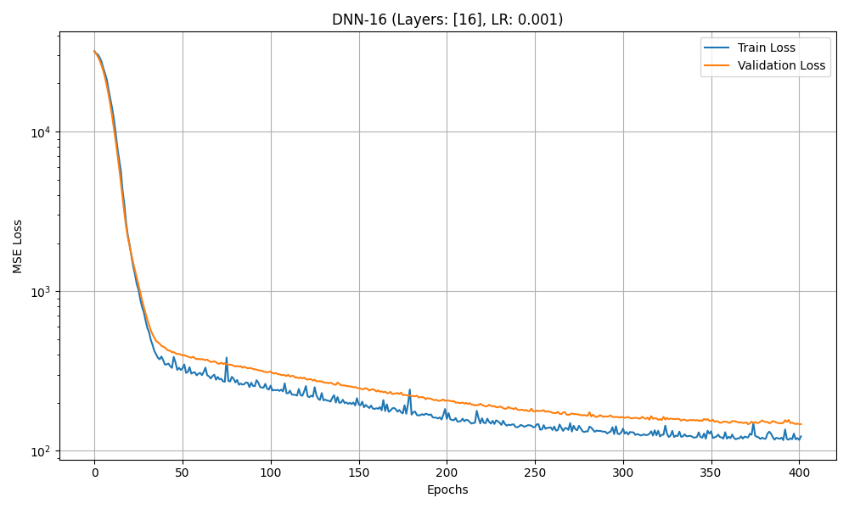

- DNN-30-16-8 with learning rate 0.01 (r2 = 0.81)
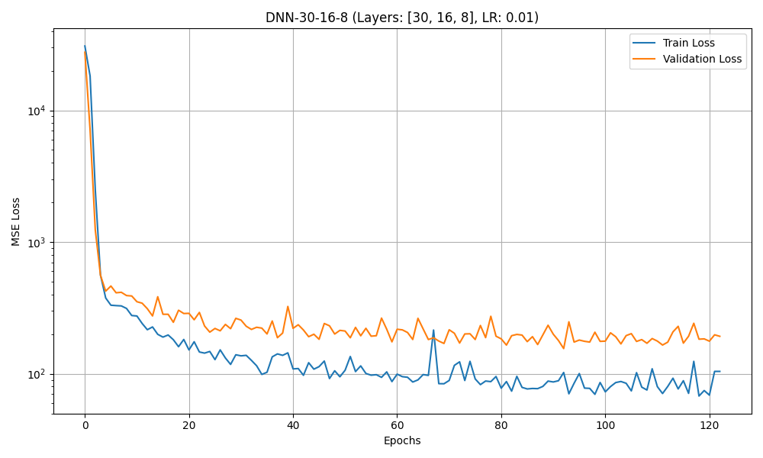
- DNN-30-16-8-4 with learning rate 0.01 (r2 = 0.79)
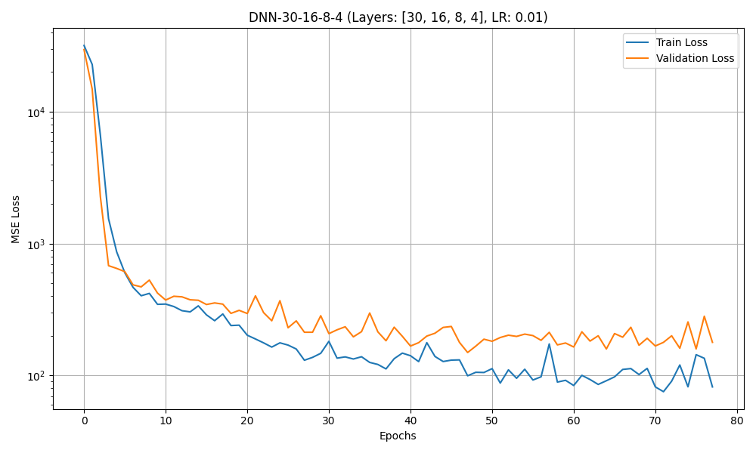
- DNN-64-30-16-8 (custom model) with learning rate 0.01 (r2 = 0.77)
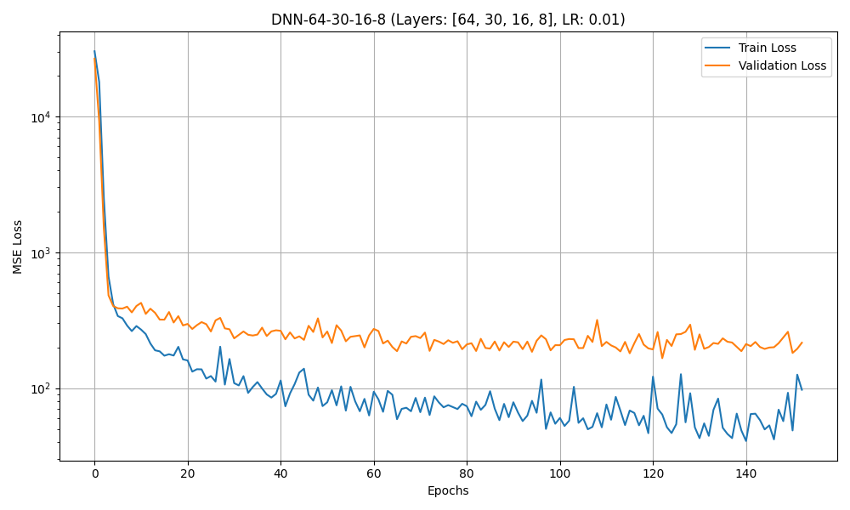
- DNN-128-64-32 with learning rate 0.01 (r2 = 0.74)
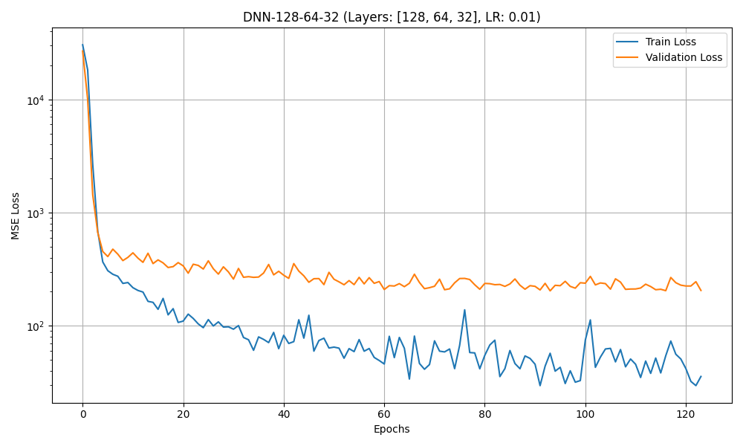
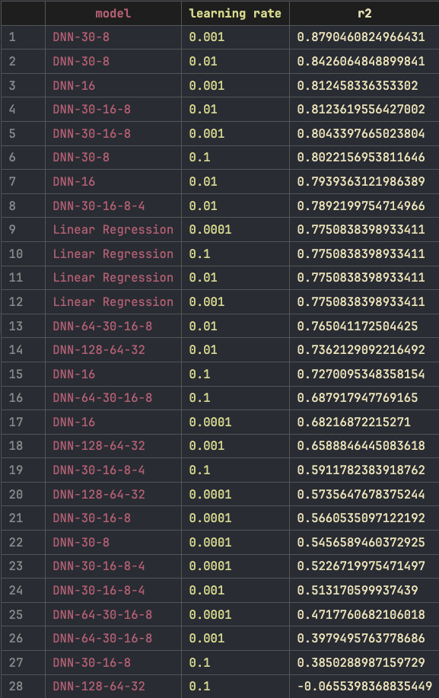
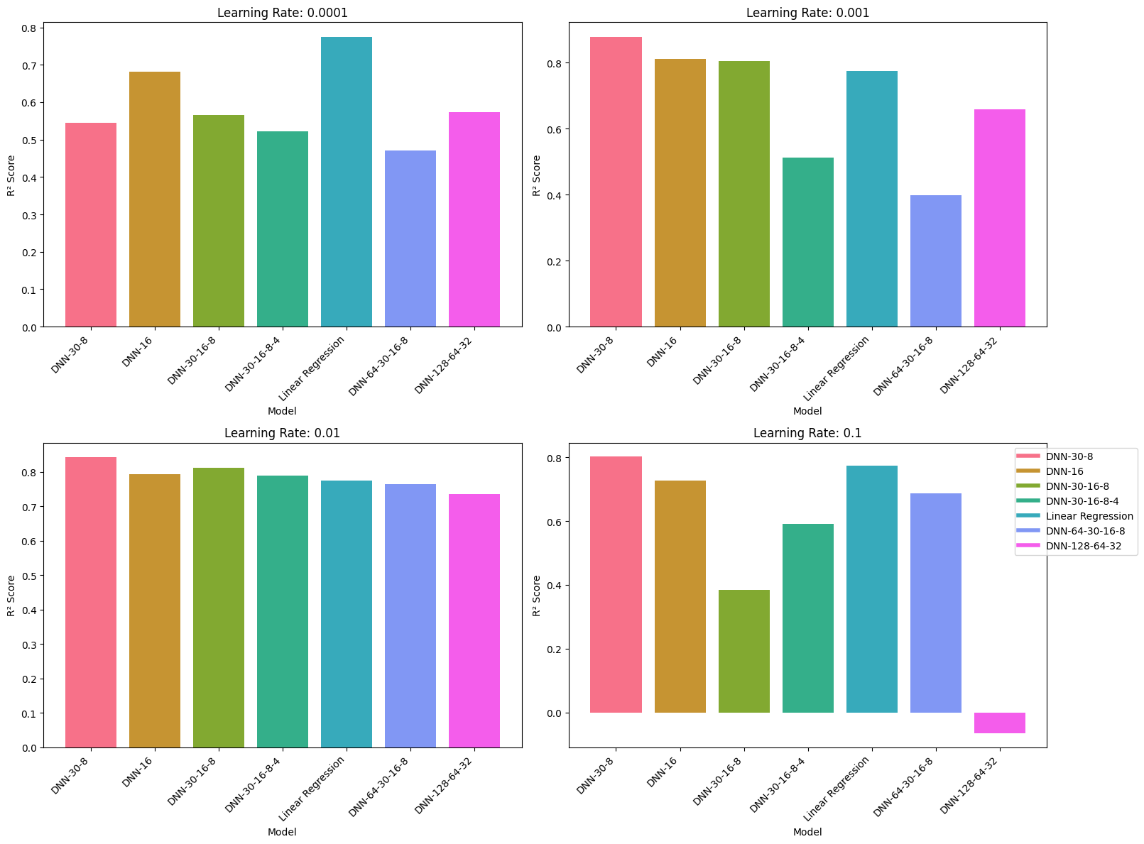
Below plot helps visualize the performance for comparison:

It’s noticeable that increasing model’s capacity for this dataset decreases the performance a lot. The 2 customized model I added actually performed worse than linear regression.

