# Assignment 1 – 13/8/2024

## Name: Hoàng Minh Toàn – Student ID: B21DCCN713

### Question 1:

### Use Chatgpt for generating code java

### Question 2.

### Question 3. Activity Diagram

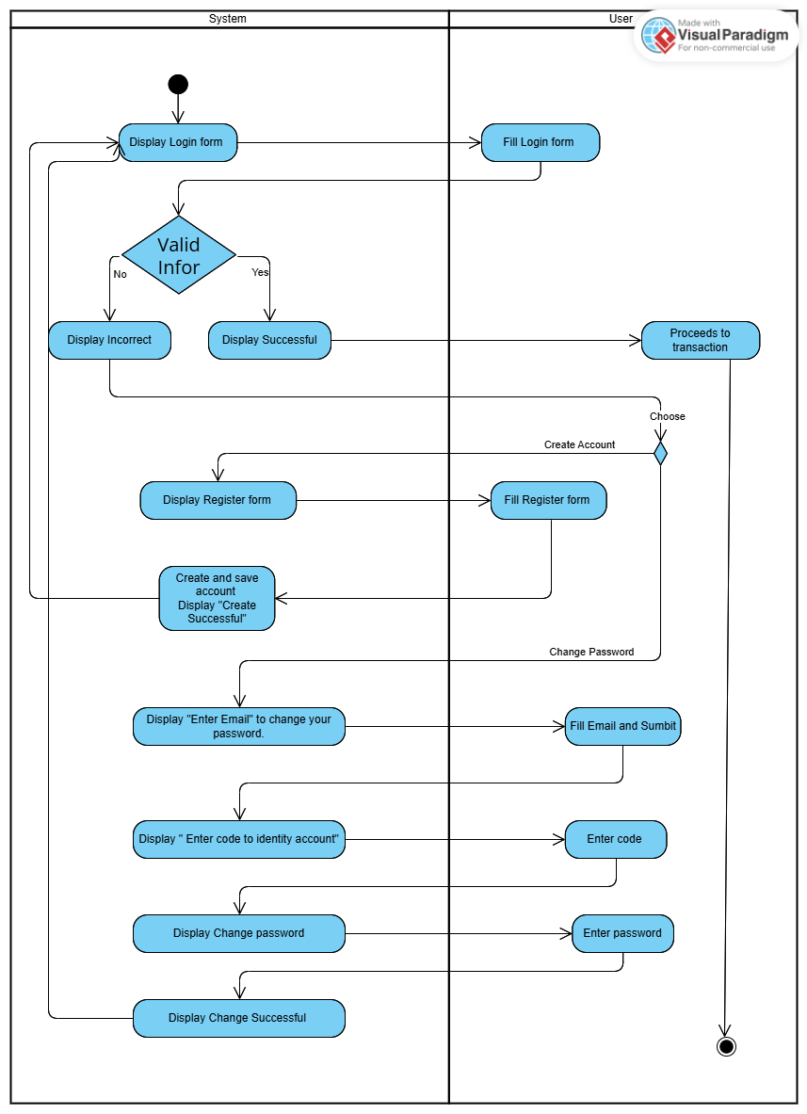

### Question 4: Do again