VLSC Registration Guide  
  
1) Go to <https://www.microsoft.com/licensing/servicecenter/home.aspx> to start registration.  
Or if you have received a Welcome Email – you can c[1]lick the link in the email.

[2]

**There are no headings in the document. Apply a heading style to the text so that it appears in the table of contents.**

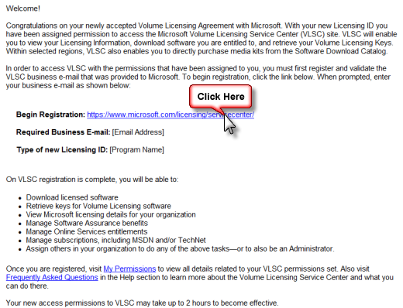

2) Click **Sign In**

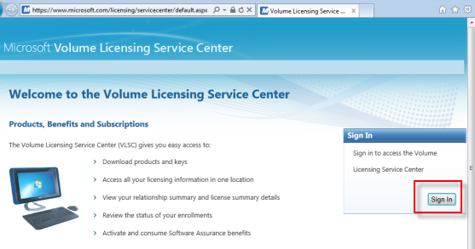

## 3) Sign in with your Windows Live ID and password

4) Enter your Business Email & Confirm your Business Email  
  
  
Click “**Submit**” when you are done  
  
5) If your business email address **matches** with the one stated in Open License and / or Volume License Agreement, you will land to this page

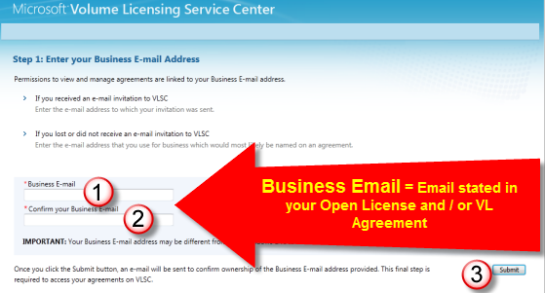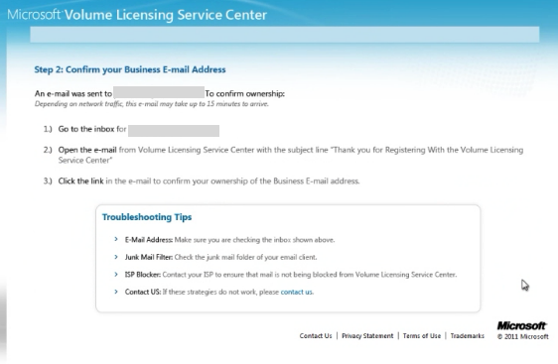

6) Wait for about 15-30 minutes. Go to your inbox to look for the **Validation Email** from **Volume** Licensing Service Center, titled “Thank you for registering with the Microsoft Volume Licensing Service Center (VLSC)” Note: It can be in your Junk Mail folder as well.  
Click on the link. If it does not work, please follow the instructions in the email.  
  
  
7) Done! You have now successfully completed VLSC registration.  
  
**Unsuccessful VLSC Registration**If your business email address **does not match** with the email address stated in Open License and / or Volume License Agreement, you will see this page. Please follow the advices in the pages, and retry.

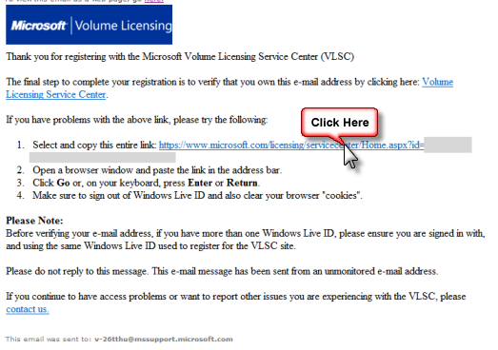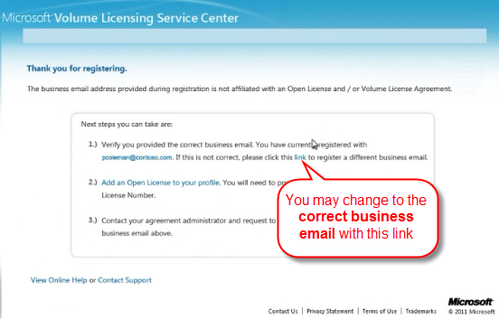

This also happens when you try to register and you are **neither** the Primary Contact **nor** the Notices Contact.

1.
2.