# The Flavorful Tuscany Meetup

## Welcome letter

* Dear Guest,

We are delighted to welcome you to the annual *Flavorful Tuscany Meetup*. We hope you will enjoy the program as well as your stay at the [Bilancino Hotel](http://ckeditor.com/).

1. 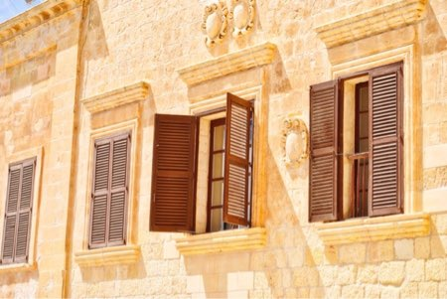

| **Saturday, July 14** | |
| --- | --- |
| 9:30 AM - 11:30 AM | **Americano vs. Brewed** - “know your coffee” with:   * Giulia Orlanda * Stefano Garau * Giuseppe Russo |
| 1:00 PM - 3:00 PM | **Regional delicacies of Tuscany** - live cooking  Incorporate the freshest ingredients   with Rita Fresco |
| 5:00 PM - 8:00 PM | **Tuscan vineyards at a glance** - wine-tasting   with Frederico Riscoli |

*The annual Flavorful Tuscany meetups are always a culinary discovery. You get the best of Tuscan flavors during an intense one-day stay at one of the top hotels in the region. All the sessions are led by top chefs passionate about their profession. I would recommend saving the date in your calendar for this one!*

*Angelina Calvino, food journalist*

Please arrive at the [Bilancino Hotel](http://ckeditor.com/) reception desk at least half an hour earlier to ensure that the registration process goes as smoothly as possible.

We look forward to welcoming you to the event.

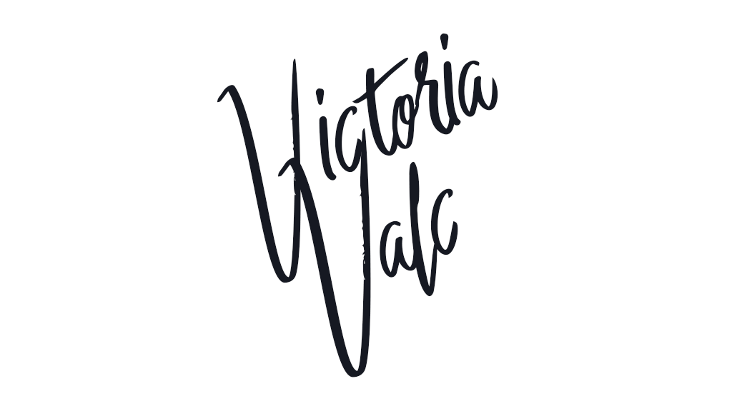

**Victoria Valc**

**Event Manager**

**Bilancino Hotel**