PRM392 - Mobile Application Development with Android
by using Java API Framework

Practical Examination

A FingerPrint Store Application

Exam Date: 2025/10/29
Time Limit: 130 minutes
Total Points: 10
*Note:
- AI Tools: Allowed (e.g., Grok, Copilot, Claude)
- Every brackets “<...>” must be substituted by using your related information which is indicated by the content inside.
Here's an example in English to illustrate how to substitute the brackets “<...>”:
Original sentence (hypothetical):
Today is <current date>. I am <AI name>, built by <company>.
After substitution using my related information:
Today is October 28, 2025. I am Grok, built by xAI.
→ Each “<...>” is replaced with the accurate corresponding information from my knowledge.
- Declare activities in AndroidManifest.xml.
- Use dependencies: RecyclerView (androidx.recyclerview:recyclerview:1.2.1).
- Test on API 28+ for fragments, notifications and so on.
- Password format: “yyyyMMdd”, e.g. “20250621” (June 21, 2025).
- Deliverables: Submit 4 times at 30, 60, 90, and 120 minutes. Include source code, roll number, and Submission Time in each submission. If your goal is to get a score of 10, don’t miss any deliverable times. Follow the guidelines carefully.
- Cheating or Hacking is not allowed, in any case, you will get 0 if any violation is found.

1. Project Setup (2 points)
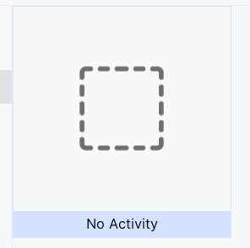
- Create a “No Activity” Project and change the app_name in strings.xml to "A FingerPrint Store". The package name must be: com.fptu.prm392.<your_rollnumber>.fingerprint (0.25 point).
Figure 1: No Activity Project Template
- Create a splash screen image by taking your selfie photo at present time and put it into the following frame, then saving it to a file with splash_screen.png name. (0.25 point)
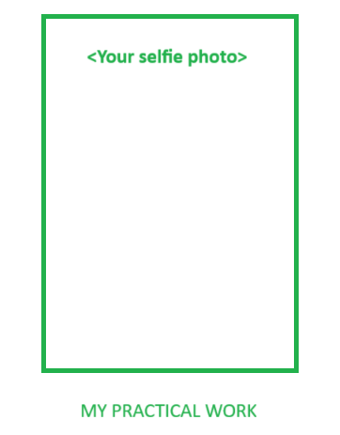
Figure 2: Splash screen image frame - paste your selfie photo in the green rectangle area
- Open your OS system’s console (refer. Appendix I) and check the following commands (You can defer this step later to do others and do it at any time during the test session):
No. | Command | Windows | Linux / macOS / Unix
1 | ping | ping | ping
2 | nslookup | nslookup | nslookup
3 | tracert | tracert | traceroute
4 | ipconfig | ipconfig | ifconfig or ip addr
5 | hostname | hostname | hostname
Table 1. Network basic commands
  - Use ping command as follow and save the result into a ping_result.txt file (0.25 point).
ping www.google.com -n 30
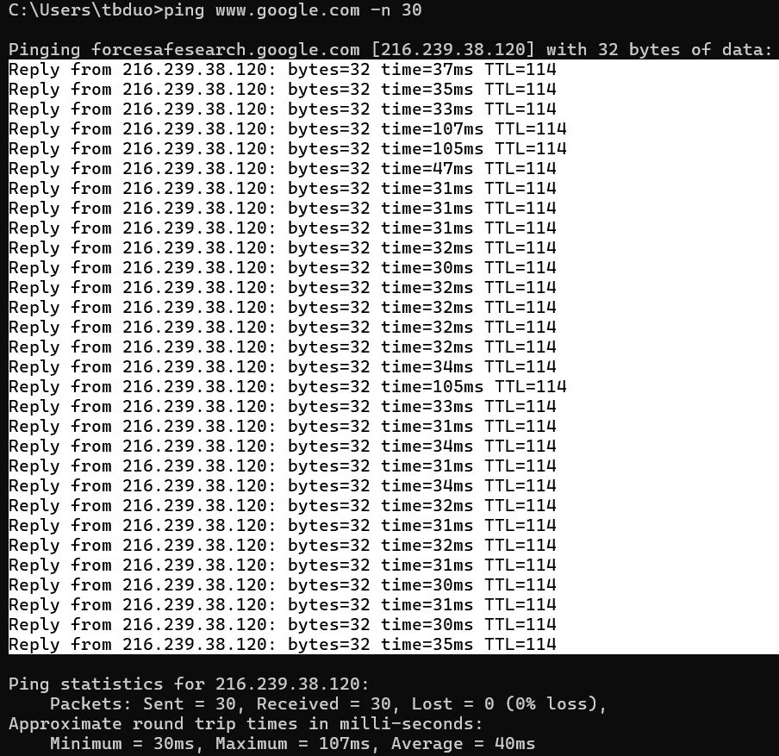 | 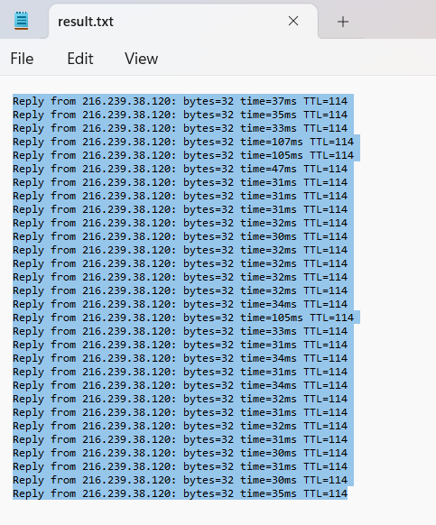
Table 2. Ping command’s result and ping_result.txt file content
  - Use hostname command to get your hostname, then store it in a string in your project strings.xml resource file (0.25 point).
hostname
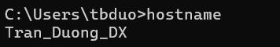
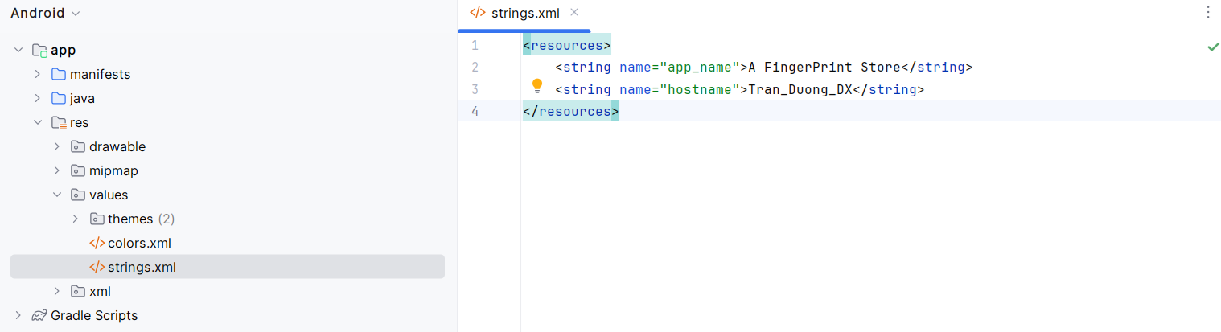
Figure 2: Example of hostname command result is put into strings.xml
  - Use nslookup command to get the result, then take the picture of the result and save it into an image file with the name of gitlab_nslookup.png (0.25 point).
nslookup
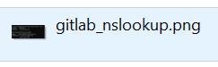 | 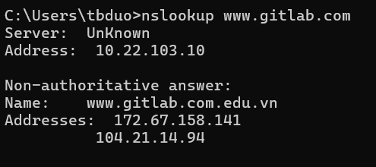
Figure 3: Example of gitlab_nslookup.png from nslookup command result
  - Use tracert command to get the result, then take the picture of the result and save it into an image file with the name of google_tracert.png (0.25 point).
tracert www.google.com
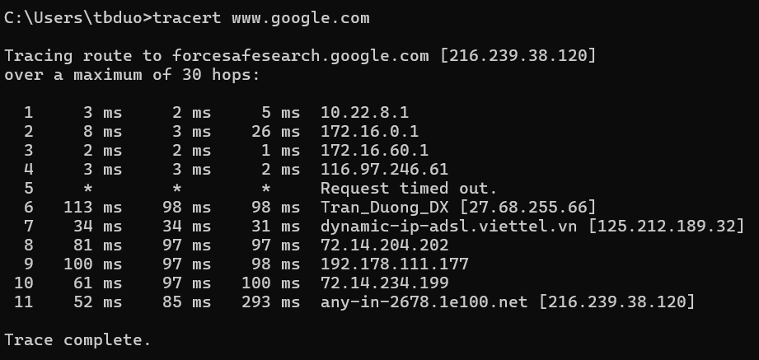
Figure 4: Example of google_tracert.png from tracert command result
  - Use ipconfig command to get the result, then take the picture of the result (the green rectangle area) and save it into an image file with the name of myhost_ipconfig.png (0.25 point).
ipconfig
Note: the saving area must include the green rectangle area but not limit.

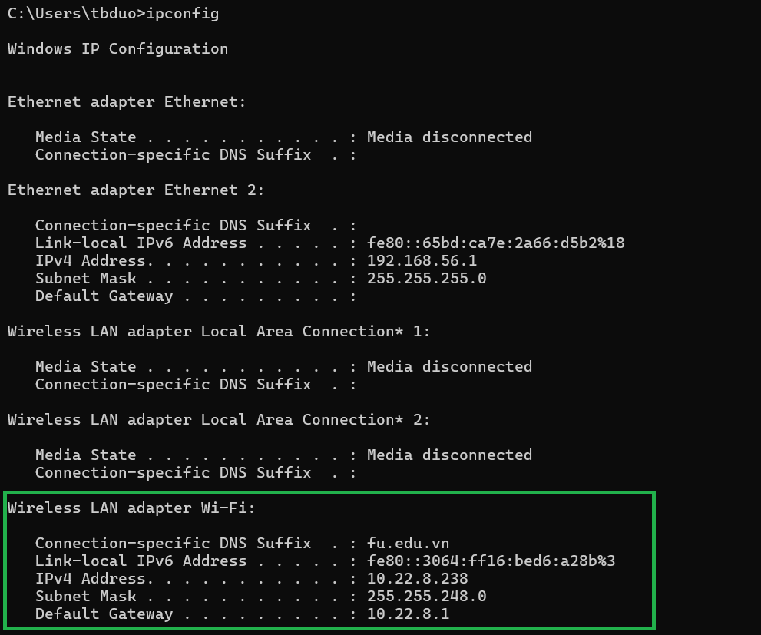
Figure 5: Example of myhost_ipconfig.png from ipconfig command result
To be evaluated to complete all of the objectives in this part, you have to put all result files to the folder “./res/raw/” of the project. (0.25 point)
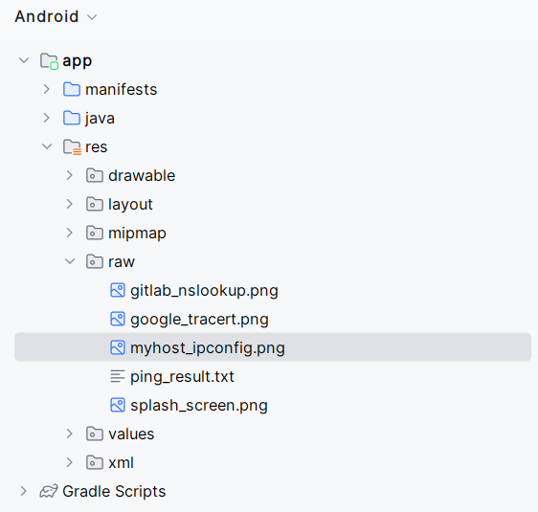
Figure 6: Raw resource files in your project

2. Build the first executable version with empty view activities (1 points)
2.1. Create a Splash Activity using the Empty View Activity Template and set it as launching activity and move it into the “activity” package folder. (0.25 point)
2.2. Create a Security Check Activity using the Empty View Activity Template and move it into the “activity” package folder. (0.25 point)
2.3. Create a Home Activity using the Empty View Activity Template and move it into the “activity” package folder. (0.25 point)
2.3. Create a Recent Ping Activity using the Empty View Activity Template and move it into the “activity” package folder. (0.25 point)
You are reaching here >>>>> the first deliverable point, you should clean your code and export to a zip file then deliver to the provided folder.

3. Complete Splash Activity with specified layout attributes requirements (2 point)
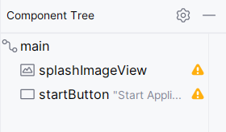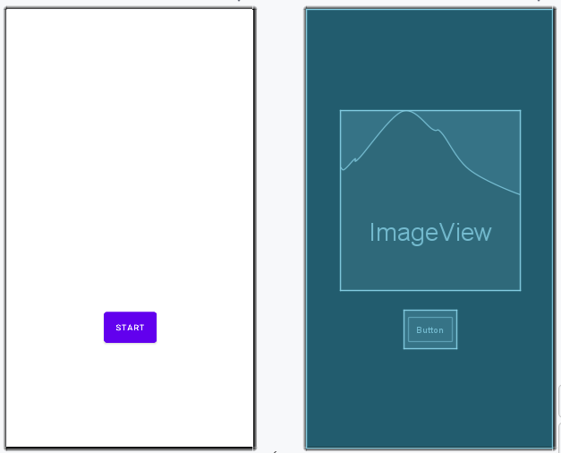
Figure 7: Layout of Splash Activity
3.1. Implement the activity_splash.xml layout file to have the structure similar to the layout viewed in Figure 7 (Component Tree). (the main layout is a Constraints Layout)
3.1.1 The Image view has layout_width and layout_height is set to be 400dp and the id is splashImageView and the bottom constraint is set to the Start button’s top. (0.5 point)
3.1.2. The Start button has layout_width and layout_height is set to be wrap_content, layout_marginTop is set to 48dp, padding attribute is set to 16dp, and the top constraint is set to the splashImageView’s bottom. (0.5 point)
3.2. Implement the logic of Splash Activity as follow:
3.2.1. When user click on Start button, the application will switch to Security Check Activity (0.5 point)
3.2.2. The Splash Activity will be finished immediately so that users won’t be able to go back to it. (0.5 point)
You are reaching here >>>>> the second deliverable point, you should clean your code and export to a zip file then deliver to the provided folder.

4. Complete Security Check Activity with personal style information (2 point)
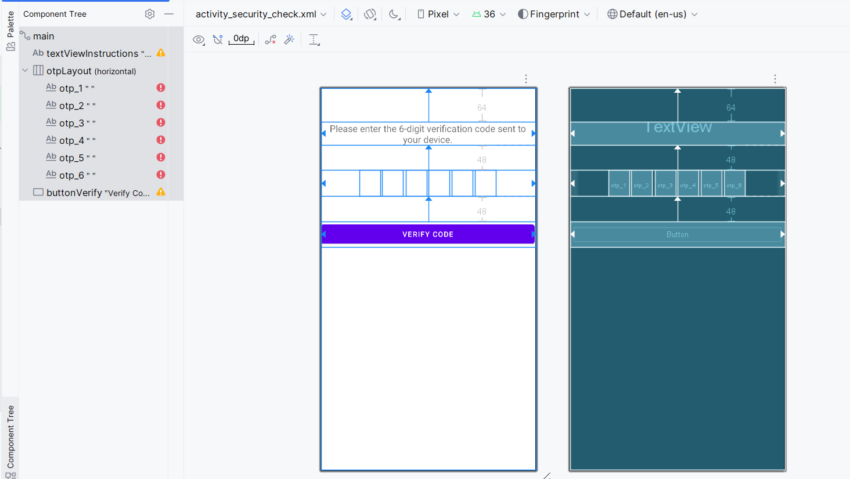
Figure 8: Layout of Security Check Activity
4.1. Implement the activity_security_check.xml layout file to have the structure similar to the layout viewed in Figure 7 (Component Tree).(the main layout is a Constraints Layout).
4.1.1. The instruction text view layout_marginTop must set to 64dp and its top constraint is set to dock to parent, the text size is set to 18sp. (0.25 point)
4.1.2. The Button has the text value which must be exact to “Verify Code”, and marginTop is set to 64dp, and layout_width is set to match the layout width. (0.25 point)
4.1.3. The series of 6 Otp Edit Text objects is put into a horizontal linear layout with the id suffix is set from 1 to 6 and has custom style (0.5 point)
I.e. style="@style/OtpDigitBox" android:id="@+id/otp_1"
4.2 Implement styles.xml file with the content as follow: (0.5 point)
<?xml version="1.0" encoding="utf-8"?>
<resources>
<style name="OtpDigitBox" parent="Widget.AppCompat.EditText">
<item name="android:layout_width">40dp</item>
<item name="android:layout_height">50dp</item>
<item name="android:gravity">center</item>
<item name="android:inputType">number</item>
<item name="android:maxLength">1</item>
<item name="android:textSize">20sp</item>
<item name="android:imeOptions">actionNext</item>
<item name="android:layout_marginEnd">4dp</item>
<item name="android:background">@drawable/otp_box_background</item>
</style>
</resources>
4.3 Implement the logic of the verify button click event as follow:
4.3.1. If the combination of 6 input text values from the user input is valid that means it is a number of permutations of your rollnumber, the user will be able to move to the next Activity (Home Activity). (0.25 point)
4.3.2. If the combination is not valid, a LENGTH_LONG interval Toast message will be showed and the application will be exited. (0.25 point)

5. Complete Home Activity with different view groups (2 point)
Implement Home Activity with vertical linear layout where there are 4 group views as follow:
5.1. The first view group has two view components, a text view to show label as "GitLab nslookup Result", the second view is an image view to display the gitlab_nslookup.png image. (0.5 point)
5.2. The second view group has two view components, a text view to show label as "Google Trace Route Result", the second view is an image view to display the google_tracert.png image. (0.5 point)
5.3. The third view group has two view components, a text view to show label as "IpConfig Result", the second view is an image view to display the myhost_ipconfig.png image.
(0.5 point)
5.4. The fourth view group has two view components, a text view show label as "Ping Result" and a button to show the Result List on Recent Ping Activity. (0.5 point)

You are reaching here >>>>> the third deliverable point, you should clean your code and export to a zip file then deliver to the provided folder.

6. Recent Ping Activity and an Exit button (1 point)
6.1. Implement a Recycler View to show the content of ping_result.txt in /res/raw folder, line by line and in separated column values such as Reply from, bytes, times, TTL. (0.75 point)
6.2. Implement the Exit button so that when user clicks on the button, the application will be properly finished (finishAffinity() function call) (0.25 point)
You are reaching here >>>>> the final deliverable point, you should clean your code and export to a zip file then deliver to the provided folder.
This is the end of Requirements in Examination Paper.

Appendix I
Program Name of The Console in each Operating System, if your AI Agent don’t understand it, give them the correct name from here:
No. | Operating System | Exact/Default Program Name | Common (Less Precise) Name
1 | Microsoft Windows | Command Prompt (or cmd.exe) | Command Line, Console
2 | Microsoft Windows (Modern) | Windows Terminal | Terminal
3 | Microsoft Windows (Power User) | PowerShell | Console
4 | macOS (Apple) | Terminal | Console
5 | Linux (Ubuntu, Debian, Fedora) | Terminal | Console
6 | Linux (KDE Desktop Environment) | Konsole | Terminal
7 | Linux (GNOME Desktop Environment) | GNOME Terminal (or just Terminal) | Terminal

