SOFTWARE REQUIREMENT SPECIFICATION
for
Arena3
Version 1.7
11 October 2026
As-built from the current repository
This specification describes version 1.7 of Arena3, the operating system of one sports centre. It follows the outline of a full software requirements specification: purpose and scope, overall description, system features, data, external interfaces, and quality attributes. Where an older note and the running code disagree, the code is what this document says.

Revision history
Version | Date | Reason
1.0 | 20 September 2026 | First as-built specification.
1.1 | 4 October 2026 | Staff accounts, reschedule, payOS, class lifecycle, training, report export.
1.2 | 5 October 2026 | Screen flows, use cases, and the later desk and manager functions.
1.3 | 5 October 2026 | Use case specifications for UC-01 to UC-37.
1.4 | 5 October 2026 | Full SRS outline: scope, environment, constraints, business-rule catalogue, data dictionary, external interfaces, and quality attributes.
1.5 | 5 October 2026 | State diagrams for the account, the session, and the plan. A use-case diagram with include and extend. Swimlanes for register, sign-in, online payment, and cancel.
1.6 | 5 October 2026 | Context diagram and sequence diagrams for register, sign-in, online payment, and cancel. A class runs on whole court hours.
1.7 | 11 October 2026 | Updated as-built: 8-actor model (Guest, Member, Receptionist, Coach, Manager, AI Assistant, Mail System, Scheduler), DFD Level 0 Context Diagram with 100% noun data flows, Swimlane Register with Mail OTP across 5 lanes, VietQR dynamic payment, coach classes screen, gate check-in with member code.

Contents
Revision history 1
Contents 1
1. Introduction 5
1.1 Purpose 5
1.2 Document conventions 5
1.3 Project scope and product features 5
1.3.1 Features included 5
1.3.2 Features excluded 5
1.3.3 Planned features 6
1.3.4 Long-term improvements 6
1.4 References 6
2. Overall description 6
2.1 Product perspective 6
2.1.1 Context diagram 6
2.1.2 Use case diagram 7
2.1.3 Activity diagrams 8
2.1.4 Sequence diagrams 12
2.1.5 State diagrams 15
2.2 User classes and characteristics 19
2.3 Operating environment 19
2.3.1 Client environment 19
2.3.2 Server environment 20
2.3.3 Database environment 20
2.3.4 External service environment 20
2.4 Design and implementation constraints 20
2.4.1 Technology constraints 20
2.4.2 Architecture constraints 20
2.4.3 Security constraints 20
2.4.4 Database constraints 20
2.4.5 Development constraints 21
2.4.6 Deployment constraints 21
2.4.7 Integration constraints 21
2.4.8 Completion constraints 21
2.5 Assumptions and dependencies 21
2.5.1 Assumptions 21
2.5.2 Dependencies 21
3. System features 21
3.1 Business rules 21
3.2 Use cases 23
UC-01 Register 25
UC-02 Confirm with OTP 26
UC-03 Sign in 26
UC-04 Reset password 27
UC-05 Edit own profile 27
UC-06 Book a court 28
UC-07 Reschedule a booking 28
UC-08 Cancel a booking 29
UC-09 Buy or renew a plan 29
UC-10 Join or leave a class 30
UC-11 Answer a waitlist offer 30
UC-12 Pay online 31
UC-13 View a receipt 31
UC-14 Ask the assistant 32
UC-15 Send a support request 32
UC-16 Walk-in court rental 33
UC-17 Open and close a shift 33
UC-18 Reconcile a transfer 34
UC-19 Refund a payment 34
UC-20 Rent and return gear 35
UC-21 Sell and use a day pass 35
UC-22 Fixed weekly booking 36
UC-23 Gate check-in 36
UC-24 Mark attendance 37
UC-25 Record training 37
UC-26 Manage classes 38
UC-27 Manage plans and prices 38
UC-28 Manage staff 38
UC-29 Read reports and export 39
UC-30 Read the audit log 39
UC-31 Configure the centre 40
UC-32 Promotions 40
UC-33 Points 41
UC-34 Coach commission 41
UC-35 Maintenance 42
UC-36 Export invoice data 42
UC-37 Expire and sweep 43
3.3 Functions with no screen 43
4. Data requirements 43
4.1 Logical data model 44
4.2 Data dictionary 45
4.2.1 Login 45
4.2.2 Register 45
4.2.3 Book a court 46
4.2.4 Walk-in 46
4.2.5 Day pass 46
4.2.6 Fixed weekly booking 47
4.2.7 Attendance 47
4.2.8 Redeem points 47
4.3 Reports 47
4.4 Data integrity, retention, and disposal 47
4.4.1 Schedule integrity 47
4.4.2 Money integrity 47
4.4.3 Document numbers 47
4.4.4 Audit retention 47
4.4.5 Short-lived data 48
4.4.6 Personal data 48
4.4.7 Backup 48
5. External interface requirements 48
5.1 User interfaces 48
5.1.1 Web application 48
5.1.2 Consistent interface 48
5.1.3 Responsive layout 48
5.1.4 Guidance 48
5.1.5 Feedback 48
5.1.6 Destructive actions 48
5.1.7 Screens 48
5.2 Software interfaces 51
5.2.1 payOS 51
5.2.2 Assistant model 51
5.3 Hardware interfaces 51
5.4 Communications interfaces 51
5.4.1 Browser and server 51
5.4.2 payOS 51
5.4.3 Messages to people 52
6. Quality attributes 52
6.1 Usability 52
6.2 Performance 52
6.3 Security 52
6.4 Safety 52
6.5 Availability 52
6.6 Robustness 52
Appendix 53
A. Messages a person meets 53
B. Catalogue of use cases 53

1. Introduction

1.1 Purpose
Arena3 lets one centre sell casual court hire, coached classes, memberships, and whatever the front desk takes money for, on one schedule and one ledger. A court is busy only through an occupancy. Money is a payment row, and the service it pays for is confirmed in the same transaction.
This document is for the people who analyse, build, test, and accept the product: the centre's manager, the desk, coaches, and the developers. Unless a section says otherwise, a requirement here is in the version that the repository implements today.

1.2 Document conventions
- UC-nn is a use case. BR-nn is a business rule the server can return with a refusal. A fact that has no rule code is labelled Fact.
- Money is an integer number of dong. Dates and times for the centre are Indochina Time (Asia/Ho_Chi_Minh).
- A requirement names the behaviour the code implements. Section 1.3.2 lists what this version does not do, so those items are not read as requirements.

1.3 Project scope and product features
The centre sells four things that share the courts. On paper those four collide: a court sold twice, a class taught on a booked court, a payment with nothing to show for it. Arena3 keeps one schedule and one ledger so they cannot.

1.3.1 Features included
- Registration with a one-time code, sign-in, password reset, and one role per person: member, receptionist, coach, or manager.
- Court booking by hold then payment, walk-in rental, reschedule, and cancellation with the centre's refund tiers.
- Membership plans, renewal, deposits, and paying a court with remaining plan hours.
- Classes, enrolment, waitlist, attendance, and coach training records when feature flag F4 is on. A class runs for 60, 120, or 180 minutes, on the hour, so it fills whole court slots.
- Front desk: till shift, cash, card, and bank-transfer reconciliation, gate check-in, gear loans, day passes, and fixed weekly bookings.
- payOS for one online VietQR link per sale. The receipt number is PAY-YYYYMMDD-nnnn.
- Refunds, with a manager approval above a threshold. Reports and an invoice XML export. Promotions, loyalty points, and coach commission.
- A member assistant that answers from centre data and can open a support request. It cannot take money or change a booking.

1.3.2 Features excluded
- Outbound SMS. The one-time code is not delivered to a handset. Email delivery is a stub. In-app notification is the channel that reaches the member.
- Filing a legal e-invoice. Arena3 exports XML for the centre's own software and does not submit it to the tax authority.
- A price-difference charge when a booking is moved. A different price is refused.
- Gear-loan fees and class fees as revenue. They do not create a payment row.
- A card acquirer, a bank feed, more than one centre, and a change of timezone or currency.
- A stored day-close archive, a queue of stuck payOS orders, a VietQR that pays a refund out, and an automatic switch that hides payOS after an outage.

1.3.3 Planned features
No later release is committed by this document. The items in 1.3.2 were considered and are not built. They are not a roadmap.

1.3.4 Long-term improvements
A real SMS or email transport for the one-time code, and a submission step for the legal e-invoice, are the two gaps a later version would have to close before the centre could drop the workarounds it uses today.

1.4 References
- The Arena3 repository, branch working, as the behaviour this document describes.
- docs/SRS.md version 1.1, the earlier as-built note. This document supersedes it where they differ.
- payOS, the only online payment channel.

2. Overall description

2.1 Product perspective
Arena3 is a web application. Members, the desk, coaches, and the manager use the same site. The server checks the role on every request. The browser does not talk to the database.

2.1.1 Context diagram
Figure 1 puts Arena3 in its operational setting (DFD Level 0 Context Diagram). The system interacts with seven external entities and actors: Guest, Member, Receptionist, Coach, Manager, payOS Payment Gateway, and Mail Delivery Service. All data flows are strictly noun-based phrases compliant with FPT University SE curriculum standards (e.g., Account Registration Data, Schedule Inquiries, Trainee Performance Evaluations, Booking Invoices, and Webhook Payloads). The background scheduler executes automated routines (expiring holds, marking no-shows, generating classes). payOS provides live VietQR dynamic payment links and confirms payments via signed webhooks.
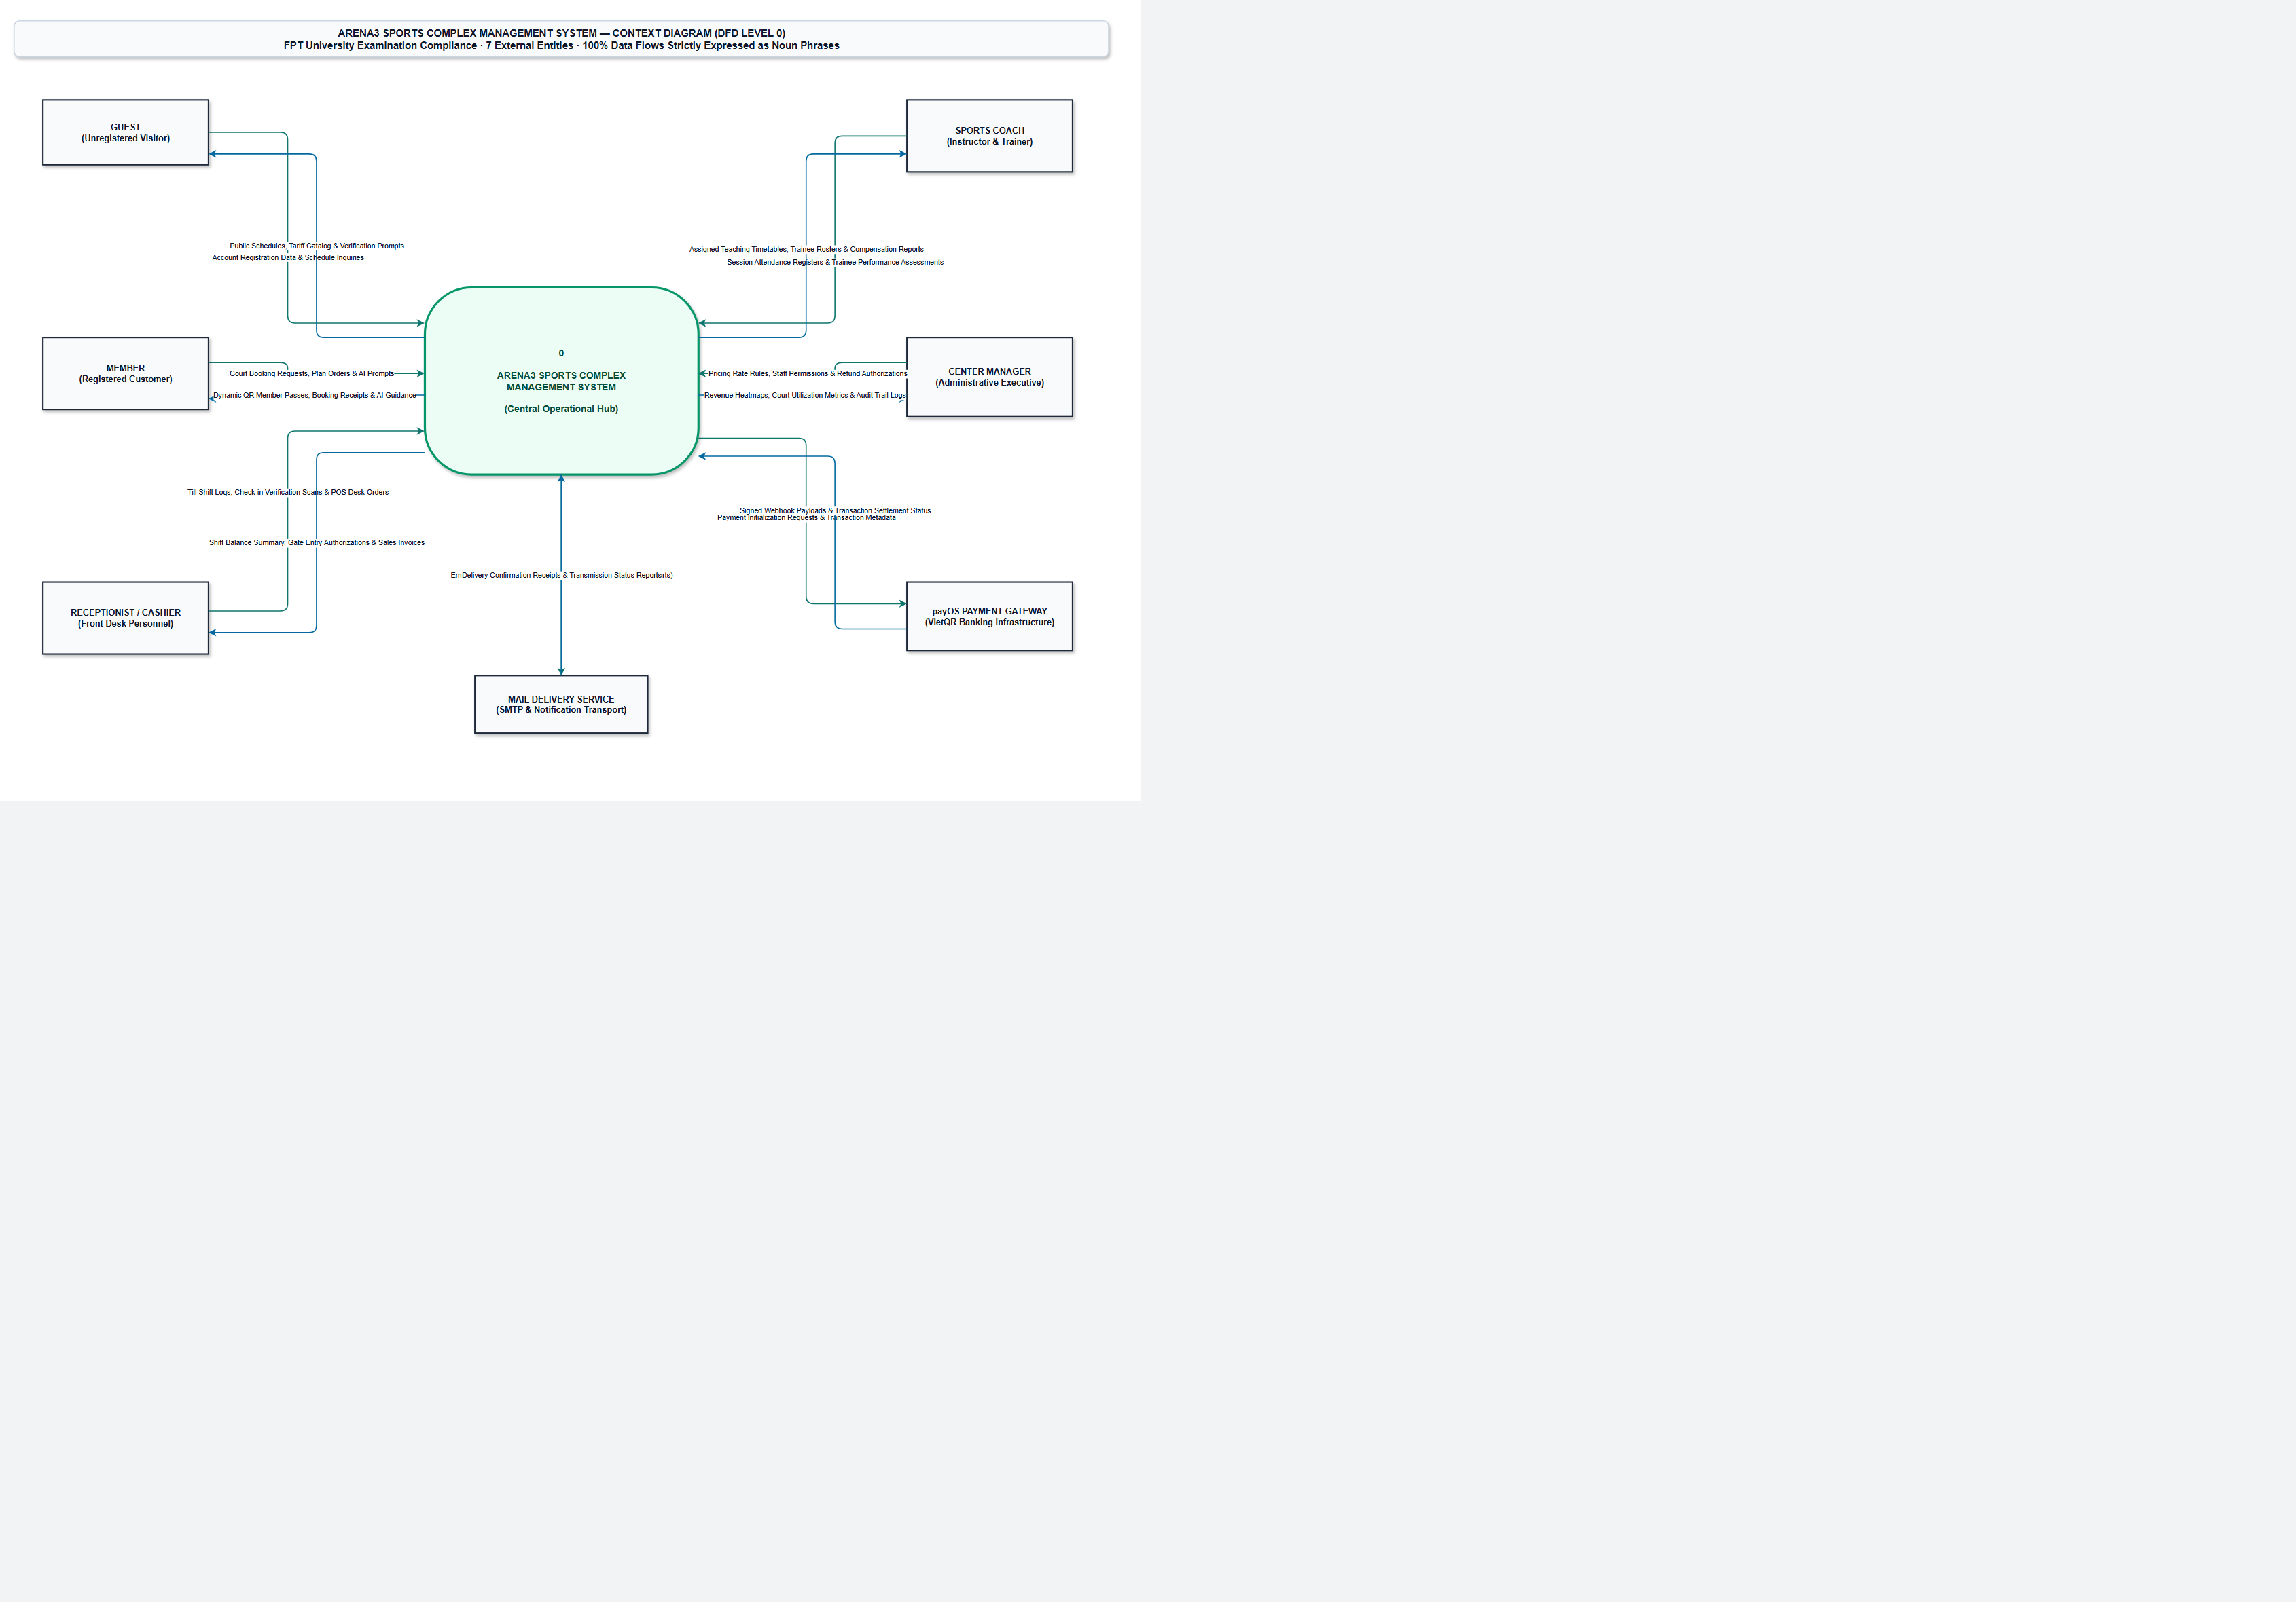
Figure 1. System context.

2.1.2 Use case diagram
Figure 2 illustrates the system boundary, the 9 actors outside it, and the functional use cases organized across six core business packages compliant with UML 2.0. Solid lines connect primary initiating actors. Dashed lines indicate <<include>> and <<extend>> dependencies. Guest browses public schedules and registers an account. Member books courts, joins classes, purchases plans, views training progress, and queries the AI Assistant. Receptionist manages till shifts, processes cash and VietQR POS sales, checks members in via QR pass or member code, and handles gear rentals. Coach manages assigned classes, attendance registers, training evaluations, and student drills. Manager oversees center settings, pricing matrices, promo vouchers, staff permissions, class lifecycles, and financial/capacity analytics. AI Assistant provides smart conversational guidance. Mail Delivery Service dispatches verification codes and electronic invoices. Background Scheduler executes maintenance sweeps.
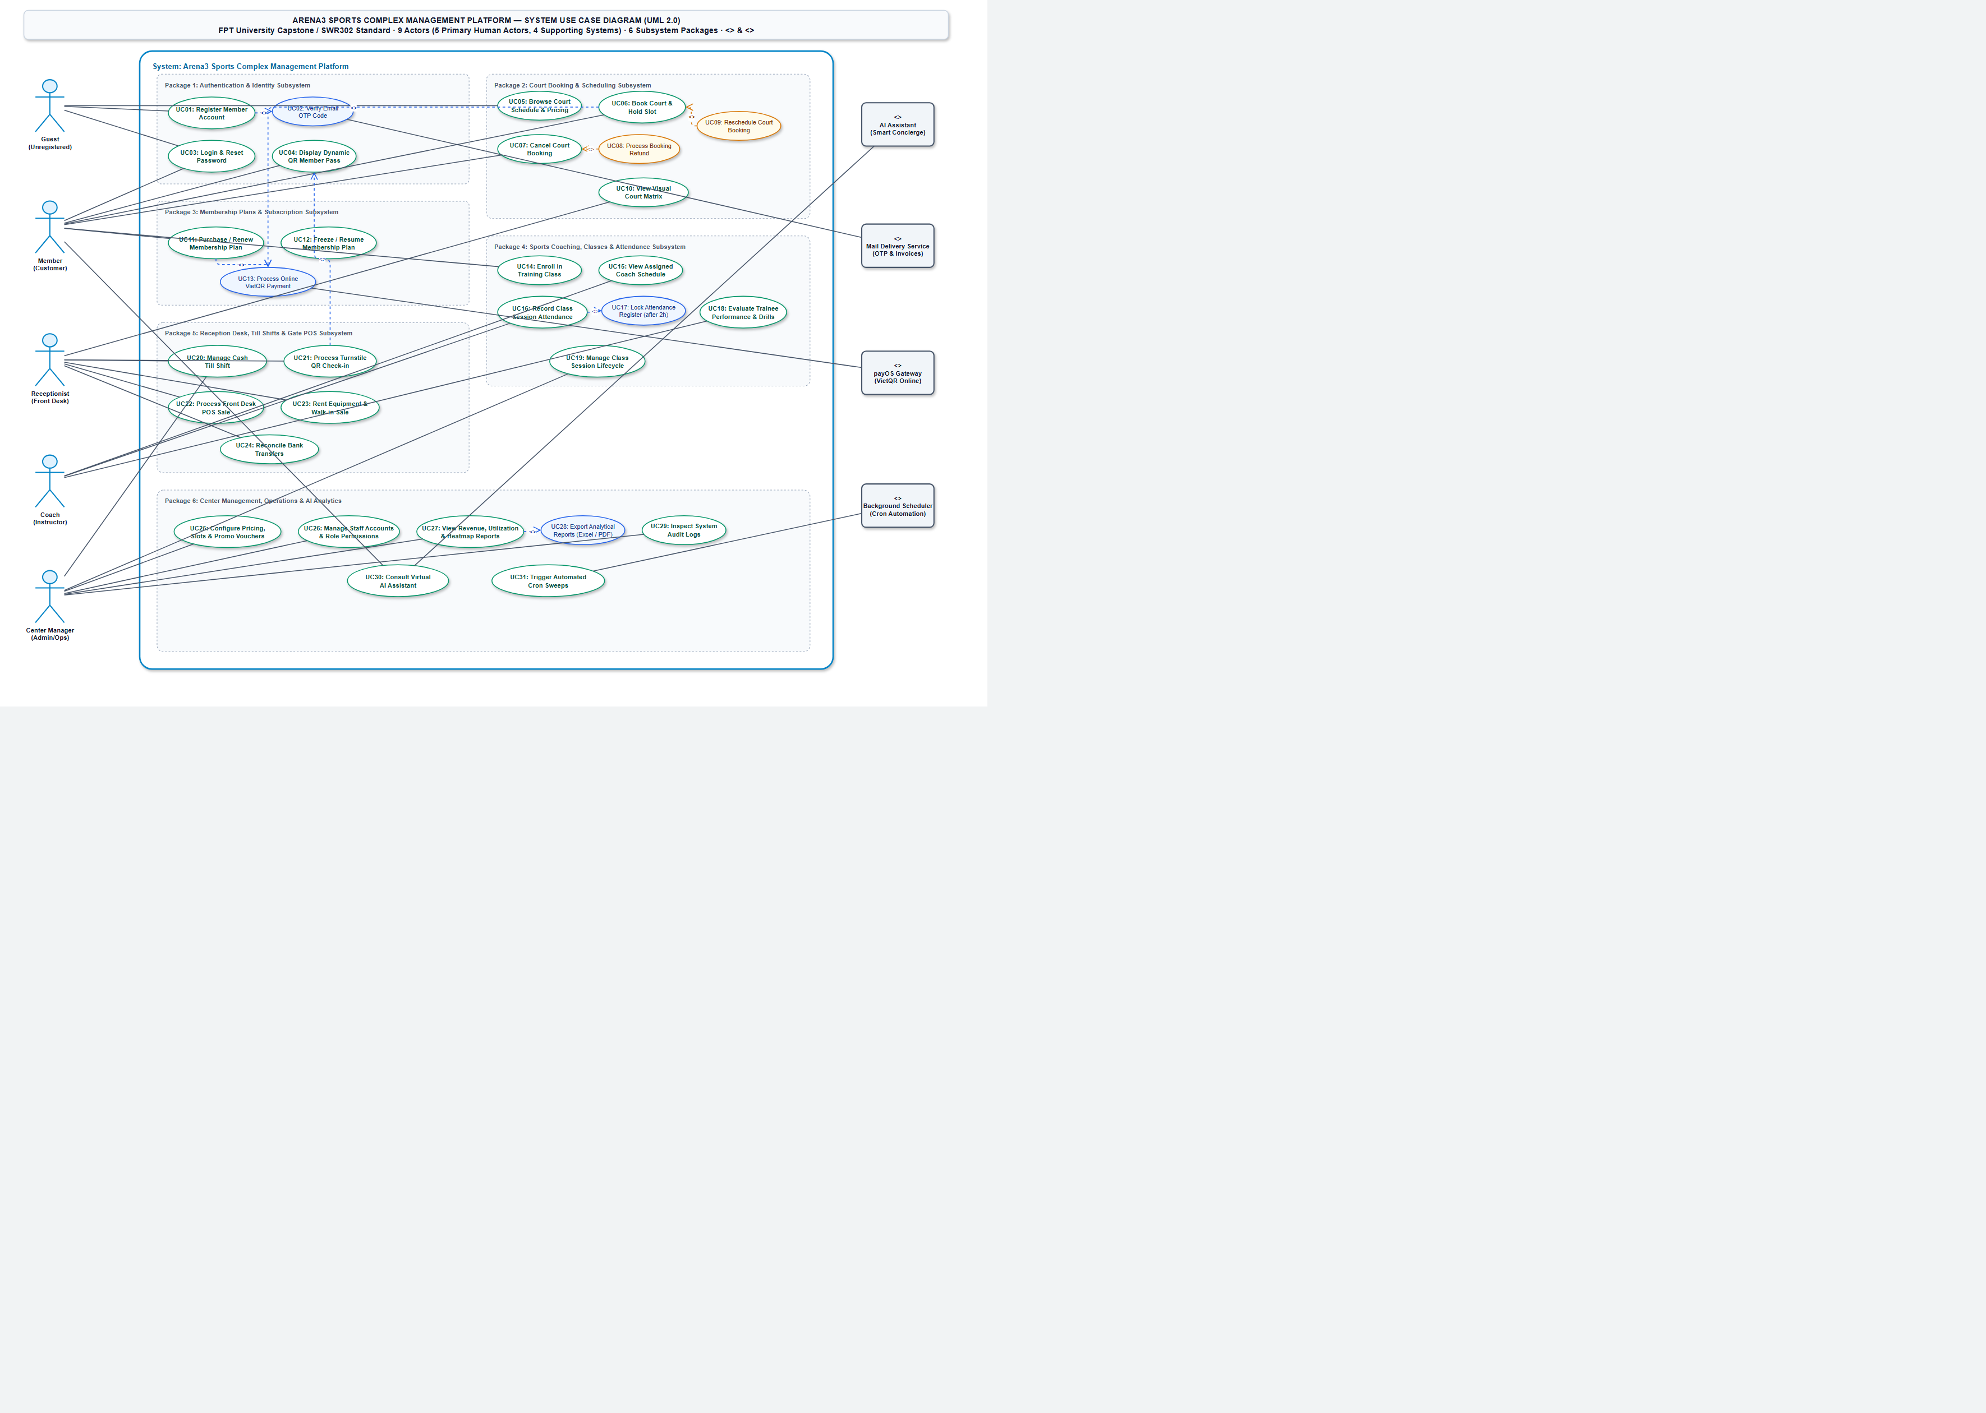
Figure 2. Arena3 use cases.

2.1.3 Activity diagrams
The four flows below are activity diagrams, drawn as swimlanes. A red box is a refusal. A green box is the end that succeeded.
Figure 3 is the registration workflow depicted as a five-lane activity diagram: Guest, Web UI Frontend, Arena3 Backend API, Mail Service, and PostgreSQL Database. When the Guest submits registration info, the frontend validates inputs and calls the API. Arena3 generates a 6-digit OTP, hashes it, stores the temporary challenge with a 5-minute TTL in the database, and dispatches the OTP via the Mail Service. The Guest enters the OTP received via email; once verified against the database, the active member account is created with a unique member code, the challenge is consumed, and the user session is issued.
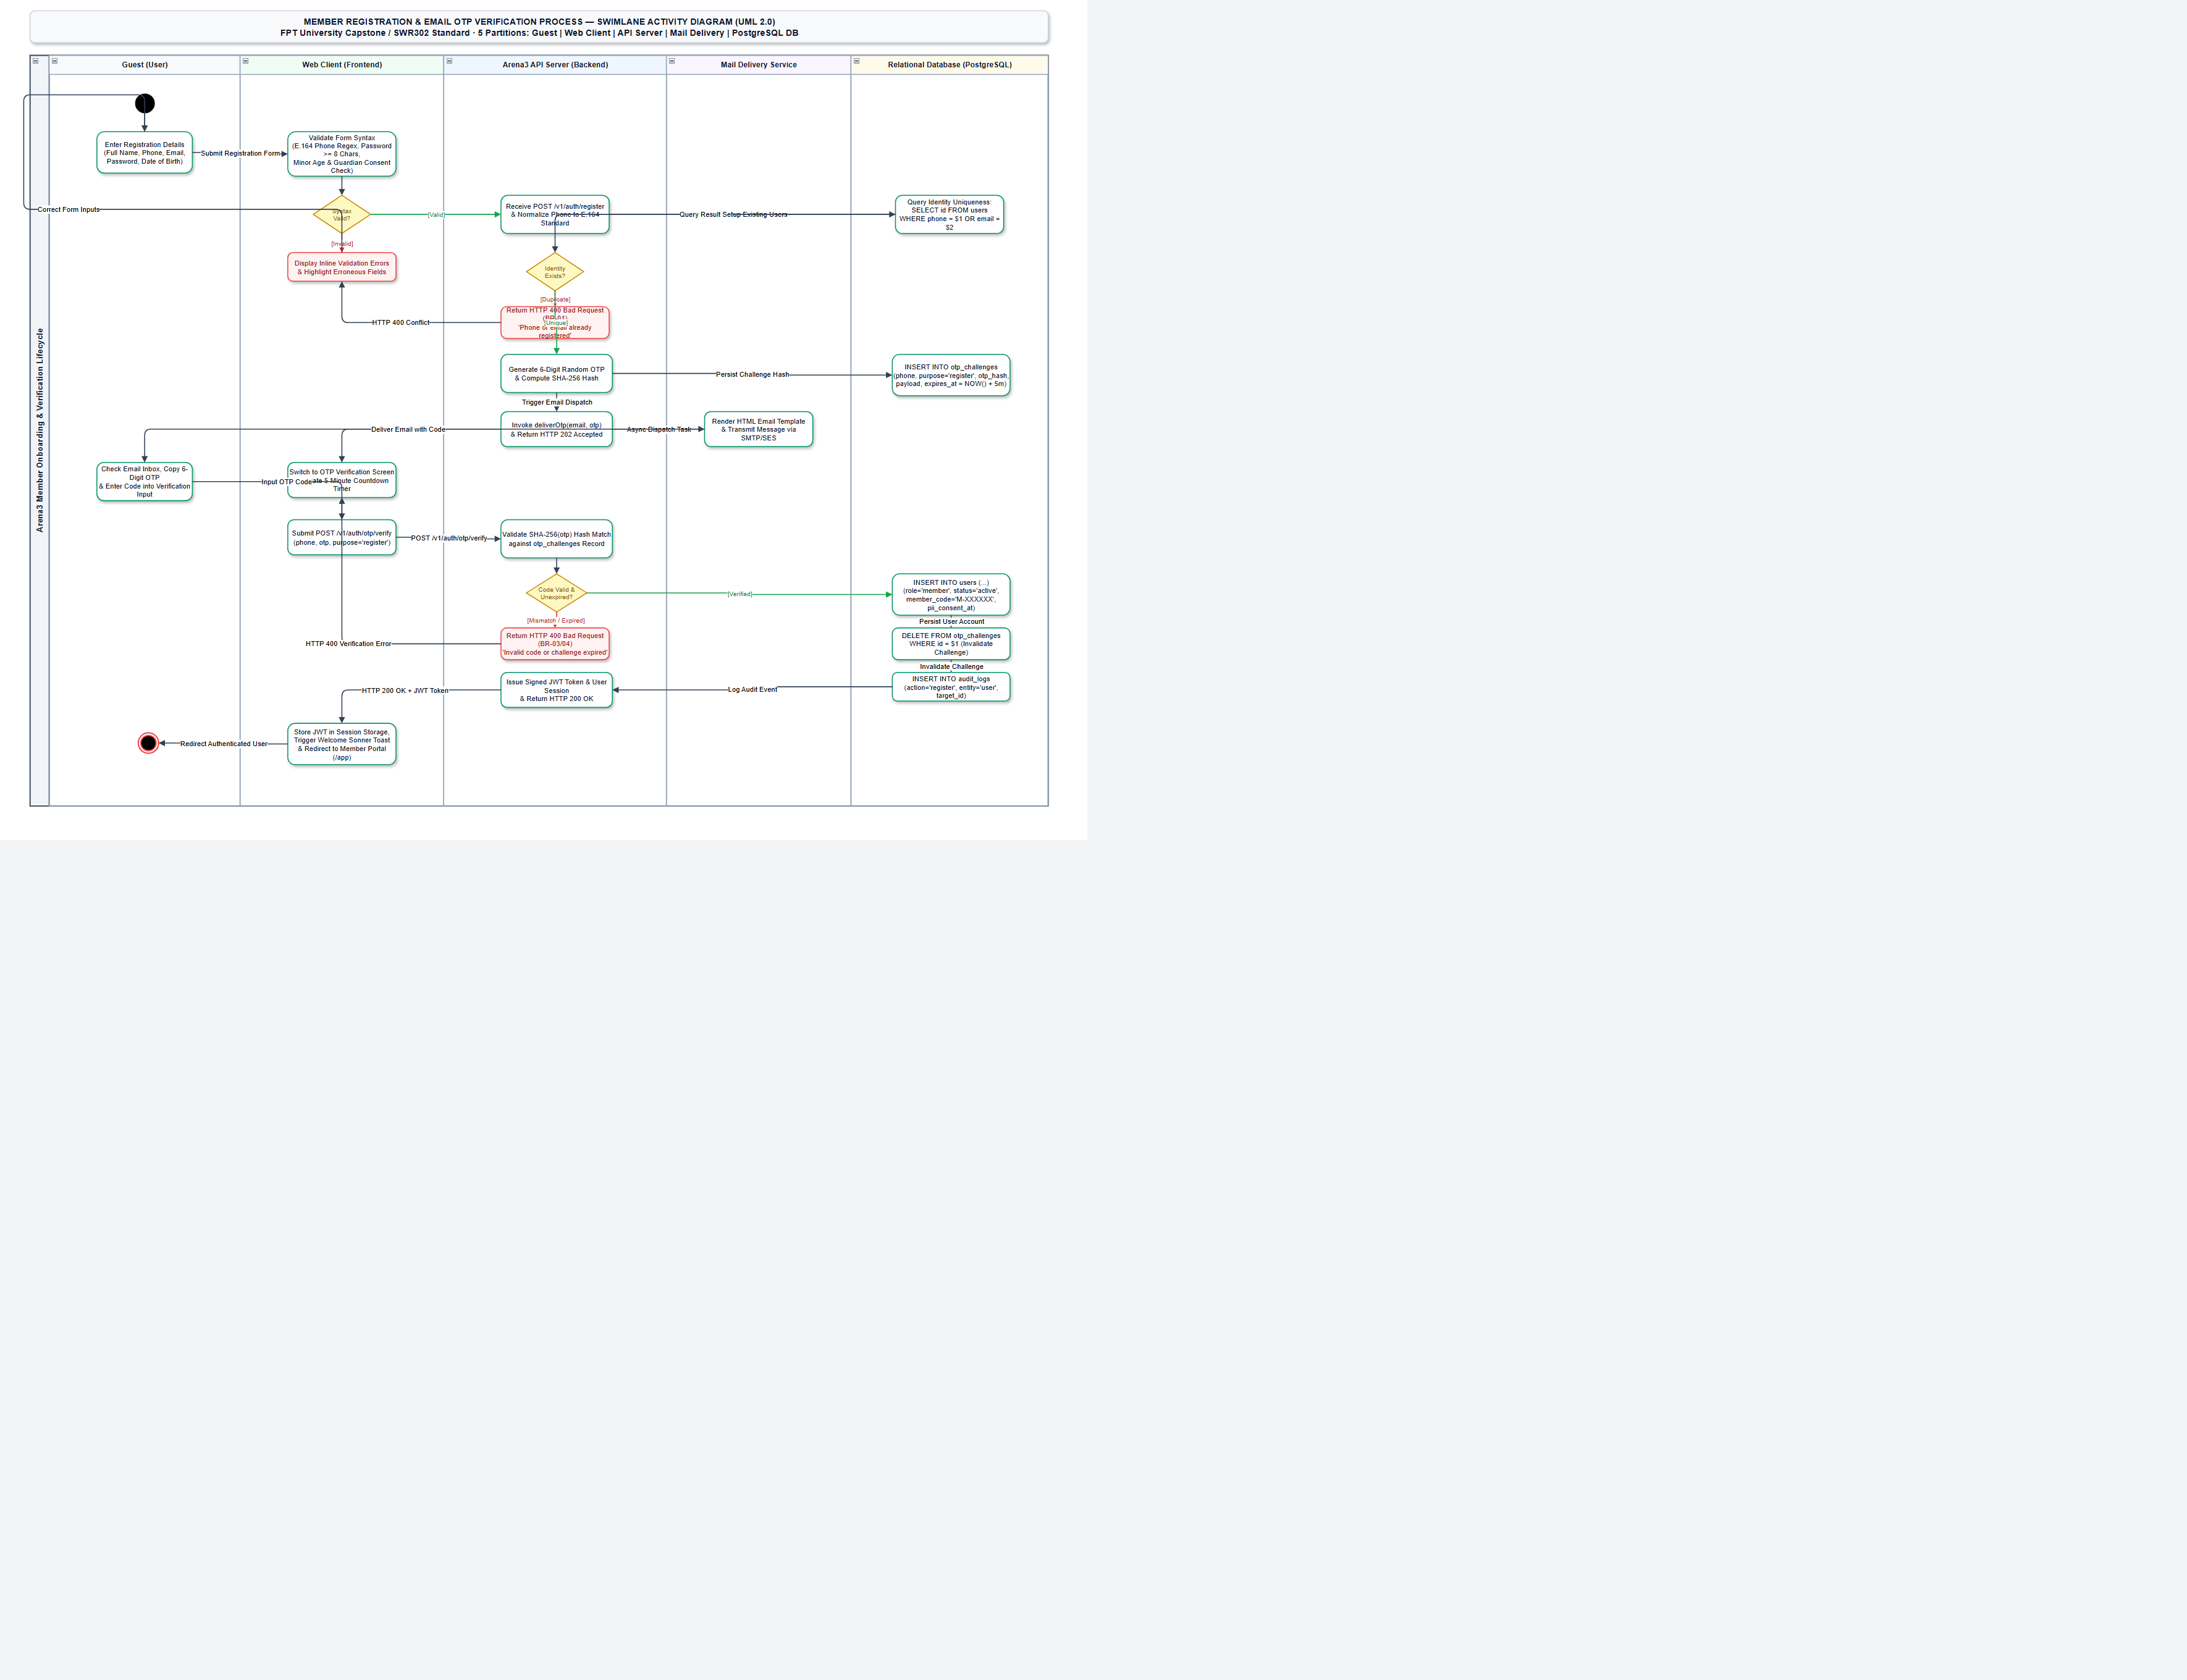
Figure 3. Register, then confirm the code.
Figure 4 is sign-in. A missing account and a wrong password use the same refusal. An account whose status is not active is refused as not active. Five wrong passwords start a 15-minute timer and leave the status active. A member session lasts 7 days. Every other role lasts 12 hours. Sign-in opens that role's home. An account that must change its password still opens the home. Account opens on Security while that flag is set, and a valid change clears the flag and opens the home again.
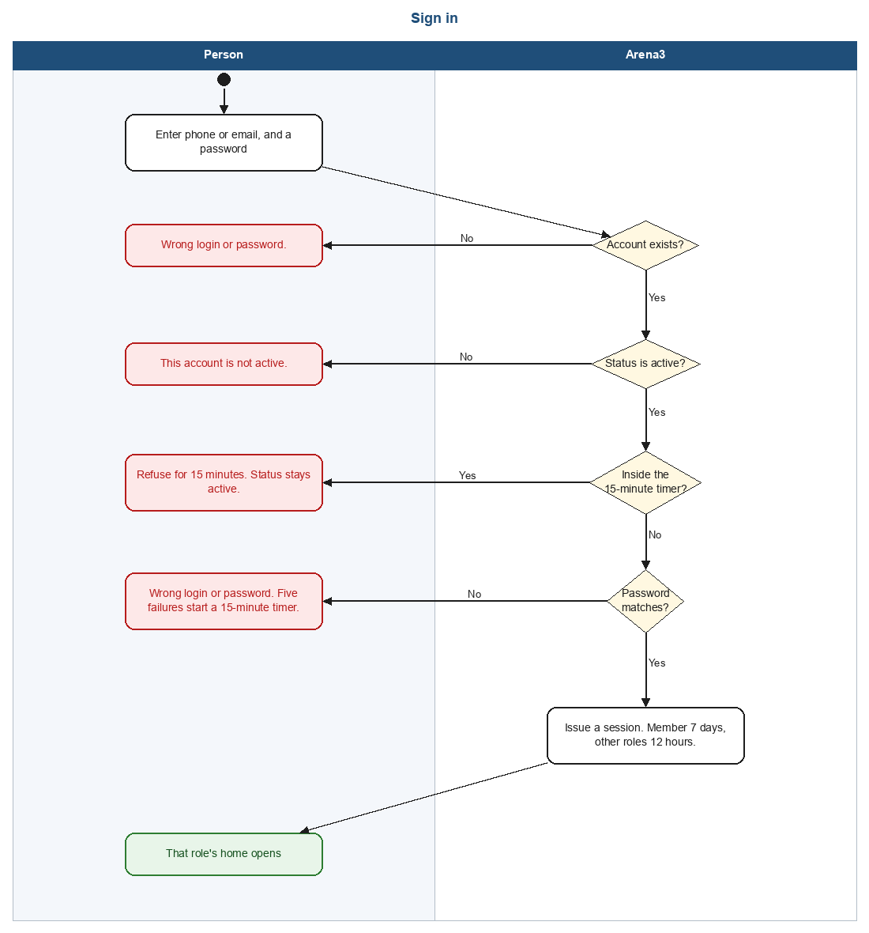
Figure 4. Sign in.
Figure 5 is an online court booking. The slot is held for five minutes. payOS shows one VietQR. Arena3 confirms the booking only after it has polled payOS, or a webhook whose signature checks arrives, and the amount paid covers the amount due, and the hold is still alive. The browser's return page posts nothing. If no price matches, nothing is held.
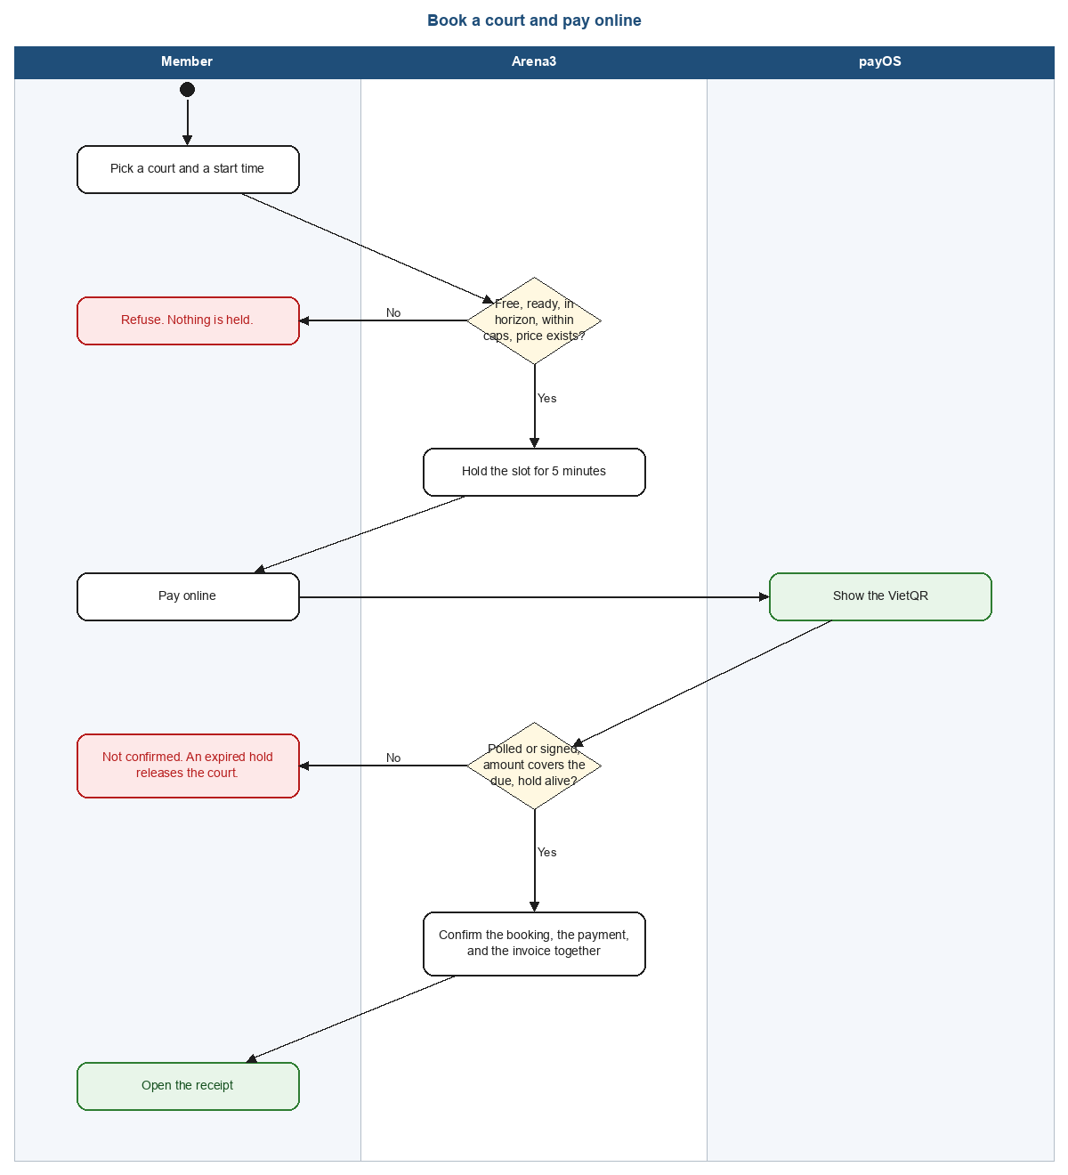
Figure 5. Book a court and pay online.
Figure 6 is a cancellation. A hold is released with no refund. A confirmed booking is refunded on the centre's tiers: 100 percent at 24 hours or more, 50 percent from 4 hours, and nothing under 4 hours, including after the start. A staff waive is 100 percent. Plan hours come back only when the refund is at least 50 percent. A refund of at least 1,000,000đ waits for the manager. The same payment cannot be refunded twice. In use, completed, and no-show are not cancelled on this path. cancel_court_hours (default 2 hours) gates a reschedule, not a cancellation.
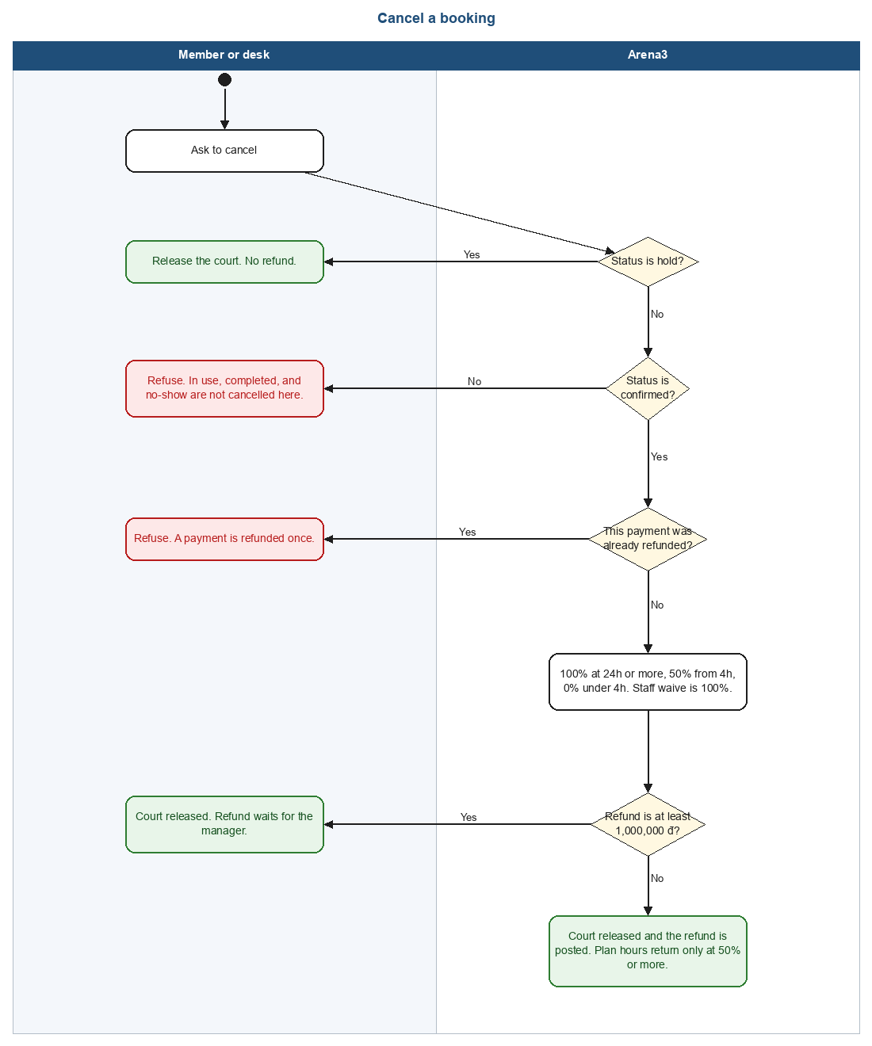
Figure 6. Cancel a booking.

2.1.4 Sequence diagrams
Figures 7 to 10 are the same four paths as messages in time. A solid arrow is a request. A dashed arrow is the reply. A line marked alt is one outcome, not a step that always runs.
Figure 7 is registration. The form does not create the account. A five-minute code is stored first, and the member is created only when the code matches. A sixth wrong try locks that code for 15 minutes.
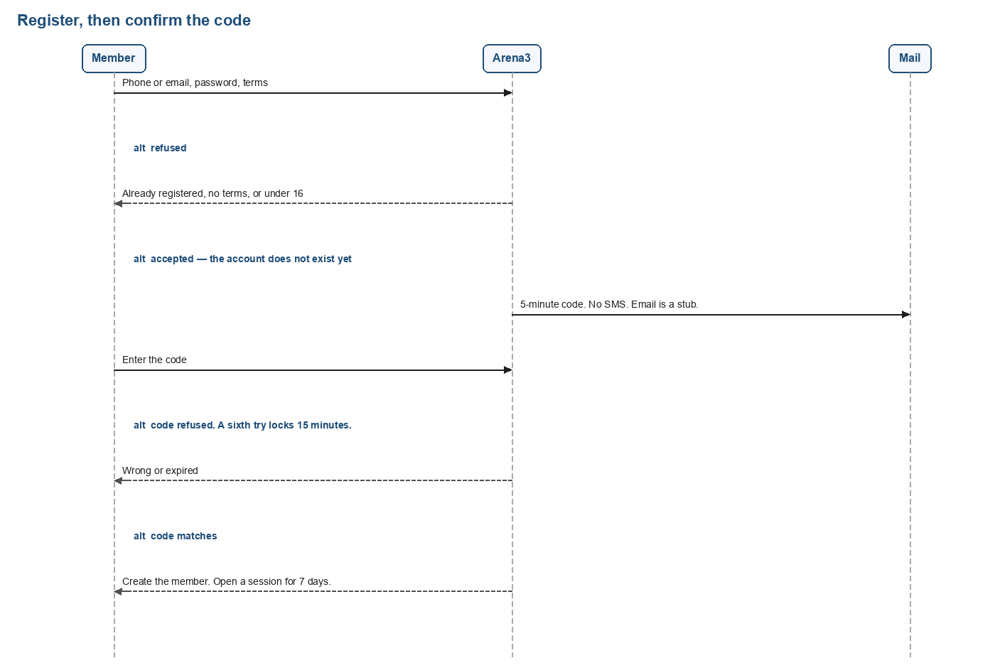
Figure 7. Register, as a sequence.
Figure 8 is sign-in. A missing account and a wrong password share one refusal. Five failures start a 15-minute timer and leave the account active. The session is 7 days for a member and 12 hours for every other role.
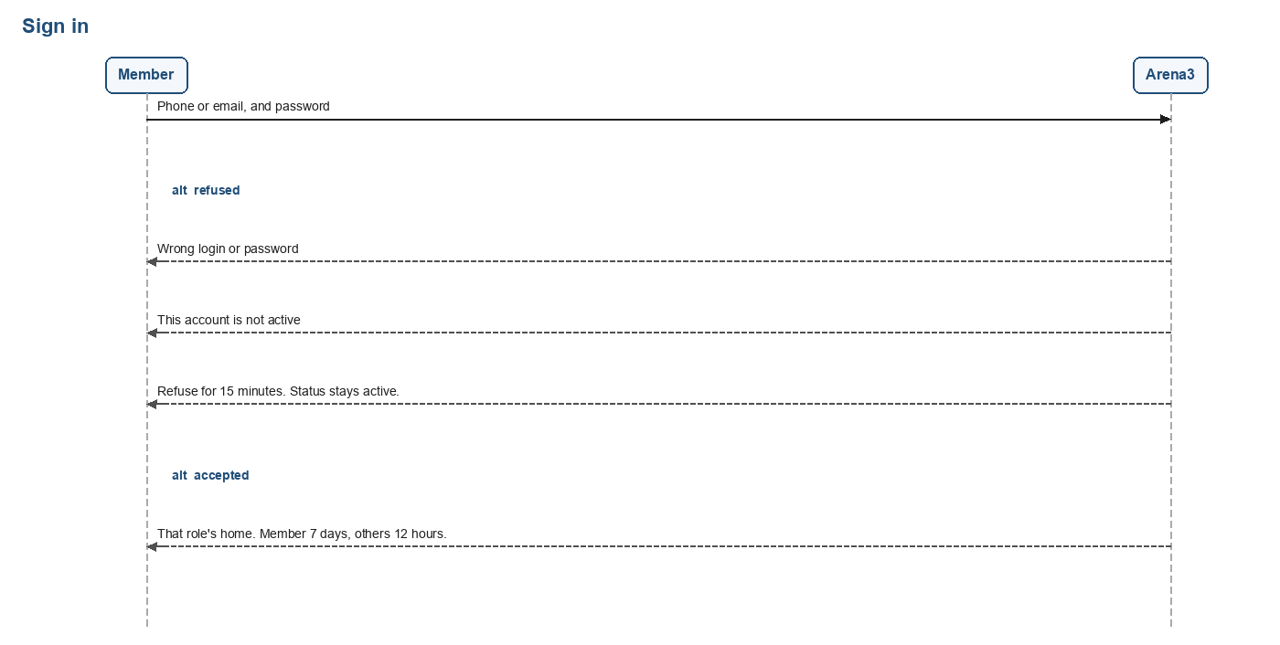
Figure 8. Sign in, as a sequence.
Figure 9 is an online booking. The return page is not a message that posts money. Arena3 confirms the booking only from a poll or a signed webhook, while the hold is still alive and the amount covers what is due.
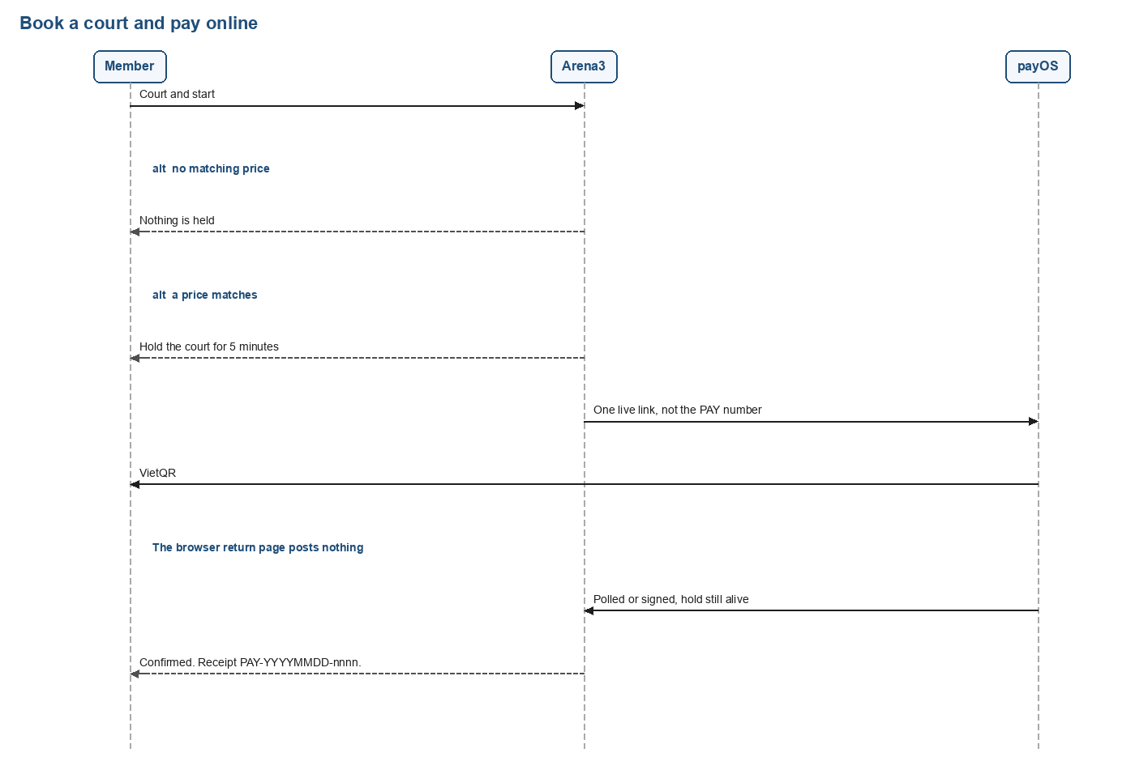
Figure 9. Book a court and pay online, as a sequence.
Figure 10 is a cancellation. A hold ends with no refund. A confirmed booking uses the hour tiers, a staff waive is the full amount, and a refund of at least 1,000,000đ waits for the manager. Plan hours come back only at 50 percent or more.
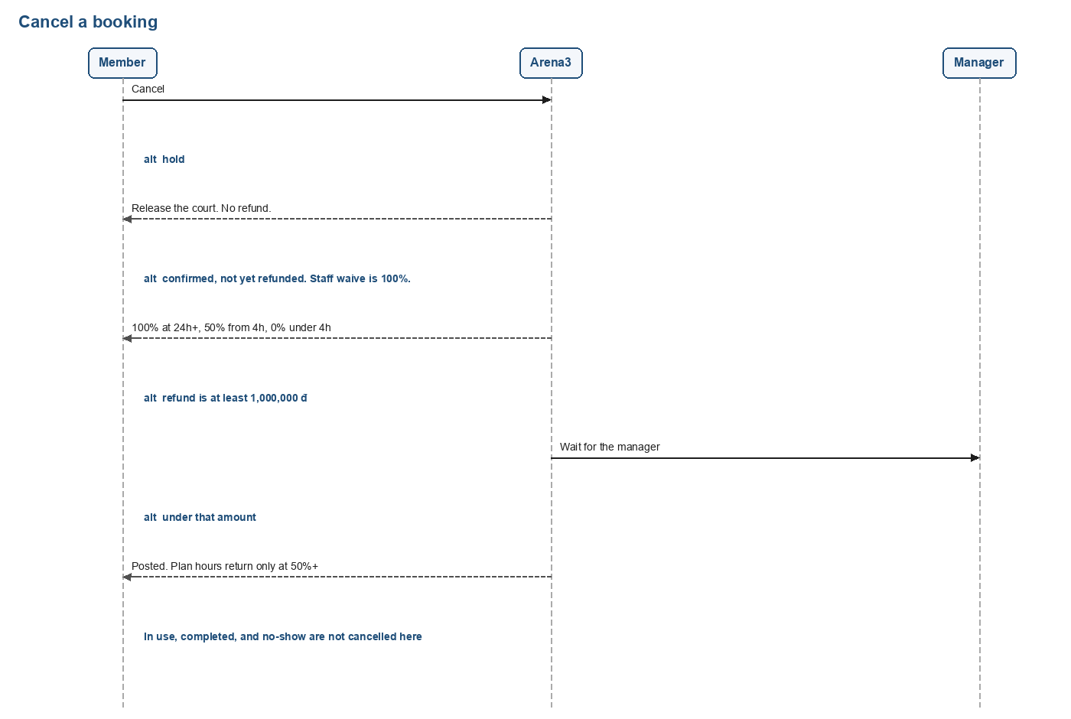
Figure 10. Cancel a booking, as a sequence.

2.1.5 State diagrams
A court booking moves through the states in Figure 11. A hold is not yet a sale. Paying confirms it. Check-in marks it in use, and the end of the slot completes it. A hold that expires, or a hold that is cancelled, releases the court. A confirmed booking that is cancelled also releases it. A confirmed booking that nobody checks in becomes a no-show after the grace period. A no-show is not a cancellation, so the refund tiers do not apply. No-show is never reached from in use.
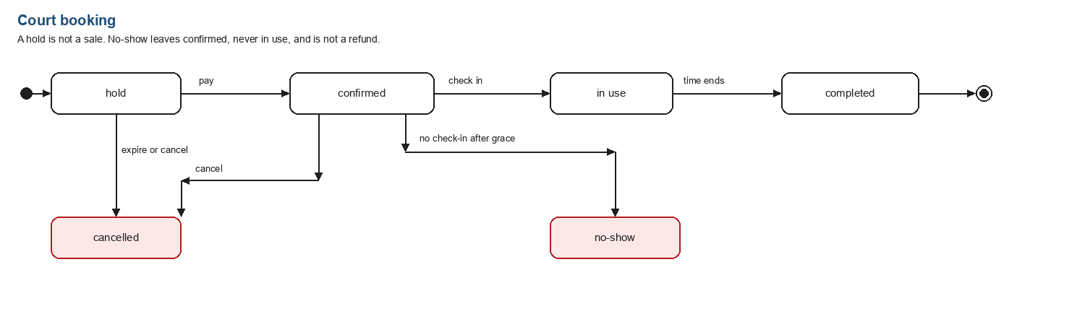
Figure 11. Court booking states.
Figure 12 is the other state a reader meets. A manager sets a staff account to active or locked. Locking revokes that person's open sessions, and a manager cannot lock their own account. Five wrong passwords do not change this status. They start a 15-minute timer, and the account stays active. The value disabled exists on the account, and no screen sets it.
A session starts as a guest. Sign-in stores a token on the device. Closing the browser does not end it. Logout deletes it. It also ends when it expires: 7 days for a member, and 12 hours for every other role.
A membership plan is pending until its payment is posted, then active. The desk or the manager can freeze an active plan for 1 to 90 days, inside the yearly cap, and the end date moves by those days. Unfreeze returns it to active. A job moves an active plan to expired when the end date is before today.
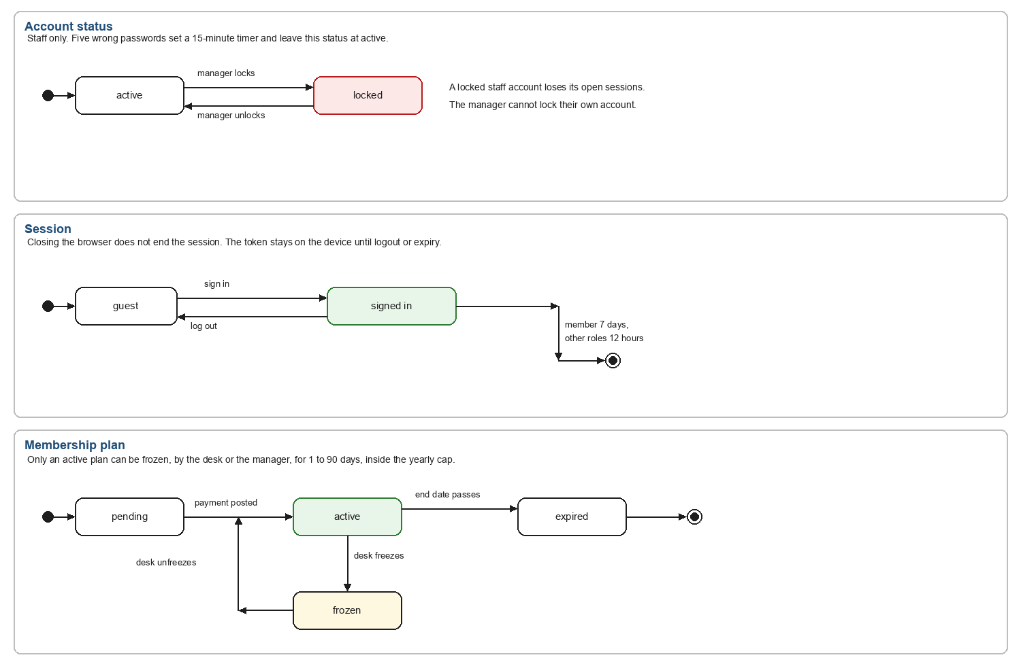
Figure 12. Account, session, and membership-plan states.
The five maps that follow are the screens each role walks through. A box is a screen or a panel. Screens added after those maps were drawn are in Figure 18.

Public and authentication
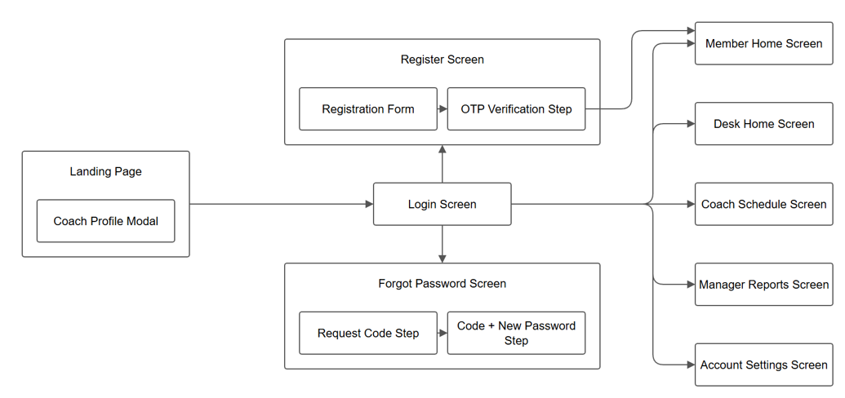
Figure 13. Public pages and sign-in.

Member
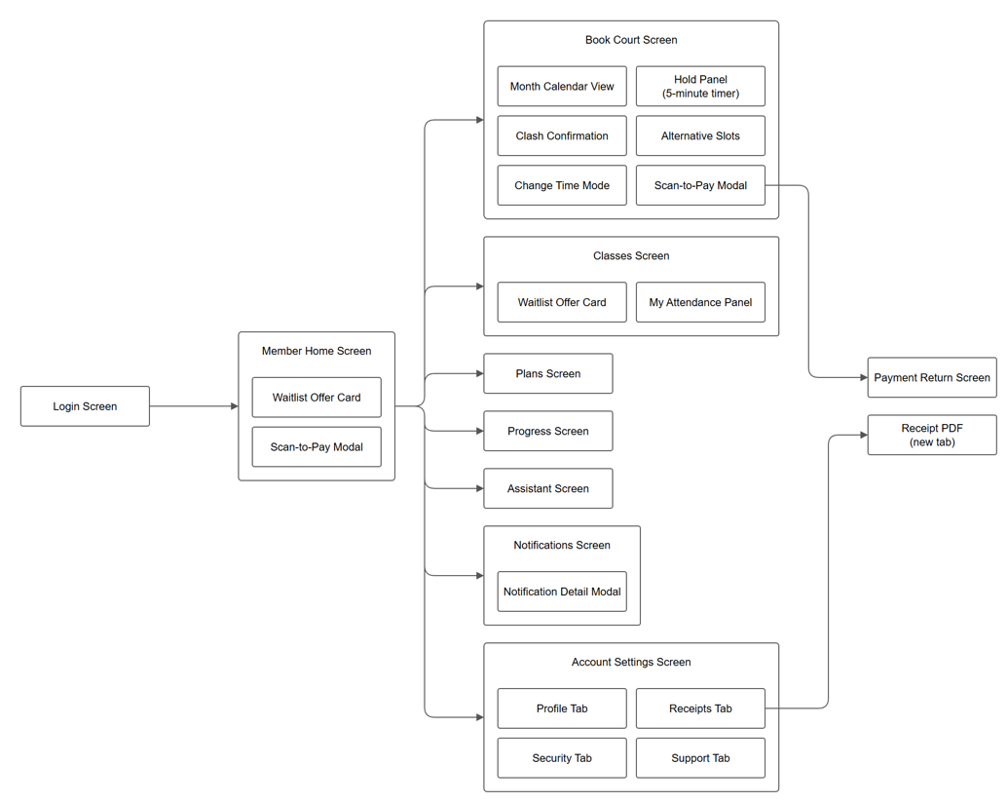
Figure 14. Member screens.

Receptionist
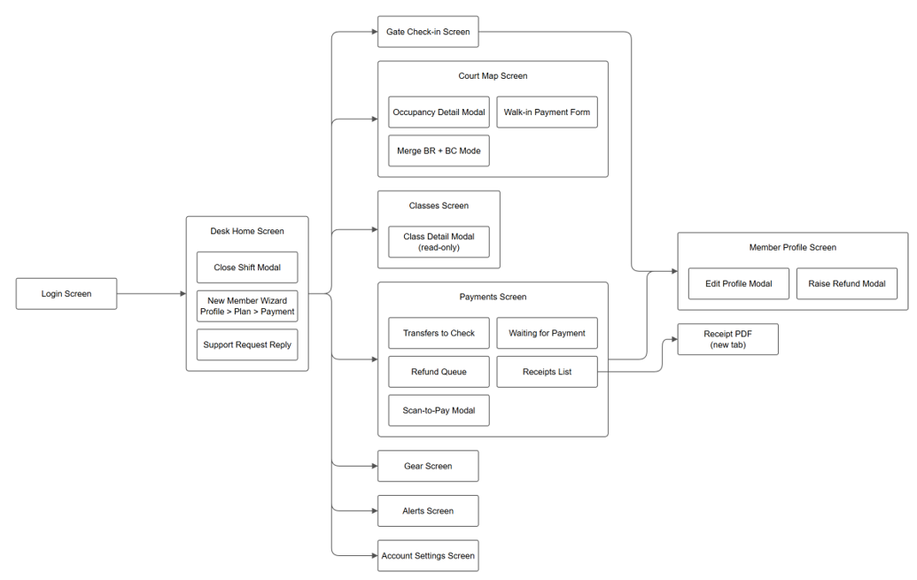
Figure 15. Front desk screens.

Coach
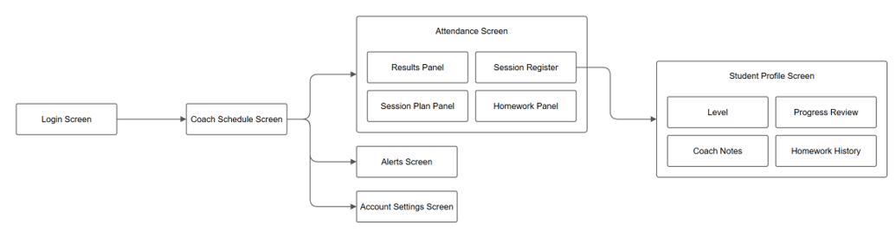
Figure 16. Coach screens.

Manager
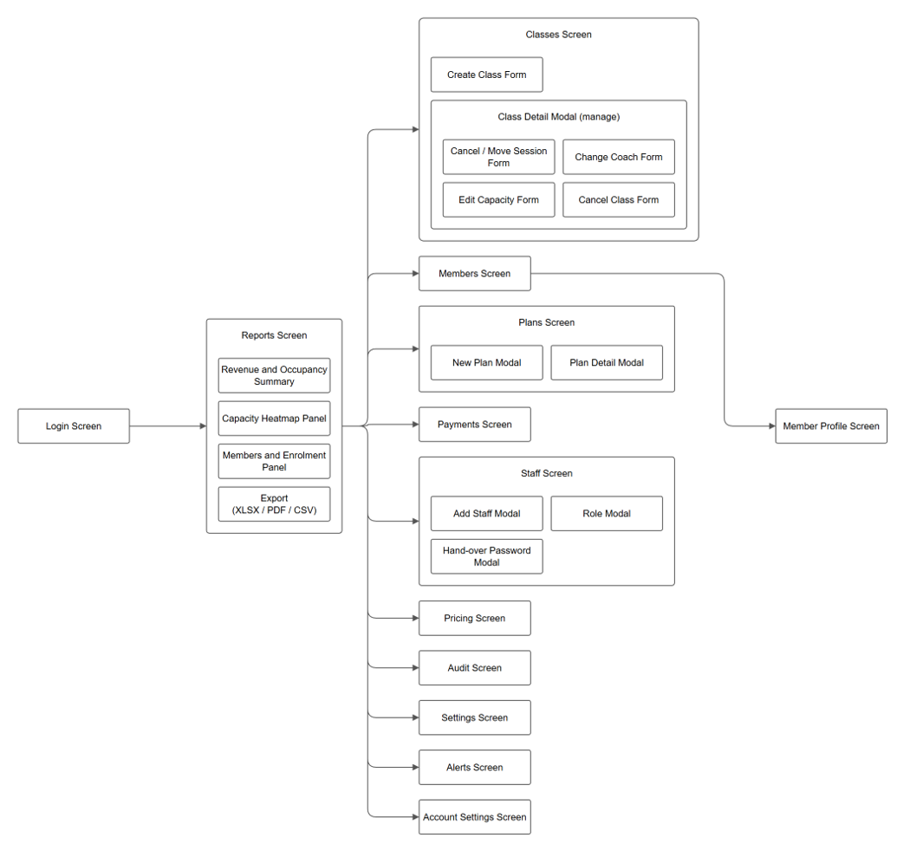
Figure 17. Manager screens.
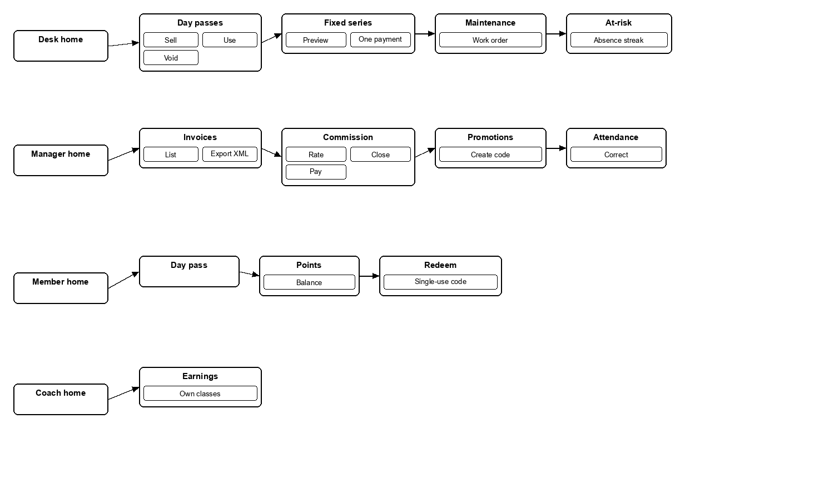
Figure 18. Day pass, points, fixed series, maintenance, invoices, commission, promotions, and coach earnings.

2.2 User classes and characteristics
The system defines nine actors: five primary human user classes (Guest, Member, Receptionist, Coach, Manager) and four automated/external services (AI Assistant, Mail Delivery Service, Background Scheduler, and payOS Payment Gateway).
# | Actor | Description
1 | Guest (Unregistered Visitor) | Unregistered visitor. Browses public court schedules, tariff catalog, coach rosters, and initiates account registration with Email OTP verification.
2 | Member (Registered Customer) | Registered active customer. Books courts, enrolls in training classes, purchases membership plans, checks in at gate via dynamic QR pass or member code, interacts with AI Assistant, and tracks personal training progress.
3 | Receptionist (Front Desk / POS) | Front-desk personnel. Opens/closes cash till shifts, accepts cash and VietQR POS payments, scans QR passes or inputs member codes for gate check-in, rents equipment, and processes walk-ins.
4 | Coach (Sports Instructor) | Conducts sports training classes. Views assigned teaching schedules, manages session attendance registers, records trainee skill assessments, drills, and homework.
5 | Center Manager (Operations / Admin) | Executive administrator. Manages pricing matrices, promo vouchers, staff permissions, class lifecycles, center settings, and views/exports financial and court utilization analytics (Excel/PDF).
6 | AI Assistant (Smart Concierge) | In-app intelligent virtual assistant. Provides conversational guidance regarding court availability, membership plans, schedules, and complex center rules.
7 | Mail Delivery Service (Email Engine) | External communication infrastructure. Dispatches transactional email OTP verification codes for registration and password resets, as well as e-invoices and booking alerts.
8 | Background Scheduler (Cron Engine) | Automated background job engine. Periodically releases expired court holds, marks booking no-shows, materializes class sessions, and executes database maintenance routines.
9 | payOS Payment Gateway (VietQR) | External banking payment gateway. Generates standard Napas247 VietQR payment links, verifies digital transaction signatures, and broadcasts signed webhook confirmations.
Yes in the matrix means the role can open that function. Own means only that person's records. A dash means the server refuses the request. The manager can also open the desk and the coach screens.
Screen or function | Manager | Coach | Receptionist | Member | Guest
Landing, login, register, forgot password | Yes | Yes | Yes | Yes | Yes
Member home, book, classes, plans | — | — | — | Yes | —
Progress, day pass, points, assistant | — | — | — | Yes | —
Own receipts and support | Yes | Yes | Yes | Own | —
Desk home, court map, walk-in | Yes | — | Yes | — | —
Gate, gear, day pass sale, fixed series | Yes | — | Yes | — | —
Take cash, card, transfer, show QR | Yes | — | Yes | — | —
Pay a held court online | Yes | — | Yes | Own hold | —
Reconcile or reject a transfer | Yes | — | Yes | — | —
Raise a refund | Yes | — | Yes | — | —
Approve a refund at or above the threshold | Yes | — | — | — | —
Approve a refund below the threshold | Yes | — | Yes | — | —
Coach schedule, register, student, earnings | Yes | Own | — | — | —
Correct a locked register | Yes | — | — | — | —
Create and cancel classes, change coach | Yes | — | — | — | —
Plans, prices, promotions, settings, staff | Yes | — | — | — | —
Reports, export, audit, invoice XML | Yes | — | — | — | —
Commission close and mark paid | Yes | Own earnings | — | — | —

2.3 Operating environment
The product is a web application used from a desk computer or a phone.

2.3.1 Client environment
- The interface is React and TypeScript, styled so every screen is usable at a phone width. The member site can be installed as a progressive web app.
- It runs in current Chrome, Edge, and Safari on Windows, macOS, and phones.
- Running text uses a face that renders Vietnamese diacritics. Amounts are written 1,500,000đ.

2.3.2 Server environment
- The server is Node, using TanStack Start. The deployed site is served over HTTPS.
- Authorization is decided on the server. The menu only reflects that decision.

2.3.3 Database environment
- The live database is PostgreSQL. Schema changes are SQL files under migrations and are applied in filename order. Editing a file that has already been applied does not run it again.
- With no external database configured, a local copy can start on an embedded database. That mode is for a fresh copy, not for the centre's live data.

2.3.4 External service environment
- payOS issues the VietQR link and is the only authority for whether an online payment was paid.
- The assistant may call a model. If the key is absent, it answers from rules. Health notes and guardian details are not sent with that call.
- There is no SMS provider. Email delivery is a stub.

2.4 Design and implementation constraints

2.4.1 Technology constraints
- The interface is React and TypeScript. The server is Node. The database is PostgreSQL.
- The browser and the server exchange JSON. The browser does not open a database connection.

2.4.2 Architecture constraints
- A court becomes busy only by an occupancy. A booking, a class session, and a maintenance job share that rule.
- A confirmed booking, its payment, and its invoice are written in one transaction, or not at all.
- Two requests for the same court-time cannot both win. The court row is locked, and the database rejects the overlap.

2.4.3 Security constraints
- Passwords are stored as salted hashes. A session token is stored as a SHA-256 hash. The raw token stays on the client. This is a bearer session, not a refresh-token cookie.
- A member session lasts 7 days. A staff session lasts 12 hours.
- There are four roles and no separate administrator role. A manager cannot lock or demote themselves. There is no public staff sign-up.
- The one-tap demo sign-in is off in production unless it is explicitly switched on. The one-time code is not echoed there.

2.4.4 Database constraints
- Money is an integer number of dong. A price is above 0 and at most 5,000,000đ, rounded to round_vnd (default 1,000).
- Document numbers come from one counter. The receipt form is PAY-YYYYMMDD-nnnn. The payOS order code is a different number and is not the receipt.
- Audit rows are append-only. No request deletes one.

2.4.5 Development constraints
- Source is kept in Git. Secrets, including the database URL and the payOS checksum key, are not written into the repository.

2.4.6 Deployment constraints
- The application is deployed as a web service over HTTPS. A push of the working branch produces a preview. Production is updated by promoting a deployment, not by the push alone.

2.4.7 Integration constraints
- payOS is called only from the server. The checksum key is not sent to the browser.
- A payment is trusted only from a poll of payOS or from a webhook whose signature checks, and only when the amount paid covers the amount due.
- If payOS is not configured, online payment is refused and the desk can still take the money.

2.4.8 Completion constraints
A feature is treated as done when the server enforces the rule, a refusal is a sentence that says what to do next, and a sale that takes money commits the payment and the thing it paid for together.

2.5 Assumptions and dependencies

2.5.1 Assumptions
- AS-1. The centre is one site in Vietnam. Timezone and currency stay fixed.
- AS-2. A member is identified by one Vietnamese phone number.
- AS-3. A bank transfer is reconciled by a person. There is no bank feed.
- AS-4. Opening hours, slot length, hold length, and the refund tiers are settings. The defaults in this document are the defaults in the database, and the manager can change them.

2.5.2 Dependencies
- DE-1. Online payment depends on payOS. The desk does not.
- DE-2. The live data depends on the hosted PostgreSQL database.
- DE-3. Model answers from the assistant depend on a configured model key. Rule-based answers do not.

3. System features

3.1 Business rules
A constraint is something the server refuses. A fact is something the product does. Dynamic means the number comes from centre settings. Static means the code fixes it. The source column names the module, not every line.
ID | Rule | Type | Changes | Source
BR-01 | One account per phone number or email. | Constraint | Static | auth.ts
BR-02 | A password is at least 8 characters and mixes letters and digits. | Constraint | Static | auth.ts
BR-07 | A member under minor_age (default 16) needs a guardian name and phone. | Constraint | Dynamic | auth.ts
BR-08 | Registration requires the terms and the privacy notice. | Constraint | Static | auth.ts
Fact | An account is created only after the one-time code matches. The code expires in 5 minutes. Five wrong attempts lock it for 15 minutes. | Fact | Static | auth.ts
Fact | A password reset returns the same response whether or not the phone has an account. | Constraint | Static | auth.ts
Fact | Five wrong passwords lock sign-in for 15 minutes. | Constraint | Static | auth.ts
Fact | A member session lasts 7 days. A staff session lasts 12 hours. | Fact | Static | session.ts
BR-32 | A booking stays inside book_ahead_days (default 7) and max_slots_per_day (default 2). | Constraint | Dynamic | bookings.ts
BR-34B | No matching price rule means no price. The price is above 0 and at most 5,000,000đ. | Constraint | Static | policy.ts
BR-35 | A slot is inside opening hours, and the court is ready. | Constraint | Dynamic | bookings.ts
BR-44 | A member over the debt limit cannot book until they settle. | Constraint | Dynamic | bookings.ts
BR-66 | No booking in the past. A walk-in into a slot already started needs 20 minutes left. | Constraint | Static | bookings.ts
Fact | A hold lasts hold_minutes (default 5). Choosing bank transfer extends it to transfer_hold_minutes (default 120) and posts no payment. | Fact | Dynamic | bookings.ts
Fact | Cancel refund tiers default to 100% at 24 hours or more, 50% from 4 to 24, and 0% under 4. Moving a booking is refused inside cancel_court_hours (default 2), and is refused when the price would change. | Fact | Dynamic | policy.ts
BR-12 | Class enrolment needs an active plan that covers that sport. | Constraint | Static | classes
BR-14 | Only an active plan can be frozen, and a frozen plan blocks buying another. | Constraint | Static | subscriptions
BR-15 | Freeze days per year are capped. | Constraint | Dynamic | subscriptions
BR-17 | Paying with quota needs court hours left. One hour is consumed. | Constraint | Static | bookings.ts
BR-18 | A session-quota plan must have sessions left. | Constraint | Static | classes
BR-20 | A member leaves a class only up to cancel_class_hours (default 4) before the next session. | Constraint | Dynamic | classes
BR-21 | A court or a coach cannot be in two places at once. | Constraint | Static | occupancy
BR-22 | Capacity cannot drop below the number enrolled. | Constraint | Static | classes
BR-23 | A coach is assigned only in a sport they teach. | Constraint | Static | classes
BR-24 | No duplicate enrolment, and no enrolment that clashes with one the member already has. | Constraint | Static | classes
BR-25 | A waitlist offer expires (default 2 hours). | Fact | Dynamic | jobs.ts
BR-26 | When the centre cancels a session, a per-session plan gets that session back once. | Constraint | Static | classes
BR-27 | A class can be handed to another coach from now on. | Fact | Static | classes
BR-28 | Moving a session less than 12 hours before it starts needs a reason. | Constraint | Static | classes
BR-39 | Occupancy stays consistent with the booking or the session that owns it. | Constraint | Static | database
BR-49 | An open till shift is required before staff take money. | Constraint | Static | desk.ts
BR-65 | A plan withdrawn from sale cannot be ordered. Members who already hold it keep it. | Constraint | Static | plans
BR-67 | Enrolment requires the class to be open. | Constraint | Static | classes
BR-70 | Only a manager creates or pauses a promotion. A used code is not deleted. | Constraint | Static | extras.ts
Fact | A refund at or above refund_manager_vnd (default 1,000,000đ) waits for the manager. The same payment cannot be refunded twice. | Constraint | Dynamic | desk.ts
BR-38 | Gear cannot be loaned beyond stock. The fee is not a payment. | Constraint | Static | desk.ts
Fact | A day pass defaults to 60,000đ, for one date, status issued, used, or void. | Fact | Dynamic | extras.ts
Fact | A fixed weekly booking is one court, one weekday, one hour, for 4 to 12 weeks. A taken week is skipped and not charged. | Fact | Dynamic | extras.ts
Fact | Points are posted court, plan, and day-pass payments divided by 10,000đ, plus adjustments. Redeem at least 50 points at 100đ each. | Fact | Dynamic | extras.ts
BR-53 | The register locks 2 hours after the session. A manager correction needs a reason of at least 3 characters. | Constraint | Static | attendance
BR-54 | Gate check-in never writes class attendance. | Constraint | Static | desk.ts
BR-55 | Health notes stay inside the viewer's scope and are not sent to the assistant model. | Constraint | Static | assistant
BR-56 | Training never charges money and never changes a plan balance. | Constraint | Static | training
BR-57 | Late is the coach's mark, not a calculation from the gate. | Fact | Static | attendance
BR-58 | Three Absent marks in a row raise an alert. Excused breaks the streak. The enrolment stays. | Fact | Static | jobs.ts
BR-59 | A coach works only the classes they lead or assist. | Constraint | Static | attendance
BR-62 | A switched-off feature flag answers 403 with BR-62. | Constraint | Static | training
Fact | Timezone stays Asia/Ho_Chi_Minh and currency stays VND. | Constraint | Static | settings

3.2 Use cases
The catalogue names every use case. The specification under each identifier follows the same fields: who starts it, what must already be true, the normal flow, the branches, and the refusals.
ID | Use case | Actors | Description
UC-01 | Register | Member | Create an account with name, phone, date of birth and a password. A minor must give a guardian. Terms must be accepted.
UC-02 | Confirm with OTP | Member, System | Enter the one-time code. The account is created only after the code matches. There is no SMS transport, so the code is not sent to a phone in this version.
UC-03 | Sign in | Member, Receptionist, Coach, Manager | Sign in with phone or email and a password. The home screen is the one for that role. Five wrong passwords lock the account for 15 minutes.
UC-04 | Reset password | Any signed-up user | Request a code, then set a new password of at least 8 characters mixing letters and digits, typed twice.
UC-05 | Edit own profile | Any signed-in user | Change own name and health notes, and own password. Nobody edits another person's password this way.
UC-06 | Book a court | Member | See live availability, hold a slot (default 5 minutes), then pay. Two people cannot hold the same court-time.
UC-07 | Reschedule a booking | Member | Move a confirmed booking to another slot outside the cancellation window. A different price is refused. A lost race leaves the booking where it was.
UC-08 | Cancel a booking | Member, Receptionist, Manager | Cancel a hold or a confirmed booking. A hold is released. A confirmed booking is refunded by the tiers (default 100% at 24 hours or more, 50% from 4 to 24 hours, nothing under 4). Staff may waive the fee.
UC-09 | Buy or renew a plan | Member, Receptionist | Order a plan that is on sale. It stays pending until the money is recorded. A frozen plan blocks a second purchase.
UC-10 | Join or leave a class | Member | Enrol when the plan covers that sport and the class is open. A full class offers a waitlist place. Leaving is allowed up to the class cancellation window.
UC-11 | Answer a waitlist offer | Member, System | Accept or let the offer expire (default 2 hours). An expired or over-full acceptance is refused.
UC-12 | Pay online | Member, Receptionist, payOS | Raise one payOS link for a held court or a pending plan. The booking or plan changes only after payOS reports the money.
UC-13 | View a receipt | Member, Receptionist, Manager | Open any receipt the person is allowed to see, as a PDF. A member sees only their own.
UC-14 | Ask the assistant | Member | Ask about hours, prices, plans, coaches and classes. The assistant reads centre data and cannot take money or change a booking.
UC-15 | Send a support request | Member, Receptionist | Write to the desk. The desk replies or closes the request. A reply notifies the member.
UC-16 | Walk-in court rental | Guest, Receptionist | Sell a free slot to a person with no account. A slot already under way can be sold if at least 20 minutes remain.
UC-17 | Open and close a shift | Receptionist | Open the till before taking money. Close it by counting cash against the expected total. One open shift per receptionist.
UC-18 | Reconcile a transfer | Receptionist, Manager | A transfer chosen in the app holds the slot and posts no payment. Staff mark it received, or reject it if the money never arrives.
UC-19 | Refund a payment | Receptionist, Manager | Raise a refund. Above the manager threshold (default 1,000,000đ) it waits for the manager. The same payment cannot be refunded twice.
UC-20 | Rent and return gear | Receptionist, Guest, Member | Loan gear to a member found by search, or to a guest by phone. Stock is enforced. Return restores that loan once. The fee is not a revenue row.
UC-21 | Sell and use a day pass | Receptionist, Member, Guest | Sell a pass for one date, take the payment, then mark it used at the gate or void it.
UC-22 | Fixed weekly booking | Receptionist, Manager | Same court, weekday and hour, for 4 to 12 weeks. A week that is taken is skipped and not charged. One payment up front.
UC-23 | Gate check-in | Receptionist | Check a member in by phone or member code. This does not mark class attendance.
UC-24 | Mark attendance | Coach, Manager | Present, Late, Absent or Excused for a session the coach teaches. The register locks 2 hours after the session. Only a manager can correct it, with a reason.
UC-25 | Record training | Coach, Member | Session results, a plan, homework and a review. Nothing here charges money. Off when feature flag F4 is off.
UC-26 | Manage classes | Manager | Create, publish, move or cancel a session, change the coach, and change capacity. A clash or a capacity below the roster is refused.
UC-27 | Manage plans and prices | Manager | Create plans, withdraw one from sale, and set price rules by sport, court class, day and hour. No matching rule means no invented price.
UC-28 | Manage staff | Manager | Create a receptionist or coach, lock, unlock, change role, reset a temporary password, and revoke sessions. A manager cannot lock themselves.
UC-29 | Read reports and export | Manager | Revenue, occupancy, capacity heatmap, members and enrolment, for a period, against the previous period. Export Excel or PDF.
UC-30 | Read the audit log | Manager | Filter sensitive staff actions by actor, action, entity and date. Rows are never deleted.
UC-31 | Configure the centre | Manager | Opening hours, slot and hold length, cancellation, debt and refund limits, VAT, rounding, series length, day-pass price and point rates.
UC-32 | Promotions | Manager, Member | A manager creates a code. A member previews it. A used code is not deleted. An order already priced keeps its discount.
UC-33 | Points | Member, Receptionist, Manager | Points accrue from posted court, plan and day-pass payments. A member redeems at least 50 points for a single-use code. Staff may adjust with a reason.
UC-34 | Coach commission | Manager, Coach | A manager sets a rate, closes a finished month so a later rate change cannot rewrite it, and marks it paid. A coach sees only their own earnings.
UC-35 | Maintenance | Receptionist, Manager | Open a work order on a court. The court is busy through the same occupancy rules as a booking, so it cannot be sold at the same time.
UC-36 | Export invoice data | Manager | Export receipt data as XML for the centre's e-invoice software. Arena3 does not file the legal invoice with the tax authority.
UC-37 | Expire and sweep | System | Expire unpaid holds, mark no-shows, complete finished bookings, generate upcoming sessions, pass on waitlist offers, and lock old registers.

UC-01 Register
ID and name | UC-01 Register
Primary actor | Person registering (becomes a Member)
Secondary actors | None.
Description | Start an account with name, phone and password. The account is not created in this use case.
Trigger | The person opens Register.
Preconditions | The registration page is public.
Postconditions | An OTP challenge for purpose register exists and expires in 5 minutes.  No user row exists yet.
Normal flow | 1. The person enters a full name, a Vietnamese phone number and a password. Date of birth and email are taken when given.  2. The person accepts the terms and the data-privacy notice.  3. When the date of birth is under minor_age (default 16), the person also enters a guardian name and phone.  4. The server stores those details, including the password hash, on the challenge.  5. The person continues at UC-02.
Alternative flows | 3a. The date of birth is missing or the person is not a minor. Guardian details are not required.
Exceptions | The phone is not a valid Vietnamese number. Nothing is stored.  The phone or email already has an account (BR-01).  The password is shorter than 8 characters or does not mix letters and digits (BR-02).  The terms are not accepted (BR-08).  A minor is missing a guardian name or phone (BR-07).
Priority | High
Frequency of use | Once per new member.
Business rules | BR-01, BR-02, BR-07, BR-08.

UC-02 Confirm with OTP
ID and name | UC-02 Confirm with OTP
Primary actor | Person registering
Secondary actors | System
Description | The account is created only after the one-time code matches. This version has no SMS transport. Email delivery is a stub. The code is shown on screen only when OTP echo is on, which is off in production.
Trigger | The person submits the code from UC-01.
Preconditions | A register challenge exists for that phone.
Postconditions | An active member exists, with a member code.  A session is open and Member home is shown.  The challenge is deleted.
Normal flow | 1. The person enters the phone and the code.  2. The latest register challenge for that phone is locked and the code matches its hash.  3. The server creates the member from the stored details, assigns the next member code, and writes an audit row.  4. A session is issued and Member home opens.
Alternative flows | None. Password reset uses the same check with purpose reset, and is specified in UC-04.
Exceptions | No challenge is pending for that phone and purpose.  The challenge is older than 5 minutes.  The code is wrong. The attempt count goes up by one.  Five wrong attempts lock the challenge for 15 minutes.  The phone was taken by another account between the two steps (BR-01). The member is not created.
Priority | High
Frequency of use | Once per registration.
Business rules | BR-01.

UC-03 Sign in
ID and name | UC-03 Sign in
Primary actor | Member, Receptionist, Coach, Manager
Secondary actors | None.
Description | Open a session with phone or email and a password. The home screen is the one for that role.
Trigger | The person submits Login.
Preconditions | An account exists for that phone or email.
Postconditions | A session exists.  The failed-login count is zero.  The app opens that role's home.
Normal flow | 1. The person enters a phone or an email, and a password.  2. The account is active and is not inside a lock window.  3. The password matches. The server clears the failed-login count and issues a session.  4. The app opens the home for that role.
Alternative flows | 4a. The account has must_change_password set, which a manager does when creating or resetting staff. Sign-in still opens the role home. Account opens on the password form until the person changes it.
Exceptions | Unknown login, wrong password, or an account that is not active. The message does not say which.  Five wrong passwords lock the account for 15 minutes.  The account is already inside that lock.
Priority | High
Frequency of use | Every visit.
Business rules | None beyond the lock.

UC-04 Reset password
ID and name | UC-04 Reset password
Primary actor | Any person who knows a phone number
Secondary actors | None.
Description | Replace the password after a one-time code. The response is the same whether or not the phone has an account.
Trigger | The person opens Forgot password.
Preconditions | The phone is a valid Vietnamese number.
Postconditions | When the phone belongs to an account and the code matches, that account's password is the new one and the lock is cleared.
Normal flow | 1. The person enters a phone number.  2. The server stores a reset challenge for 5 minutes. A code is emailed only when that phone has an account. The answer looks the same either way.  3. The person enters the code and a new password.  4. The code matches. The password is replaced, the failed-login count is cleared, and the challenge is deleted.
Alternative flows | 2a. The phone has no account. A challenge is still stored and no code is emailed, so the first response does not reveal whether the phone is known.
Exceptions | The phone is not a valid Vietnamese number.  The code is missing, wrong, expired, or the challenge is locked after five attempts. Same rules as UC-02.  The new password fails BR-02.
Priority | Medium
Frequency of use | When a password is forgotten.
Business rules | BR-02.

UC-05 Edit own profile
ID and name | UC-05 Edit own profile
Primary actor | Any signed-in user
Secondary actors | None.
Description | Change own name and health notes, and own password. Nobody edits another person's password this way.
Trigger | The person opens Account.
Preconditions | The person is signed in.
Postconditions | Own name or health notes are updated, or own password is replaced and must_change_password is cleared.
Normal flow | 1. The person opens Account.  2. On Profile they change their name or health notes and save.  3. On Security they enter the current password and a new password.  4. The server updates only that user's row.
Alternative flows | 2a. A staff account with must_change_password opens Account on Security. Sign-in itself still opens the role home. After a valid change the flag is cleared and the role home opens.
Exceptions | The new password fails BR-02.  The current password does not match, on a password change.
Priority | Medium
Frequency of use | When that task comes up.
Business rules | BR-02.

UC-06 Book a court
ID and name | UC-06 Book a court
Primary actor | Member
Secondary actors | None.
Description | See live availability, hold a slot, then pay. The hold is not yet a booking.
Trigger | The member opens Book a court.
Preconditions | The member is signed in.  The member is not over the debt limit.  The chosen day is not in the past and is within book_ahead_days (default 7).
Postconditions | A hold exists for hold_minutes (default 5).  After payment, the hold is a confirmed booking, a payment row exists, and an invoice is issued, in one transaction.
Normal flow | 1. The member picks a sport, a day and a free slot. A month view shows up to 62 days. Days outside the horizon are visible and not selectable.  2. The server creates a hold. A second request for that court-time is refused.  3. The member pays the price, or pays with remaining plan hours, or continues at UC-12.  4. Payment converts the hold to a confirmed booking and posts the receipt.
Alternative flows | 3a. The member chooses bank transfer. Nothing is confirmed. The hold is extended to transfer_hold_minutes (default 120) and UC-18 finishes it.  3b. A plan still has court hours for that sport. The member pays with quota instead of money.  3c. The new slot overlaps one of the member's own bookings. The app warns before the hold is kept.  1a. The chosen slot is taken. The app offers nearby free slots.
Exceptions | The member already holds max_slots_per_day slots that day (default 2) (BR-32).  The day is outside the booking horizon (BR-32).  Two requests arrive together. The database rejects the overlap. The loser receives 409 and nothing is half-written.  The member's debt is over debt_limit_vnd.  No price rule matches. The server does not invent a price.
Priority | High
Frequency of use | Many times a day.
Business rules | BR-32. Deposit, when deposit_pct is on and the hour is in scope, is the amount due to confirm. deposit_vnd 0 means the whole price.

UC-07 Reschedule a booking
ID and name | UC-07 Reschedule a booking
Primary actor | Member
Secondary actors | None.
Description | Move a confirmed booking to another slot. A different price is refused. There is no price-difference charge.
Trigger | The member chooses Change time on a confirmed booking.
Preconditions | The booking is confirmed and belongs to the member.  At least cancel_court_hours (default 2) remain before the start.
Postconditions | The booking occupies the new slot.  The price is unchanged.  A lost race leaves the booking on the old slot.
Normal flow | 1. The member picks another free slot of the same sport, on a ready court, inside the horizon, not in the past.  2. The server checks the price of the new slot against the price already paid.  3. The prices match. The occupancy moves in one transaction.
Alternative flows | 2a. The booking was paid with plan hours. There is no money price to compare, so the move is not refused for price.
Exceptions | Fewer than cancel_court_hours remain. The move is refused.  The new slot has a different price. The response includes paid_vnd and new_price_vnd. The booking stays where it was.  The new slot was taken between the look and the save. The booking stays where it was.
Priority | Medium
Frequency of use | When that task comes up.
Business rules | The cancellation window gates the move. It does not by itself block UC-08.

UC-08 Cancel a booking
ID and name | UC-08 Cancel a booking
Primary actor | Member, Receptionist, Manager
Secondary actors | None.
Description | Release a hold or a confirmed booking. A confirmed booking is refunded by the centre's tiers.
Trigger | The member or the desk cancels a booking.
Preconditions | The booking is a hold or confirmed.  A member can cancel only their own.
Postconditions | The court is free.  A confirmed booking stores the refund percent and fee.  A refund above the manager threshold waits for the manager.
Normal flow | 1. The actor asks what the cancellation would cost. The quote is read-only.  2. The actor confirms.  3. A hold is released and no refund is written.  4. A confirmed booking is released. The refund percent is the first tier whose hours are less than or equal to the hours remaining. Defaults: 100% at 24 hours or more, 50% from 4 up to 24, 0% under 4, including after the start.  5. When money is due back, a negative payment is posted, or marked refund_pending when the amount reaches refund_manager_vnd (default 1,000,000đ).
Alternative flows | 4a. Staff pass waive. The quote is 100% whatever the tier says.  4b. The booking used plan hours. At 50% or more the hours go back on the subscription. Under 50% they do not.  5a. The refund is the full amount paid. A promotion use on that booking is restored.
Exceptions | The booking is not a hold or confirmed.  A member names someone else's booking.  A second refund of the same payment is refused.
Priority | High
Frequency of use | Whenever a booking is given up.
Business rules | Default tiers are settings, not a hard-coded formula. Staff waive is the force-majeure path.

UC-09 Buy or renew a plan
ID and name | UC-09 Buy or renew a plan
Primary actor | Member, Receptionist
Secondary actors | None.
Description | Order a plan that is on sale. It stays pending until the money is recorded.
Trigger | The member opens Plans, or the desk starts onboarding.
Preconditions | The plan is on sale.  The member has no frozen plan blocking a second purchase.
Postconditions | A pending subscription exists until UC-12 or a desk payment posts it.
Normal flow | 1. The actor picks a plan on sale.  2. The server creates a pending subscription. It does not start the plan.  3. The member pays online, or the desk takes the money.  4. The payment and the invoice are written, and the subscription becomes active.
Alternative flows | 3a. The desk collects for a member who is standing at the counter, including by the same payOS QR.
Exceptions | The plan is not on sale.  The plan is not pending when someone tries to pay it.  A frozen plan blocks another purchase.
Priority | Medium
Frequency of use | When that task comes up.
Business rules | A renewal counted in reports is a new plan starting within 30 days of the previous one ending.

UC-10 Join or leave a class
ID and name | UC-10 Join or leave a class
Primary actor | Member
Secondary actors | None.
Description | Enrol when the plan covers that sport and the class is open. A full class offers a waitlist place.
Trigger | The member opens Classes.
Preconditions | The member is signed in.  The class is open.  The member's plan covers that sport.
Postconditions | The member is enrolled, or is on the waitlist.  A leave removes the enrolment when it is inside the class cancellation window.
Normal flow | 1. The member opens a class their plan covers.  2. The class has a free place. The server enrols the member.  3. To leave, the member asks at least cancel_class_hours (default 4) before the next session.  4. The enrolment ends. The place can be offered on the waitlist.
Alternative flows | 2a. The class is full. The member joins the waitlist instead of the roster. UC-11 continues it.
Exceptions | The plan does not cover the sport.  The class is not open.  The member tries to leave inside the class cancellation window (BR-20).
Priority | Medium
Frequency of use | When that task comes up.
Business rules | BR-20. Class fees are not a payment, so leaving does not write a refund row.

UC-11 Answer a waitlist offer
ID and name | UC-11 Answer a waitlist offer
Primary actor | Member
Secondary actors | System
Description | Accept a place the system offered, or let it expire.
Trigger | A place opens and the system offers it to the next member.
Preconditions | The member is on the waitlist.  An offer is open.
Postconditions | Accepted: the member is enrolled and the offer is closed.  Expired: the offer is closed and can pass to the next person.
Normal flow | 1. The system opens an offer. The member is notified. The offer lasts waitlist hours (default 2).  2. The member accepts while the offer is open and the class still has room.  3. The member is enrolled.
Alternative flows | 2a. The member does nothing. The job expires the offer and the place can be offered again.
Exceptions | The offer has expired.  The class filled before the accept. The accept is refused.
Priority | Medium
Frequency of use | When that task comes up.
Business rules | None.

UC-12 Pay online
ID and name | UC-12 Pay online
Primary actor | Member, Receptionist
Secondary actors | payOS
Description | One payOS link for a held court or a pending plan. The sale changes only after payOS reports the money.
Trigger | The actor chooses to pay a hold or a pending plan online.
Preconditions | A hold or a pending plan exists.  No other live link exists for that same thing.
Postconditions | When payOS reports an amount that covers the amount due, the payment is posted with capture_mode auto, the invoice exists, and the hold or plan is confirmed.
Normal flow | 1. The server asks payOS for one link. The link does not outlive the hold, and does not outlive transfer_hold_minutes.  2. The person pays in their banking app.  3. The server learns the result by polling payOS or by a webhook whose signature checks.  4. The amount paid covers the amount due. The payment, the invoice and the confirmation are one transaction.  5. The payer is notified with the amount and a link to the receipt. The receipt code is PAY-YYYYMMDD-nnnn.
Alternative flows | 5a. The same request is repeated with the same idempotency key. The original payment is returned and money is not taken twice.
Exceptions | The person only opens the return page. That page asks the server; it does not itself post a payment.  The webhook signature does not check.  The amount paid is short of the amount due.  The link expires with the hold. The job expires the gateway link.  payOS is the only online channel. There is no card acquirer.
Priority | High
Frequency of use | Whenever someone pays online.
Business rules | The payOS order code is not the receipt code. Receipts come from the daily counter.

UC-13 View a receipt
ID and name | UC-13 View a receipt
Primary actor | Member, Receptionist, Manager
Secondary actors | None.
Description | Open a receipt the person is allowed to see, as a PDF.
Trigger | The person opens a receipt from Account, a notification, or the desk.
Preconditions | A posted payment with an invoice exists.
Postconditions | A PDF is shown. Nothing is written.
Normal flow | 1. The person opens the receipt.  2. A member is shown only their own.  3. The desk and the manager can open the receipts their role is allowed to see.
Alternative flows | None.
Exceptions | A member asks for another person's receipt. The server refuses.
Priority | Medium
Frequency of use | When that task comes up.
Business rules | Staff receipts of the centre live under Payments, not on the staff Account screen.

UC-14 Ask the assistant
ID and name | UC-14 Ask the assistant
Primary actor | Member
Secondary actors | None.
Description | Ask about this centre. The assistant reads centre data and cannot take money or change a booking.
Trigger | The member opens Assistant.
Preconditions | The member is signed in.
Postconditions | An answer is shown. No booking, payment or register row is changed, unless the member goes on to UC-15.
Normal flow | 1. The member types a question of at most 800 characters.  2. The assistant answers about hours, prices, plans, coaches, classes, booking, cancelling and waitlists, from the centre's data.  3. At most 20 questions a minute are accepted.
Alternative flows | 2a. No model key is configured. The assistant answers from rules and says so.  2b. The member asks it to pass a message to the desk. That continues at UC-15. A ticket: prefix is stripped before the desk reads it.
Exceptions | The question is over 800 characters, or the member has asked more than 20 times in a minute.  The question asks for medical advice. The assistant refuses.  The model is down. Only the assistant fails. Booking and payment keep working.
Priority | Medium
Frequency of use | When that task comes up.
Business rules | Health notes and guardian details are not sent to the model.

UC-15 Send a support request
ID and name | UC-15 Send a support request
Primary actor | Member, Receptionist
Secondary actors | None.
Description | The member writes to the desk. The desk replies or closes the request.
Trigger | The member writes from Account or from the assistant.
Preconditions | The member is signed in.
Postconditions | A request exists.  A reply notifies the member and closes the request.
Normal flow | 1. The member sends a message.  2. The request appears on the desk queue.  3. The receptionist writes a reply.  4. The member is notified, the reply records which staff member wrote it, and the request closes.
Alternative flows | 3a. The receptionist closes the request without a reply.
Exceptions | The message is empty. It is refused.  The member reads only the requests they sent.
Priority | Medium
Frequency of use | When that task comes up.
Business rules | None.

UC-16 Walk-in court rental
ID and name | UC-16 Walk-in court rental
Primary actor | Guest, Receptionist
Secondary actors | None.
Description | Sell a free slot to a person with no account, against a name and a Vietnamese phone number.
Trigger | The receptionist sells a court from the court map.
Preconditions | The receptionist has an open shift when money is taken.  The slot is free.
Postconditions | The slot is occupied.  A payment and an invoice exist for the sale.
Normal flow | 1. The receptionist picks a free slot and enters the guest's name and phone.  2. The server prices the slot from the price rules and takes the payment.  3. The occupancy, the payment and the invoice are written together.
Alternative flows | 1a. The slot has already started and at least 20 minutes remain. The sale is still allowed (BR-66).
Exceptions | The slot is taken, or fewer than 20 minutes remain on a slot already under way (BR-66).  The start is in the past beyond that allowance (BR-66).  No price rule matches.
Priority | High
Frequency of use | Throughout the day at the desk.
Business rules | BR-66. The guest does not get an account.

UC-17 Open and close a shift
ID and name | UC-17 Open and close a shift
Primary actor | Receptionist
Secondary actors | None.
Description | Open the till before taking money. Close it by counting cash against the expected total.
Trigger | The receptionist opens or closes the shift on Desk home.
Preconditions | The receptionist is signed in.
Postconditions | One shift is open for that receptionist, or the shift is closed with the counted cash recorded.
Normal flow | 1. The receptionist opens a shift.  2. Sales on that shift record the shift on the payment.  3. The receptionist counts the cash and closes the shift. The expected total and the counted total are both stored.
Alternative flows | None.
Exceptions | A second shift is opened while one is already open for that receptionist.
Priority | High
Frequency of use | Once per receptionist per shift.
Business rules | One open shift per receptionist.

UC-18 Reconcile a transfer
ID and name | UC-18 Reconcile a transfer
Primary actor | Receptionist, Manager
Secondary actors | None.
Description | A transfer chosen in the app holds the slot and posts no payment until a person marks the money received.
Trigger | The member chose bank transfer, or the desk opens an unmatched transfer.
Preconditions | A hold is waiting on a transfer.  The receptionist is on shift.
Postconditions | Received: a manual-capture payment is posted and the sale is confirmed.  Rejected: the hold ends and no payment is posted.
Normal flow | 1. The member's choice of transfer extends the hold. It does not confirm the booking or the plan.  2. The receptionist sees the money in the bank and marks it received.  3. The payment is posted with capture_mode manual, and the sale is confirmed.
Alternative flows | 2a. The money never arrives. The receptionist rejects the transfer. The hold ends.
Exceptions | There is no open shift.  The hold has already expired.
Priority | Medium
Frequency of use | When that task comes up.
Business rules | A manual transfer is a person's word. payOS is a different path (UC-12).

UC-19 Refund a payment
ID and name | UC-19 Refund a payment
Primary actor | Receptionist, Manager
Secondary actors | None.
Description | Record a refund once. Above the threshold it waits for the manager.
Trigger | Staff open a payment, or a cancellation in UC-08 produces a refund.
Preconditions | A posted payment exists.  That payment has not already been refunded.
Postconditions | Under the threshold, a receptionist on shift can approve and the refund is posted.  At or above refund_manager_vnd (default 1,000,000đ) the refund stays pending until the manager approves or rejects it.
Normal flow | 1. The actor raises a refund for a payment.  2. The server looks at the whole ledger of that sale.  3. Under the threshold, the receptionist approves and the negative payment is posted.  4. The member is notified. Approve and reject are audited.
Alternative flows | 3a. The amount reaches the threshold. The row waits. The manager approves or rejects it.
Exceptions | The same payment is refunded a second time.  A receptionist approves an amount that needs the manager.
Priority | High
Frequency of use | When that task comes up.
Business rules | The guard is the ledger of the sale, not a flag on one row.

UC-20 Rent and return gear
ID and name | UC-20 Rent and return gear
Primary actor | Receptionist, Guest, Member
Secondary actors | None.
Description | Loan gear against stock. The fee is not a revenue row.
Trigger | The receptionist opens gear.
Preconditions | The item has stock left.  The borrower is a member found by search, or a guest identified by phone.
Postconditions | A loan is open.  A return closes that loan once and restores the stock.
Normal flow | 1. The receptionist picks an item and the borrower.  2. Stock is reduced and the loan is open.  3. On return, that loan is closed once and the stock comes back.
Alternative flows | None.
Exceptions | Stock would go below zero (BR-38).  The same loan is returned twice.
Priority | Medium
Frequency of use | When that task comes up.
Business rules | BR-38. No payment row is written, so the fee is absent from revenue.

UC-21 Sell and use a day pass
ID and name | UC-21 Sell and use a day pass
Primary actor | Receptionist, Member, Guest
Secondary actors | None.
Description | One paid pass for one date. The member can see their pass. Selling, using and voiding are desk actions.
Trigger | The desk opens Day passes, or the member opens Day pass.
Preconditions | The date is today or later.  To use or void, the pass status is issued.
Postconditions | A pass is issued, used, or void.  The sale is a normal payment, so it is in revenue.
Normal flow | 1. The receptionist sells a pass for a date at day_pass_vnd (default 60,000đ) and takes the payment.  2. The pass is issued.  3. On that date the receptionist marks it used. The time is stored.
Alternative flows | 3a. The receptionist voids an unused pass. A negative payment is written for the price. At or above the refund threshold it is refund_pending; otherwise it is posted.
Exceptions | The date is in the past.  Use is attempted on a day other than valid_on, or the pass is not issued.  Void is attempted on a pass that is already used or void.
Priority | Medium
Frequency of use | When that task comes up.
Business rules | Using and voiding require the desk or the manager. The member's screen shows their own pass.

UC-22 Fixed weekly booking
ID and name | UC-22 Fixed weekly booking
Primary actor | Receptionist, Manager
Secondary actors | None.
Description | Same court, weekday and hour, for 4 to 12 weeks, paid once. Not available in the member app.
Trigger | The desk opens Fixed series.
Preconditions | The actor is a receptionist or a manager.  The court, weekday and hour are chosen.
Postconditions | A series is active.  One payment covers the weeks that fitted.  Skipped weeks are not charged.
Normal flow | 1. The actor picks one court, one weekday, one start time, and a length between series_min_weeks and series_max_weeks (default 4 and 12).  2. Preview checks each week against occupancy. A taken week is listed as skipped.  3. The actor confirms. One payment is taken for the weeks that fitted, at the higher of the member discount and series_discount_pct (default 10%).
Alternative flows | 3a. Later, the desk cancels the series. Each remaining confirmed week is cancelled through UC-08, so the same refund tiers apply. The series is then cancelled.
Exceptions | The length is outside 4 to 12.  The series is already cancelled.  A member tries this from the member app. The server refuses.
Priority | Medium
Frequency of use | When that task comes up.
Business rules | A week that does not fit is not charged. It is not forced onto another court.

UC-23 Gate check-in
ID and name | UC-23 Gate check-in
Primary actor | Receptionist
Secondary actors | None.
Description | Check a member in at the gate by phone or member code. This does not mark class attendance.
Trigger | The receptionist opens the gate screen.
Preconditions | The receptionist is signed in.  The person has a member account.
Postconditions | A gate check-in is recorded.  The class register is unchanged.
Normal flow | 1. The receptionist enters a phone or a member code.  2. The server finds the member and records the check-in.
Alternative flows | None.
Exceptions | No member matches.  Class attendance is a different use case (UC-24).
Priority | Medium
Frequency of use | When that task comes up.
Business rules | The gate and the register are different events.

UC-24 Mark attendance
ID and name | UC-24 Mark attendance
Primary actor | Coach, Manager
Secondary actors | None.
Description | Present, Late, Absent or Excused for a session the coach teaches.
Trigger | The coach opens a session, or a manager corrects a locked register.
Preconditions | The session exists.  The coach teaches that class, unless the actor is the manager.
Postconditions | Each enrolled member has a mark.  After the lock, only a manager's correction changes it, and that correction is audited.
Normal flow | 1. The coach opens the session.  2. The coach marks each member Present, Late, Absent or Excused. Late is the coach's judgement.  3. The register locks 2 hours after the session, or when the session is done.
Alternative flows | 3a. A manager corrects a locked mark and gives a reason of at least 3 characters.  2a. Three Absent marks in a row raise an at-risk alert. An Excused mark breaks the streak. The enrolment is not cancelled.
Exceptions | A coach opens another coach's class.  A coach edits a locked register.  A manager corrects a lock without a long enough reason.
Priority | Medium
Frequency of use | Once per class session.
Business rules | The gate check-in does not fill this register.

UC-25 Record training
ID and name | UC-25 Record training
Primary actor | Coach, Member
Secondary actors | None.
Description | Session results, a plan, homework and a review. Nothing here charges money. The whole area is off when F4 is off.
Trigger | A coach opens a student, or a member opens Progress, and F4 is on.
Preconditions | F4 is on.  The coach is assigned to that student, or the member is reading their own record.
Postconditions | A result, plan, homework item or review is stored.  No payment is written.
Normal flow | 1. The member opens Progress and sees their goal, level, next sessions, recent results, recent reviews and open homework. Staff notes are not in that response.  2. The coach records plan-completion and optional metrics that have upper bounds.  3. The coach writes a plan of up to 12 blocks and homework of up to 20 items.  4. The coach writes a review. Technique, fitness and attitude are each scored from 1 to 5. The review is append-only and the student is notified.
Alternative flows | 2a. Suggest drafts a plan from sport, level and focus. Copying last week creates drafts. The coach still publishes them.
Exceptions | F4 is off. The routes answer 403 with BR-62 and the Progress tab is hidden.  A score is outside 1 to 5, or the plan or homework is over its limit.
Priority | Medium
Frequency of use | When that task comes up.
Business rules | BR-62.

UC-26 Manage classes
ID and name | UC-26 Manage classes
Primary actor | Manager
Secondary actors | None.
Description | Create, publish, move or cancel a session, change the coach, and change capacity.
Trigger | The manager opens the class screens.
Preconditions | The actor is the manager.
Postconditions | The class or session matches what was saved.  A published class can take enrolments.  Upcoming sessions exist because the job generates them.
Normal flow | 1. The manager creates a class and publishes it.  2. The manager sets the coach, the court and the capacity.  3. The manager moves or cancels a session when the week changes.
Alternative flows | None.
Exceptions | The coach or the court clashes with something already occupying that time.  The new capacity is below the current roster.
Priority | Medium
Frequency of use | When that task comes up.
Business rules | A class occupies the court through the same occupancy rules as a booking.

UC-27 Manage plans and prices
ID and name | UC-27 Manage plans and prices
Primary actor | Manager
Secondary actors | None.
Description | Create plans, withdraw one from sale, and set price rules.
Trigger | The manager opens plans or price rules.
Preconditions | The actor is the manager.
Postconditions | A plan is on sale or withdrawn.  A price rule matches sport, court class, day and hour, or there is no price.
Normal flow | 1. The manager creates a plan and puts it on sale.  2. The manager adds a price rule for a sport, a court class, a day and an hour.  3. Booking and walk-in use that rule.
Alternative flows | 1a. The manager withdraws a plan from sale. Existing subscriptions are not deleted. A new purchase is refused.
Exceptions | No rule matches the slot. The sale is refused rather than priced at a guess.
Priority | Medium
Frequency of use | When that task comes up.
Business rules | Prices include VAT in the only mode this version runs. Money is whole dong, rounded to round_vnd (default 1,000).

UC-28 Manage staff
ID and name | UC-28 Manage staff
Primary actor | Manager
Secondary actors | None.
Description | Create a receptionist or a coach, lock, unlock, change role, reset a temporary password, and revoke sessions.
Trigger | The manager opens Staff.
Preconditions | The actor is the manager.
Postconditions | The staff account matches the change.  A reset password must be changed at the next visit to Account.  Revoked sessions no longer authenticate.
Normal flow | 1. The manager creates a receptionist or a coach with a temporary password. must_change_password is set.  2. The manager locks or unlocks the account, or changes the role between receptionist and coach.  3. The manager resets the password or revokes sessions.  4. Every action is audited with who and when.
Alternative flows | None.
Exceptions | The manager tries to lock or demote themselves.  There is no public staff sign-up and no separate admin role.
Priority | Medium
Frequency of use | When that task comes up.
Business rules | A person has exactly one role.

UC-29 Read reports and export
ID and name | UC-29 Read reports and export
Primary actor | Manager
Secondary actors | None.
Description | Revenue, occupancy, capacity, members and enrolment for a period, and a file of the same figures.
Trigger | The manager opens Reports and picks a period.
Preconditions | The actor is the manager.
Postconditions | The screen shows the period and the previous period of equal length.  An export is generated on request and is not stored.
Normal flow | 1. The manager picks a period.  2. Revenue splits court and plan, subtracts refunds, and can be filtered by cash, transfer, card, gateway or quota.  3. The capacity heatmap covers up to 93 days, by court and by hour.  4. The manager exports Excel or PDF. The file uses the same queries as the screen.
Alternative flows | 2a. Attendance percent is hidden when nothing has been marked, rather than shown as zero.
Exceptions | A coach or a receptionist asks for the export.  The format is neither Excel nor PDF. The server answers 400.
Priority | Medium
Frequency of use | When that task comes up.
Business rules | Class fees and gear fees are not in revenue, because they are not payments. Court revenue is kept apart from class activity.

UC-30 Read the audit log
ID and name | UC-30 Read the audit log
Primary actor | Manager
Secondary actors | None.
Description | Filter sensitive staff actions. Rows are never deleted.
Trigger | The manager opens the audit log.
Preconditions | The actor is the manager.
Postconditions | A filtered list is shown. Nothing is deleted or edited.
Normal flow | 1. The manager filters by actor, action, entity and date.  2. The matching rows are shown.
Alternative flows | None.
Exceptions | Another role asks for the log. The server refuses.
Priority | Medium
Frequency of use | When that task comes up.
Business rules | Audit rows are append-only.

UC-31 Configure the centre
ID and name | UC-31 Configure the centre
Primary actor | Manager
Secondary actors | None.
Description | Opening hours, slot and hold length, cancellation, debt and refund limits, VAT, rounding, series length, day-pass price and point rates.
Trigger | The manager opens Settings.
Preconditions | The actor is the manager.  There is one centre (center_settings id 1).
Postconditions | The saved settings are what the next booking, refund or job reads.
Normal flow | 1. The manager edits a setting and saves.  2. Later sales and jobs read the new value.
Alternative flows | None.
Exceptions | The manager tries to change the timezone away from Asia/Ho_Chi_Minh, or the currency away from VND. The save is refused.
Priority | Medium
Frequency of use | When that task comes up.
Business rules | One centre, one timezone, one currency.

UC-32 Promotions
ID and name | UC-32 Promotions
Primary actor | Manager, Member
Secondary actors | None.
Description | A manager creates a code. A member previews it. The discount on an order is the discount that was quoted.
Trigger | The manager opens Promotions, or a member types a code at checkout.
Preconditions | A code is active, inside its dates, and has uses left.
Postconditions | Preview writes nothing.  An order that was priced keeps that discount if the code later changes.
Normal flow | 1. The manager creates, edits or pauses a code.  2. The member enters the code. Preview tells the form what it would take off and writes nothing.  3. The member confirms the order. The quoted discount is what is stored.
Alternative flows | 1a. The code has already been used. The manager does not delete it. An edit affects only orders priced afterwards.
Exceptions | The code is paused, expired, or out of uses.  A member tries to create a code. Only a manager can.
Priority | Medium
Frequency of use | When that task comes up.
Business rules | A full refund of the sale restores one use of the code.

UC-33 Points
ID and name | UC-33 Points
Primary actor | Member, Receptionist, Manager
Secondary actors | None.
Description | Points follow posted court, plan and day-pass payments. Spending points does not lower the tier.
Trigger | The member opens Points, or a manager adjusts a balance.
Preconditions | The member has an account.
Postconditions | A redemption creates one single-use code and a negative adjustment.  A staff adjustment stores a reason and is audited.
Normal flow | 1. Points equal the member's posted booking, subscription and day-pass payments, divided by loyalty_earn_vnd (default 10,000đ per point), plus adjustments. The division rounds down.  2. The tier is bronze, silver at 200 lifetime points, or gold at 600. Lifetime points ignore spending, so a redemption does not demote.  3. The member redeems a whole number of points, at least 50.  4. The server creates a code DIEM… worth points times loyalty_redeem_vnd (default 100đ), valid 60 days, one use, for a court or a plan, and subtracts the points.
Alternative flows | 3a. A manager adds or removes points, not zero and at most 100,000 in either direction, and writes why. A receptionist can look up the balance and cannot adjust it.
Exceptions | The member redeems fewer than 50 points, a fraction, or more points than they have.  A receptionist submits an adjustment.  The manager submits zero points, or no reason.
Priority | Medium
Frequency of use | When that task comes up.
Business rules | Points are derived from the payment ledger plus the adjustment table. They are not a second balance that is edited in place.

UC-34 Coach commission
ID and name | UC-34 Coach commission
Primary actor | Manager, Coach
Secondary actors | None.
Description | A closed month stays still when the rate later changes. A coach sees only their own earnings.
Trigger | The manager opens Commission, or a coach opens Earnings.
Preconditions | A coach has a rate.  A month can be closed only after it has finished.
Postconditions | A closed month stores its figures.  A paid month records the payout.
Normal flow | 1. The manager sets the coach's rate and reads the report.  2. After the month has finished, the manager closes it. The figures are copied.  3. The manager marks the month paid.  4. The coach opens Earnings and sees only their own classes.
Alternative flows | 2a. The manager changes the rate later. Closed months are not rewritten.
Exceptions | The coach asks for another coach's earnings, or for the centre's payment totals.  The month has not finished and someone tries to close it.
Priority | Medium
Frequency of use | When that task comes up.
Business rules | Commission is not a member payment. It does not create a PAY receipt.

UC-35 Maintenance
ID and name | UC-35 Maintenance
Primary actor | Receptionist, Manager
Secondary actors | None.
Description | A work order occupies a court through the same rules as a booking, so the hour cannot be sold.
Trigger | The desk or the manager opens Maintenance.
Preconditions | The court-time is free, or the order is being updated without creating an overlap.
Postconditions | While the work order is open, that court-time is busy.  Closing it releases the court.
Normal flow | 1. The actor creates a work order on a court for a time range.  2. The occupancy blocks booking, a class and another work order.  3. The actor updates or finishes the order. Finishing releases the court.
Alternative flows | None.
Exceptions | The time overlaps a booking, a class or another work order. The order is refused.
Priority | Medium
Frequency of use | When that task comes up.
Business rules | One occupancy model for every way a court becomes busy.

UC-36 Export invoice data
ID and name | UC-36 Export invoice data
Primary actor | Manager
Secondary actors | None.
Description | Export receipt data as XML for the centre's e-invoice software. Arena3 does not file the legal invoice.
Trigger | The manager opens Invoices and exports.
Preconditions | The actor is the manager.  Invoices exist for the selection.
Postconditions | An XML file is produced.  No invoice is submitted to the tax authority.
Normal flow | 1. The manager filters the invoice list.  2. The manager exports one invoice or the list.  3. The file is shaped for the centre's e-invoice software.
Alternative flows | None.
Exceptions | Another role asks for the export.
Priority | Medium
Frequency of use | When that task comes up.
Business rules | The legal submission happens outside Arena3.

UC-37 Expire and sweep
ID and name | UC-37 Expire and sweep
Primary actor | System
Secondary actors | System
Description | The job loop. It is not a person and does not sign in.
Trigger | The job is due.
Preconditions | The application process is running.
Postconditions | Holds, no-shows, sessions, offers and registers match the rules below.
Normal flow | 1. Expire holds whose time is up, and expire gateway links with them.  2. Mark a confirmed booking with no check-in as a no-show after noshow_grace_minutes. It is not refunded, and the court is released.  3. Complete bookings whose end has passed.  4. Generate upcoming class sessions.  5. Expire waitlist offers and pass the place on.  6. Lock registers that are 2 hours past the session.  7. Send expiry reminders and flush the notification outbox. In-app is the channel that reaches the member.
Alternative flows | 7a. Email delivery is a stub. There is no SMS provider.
Exceptions | A job finds nothing due. It sleeps until the next time.
Priority | High
Frequency of use | Continuously, on the job loop.
Business rules | No-show is not a cancellation, so UC-08's tiers are not applied.

3.3 Functions with no screen
These run without a person clicking. They are why a hold disappears, a no-show is recorded, and a class has sessions next week.
# | Feature | Function | Description
1 | Holds | Expire holds | A hold whose clock has passed is released and the slot goes back on sale. The member is told.
2 | Bookings | Mark no-show | A confirmed booking still not checked in after the grace period becomes a no-show. The court is released. It is not refunded.
3 | Bookings | Complete bookings | A booking in use is marked completed a short time after it ends.
4 | Plans | Subscription status | A plan past its end date stops giving benefits.
5 | Plans | Expiry reminder | A member is reminded before a plan ends.
6 | Classes | Generate sessions | Upcoming sessions are created from each open class's weekly rule, and they occupy the court and the coach.
7 | Classes | Waitlist offer | An offer that expires is passed to the next person.
8 | Attendance | Lock the register | The register closes on the centre's rule (2 hours after the session, or when the session is done).
9 | Payments | Allocate a PAY code | Each receipt takes the next PAY-YYYYMMDD-nnnn from the daily counter. The number is not reused.
10 | Payments | payOS webhook | The signature is checked. The order code, the amount and the pending state must match. A repeat is processed once.
11 | Payments | Expire a link | A payOS link that outlives its hold is expired. The slot follows the hold rules.
12 | Notifications | Deliver the outbox | In-app notifications are written for the member. Email delivery is a stub. SMS is not a feature.

4. Data requirements

4.1 Logical data model
A user books a court by way of a booking, and that booking occupies the court. The same court is used by a class, and a session runs on it. A booking is paid by a payment, and the payment issues an invoice. A class is covered by a plan, which a member holds as a subscription. Class fees and gear loans are not payments, so they are not drawn as one.
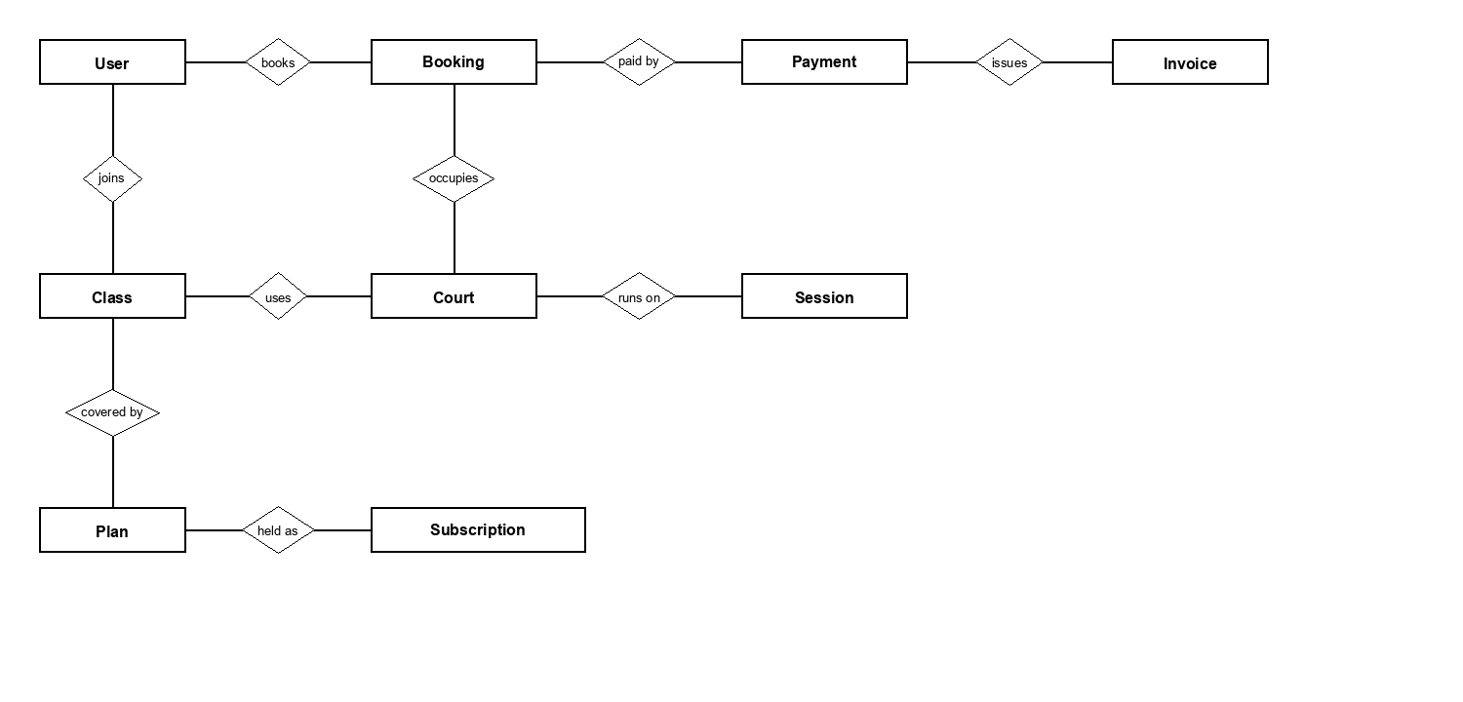
Figure 19. Conceptual entities.
Figure 20 is the logical model of the running database. The table under it names the entities a reader of this specification needs. It does not repeat every column. provider_sequences is the payOS order-code high-water mark, not the PAY document number.
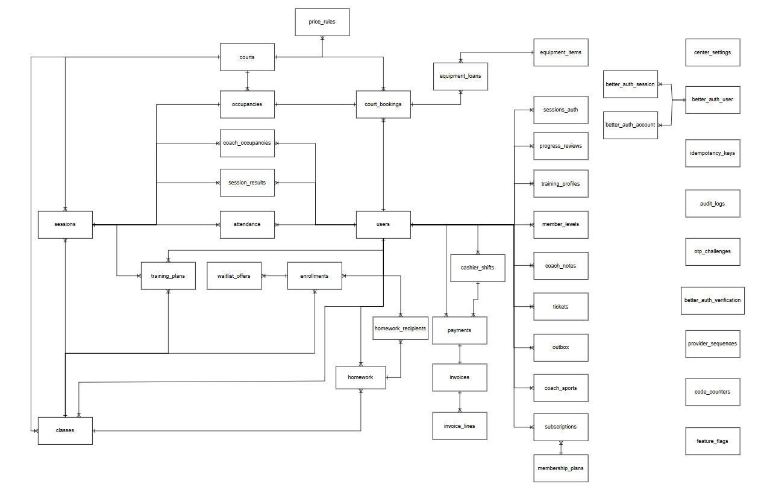
Figure 20. Logical entity relationship diagram.
# | Entity | Description
1 | users | One person, one role: member, receptionist, coach or manager. Phone is unique. A minor stores guardian name and phone.
2 | courts | A bookable court, with a sport and a status: ready, maintenance or closed. A court that is not ready cannot be sold.
3 | occupancies | The row that makes a court busy. A booking, a class session or a work order attaches one. Overlap is rejected in the database.
4 | court_bookings | A hold, a confirmed booking, or a finished one. Carries the price, what has been paid, the optional series, and the quota hours used.
5 | booking_series | A fixed weekly booking: one court, one weekday, one hour, a number of weeks. Weeks that were taken are not rows.
6 | classes | A coached class: sport, level, court, coach, weekly rule, capacity, and status draft, open, closed or cancelled.
7 | sessions | One occurrence of a class. A scheduled session has an occupancy. A cancelled or finished one does not.
8 | enrollments | A member on a class, or on its waitlist.
9 | attendance | Present, Late, Absent or Excused for one student and one session.
10 | payments | One receipt or one refund. Code PAY-YYYYMMDD-nnnn. Method cash, transfer, card, gateway or quota. Status posted, pending, expired, failed, or a refund state.
11 | invoices | The receipt issued with a payment, with buyer name and phone and invoice lines.
12 | membership_plans | What is for sale: price, duration, court hours or sessions, discount, sport, and whether it is still on sale.
13 | subscriptions | A member's plan. Pending until paid, then active, frozen, or ended.
14 | cashier_shifts | One open till per receptionist. Closing stores the counted cash.
15 | price_rules | The price for a sport, court class, day type and hour band. No matching rule means the sale is refused.
16 | promotions | A discount code. A redemption does not rewrite an order already priced.
17 | day_passes | A pass for one date: issued, used or void, tied to the payment that sold it.
18 | loyalty_adjustments | Points added or spent, with a reason. Redeeming writes a single-use promotion.
19 | equipment_items / equipment_loans | Stock, and one loan to a member or a guest phone. Return restores that quantity once.
20 | tickets | A member's message to the desk, and the staff reply.
21 | audit_logs | Who changed something a member cannot change, and when. No delete.
22 | center_settings | The single centre: hours, limits, VAT, series, day pass, points. One row.
23 | code_counters | The daily document numbers, including PAY.
24 | provider_sequences | The payOS order-code high-water mark. It is not the PAY document number.

4.2 Data dictionary
Each table is the data a person enters on that screen. Unique and editable describe the stored value. A one-time password is not a stored profile field, so editable is n/a.

4.2.1 Login
Phone or email, plus the password. There is no remember-me flag.
Field | Type | Unique | Required | Editable | Size / default
Login — phone or email | String | Yes | Yes | No | Vietnamese phone, or email
Password | String | No | Yes | n/a | Not stored from this form

4.2.2 Register
The account is not created here. The values are stored on a one-time challenge until UC-02.
Field | Type | Unique | Required | Editable | Size / default
Full name | String | No | Yes | Yes, later | Required
Phone | String | Yes | Yes | Staff can correct | Vietnamese mobile
Email | String | Yes | No | Yes | Optional
Date of birth | Date | No | No | Staff can correct | Required for the minor check
Password | String | No | Yes | Yes, via reset | At least 8, letters and digits. Stored as a hash.
Guardian name and phone | String | No | If under 16 | Staff can correct | BR-07
Terms accepted | Boolean | No | Yes | No | Must be true. BR-08

4.2.3 Book a court
Creates a hold, not a booking. Payment is a separate step.
Field | Type | Unique | Required | Editable | Size / default
Court | Reference | No | Yes | By reschedule | A ready court
Start | Timestamp | No | Yes | By reschedule | Inside the horizon, not in the past
Pay with plan hours | Boolean | No | No | n/a | Only when the plan has court hours left

4.2.4 Walk-in
A guest has no account. The desk enters the name and the phone.
Field | Type | Unique | Required | Editable | Size / default
Guest name | String | No | Yes | No | Not an account
Phone | String | No | Yes | No | Vietnamese phone
Court and start | Reference | No | Yes | No | Free slot. 20 minutes must remain if it has started.
Method | Enum | No | Yes | No | Cash, card, or transfer

4.2.5 Day pass
One pass for one date. Selling writes a payment.
Field | Type | Unique | Required | Editable | Size / default
Date | Date | No | Yes | No | Today or later. Default today.
Phone | String | No | No | No | Member or guest
Price | Integer | No | Yes | Setting | day_pass_vnd, default 60,000

4.2.6 Fixed weekly booking
Desk and manager only. One payment for the weeks that fitted.
Field | Type | Unique | Required | Editable | Size / default
Court, weekday, hour | Reference | No | Yes | No | One of each
Weeks | Integer | No | Yes | No | 4 to 12

4.2.7 Attendance
One mark per member per session. The gate does not write this.
Field | Type | Unique | Required | Editable | Size / default
Mark | Enum | No | Yes | Until lock | Present, Late, Absent, Excused
Correction reason | String | No | When locked | No | At least 3 characters, manager only

4.2.8 Redeem points
Creates a single-use code. It does not pay for anything by itself.
Field | Type | Unique | Required | Editable | Size / default
Points | Integer | No | Yes | No | At least 50, and not more than the balance

4.3 Reports
- The manager can read revenue, split between court and plan and net of refunds, for a period and the previous period of the same length. Filter by cash, transfer, card, gateway, or quota.
- Occupancy and a capacity heatmap, up to 93 days, by court and by hour. Class activity is not given a revenue number, because class fees are not payments.
- Excel or PDF export uses the same queries as the screen and is not stored. Coaches and receptionists are refused.
- Invoice XML is a separate export for the centre's e-invoice software. Arena3 does not submit it.

4.4 Data integrity, retention, and disposal

4.4.1 Schedule integrity
Two bookings cannot own the same court-time, including two requests that arrive together. The same rule holds for a coach, a class session, and a work order.

4.4.2 Money integrity
A confirmed booking has its payment and its invoice, written in one transaction. A repeated request with the same idempotency key returns the original payment.

4.4.3 Document numbers
Member, payment, and invoice codes come from one counter and are not reused. Seeded demonstration receipts may use a 9xxx sequence on a day so they never meet the live counter.

4.4.4 Audit retention
Sensitive staff actions write an audit row with the actor, the action, the entity, and the time. Rows are not deleted.

4.4.5 Short-lived data
A hold expires. An unpaid gateway link expires with it. A one-time code expires in five minutes. A waitlist offer expires. The register locks. These deletions are the product, not a loss of the sale.

4.4.6 Personal data
A member reads only their own bookings, receipts, tickets, and profile. Health notes and guardian details are not sent to the assistant's model.

4.4.7 Backup
The live database is hosted PostgreSQL. Arena3 does not run a separate backup job of its own. Recovery of the hosted database is the host's, not a screen in the product.

5. External interface requirements

5.1 User interfaces

5.1.1 Web application
One site. After sign-in, a member, a receptionist, a coach, and a manager each land on their own home.

5.1.2 Consistent interface
Navigation, type, and the way a refusal is phrased stay the same across roles. A refusal is a sentence. The rule code travels with it for support.

5.1.3 Responsive layout
Every screen is usable at a phone width. The member site is installable.

5.1.4 Guidance
A form says which field failed. A price change on reschedule shows both amounts. A cancellation can be quoted before it is confirmed.

5.1.5 Feedback
Saving, paying, and a failed request each tell the person what happened. Online payment shows a QR and closes when the server, not the return page, confirms it.

5.1.6 Destructive actions
Cancelling a booking shows the refund quote first. Voiding a day pass and refunding a payment are explicit desk or manager actions, not a side effect of opening the record.

5.1.7 Screens
The tables name the screens behind Figures 13 to 17.

Public
# | Feature | Screen | Description
1 | Landing | Landing page (/) | Public home of the centre. Shows what is on offer and links to Login and Register.
2 | Landing | Coach profile | Opens from the coach list and shows one coach.
3 | Login | Login (/login) | Signs in. On success the app opens that role's home. A password that must be changed does not redirect login. Account opens on the security tab while that flag is set.
4 | Register | Registration (/register) | A new member enters their details.
5 | Register | OTP step | The member enters the one-time code. After it matches, the account exists and Member home opens.
6 | Forgot password | Request code (/forgot) | The user enters their phone number to receive a reset code.
7 | Forgot password | Code and new password | The user enters the code and a new password, then returns to Login.
8 | Online payment | Payment return (/pay/return) | The page after payOS. It asks the server what happened. Opening this address is not itself proof of payment.

Member
# | Feature | Screen | Description
1 | Home | Member home (/app) | Upcoming bookings, the active plan, and shortcuts.
2 | Home | Waitlist offer | Shown when a place opens. The member accepts or lets it expire.
3 | Payment | Scan-to-pay | QR and amount for an outstanding payment. Closes when the server confirms it.
4 | Court booking | Book a court (/app/book) | Pick a date, sport and slot, then pay.
5 | Court booking | Month calendar | Which days still have free slots, up to 62 days. Past days and days beyond the booking horizon cannot be chosen.
6 | Court booking | Hold panel | Holds the slot (default 5 minutes) while the member pays.
7 | Court booking | Clash confirmation | Warns when the new slot overlaps one of the member's own bookings.
8 | Court booking | Alternative slots | Suggests nearby free slots when the chosen one is taken.
9 | Court booking | Change time | Moves an existing booking instead of creating one. A price change is refused.
10 | Classes | Classes (/app/classes) | Classes the member can join, wait for, or leave, plus their own attendance.
11 | Plans | Plans (/app/plans) | The current plan and the plans on sale.
12 | Training | Progress (/app/train) | Level, results and homework. Hidden when F4 is off.
13 | Day pass | Day pass (/app/pass) | The member's day pass for a date.
14 | Points | Points (/app/points) | Balance, tier, and redeeming points for a single-use code.
15 | Assistant | Assistant (/app/assistant) | Answers from the centre's own timetable, prices and coaches.
16 | Notifications | Notifications (/app/notifications) | The member's messages. Opening one shows the full text and a link to the related screen.
17 | Account | Account (/account) | Profile, password, receipts and support. Shared by every role.
18 | Receipts | Receipt PDF | A printable receipt. A member opens only their own.

Receptionist
# | Feature | Screen | Description
1 | Home | Desk home (/desk) | The shift, open support requests, and the way into every desk screen.
2 | Shift | Close shift | Records counted cash against the expected total.
3 | Onboarding | New member | Profile, plan, then payment, at the counter.
4 | Support | Reply | Read a request and reply, or close it without a reply.
5 | Check-in | Gate (/desk/gate) | Check a member in by phone or member code. Does not fill the class register.
6 | Courts | Court map (/desk/courts) | Every court and who holds it. A cell opens the person, the code, the time and the amount.
7 | Courts | Walk-in payment | Book and charge a guest on a free court.
8 | Courts | Convertible courts | A free badminton/basketball pair can be treated as one court while both sides are free.
9 | Classes | Classes (/desk/classes) | Read-only timetable and roster, including the waitlist.
10 | Payments | Payments (/desk/payments) | Transfers to check, waiting for payment, the refund queue, receipts, and a counter QR.
11 | Gear | Gear (/desk/gear) | Loan to a member or a guest. Stock falls on the way out and returns with that loan.
12 | Day pass | Day passes (/desk/day-passes) | Sell, mark used, or void a pass for one date.
13 | Series | Fixed series (/desk/series) | Preview the weeks, skip the taken ones, and take one payment.
14 | Maintenance | Maintenance (/desk/maintenance) | Work orders that occupy a court.
15 | At risk | At risk (/desk/at-risk) | Students with a repeated absence streak.
16 | Members | Member profile (/desk/member/:id) | Plan, bookings and payments. Staff can correct details and raise a refund.
17 | Alerts | Alerts (/alerts) | Alerts for the signed-in staff member.

Coach
# | Feature | Screen | Description
1 | Schedule | Coach home (/coach) | That coach's sessions only, by day, with court, class, enrolment and level.
2 | Attendance | Attendance (/coach/attendance) | The register, results, the session plan and homework for one session.
3 | Students | Student (/coach/student/:id) | Level, reviews, homework and staff-only notes. Health notes stay inside the coach's own classes.
4 | Earnings | Earnings (/coach/earnings) | That coach's commission. Not another coach's, and not the centre's revenue.
5 | Alerts | Alerts (/alerts) | Including an absence-streak alert.
6 | Account | Account (/account) | Own profile and password.

Manager
# | Feature | Screen | Description
1 | Reports | Reports (/manager) | Revenue and occupancy for a period, compared with the previous period of the same length.
2 | Reports | Capacity heatmap | How full the centre is by day and hour, peak against off-peak.
3 | Reports | Members and enrolment | New and renewing members, enrolment per class, attendance percent when F4 is on.
4 | Reports | Export | Excel or PDF of the same figures the screen shows. Money cells are numbers.
5 | Classes | Classes (/manager/classes) | Create a class, then cancel or move a session, change coach, edit capacity, or cancel the class.
6 | Members | Members (/manager/members) | Search, filter and open a member. The profile is the desk profile.
7 | Payments | Payments (/desk/payments) | The desk queue, used here to approve or reject a large refund.
8 | Plans | Plans (/manager/plans) | Create and edit plans. Stop selling withdraws a plan. It is not hard-deleted.
9 | Staff | Staff (/manager/staff) | Create an account, change role, and hand over a temporary password.
10 | Pricing | Pricing (/manager/prices) | Price rules per sport, court class, day type and hour band.
11 | Promotions | Promotions (/manager/promos) | Create, pause and read redemptions. A used code stays.
12 | Commission | Commission (/manager/commission) | Rates, close a month, mark paid.
13 | Invoices | Invoices (/manager/invoices) | Receipts in a period, and the XML export.
14 | Attendance | Attendance (/manager/attendance) | Correct a locked register, with a reason.
15 | Audit | Audit (/manager/audit) | Who did what, filterable. Nothing on this screen deletes a row.
16 | Settings | Settings (/manager/settings) | Hours, limits, VAT, feature flags, series, day pass and points. Timezone and currency stay fixed.

5.2 Software interfaces

5.2.1 payOS
- The server asks payOS for one live link per thing being paid. The link does not outlive the hold.
- The sale is posted only when the reported amount covers the amount due.
- The checksum key stays on the server.
- If payOS is unavailable, the sale is not posted and the desk can take the money another way.

5.2.2 Assistant model
- A member question is at most 800 characters, and at most 20 a minute.
- The assistant may talk about hours, prices, plans, coaches, classes, booking, and waitlists. It refuses medical advice.
- It cannot take money, book, cancel, or change a record. It can open a support request.
- With no model key it answers from rules. A failure of the model does not stop booking or payment.

5.3 Hardware interfaces
No special hardware is required. The gate is a phone number or a member code typed at the desk, not a turnstile. Gear is counted in the application, not by a scanner.

5.4 Communications interfaces

5.4.1 Browser and server
- The browser talks to the application over HTTPS, in JSON.
- A session token is sent as a bearer token. It is not a password, and it is not written into the page.

5.4.2 payOS
- Arena3 calls payOS over HTTPS from the server.
- A webhook is accepted only when its signature checks.

5.4.3 Messages to people
- In-app notification is the channel that reaches the member, including receipts and replies.
- There is no SMS. Email is a stub and is not a delivery guarantee.
- The one-time code is not placed in a message that also contains the password.

6. Quality attributes

6.1 Usability
- USE-1. Every screen works at a phone width, and the member site is installable.
- USE-2. A refusal tells the person what to do next. The rule code is carried alongside the sentence.
- USE-3. Vietnamese diacritics render in running text. Amounts use đ, never a capital D.

6.2 Performance
- PER-1. The sign-in profile is several independent reads issued together, not one after another.
- PER-2. A read-only request does not open a transaction.
- PER-3. The desk badge is one aggregate, not the full queue.
- PER-4. The job loop sleeps until the next job is due.

6.3 Security
- SEC-1. Passwords are salted hashes. Session tokens are stored as SHA-256 hashes.
- SEC-2. Every request is authorized on the server. Hiding a button is not a control.
- SEC-3. A member reads only their own bookings, receipts, tickets, and profile.
- SEC-4. Health notes and guardian details are not sent to the assistant model.
- SEC-5. Demo sign-in and one-time-code echo are off in production unless explicitly switched on.
- SEC-6. An online payment is trusted only from payOS, and only for the amount due.

6.4 Safety
- SAF-1. The assistant refuses medical advice and does not change a booking or take money.
- SAF-2. The system does not invent a price when no rule matches, and it does not invent a revenue number for class fees or gear.
- SAF-3. A refund above the threshold is not paid out by the receptionist alone.

6.5 Availability
- AVL-1. If the assistant's model is down, only the assistant degrades. Booking, payment, and the register do not.
- AVL-2. If payOS is not configured, the desk can still take cash, card, and transfer.
- AVL-3. A local copy can start on an embedded database when no external database is configured. The centre's live data stays on the hosted database.

6.6 Robustness
- ROB-1. Two overlapping bookings cannot both commit. The loser receives a conflict and nothing is half-written.
- ROB-2. A retried payment with the same idempotency key returns the original result and does not charge twice.
- ROB-3. Opening the payment return page does not post a payment.
- ROB-4. A feature flag that is off answers 403 with BR-62 on every one of its routes, so a screen can tell switched off from not allowed.

Appendix

A. Messages a person meets
The product shows a full sentence. The line here is the situation that produces it.
ID | Type | When it appears
MSG-AUTH-01 | Information | The one-time code is shown so the member can finish registration or a reset. It is not sent by SMS.
MSG-AUTH-02 | Error | The password must be at least 8 characters and mix letters and digits.
MSG-AUTH-03 | Error | That phone number already has an account.
MSG-BOOK-01 | Error | That court-time is already held. The second person is refused, not queued.
MSG-BOOK-02 | Error | The hold has expired. The court may already have been sold.
MSG-BOOK-03 | Error | That slot is in the past, outside opening hours, or the court is not ready.
MSG-BOOK-04 | Error | Changing to a slot with a different price is refused. Cancel and book again. The amounts are shown.
MSG-BOOK-05 | Error | The debt limit blocks a new booking until it is settled.
MSG-PAY-01 | Error | Open a till shift before taking payment.
MSG-PAY-02 | Error | Online payment is not set up. Take it at the desk.
MSG-PAY-03 | Information | A refund at or above the manager threshold is waiting for the manager.
MSG-PAY-04 | Error | That payment has already been refunded.
MSG-CLS-01 | Information | The class is full. The member is placed on the waitlist with a position.
MSG-CLS-02 | Error | The plan does not cover this sport, or it has no sessions left.
MSG-CLS-03 | Error | The coach or the court is already busy at that time.
MSG-TRN-01 | Error | The register is closed. A manager can correct it with a reason.
MSG-TRN-02 | Error | Training is switched off.
MSG-PTS-01 | Error | Redeem at least 50 points, and not more than the balance.

B. Catalogue of use cases
The same identifiers as section 3.2, for cross-reference.
ID | Use case | Actors | Description
UC-01 | Register | Member | Create an account with name, phone, date of birth and a password. A minor must give a guardian. Terms must be accepted.
UC-02 | Confirm with OTP | Member, System | Enter the one-time code. The account is created only after the code matches. There is no SMS transport, so the code is not sent to a phone in this version.
UC-03 | Sign in | Member, Receptionist, Coach, Manager | Sign in with phone or email and a password. The home screen is the one for that role. Five wrong passwords lock the account for 15 minutes.
UC-04 | Reset password | Any signed-up user | Request a code, then set a new password of at least 8 characters mixing letters and digits, typed twice.
UC-05 | Edit own profile | Any signed-in user | Change own name and health notes, and own password. Nobody edits another person's password this way.
UC-06 | Book a court | Member | See live availability, hold a slot (default 5 minutes), then pay. Two people cannot hold the same court-time.
UC-07 | Reschedule a booking | Member | Move a confirmed booking to another slot outside the cancellation window. A different price is refused. A lost race leaves the booking where it was.
UC-08 | Cancel a booking | Member, Receptionist, Manager | Cancel a hold or a confirmed booking. A hold is released. A confirmed booking is refunded by the tiers (default 100% at 24 hours or more, 50% from 4 to 24 hours, nothing under 4). Staff may waive the fee.
UC-09 | Buy or renew a plan | Member, Receptionist | Order a plan that is on sale. It stays pending until the money is recorded. A frozen plan blocks a second purchase.
UC-10 | Join or leave a class | Member | Enrol when the plan covers that sport and the class is open. A full class offers a waitlist place. Leaving is allowed up to the class cancellation window.
UC-11 | Answer a waitlist offer | Member, System | Accept or let the offer expire (default 2 hours). An expired or over-full acceptance is refused.
UC-12 | Pay online | Member, Receptionist, payOS | Raise one payOS link for a held court or a pending plan. The booking or plan changes only after payOS reports the money.
UC-13 | View a receipt | Member, Receptionist, Manager | Open any receipt the person is allowed to see, as a PDF. A member sees only their own.
UC-14 | Ask the assistant | Member | Ask about hours, prices, plans, coaches and classes. The assistant reads centre data and cannot take money or change a booking.
UC-15 | Send a support request | Member, Receptionist | Write to the desk. The desk replies or closes the request. A reply notifies the member.
UC-16 | Walk-in court rental | Guest, Receptionist | Sell a free slot to a person with no account. A slot already under way can be sold if at least 20 minutes remain.
UC-17 | Open and close a shift | Receptionist | Open the till before taking money. Close it by counting cash against the expected total. One open shift per receptionist.
UC-18 | Reconcile a transfer | Receptionist, Manager | A transfer chosen in the app holds the slot and posts no payment. Staff mark it received, or reject it if the money never arrives.
UC-19 | Refund a payment | Receptionist, Manager | Raise a refund. Above the manager threshold (default 1,000,000đ) it waits for the manager. The same payment cannot be refunded twice.
UC-20 | Rent and return gear | Receptionist, Guest, Member | Loan gear to a member found by search, or to a guest by phone. Stock is enforced. Return restores that loan once. The fee is not a revenue row.
UC-21 | Sell and use a day pass | Receptionist, Member, Guest | Sell a pass for one date, take the payment, then mark it used at the gate or void it.
UC-22 | Fixed weekly booking | Receptionist, Manager | Same court, weekday and hour, for 4 to 12 weeks. A week that is taken is skipped and not charged. One payment up front.
UC-23 | Gate check-in | Receptionist | Check a member in by phone or member code. This does not mark class attendance.
UC-24 | Mark attendance | Coach, Manager | Present, Late, Absent or Excused for a session the coach teaches. The register locks 2 hours after the session. Only a manager can correct it, with a reason.
UC-25 | Record training | Coach, Member | Session results, a plan, homework and a review. Nothing here charges money. Off when feature flag F4 is off.
UC-26 | Manage classes | Manager | Create, publish, move or cancel a session, change the coach, and change capacity. A clash or a capacity below the roster is refused.
UC-27 | Manage plans and prices | Manager | Create plans, withdraw one from sale, and set price rules by sport, court class, day and hour. No matching rule means no invented price.
UC-28 | Manage staff | Manager | Create a receptionist or coach, lock, unlock, change role, reset a temporary password, and revoke sessions. A manager cannot lock themselves.
UC-29 | Read reports and export | Manager | Revenue, occupancy, capacity heatmap, members and enrolment, for a period, against the previous period. Export Excel or PDF.
UC-30 | Read the audit log | Manager | Filter sensitive staff actions by actor, action, entity and date. Rows are never deleted.
UC-31 | Configure the centre | Manager | Opening hours, slot and hold length, cancellation, debt and refund limits, VAT, rounding, series length, day-pass price and point rates.
UC-32 | Promotions | Manager, Member | A manager creates a code. A member previews it. A used code is not deleted. An order already priced keeps its discount.
UC-33 | Points | Member, Receptionist, Manager | Points accrue from posted court, plan and day-pass payments. A member redeems at least 50 points for a single-use code. Staff may adjust with a reason.
UC-34 | Coach commission | Manager, Coach | A manager sets a rate, closes a finished month so a later rate change cannot rewrite it, and marks it paid. A coach sees only their own earnings.
UC-35 | Maintenance | Receptionist, Manager | Open a work order on a court. The court is busy through the same occupancy rules as a booking, so it cannot be sold at the same time.
UC-36 | Export invoice data | Manager | Export receipt data as XML for the centre's e-invoice software. Arena3 does not file the legal invoice with the tax authority.
UC-37 | Expire and sweep | System | Expire unpaid holds, mark no-shows, complete finished bookings, generate upcoming sessions, pass on waitlist offers, and lock old registers.

