

< Online Auction System>
Documentation

<Group>
Group Member | <TUNG DO VAN>  <CUONG DO VIET>  <TOAN TRAN DUC>

- Hanoi, <June>/<2025> -
INDEX
1. Problem Definition 3
1.1. Problem Abstraction 3
1.2. The Current System 3
1.3. The Proposed System 3
1.4. Boundaries of the System 3
1.5. Hardware and Software Requirements 3
1.5.1. Minimum Requirements 3
1.5.2. Recommended Requirements 3
2. Customer Requirements Specification 4
2.1. Users of the System 4
2.2. System functions 4
3. Architecture & Design of Project 5
3.1. Architecture 5
3.2. Data Flow Diagram 5
3.3. Flow Chart 5
3.4. Entity Relationship Diagram 5
3.5. Database Structure 5
3.5.1. Table Design 5
3.5.2. Database Diagram 5
3.6. Screen Design 5
4. Task Sheet 6
5. Checklists 7
5.1. Check List of Validation 7
5.2. Submission Checklist 7

Problem Definition

Problem Abstraction
This project aims to develop an Online Auction System that allows users to list, browse, and bid on auctioned items in real time. Traditional methods for second-hand trading or auctioning lack automation, transparency, and accessibility. This project addresses these problems by providing a digital platform for structured and secure bidding.

The Current System
Currently, there is no centralized digital auction platform for individual sellers and buyers. Existing practices may rely on forums or social media where bidding is informal, lacks tracking, and vulnerable to fraud.

The Proposed System
The proposed system enables users to register, create item listings, bid on items, and manage auctions. It incorporates automated notifications, bid validations, user ratings, and role-based access control. Admins can manage categories and block fraudulent users.

Boundaries of the System
• Platform intended for public buyers/sellers and admin users.
• Accessible via browser, no mobile app version at this stage.
• Only support for auction-style listings (not fixed-price sales).
• No payment gateway integration in initial release.

Hardware and Software Requirements

Minimum Requirements
• Processor: Dual-core CPU
• RAM: 4 GB
• Storage: 2 GB
• .NET SDK 6.0
• SQL Server Express
• Modern browser (Chrome/Edge)

Recommended Requirements
• Processor: Quad-core or higher
• RAM: 8 GB or higher
• SSD storage
• Visual Studio 2022+
• SQL Server Management Studio
• Git and GitHub Desktop

Customer Requirements Specification

Users of the System
• Administrator
• Sellers
• Buyers

System functions
    - Function: User Registration
• Input: username, password, email
• Output: new user created
• Process: check uniqueness, save to DB
• Storage: Users table

    - Function: Item Listing
• Input: title, description, images, min bid, end date
• Output: item available on site
• Process: validate fields, associate with seller
• Storage: Items table

    - Function: Bidding
• Input: bid amount
• Output: confirmation or error
• Process: must be higher than current bid
• Storage: Bids table

    - Function: Rating
• Input: score, comment
• Output: rating saved
• Process: check if auction completed
• Storage: Ratings table

    - Function: Category Management (Admin)
• Input: category name
• Output: category added or updated
• Process: check for duplicates
• Storage: Categories table

Architecture & Design of Project

Architecture
The Online Auction System is designed based on a 3-tier architecture model using ASP.NET Core MVC framework combined with Entity Framework Core for data access. The architecture separates responsibilities into three main layers, promoting scalability, testability, and ease of maintenance.

    - Layered Architecture Overview
- Presentation Layer (Web UI)
  - Developed using ASP.NET Razor Views and HTML/CSS/JS
  - Handles all user interactions including forms, item browsing, bid submission, and feedback
  - Communicates with the business layer via controllers
- Business Logic Layer (Application Core)
  - Contains application logic, services, and business rules
  - Processes user actions (e.g., placing a bid, registering an account)
  - Manages validation and interaction between UI and database layers
  - Implements interfaces for dependency injection
- Data Access Layer (Infrastructure)
  - Implements repositories and database context using Entity Framework Core
  - Handles all CRUD operations and database communication
  - Includes entity mappings and migrations

    - Architectural Flow (Description)
- A user (buyer or seller) interacts with the system via the web browser.
- HTTP requests are routed to the appropriate controller in the Web UI project.
- The controller calls a corresponding service in the Business Logic Layer to execute business rules.
- The service accesses or updates data using repositories implemented in the Data Access Layer.
- Data is persisted in a SQL Server database and results are returned back to the UI.

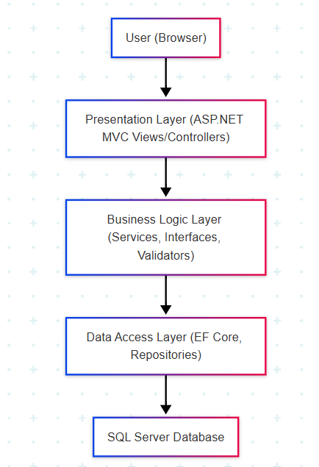

Data Flow Diagram

Context Diagram (DFD Level 0)
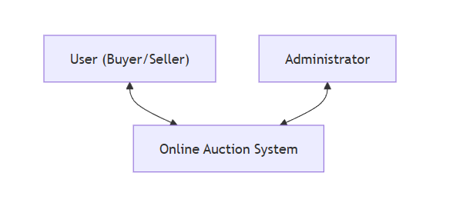

    - Level 1 DFD
Each item below represents a main process in DFD Level 1. More detailed sub-processes and their specific interactions with Data Stores will be described in DFD Level 2.

1. User Management (Process 1.0)
This process handles all user-related actions including registration, login, authentication, and profile updates. It interacts with the user data store to manage account information.
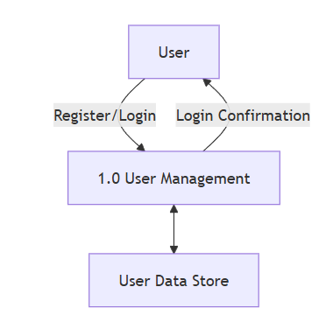

2. Item Management (Process 2.0)
This process allows sellers to add, edit, or delete products for auction. It also enables users to browse and view detailed product information. It interacts with the item data store and file data store to handle product data and media uploads.
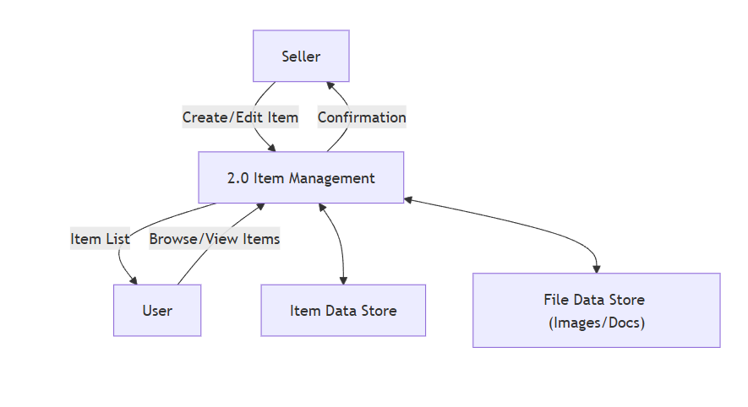
3. Bidding Process (Process 3.0)
This process manages all bidding operations. Users can place bids, and the system checks the validity, updates the current bid status, and stores data in the bidding store.
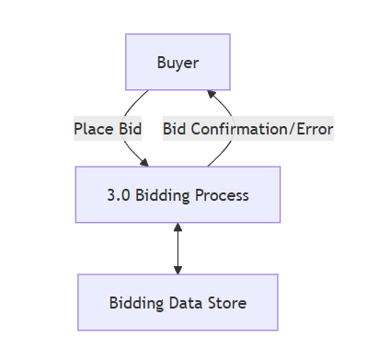

4. Category Management (Process 4.0)
This process is used by the administrator to manage product categories. Users can browse products through categories. The category data store maintains all category information.

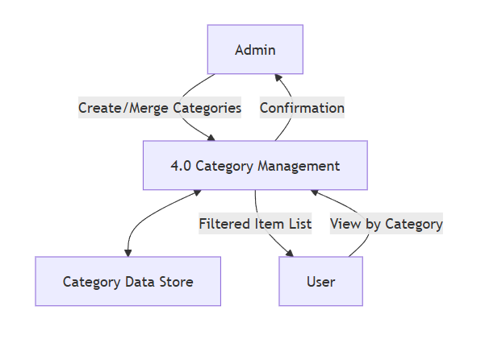
5. Notification Management (Process 5.0)
This process automatically sends notifications to users (buyer and seller) when an auction ends. It interacts with the notification data store to read and write messages.
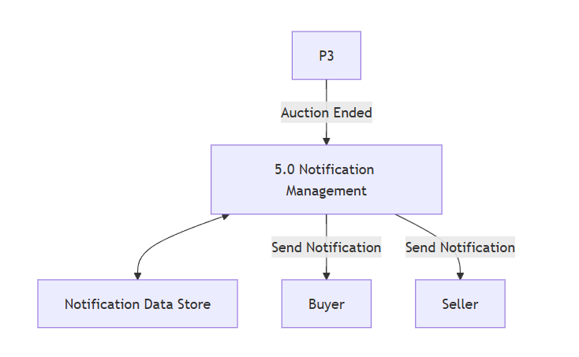
6. Rating System (Process 6.0)
This optional process allows buyers and sellers to rate each other after a transaction. The rating is recorded in the rating data store and can be used to evaluate trustworthiness.
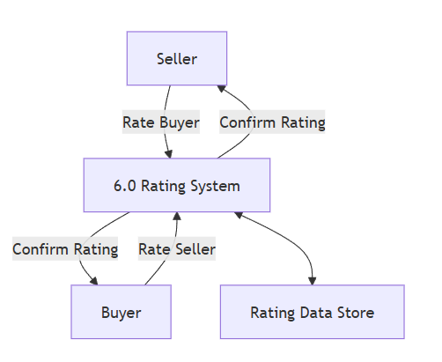

7. Admin User Control (Process 7.0)
This process allows the admin to manage user accounts, including blocking or unblocking fraudulent users. It uses the user data store for reading and updating account statuses.
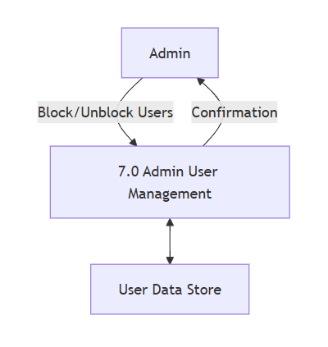

Flow Chart
    - User Registration and Login
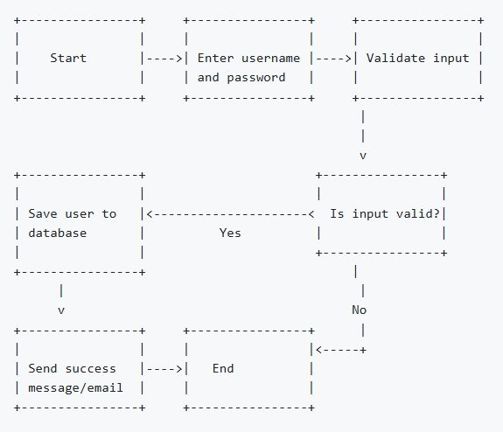

    - Item Listing by Seller
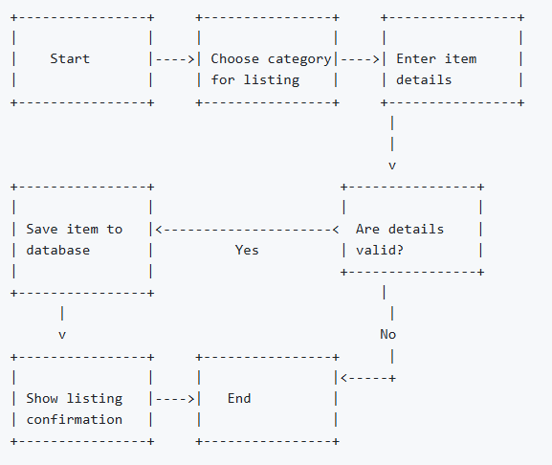
    - Bidding on an Item
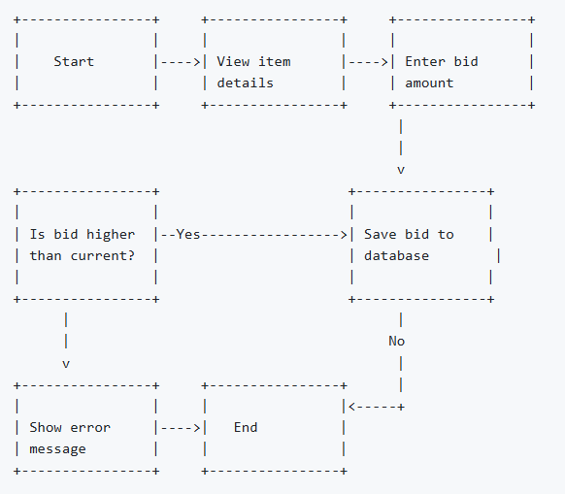

    - Auction End and Notification
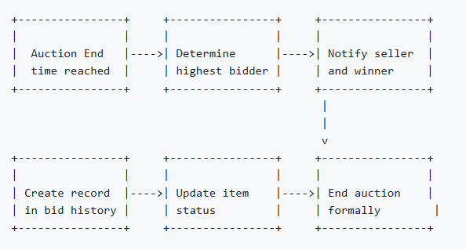

    - User Rating System
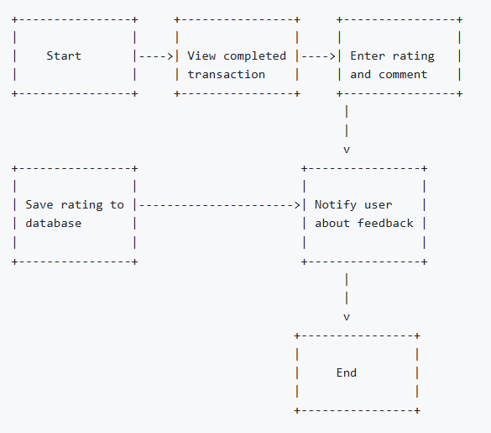

Entity Relationship Diagram

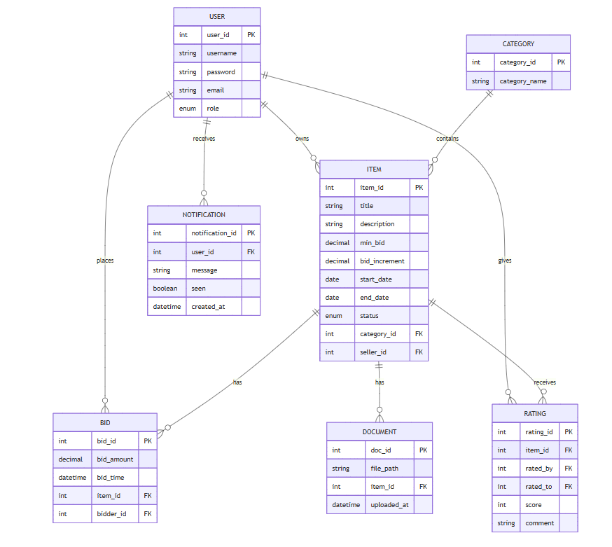

Explain the relationship

Relationship | Description
USER – ITEM (1:N) | Each user can list multiple items for sale
USER – BID (1:N) | A user can place multiple bids
USER – RATING (1:N) | A user can give and receive multiple ratings
ITEM – BID (1:N) | Each item can have multiple bids
ITEM – DOCUMENT (1:N) | Each item can have multiple associated documents
CATEGORY – ITEM (1:N) | Each category contains multiple items
ITEM – RATING (1:N) | Each item can receive multiple ratings from buyers

Database Structure

Table Design

1. Users
Field Name | Data Type | Description
UserId | INT (PK) | Unique identifier for each user
Username | NVARCHAR(100) | Unique username
Password | NVARCHAR(255) | Hashed password
Email | NVARCHAR(150) | Email address
Role | NVARCHAR(20) | 'admin', 'seller', 'buyer'
Status | NVARCHAR(10) | 'active', 'blocked'
CreatedAt | DATETIME | Date of account creation

2. Categories
Field Name | Data Type | Description
CategoryId | INT (PK) | Unique identifier
CategoryName | NVARCHAR(100) | Name of the product category

3. Items
Field Name | Data Type | Description
ItemId | INT (PK) | Unique item ID
Title | NVARCHAR(100) | Item title
Description | NVARCHAR(4000) | Detailed description
MinBid | DECIMAL(10,2) | Minimum bid price
BidIncrement | DECIMAL(10,2) | Minimum increase in bids
StartDate | DATETIME | Auction start date
EndDate | DATETIME | Auction end date
BidStatus | CHAR(1) | 'A' for active, 'I' for inactive
CategoryId | INT (FK) | Link to category
SellerId | INT (FK) | Link to user who posted the item
CreatedAt | DATETIME | Listing creation time

4. Bids
Field Name | Data Type | Description
BidId | INT (PK) | Unique bid ID
ItemId | INT (FK) | Related item ID
BidderId | INT (FK) | User who placed the bid
BidAmount | DECIMAL(10,2) | Amount of the bid
BidTime | DATETIME | When the bid was placed

5. Documents
Field Name | Data Type | Description
DocumentId | INT (PK) | Unique ID
ItemId | INT (FK) | Related item
FilePath | NVARCHAR(255) | Path to uploaded document
UploadedAt | DATETIME | Timestamp of upload

6. Notifications
Field Name | Data Type | Description
NotificationId | INT (PK) | Unique ID
UserId | INT (FK) | Recipient of the notification
Message | NVARCHAR(MAX) | Notification content
Seen | BIT | Whether notification was read
CreatedAt | DATETIME | Notification timestamp

7. Ratings
Field Name | Data Type | Description
RatingId | INT (PK) | Unique rating ID
ItemId | INT (FK) | Related item
RatedBy | INT (FK) | User who rated
RatedTo | INT (FK) | User who was rated
Score | INT | From -5 to +5
Comment | NVARCHAR(MAX) | Optional feedback

Database Diagram
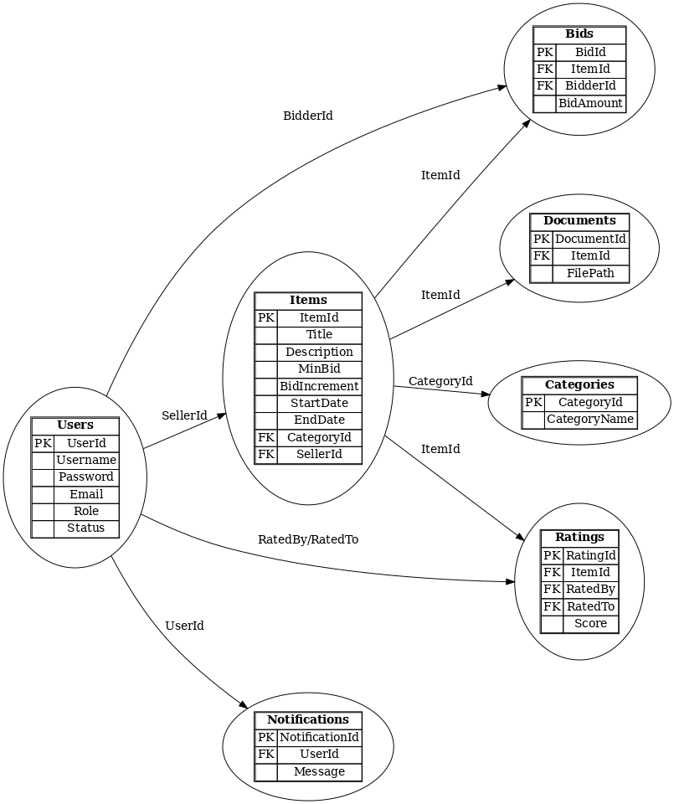

Screen Design

Task Sheet
<Liệt kê các công việc cần thực hiện trong đó chỉ rõ sự phân công trách nhiệm và thời gian bắt đầu, hoàn thành, tham khảo cuốn Project Guide đã được phát>

Checklists

Check List of Validation
<Các kiểm tra điều kiện hoạt động của hệ thống, đây là các kiểm tra của người phát triển sản phẩm dựa trên các ràng buộc thiết kế: Dữ liệu thao tác có đúng ràng buộc không,...>

Submission Checklist
<Các kiểm tra của người sử dụng hệ thống: Link có hoạt động hay không, dữ liệu vào sai có bị nhắc nhở không,...>

