

Requirement & Design Specification
Classroom Equipment Management System(CEMS)
Version: 1.0

Group 5
HE187389 – Vũ Đức Toàn (40%)
HE190002 – Phạm Văn Tuân (30%)
HE190003 – Nguyen Minh Chiến (30%)

Table of content
Table of content 2
I. Overview 2
1. User Requirements 2
1.1 Actors 2
1.2 Use Cases 3
a. Admin 3
b. Technician 4
c. Lecturer 4
d. Descriptions 4
2. Overall Functionalities 7
c2.1 Screens Flow 7
2.3 Screen Authorization 9
3. System High Level Design 10
3.1 Database Design 10
a. Database Schema 10
b. Table Descriptions 10
III. Design Specifications 12
IV. Appendix 20
1. Assumptions & Dependencies 20
2. Limitations & Exclusions 20
3. Business Rules 20

I. Overview
The Classroom Equipment Management System (CEMS) is a web-based application designed to digitalize and optimize the management of classroom equipment (such as projectors, computers, air conditioners, and audio devices) within educational institutions. Developed using ASP.NET MVC, C#, and Entity Framework Core, with data managed by Microsoft SQL Server, CEMS streamlines the daily operations of assigning assets, reporting damages, tracking repairs, and auditing equipment lifecycle history.

1. User Requirements

1.1 Actors
# | Actor | Description
1 | Admin | Has the highest system privileges. Responsible for managing core system, viewing overall dashboard statistics, and approving/rejecting equipment disposal requests.
2 | Technician | Manages daily operations including adding equipment, assigning and transferring equipment between rooms, receiving incident reports, and reviewing equipment status histories.
3 | Lecture | Represents the end-users. Can view the list and status of equipment in their assigned classrooms, submit incident/damage reports, and track the resolution status of reported issues.

1.2 Use Cases

a. Admin

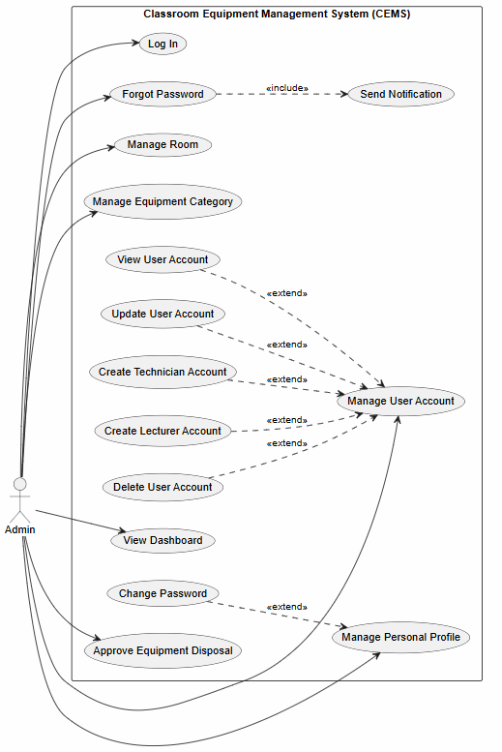

b. Technician
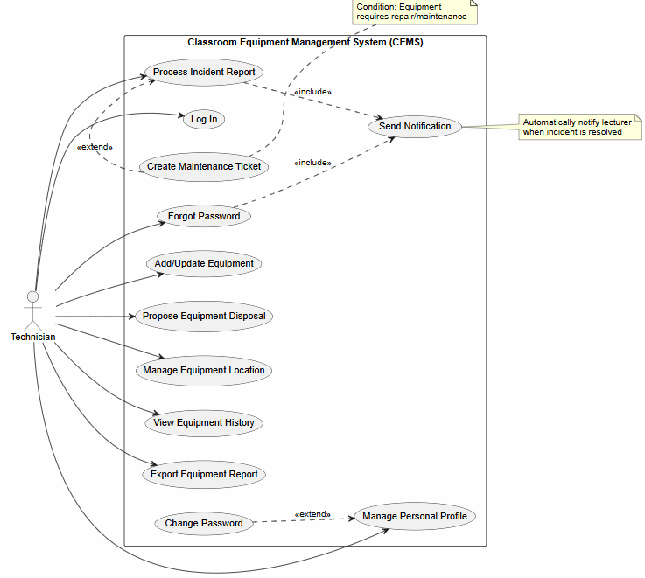

c. Lecturer
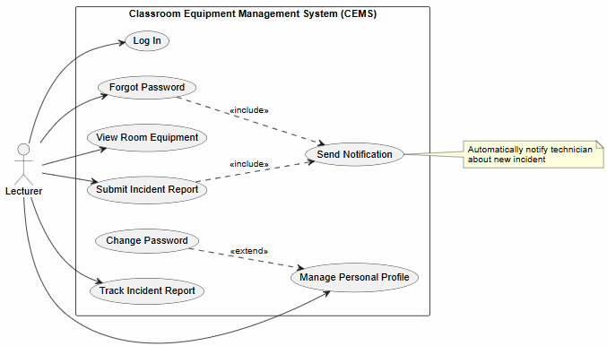

d. Descriptions

ID | Feature | Use Case | Use Case Description
01 | Common | Log In | Allows users (Admin, Technician, Lecturer) to authenticate themselves into the CEMS system using their email/user code and password.
02 |  | Manage Personal Profile | Allows users to view and update their profile details (such as Full Name, Phone Number, and Avatar).
03 |  | Change Password | Allowing users to change their current password from the profile page.
04 |  | Forgot Password | Enables users who forgot their password to request a reset link sent to their email.
05 |  | Send Notification | Included in multiple use cases to automatically send email or system notifications when critical events occur (e.g., damage reported, password reset).
06 | Admin | Manage User Account | Allows Admin to search, filter, and oversee all accounts. It acts as the base use case for creating, viewing, updating, and deleting accounts.
07 |  | Create Lecturer Account | Allowing the Admin to create a new user account with the 'Lecturer' role.
08 |  | Create Technician Account | Allowing the Admin to create a new user account with the 'Technician' role.
09 |  | View User Account | Allowing the Admin to view detailed profiles and login logs of specific users.
10 |  | Update User Account | Allowing the Admin to modify roles, contact details, or active status of existing users.
11 |  | Delete User Account | Allowing the Admin to soft-delete or deactivate a user account.
12 |  | Manage Room | Allows Admin to create, update, delete, and view classrooms (capacity, location, type, and code).
13 |  | Manage Equipment Category | Allows Admin to manage equipment classifications (CRUD categories like Projector, Air Conditioner, Laptop).
14 |  | View Dashboard | Allows Admin to view overall statistics (working equipment, pending repairs, open incident reports, and overdue tasks).
15 |  | Approve Equipment Disposal | Allows Admin to review and approve/reject equipment disposal proposals submitted by Technicians.
16 | Technician | Add/Update Equipment | Allows Technicians to add new equipment details (serial number, warranty expiry) or update existing assets.
17 |  | Propose Equipment Disposal | Allows Technicians to request disposal of obsolete or irreparable equipment. Sent to Admin for approval.
18 |  | Manage Equipment Location | Allows Technicians to assign equipment to classrooms initially and transfer devices between rooms.
19 |  | Process Incident Report | Allows Technicians to update incident status (Pending -> In Progress -> Resolved/Cancelled) and log repair details.
20 |  | Create Maintenance Ticket | Allowing Technicians to log external repair details (cost, repairer, return dates) for broken equipment.
21 |  | View Equipment History | Allows Technicians to view historical logs of status transitions and location transfers for each asset.
22 |  | Export Equipment Report | Allows Technicians to search, filter, and export equipment lists and stats to Excel/PDF.
23 | Lecturer | View Room Equipment | Allows Lecturers to view the list and working status of all equipment in the classrooms assigned to their teaching schedule.
24 |  | Submit Incident Report | Allows Lecturers to report broken or missing equipment in a room, with details and image uploads.
25 |  | Track Incident Report | Allows Lecturers to track the real-time processing status and technician resolution notes for their reported incidents.

2. Overall Functionalities

c2.1 Screens Flow
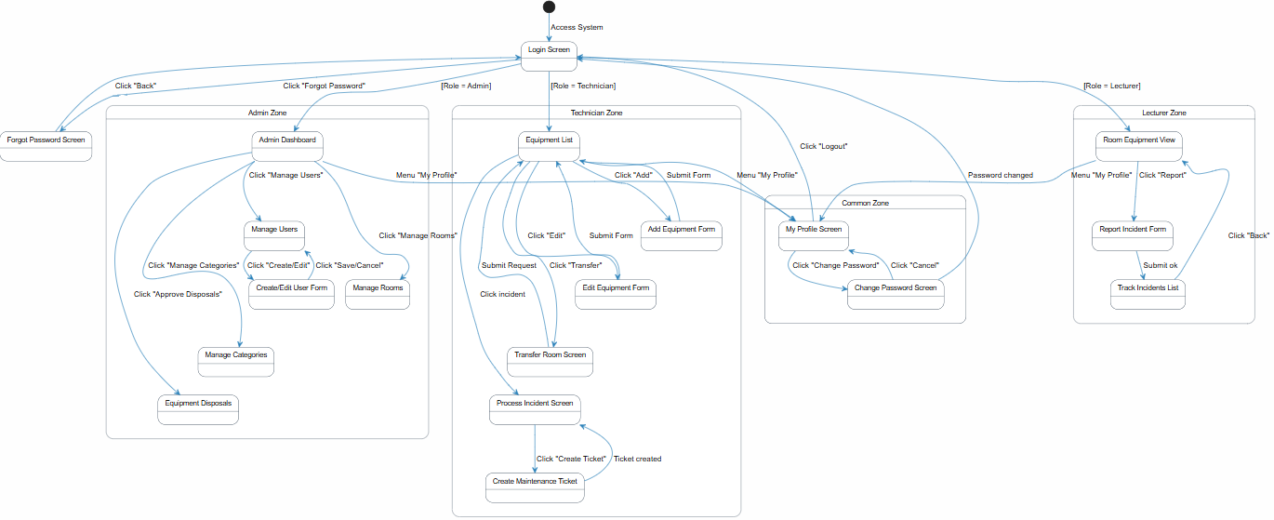2.2 Screen Descriptions
# | Feature | Screen | Description
1 | Authentication | Login Screen | This page allows users to enter their email/user code and password to log in.
2 | Authentication | Forgot Password Screen | Allows users to request a password reset link by entering their registered email.
3 | Manage Personal Profile | My Profile Screen | Users can view and update their personal information such as full name and phone number.
4 | Change Password | Change Password Screen | Users can securely change their current password and auto-logout upon success.
5 | View Dashboard | Admin Dashboard | Admin screen after logging in, displaying system statistics and overview metrics.
6 | Manage User Account | Manage Users | Admin can search, filter, and view a list of all user accounts in the system.
7 | Manage User Account | Create/Edit User Form | Admin can add, edit, lock, or delete user accounts and assign specific roles.
8 | Manage Room | Manage Rooms | Admin can add, edit, or delete classrooms and view room capacities.
9 | Manage Equipment Category | Manage Categories | Admin can add, edit, or delete equipment classifications.
10 | Approve Equipment Disposal | Equipment Disposals | Admin can review, approve, or reject equipment disposal requests submitted by technicians.
11 | Add/Update Equipment | Equipment List | Technician home screen displaying all equipment with search and filter capabilities.
12 | Add/Update Equipment | Add Equipment Form | Technician can register new equipment details and initial room assignments.
13 | Add/Update Equipment | Edit Equipment Form | Technician can update existing equipment information and operational status.
14 | Manage Equipment Location | Transfer Room Screen | Technician can transfer equipment between rooms and log the transfer history.
15 | Process Incident Report | Process Incident Screen | Technician can review incidents, update processing status (In Progress, Resolved), and log repair notes.
16 | Create Maintenance Ticket | Create Maintenance Ticket | Technician can log external repair details, expected costs, and return dates for broken equipment.
17 | View Room Equipment | Room Equipment View | Lecturer home screen to view the equipment list and operational statuses in their assigned classroom.
18 | Submit Incident Report | Report Incident Form | Lecturer can report broken or missing equipment and upload evidence images.
19 | Track Incident Report | Track Incidents List | Lecturer can track the real-time processing status of their submitted incident reports.

2.3 Screen Authorization

# | Screen | Admin | Technician | Lecture
1 | Login Screen | X | X | X
2 | Forgot Password Screen | X | X | X
3 | My Profile Screen | X | X | X
4 | Change Password Screen | X | X | X
5 | Admin Dashboard | X
6 | Manage Users | X
7 | Create/Edit User Form | X
8 | Manage Rooms | X
9 | Manage Categories | X
10 | Equipment Disposals | X
11 | Equipment List |  | X
12 | Add Equipment Form |  | X
13 | Edit Equipment Form |  | X
14 | Transfer Room Screen |  | X
15 | Process Incident Screen |  | X
16 | Create Maintenance Ticket |  | X
17 | Room Equipment View |  |  | X
18 | Report Incident Form |  |  | X
19 | Track Incidents List |  |  | X

3. System High Level Design

3.1 Database Design

Database Schema
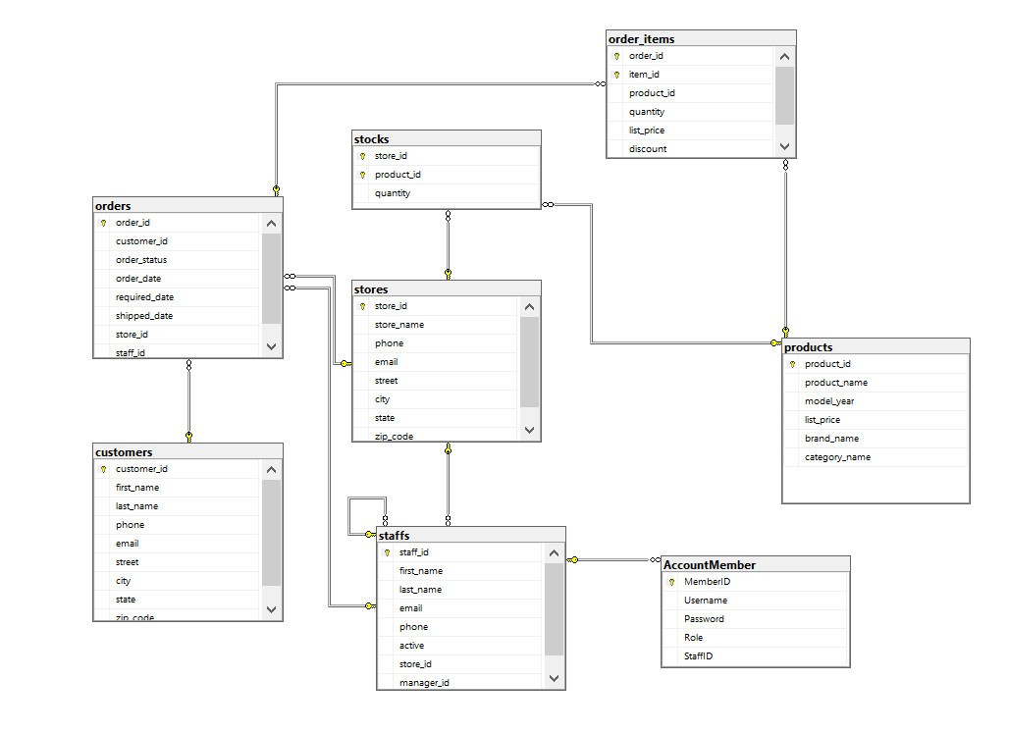

b. Table Descriptions
No | Table | Description
01 | AccountMember | - Manages user accounts with fields for MemberID, Email, Password, Role, etc.  - Primary keys: AccountID
02 | Customer | - Stores customer information with fields for CustomerID, Name, ContactInfo, etc  - Primary keys: CustomerID
03 | Orders | - Manages orders with fields for OrderID, CustomerID, OrderDate, TotalAmount, etc.  - Primary keys: for OrderID
04 | OrderItems | - Stores items within an order with fields for OrderItemID, OrderID, ProductID, Quantity, Price, etc.  - Primary keys: OrderItemID
05 | staffs | - Manage Staffs information  - Primary keys: staff_id
06 | Stores | - Manage Store information  - Foreign keys: store_id
07 | Stocks | Manage Stocks information  - Primary keys: StoreID,ProductID
08 | Products | Manage Product information  - Primary keys: ProductID

III. Design Specifications
1. Staff logs in with the designated account
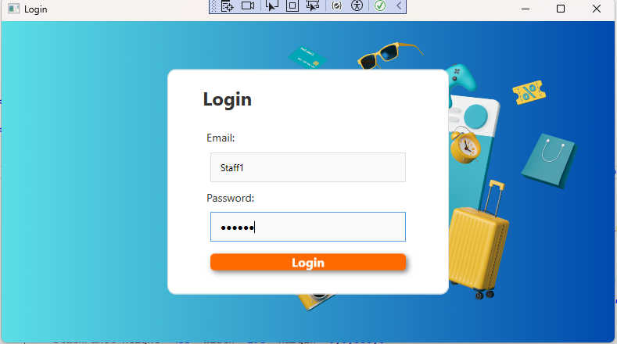

Field Name | Field Type | Description
User name | Text Box | This is for user to input user name for logging in
Password | Password Box | This is for user to input password for logging in
Login | Button | User clicks to authenticate him/herself into the system with provided email/user name & password

2. Staff screen after logging in
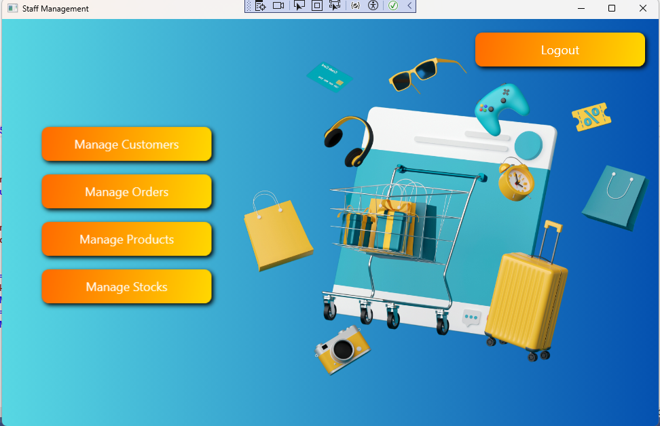

Field Name | Field Type | Description
Manage Customers | Button | Navigates to the customer management section.
Manage Orders | Button | Navigates to the order management section.
Manage Products | Button | Navigates to the product management section.
Manage Stocks | Button | Navigates to the stock management section.
Logout | Button | Logs the user out of the application.

3. Staff can add, edit or delete users on the manage customers page

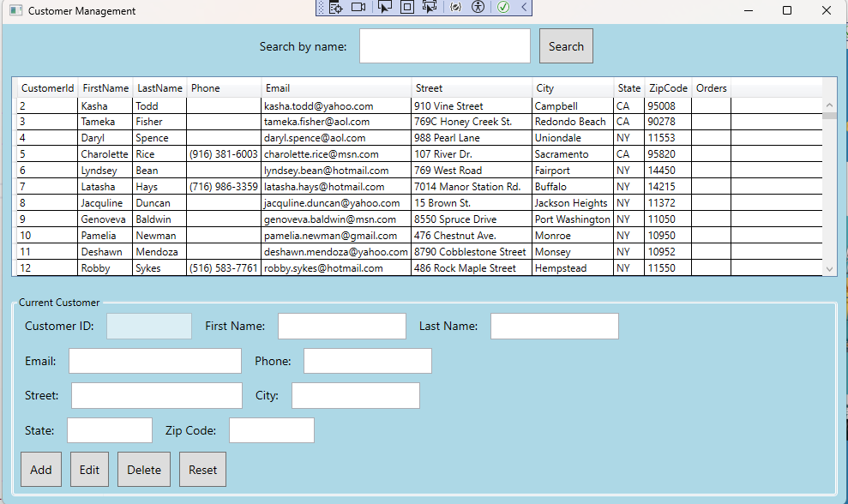

4. Staff can add, edit or delete orders on the orders order page

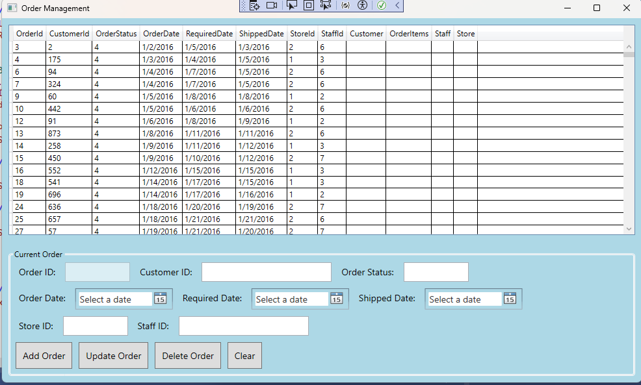

5. Staff can add, edit or delete products on the products order page

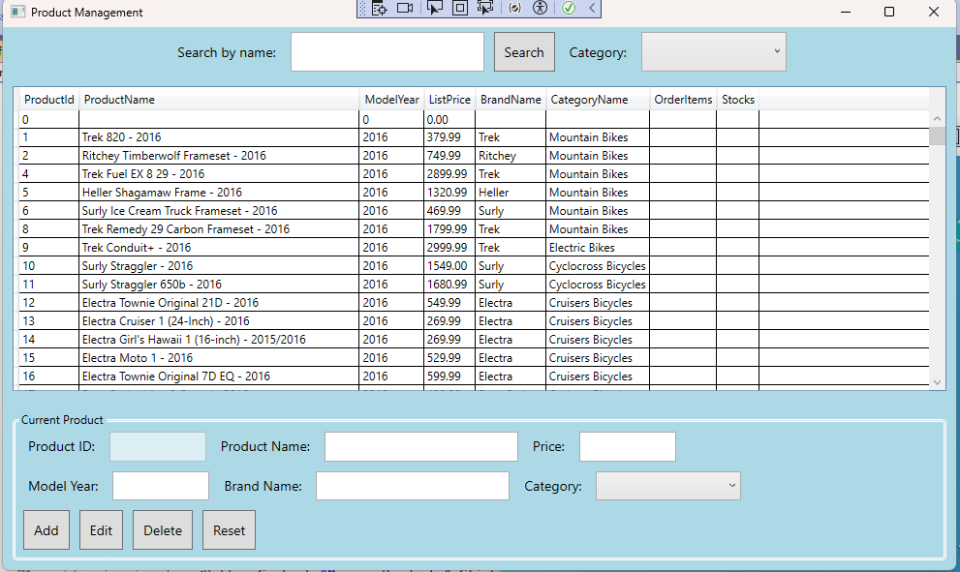

- Admin logs in with the designated account
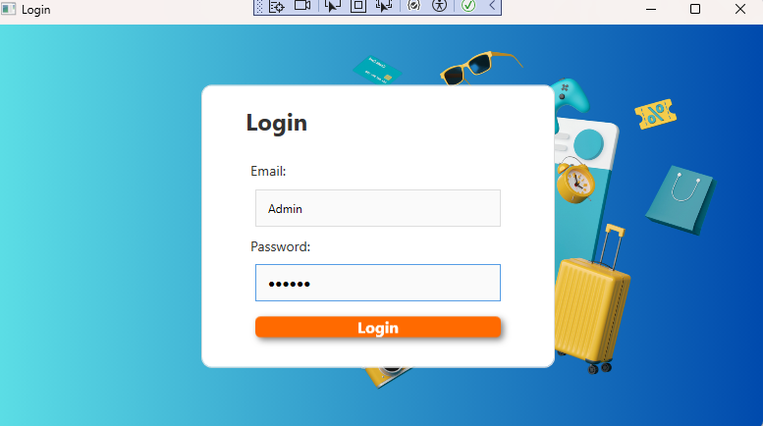

- Admin screen after logging in
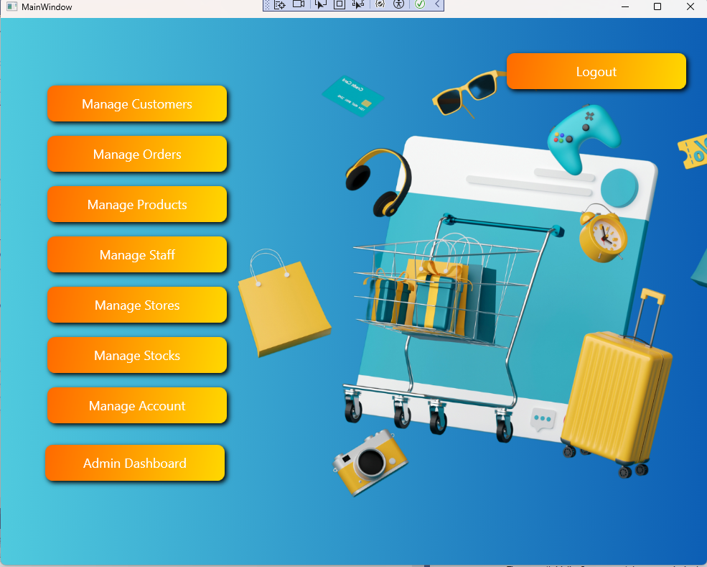

- Admin can add, edit or delete users on the manage customers page
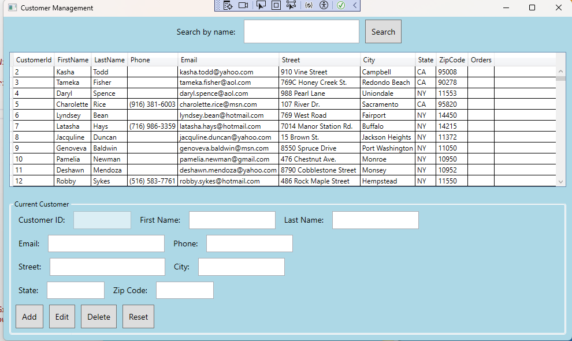

- Admin can add, edit or delete orders on the orders order page
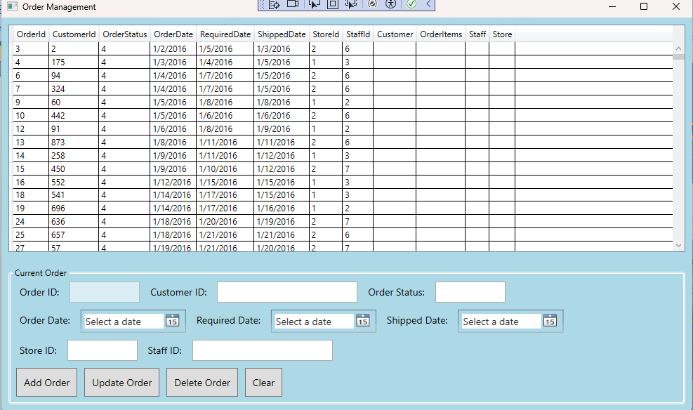

- Admin can add, edit or delete products on the products order page
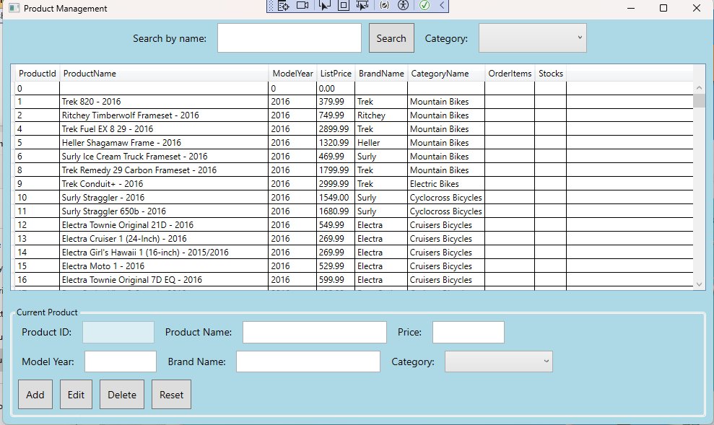

11. Admin can add, edit, and delete staff on the staff management page

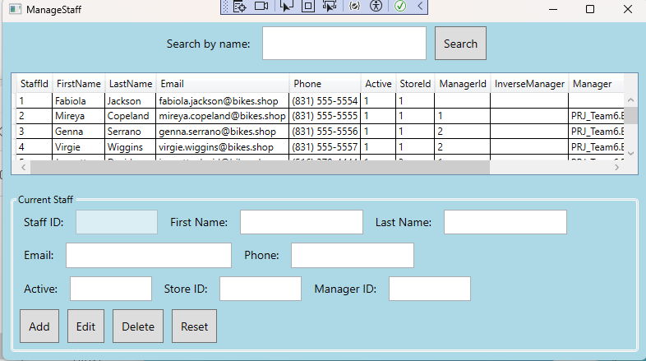

12. Admin can add, edit, and delete staff on the manage account page
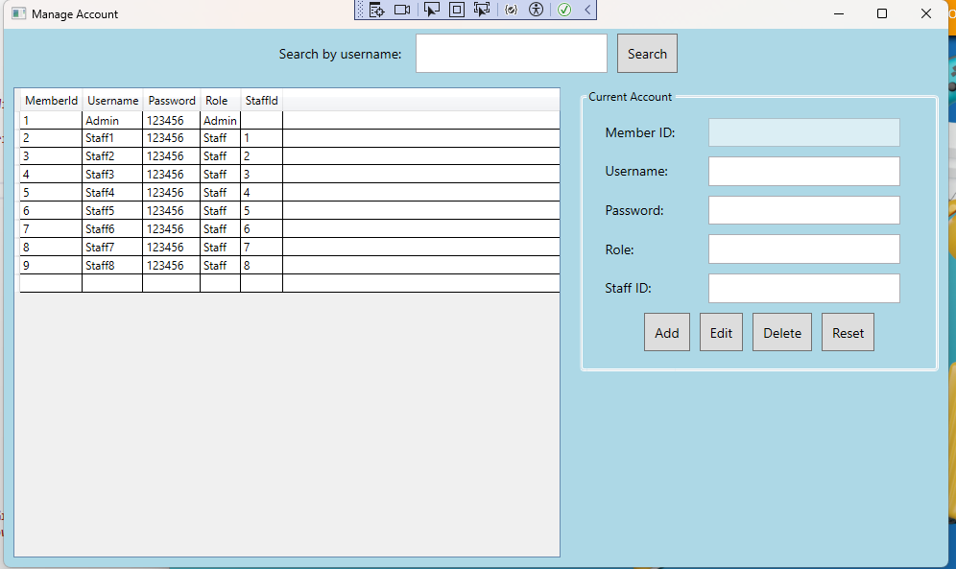

13. Admin dashboard can view the number of products in stock and can edit product quantities as well as view the top selling staff of each month and year.

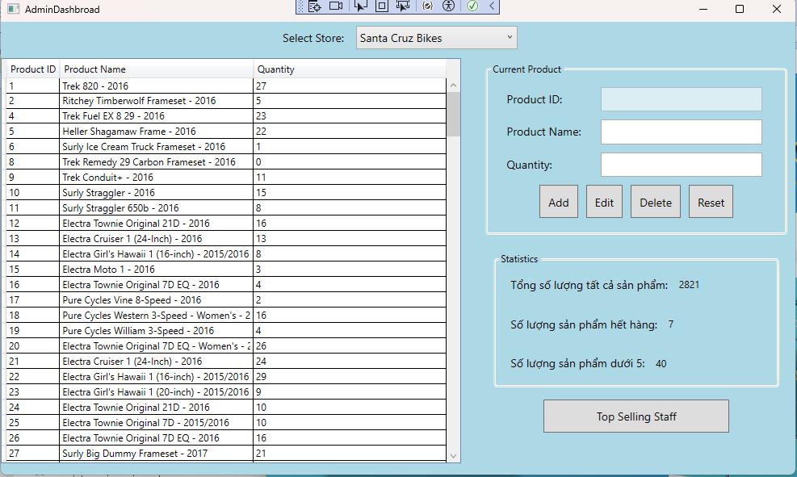

IV. Appendix

1. Assumptions & Dependencies

AS-1: The system will be used within the organization's internal network.
DE-1: Users have basic knowledge of using Windows applications.

2. Limitations & Exclusions
L-E : The system will not support mobile platforms in the current version..

3. Business Rules

BR- 1: Default admin account: MemberID is “Admin” and password is “@admin123”.
BR- 2: Default staff account: MemberID is “Staff” and password is “@staff123”.

