

Requirement & Design Specification
Store Management System(SMS)
Version: 1.0

Group 6
HE190001 – Nguyen Van A (40%)
HE190002 – Nguyen Van B (30%)
HE190003 – Nguyen Van C (30%)

Table of content
Table of content 2
Record of Changes 7
I. Overview 10
1. User Requirements 10
1.1 Actors 10
1.2 Use Cases 10
a. Diagram(s) 10
b. Descriptions 13
2. Overall Functionalities 15
2.1 Screens Flow 15
2.2 Screen Descriptions 20
2.3 Screen Authorization 24
3. System High Level Design 24
3.1 Database Design 24
a. Database Schema 25
b. Table Descriptions
II. Requirement Specifications 27
1. Common Functions 27
1.1 UC-1_SignUp 27

1.2 UC-2_Sign In 28

1.3UC-3_View all skills 28

III. Design Specifications 52

IV. Appendix 92
1. Assumptions & Dependencies 92
2. Limitations & Exclusions 92
3. Business Rules 92

I. Overview
The Store ManagementDB project is a web application project for store management. The project is developed using Microsoft Visual Studio technology, Entity Framework and data is managed by Microsoft SQL database system. The project was developed to optimise store management capabilities.

1. User Requirements

1.1 Actors
# | Actor | Description
1 | Admin | Have full system management, including all CRUD functionality for user accounts, customers, orders, and order details.
2 | Staff | Only permissions to manage customers, orders, and order details, including all CRUD functionality.

1.2 Use Cases

a. Diagram(s)

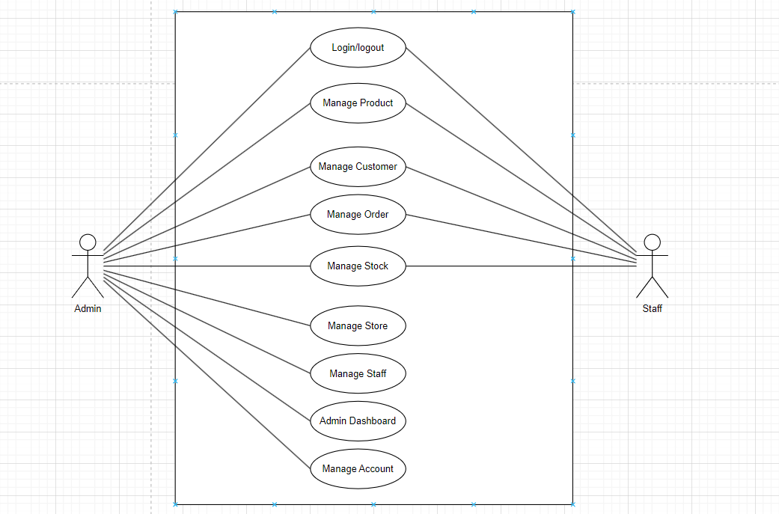

b. Descriptions

ID | Feature | Use Case | Use Case Description
01 | Admin | Manage Accounts | Add, edit, delete, view account information.
02 |  | Manage Customers | Add, edit, delete, view customer information.
03 |  | Manage Orders | Add, edit, delete, view order information.
04 |  | Manage Order Items | Add, edit, delete, view order details.
07 | Staff | Manage Customers | Add, edit, delete, view customer information.
08 |  | Manage Orders | Add, edit, delete, view order information.
09 |  | Manage Order Items | Add, edit, delete, view order details.

2. Overall Functionalities

c2.1 Screens Flow
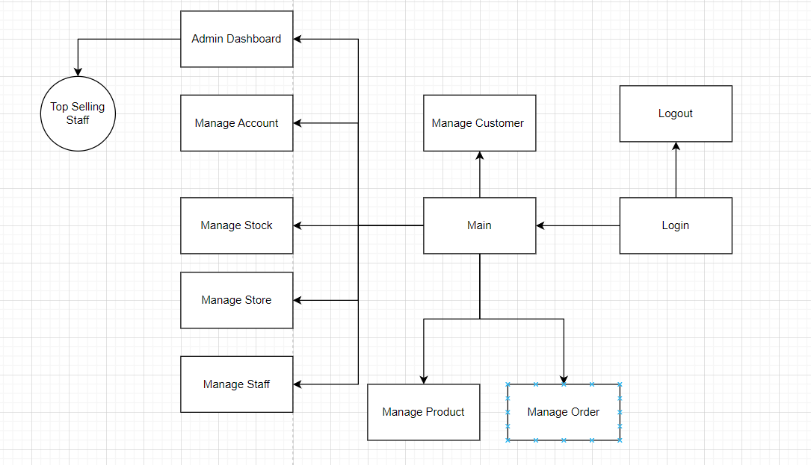

2.2 Screen Descriptions

# | Feature | Screen | Description
1 | Staff Login | Log in | This page allows User to enter username and password to login
2 | Staff Management | Home | Staff home screen interface
3 | Customer Management | Customer Management | Staff can add, edit or delete users on the manage customers page
4 | Order Management | Order Management | Staff can add, edit or delete orders on the orders order page
5 | Product Management | Product Management | Staff can add, edit or delete products on the products order page
6 | Admin Login | Login | Admin logs in with the designated account
7 | Admin Management | Home | Admin screen after logging in
8 | Customer Management | Customer Management | Admin can add, edit or delete users on the manage customers page
9 | Order Management | Order Management | Admin can add, edit or delete orders on the orders order page
10 | Product Management | Product Management | Admin can add, edit or delete products on the products order page
11 | Staff Management | ManageStaff | Admin can add, edit, and delete staff on the staff management page
12 | Account Management | Manage Account | Admin can add, edit, and delete staff on the manage account page
13 | Admin Dashboard | Admin Dashboard | Admin dashboard can view the number of products in stock and can edit product quantities as well as view the top selling staff of each month and year.

2.3 Screen Authorization
# | Screen | Admin | Manager
1 | Log in | X | X
2 | Home | X | X
3 | Customer Management | X | X
4 | Order Management | X | X
5 | Product Management | X | X
6 | ManageStaff | X
7 | Manage Account | X
8 | Admin Dashboard | X

System High Level Design

3.1 Database Design

Database Schema
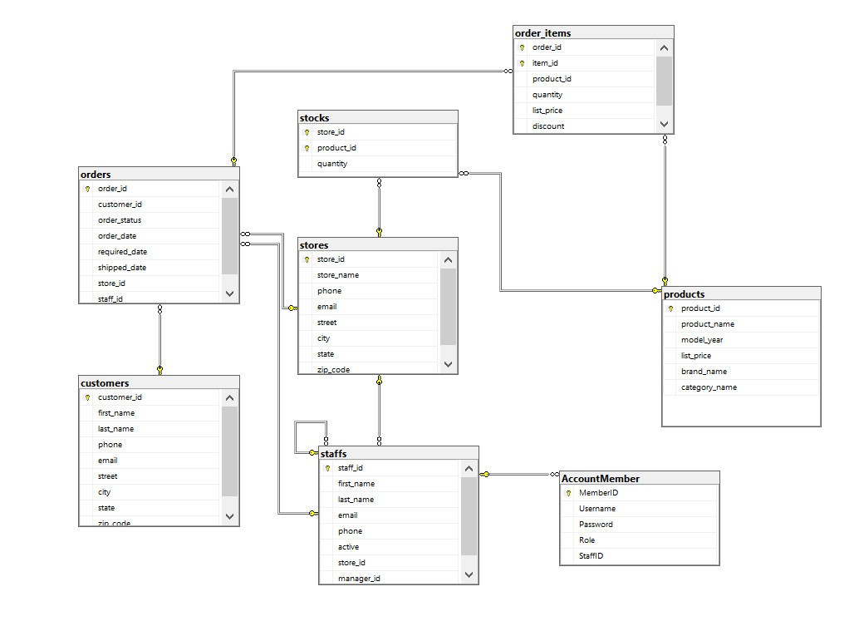

b. Table Descriptions
No | Table | Description
01 | AccountMember | - Manages user accounts with fields for MemberID, Email, Password, Role, etc.  - Primary keys: AccountID
02 | Customer | - Stores customer information with fields for CustomerID, Name, ContactInfo, etc  - Primary keys: CustomerID
03 | Orders | - Manages orders with fields for OrderID, CustomerID, OrderDate, TotalAmount, etc.  - Primary keys: for OrderID
04 | OrderItems | - Stores items within an order with fields for OrderItemID, OrderID, ProductID, Quantity, Price, etc.  - Primary keys: OrderItemID
05 | staffs | - Manage Staffs information  - Primary keys: staff_id
06 | Stores | - Manage Store information  - Foreign keys: store_id
07 | Stocks | Manage Stocks information  - Primary keys: StoreID,ProductID
08 | Products | Manage Product information  - Primary keys: ProductID

III. Design Specifications
1. Staff logs in with the designated account
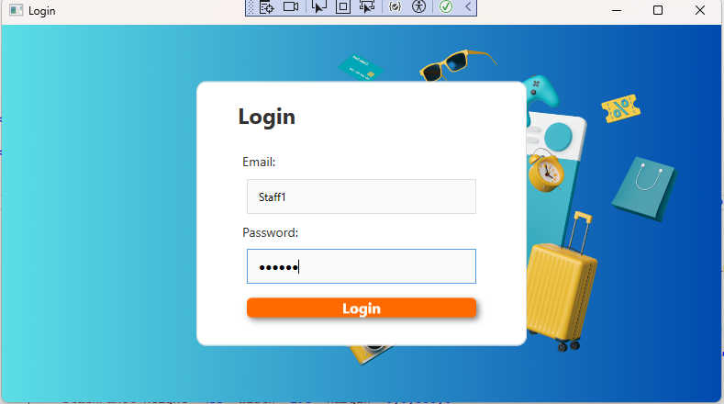

Field Name | Field Type | Description
User name | Text Box | This is for user to input user name for logging in
Password | Password Box | This is for user to input password for logging in
Login | Button | User clicks to authenticate him/herself into the system with provided email/user name & password

2. Staff screen after logging in
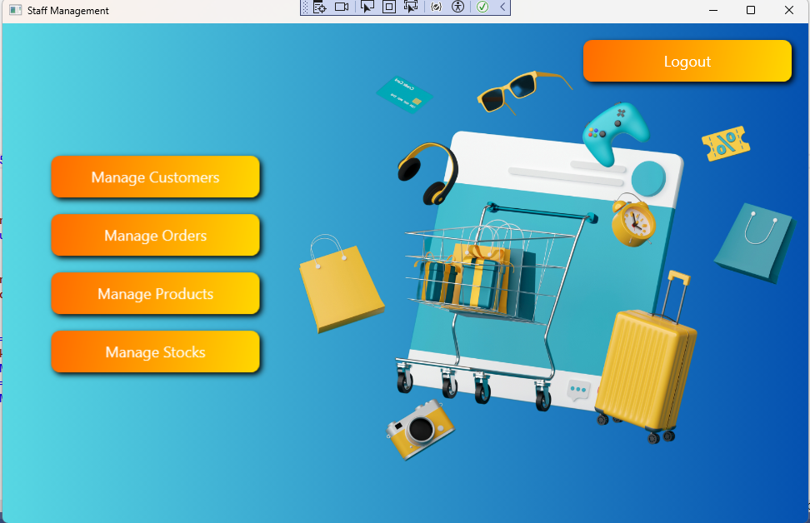

Field Name | Field Type | Description
Manage Customers | Button | Navigates to the customer management section.
Manage Orders | Button | Navigates to the order management section.
Manage Products | Button | Navigates to the product management section.
Manage Stocks | Button | Navigates to the stock management section.
Logout | Button | Logs the user out of the application.

3. Staff can add, edit or delete users on the manage customers page

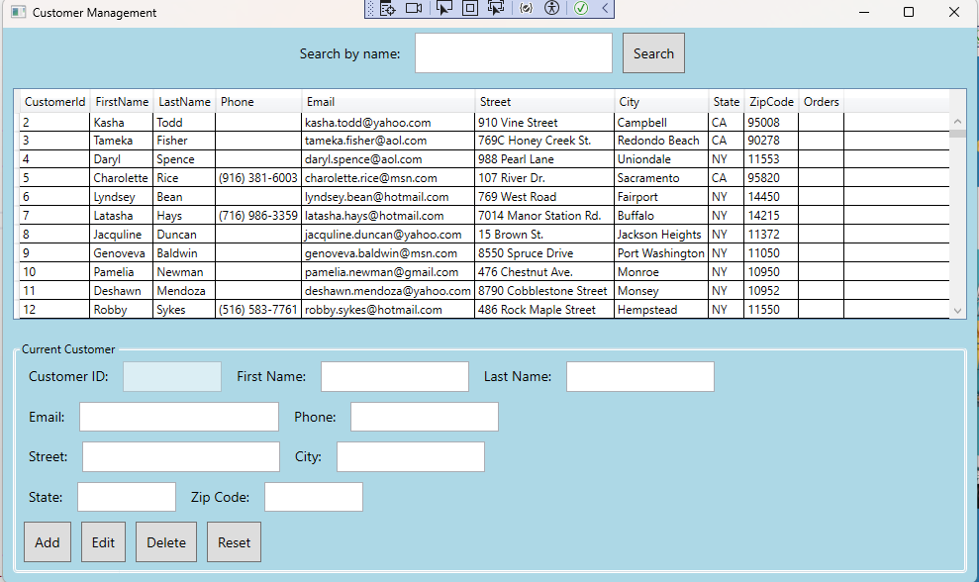

4. Staff can add, edit or delete orders on the orders order page

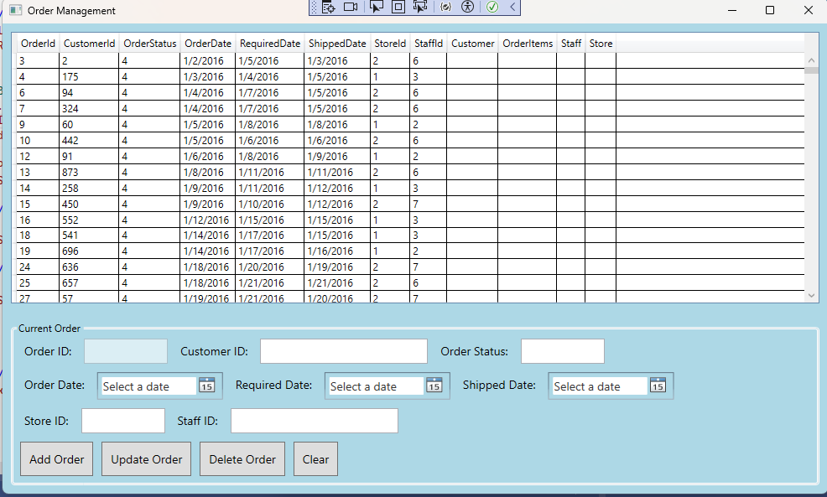

5. Staff can add, edit or delete products on the products order page

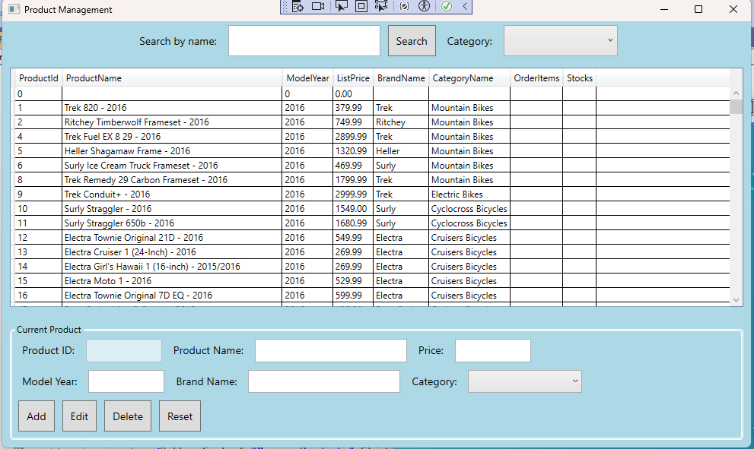

- Admin logs in with the designated account
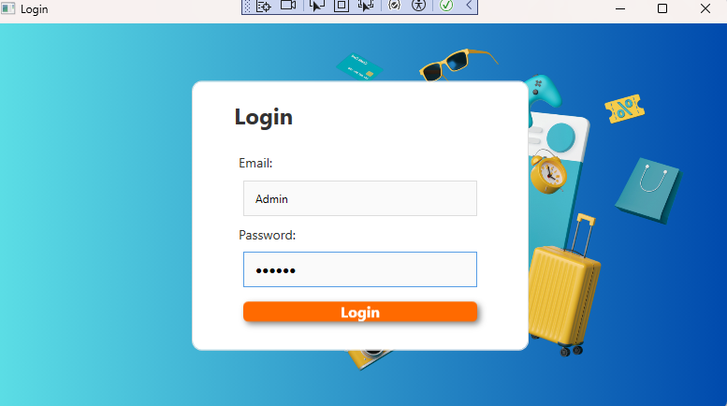

- Admin screen after logging in
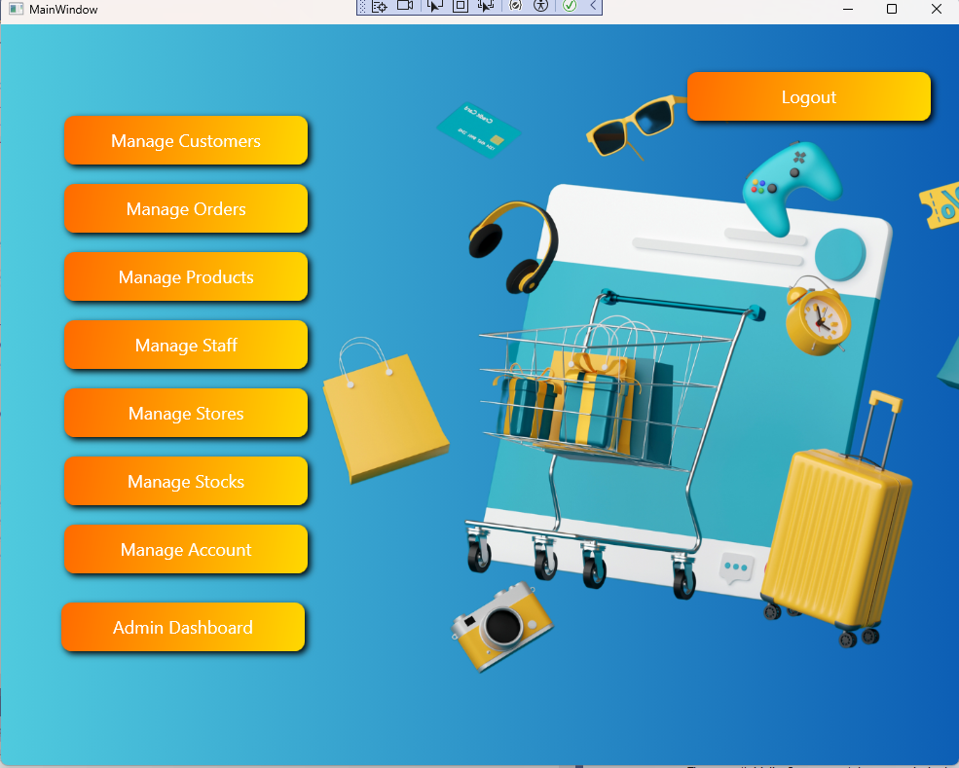

- Admin can add, edit or delete users on the manage customers page
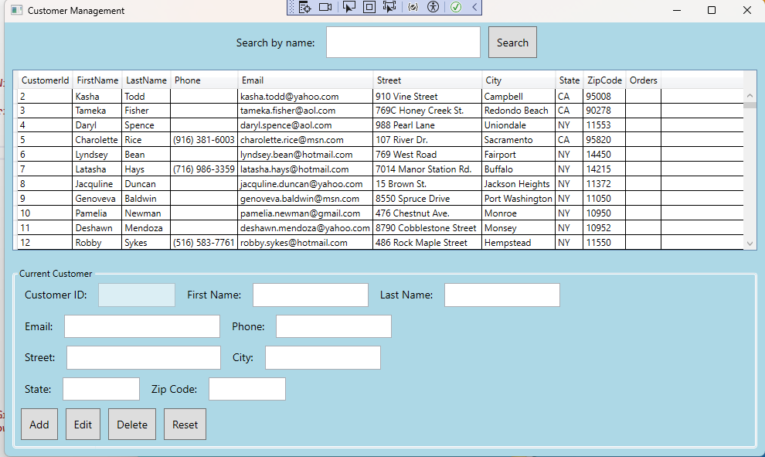

- Admin can add, edit or delete orders on the orders order page
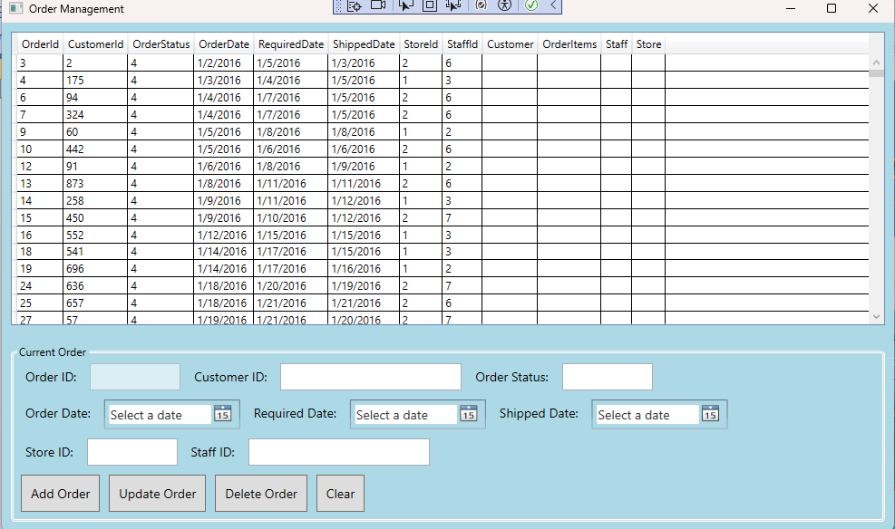

- Admin can add, edit or delete products on the products order page
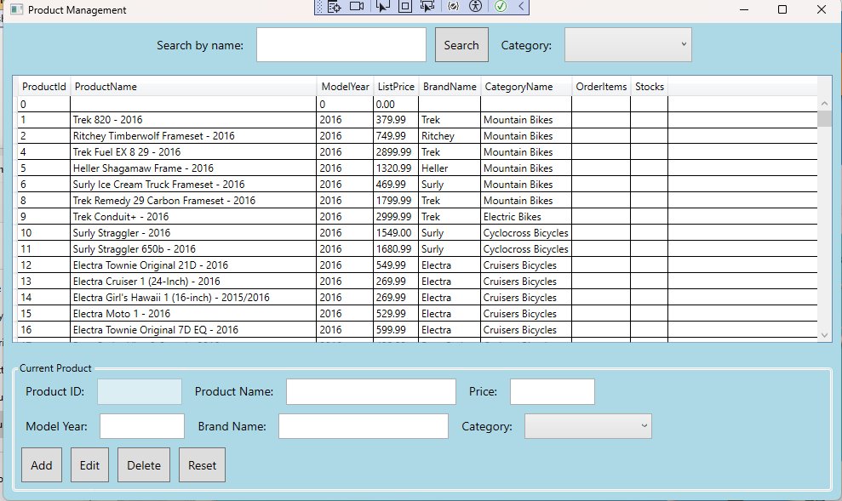

11. Admin can add, edit, and delete staff on the staff management page

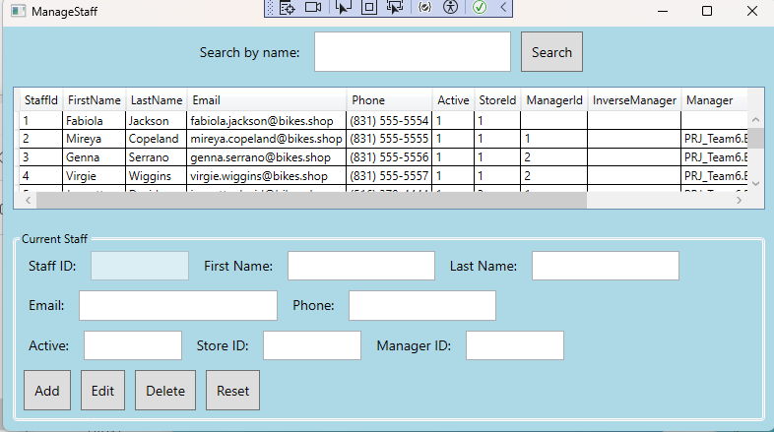

12. Admin can add, edit, and delete staff on the manage account page
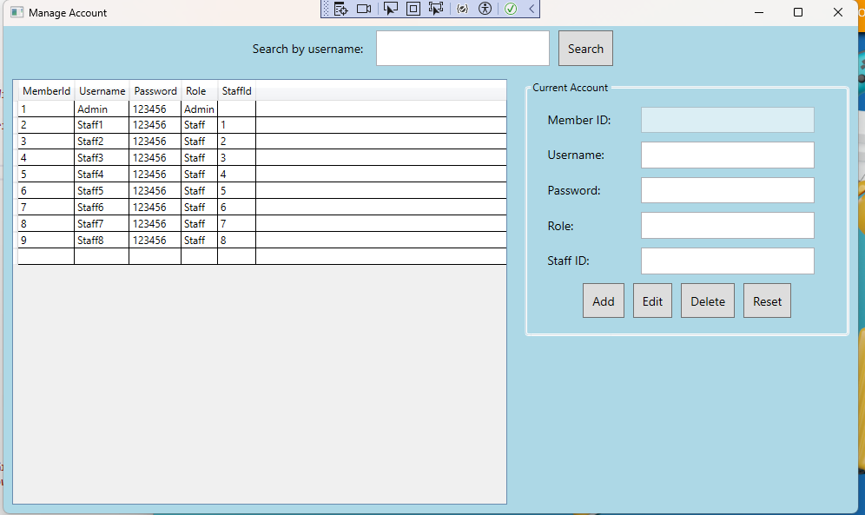

13. Admin dashboard can view the number of products in stock and can edit product quantities as well as view the top selling staff of each month and year.

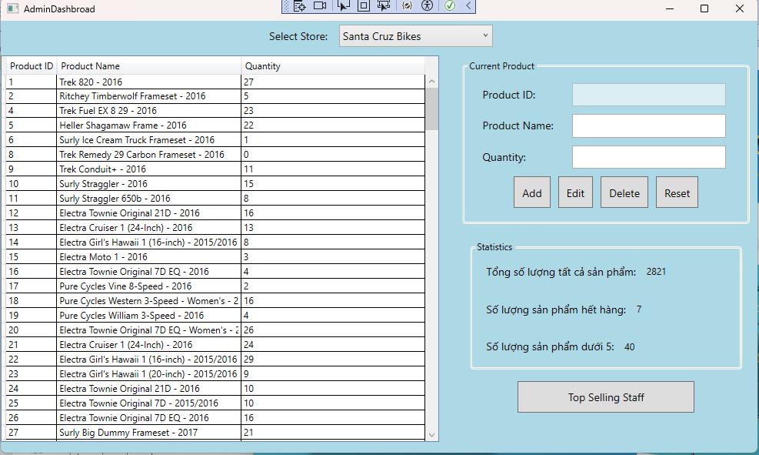

IV. Appendix

1. Assumptions & Dependencies

AS-1: The system will be used within the organization's internal network.
DE-1: Users have basic knowledge of using Windows applications.

2. Limitations & Exclusions
L-E : The system will not support mobile platforms in the current version..

3. Business Rules

BR- 1: Default admin account: MemberID is “Admin” and password is “@admin123”.
BR- 2: Default staff account: MemberID is “Staff” and password is “@staff123”.

