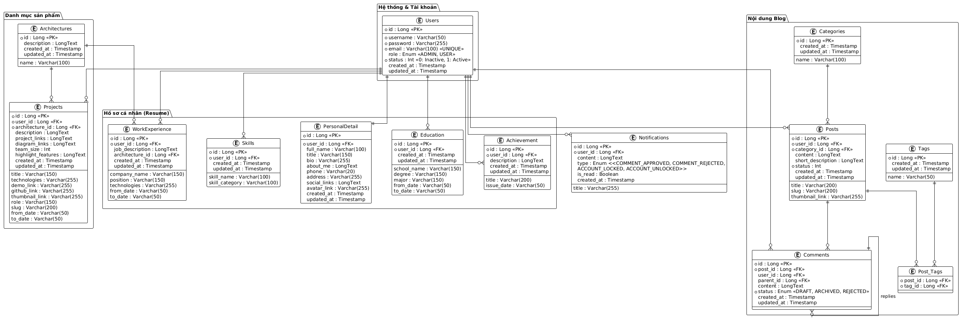

NGUỒN: SƠ ĐỒ ERD [PORTFOLIO]
Code
@startuml
!theme plain
skinparam Linetype ortho
skinparam nodesep 60
skinparam ranksep 80

package "Hệ thống & Tài khoản" {
entity "Users" as users {
* id : Long <<PK>>
--
* username : Varchar(50)
* password : Varchar(255)
* email : Varchar(100) <<UNIQUE>>
role : Enum <<ADMIN, USER>>
* status : Int <<0: Inactive, 1: Active>>
created_at : Timestamp
updated_at : Timestamp
}
}

entity "Notifications" as notifications {
* id : Long <<PK>>
* user_id : Long <<FK>>
title : Varchar(255)
content : LongText
type : Enum <<COMMENT_APPROVED, COMMENT_REJECTED, ACCOUNT_LOCKED, ACCOUNT_UNLOCKED>>
is_read : Boolean
created_at : Timestamp
}

package "Hồ sơ cá nhân (Resume)" {
entity "PersonalDetail" as personal {
* id : Long <<PK>>
--
* user_id : Long <<FK>>
full_name : Varchar(100)
title : Varchar(150)
bio : Varchar(255)
about_me : LongText
phone : Varchar(20)
address : Varchar(255)
social_links : LongText
avatar_link : Varchar(255)
created_at : Timestamp
updated_at : Timestamp
}

entity "Education" as edu {
* id : Long <<PK>>
* user_id : Long <<FK>>
school_name : Varchar(150)
degree : Varchar(150)
major : Varchar(150)
from_date : Varchar(50)
to_date : Varchar(50)
created_at : Timestamp
updated_at : Timestamp
}

entity "WorkExperience" as work {
* id : Long <<PK>>
* user_id : Long <<FK>>
company_name : Varchar(150)
position : Varchar(150)
job_description : LongText
technologies : Varchar(255)
architecture_id : Long <<FK>>
from_date : Varchar(50)
to_date : Varchar(50)
created_at : Timestamp
updated_at : Timestamp
}

entity "Achievement" as achieve {
* id : Long <<PK>>
* user_id : Long <<FK>>
title : Varchar(200)
issue_date : Varchar(50)
description : LongText
created_at : Timestamp
updated_at : Timestamp
}

entity "Skills" as skills {
* id : Long <<PK>>
* user_id : Long <<FK>>
skill_name : Varchar(100)
skill_category : Varchar(100)
created_at : Timestamp
updated_at : Timestamp
}
}

package "Danh mục sản phẩm" {

entity "Architectures" as architectures {
* id : Long <<PK>>
name : Varchar(100)
description : LongText
created_at : Timestamp
updated_at : Timestamp
}

entity "Projects" as projects {
* id : Long <<PK>>
* user_id : Long <<FK>>
* architecture_id : Long <<FK>>
title : Varchar(150)
technologies : Varchar(255)
description : LongText
project_links : LongText
diagram_links : LongText
demo_link : Varchar(255)
github_link : Varchar(255)
thumbnail_link : Varchar(255)
role : Varchar(150)
team_size : Int
highlight_features : LongText
slug : Varchar(200)
from_date : Varchar(50)
to_date : Varchar(50)
created_at : Timestamp
updated_at : Timestamp
}
}

package "Nội dung Blog" {
entity "Posts" as posts {
* id : Long <<PK>>
* user_id : Long <<FK>>
* category_id : Long <<FK>>
title : Varchar(200)
slug : Varchar(200)
content : LongText
short_description : LongText
thumbnail_link : Varchar(255)
created_at : Timestamp
updated_at : Timestamp
}

entity "Comments" as comments {
* id : Long <<PK>>
* post_id : Long <<FK>>
user_id : Long <<FK>>
parent_id : Long <<FK>>
content : LongText
* status : Enum <<DRAFT, ARCHIVED, REJECTED>>
created_at : Timestamp
updated_at : Timestamp
}

entity "Categories" as categories {
* id : Long <<PK>>
name : Varchar(100)
created_at : Timestamp
updated_at : Timestamp
}

entity "Tags" as tags {
* id : Long <<PK>>
name : Varchar(50)
created_at : Timestamp
updated_at : Timestamp
}

entity "Post_Tags" as post_tags {
* post_id : Long <<FK>>
* tag_id : Long <<FK>>
}
}

' Links
users ||--|| personal
users ||--o{ edu
users ||--o{ work
users ||--o{ achieve
users ||--o{ skills
users ||--o{ projects
users ||--o{ posts
users ||--o{ comments
users ||--o{ notifications

architectures ||--o{ projects
architectures ||--o{ work

categories ||--o{ posts
posts ||--o{ comments
posts ||--o{ post_tags
tags ||--o{ post_tags

comments ||--o{ comments : "replies"

@enduml

