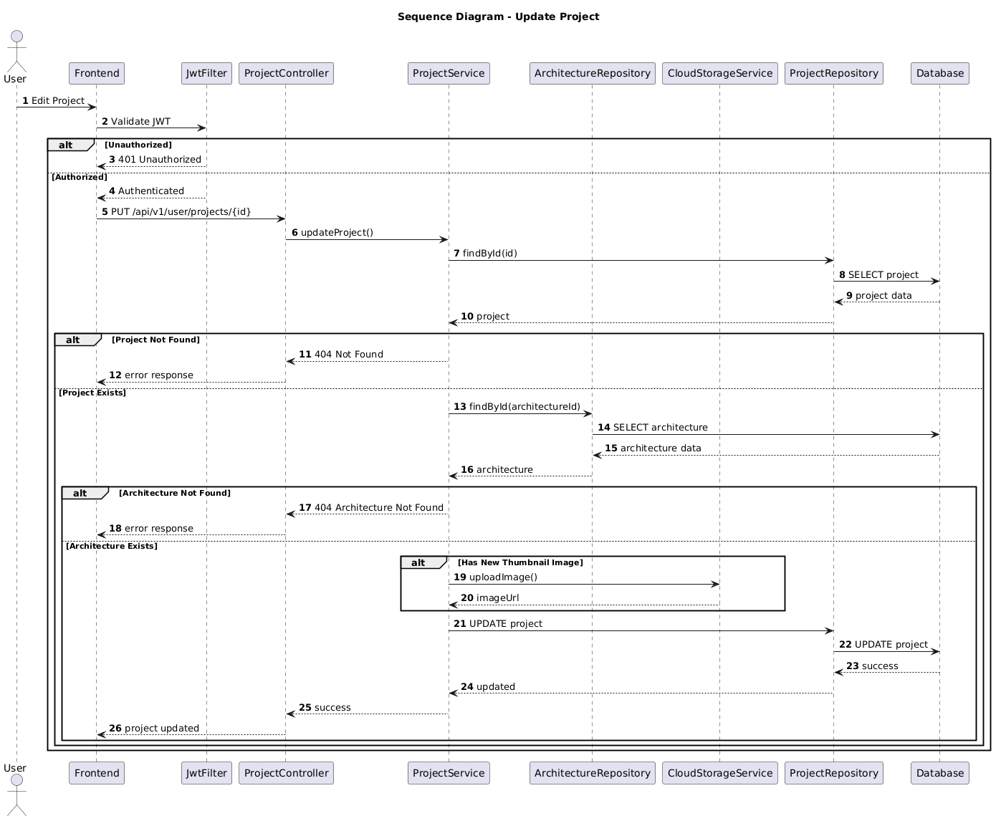

NGUỒN: SƠ ĐỒ SEQUENCE DIAGRAM - UPDATE PROJECT [PORTFOLIO]

Code
@startuml
autonumber

title Sequence Diagram - Update Project

actor User
participant Frontend
participant JwtFilter
participant ProjectController
participant ProjectService
participant ArchitectureRepository
participant CloudStorageService
participant ProjectRepository
participant Database

User -> Frontend : Edit Project

Frontend -> JwtFilter : Validate JWT

alt Unauthorized

JwtFilter --> Frontend : 401 Unauthorized

else Authorized

JwtFilter --> Frontend : Authenticated

Frontend -> ProjectController : PUT /api/v1/user/projects/{id}

ProjectController -> ProjectService : updateProject()

ProjectService -> ProjectRepository : findById(id)

ProjectRepository -> Database : SELECT project

Database --> ProjectRepository : project data

ProjectRepository --> ProjectService : project

alt Project Not Found

ProjectService --> ProjectController : 404 Not Found

ProjectController --> Frontend : error response

else Project Exists

ProjectService -> ArchitectureRepository : findById(architectureId)

ArchitectureRepository -> Database : SELECT architecture

Database --> ArchitectureRepository : architecture data

ArchitectureRepository --> ProjectService : architecture

alt Architecture Not Found

ProjectService --> ProjectController : 404 Architecture Not Found

ProjectController --> Frontend : error response

else Architecture Exists

alt Has New Thumbnail Image

ProjectService -> CloudStorageService : uploadImage()

CloudStorageService --> ProjectService : imageUrl

end

ProjectService -> ProjectRepository : UPDATE project

ProjectRepository -> Database : UPDATE project

Database --> ProjectRepository : success

ProjectRepository --> ProjectService : updated

ProjectService --> ProjectController : success

ProjectController --> Frontend : project updated

end

end

end

@enduml

