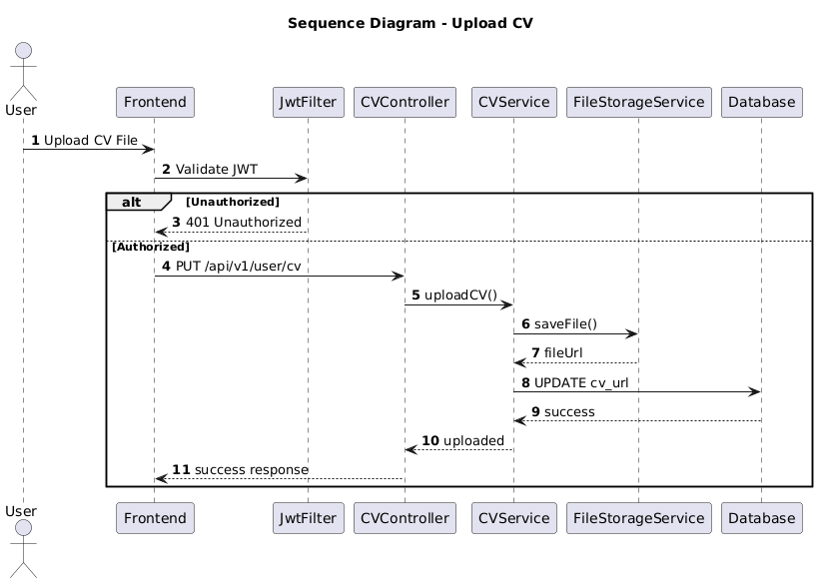

NGUỒN: SƠ ĐỒ SEQUENCE DIAGRAM - UPLOAD CV [PORTFOLIO]

Code
@startuml
autonumber

title Sequence Diagram - Upload CV

actor User
participant Frontend
participant JwtFilter
participant CVController
participant CVService
participant FileStorageService
participant Database

User -> Frontend : Upload CV File

Frontend -> JwtFilter : Validate JWT

alt Unauthorized

JwtFilter --> Frontend : 401 Unauthorized

else Authorized

Frontend -> CVController : PUT /api/v1/user/cv

CVController -> CVService : uploadCV()

CVService -> FileStorageService : saveFile()

FileStorageService --> CVService : fileUrl

CVService -> Database : UPDATE cv_url

Database --> CVService : success

CVService --> CVController : uploaded

CVController --> Frontend : success response

end

@enduml

