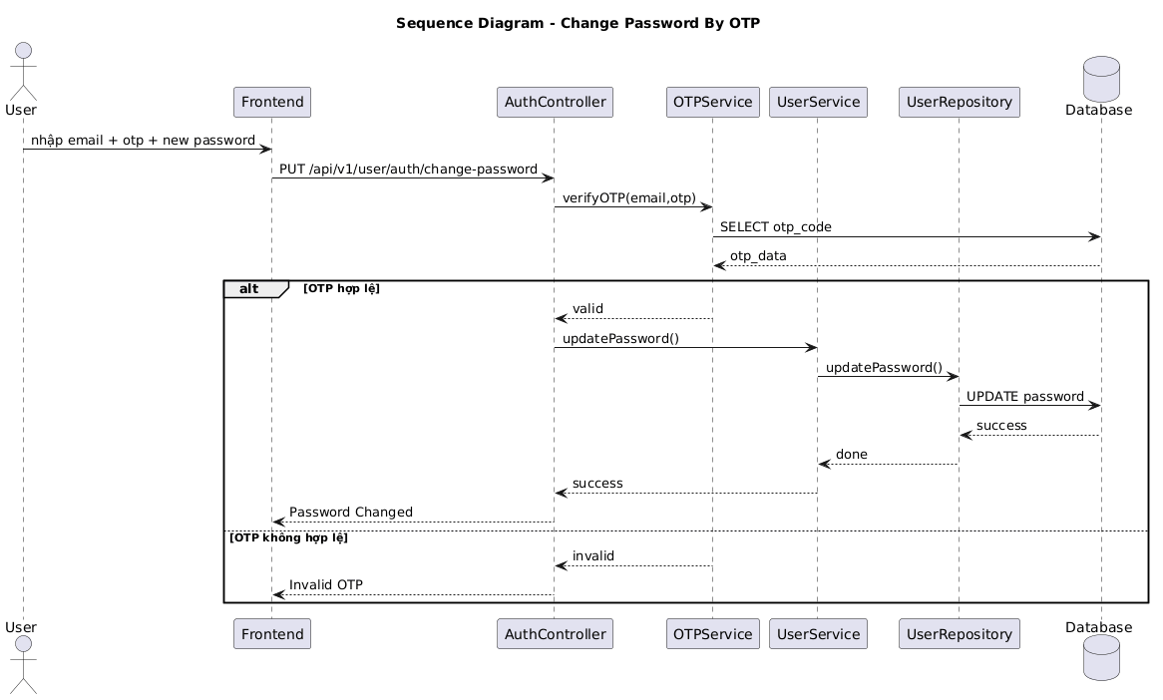

NGUỒN: SƠ ĐỒ SEQUENCE DIAGRAM - CHANGE PASSWORD [PORTFOLIO]
Code
@startuml
title Sequence Diagram - Change Password By OTP

actor User
participant Frontend
participant AuthController
participant OTPService
participant UserService
participant UserRepository
database Database

User -> Frontend : nhập email + otp + new password

Frontend -> AuthController : PUT /api/v1/user/auth/change-password

AuthController -> OTPService : verifyOTP(email,otp)

OTPService -> Database : SELECT otp_code
Database --> OTPService : otp_data

alt OTP hợp lệ

OTPService --> AuthController : valid

AuthController -> UserService : updatePassword()

UserService -> UserRepository : updatePassword()

UserRepository -> Database : UPDATE password

Database --> UserRepository : success

UserRepository --> UserService : done

UserService --> AuthController : success

AuthController --> Frontend : Password Changed

else OTP không hợp lệ

OTPService --> AuthController : invalid

AuthController --> Frontend : Invalid OTP

end

@enduml

