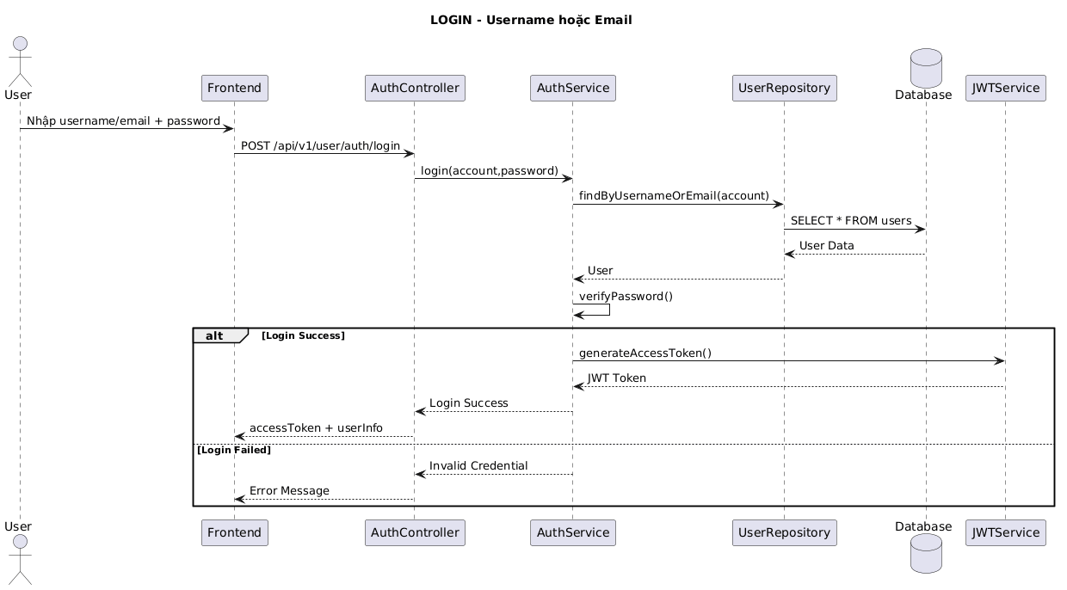

NGUỒN: SƠ ĐỒ SEQUENCE DIAGRAM - LOGIN [PORTFOLIO]
Code
@startuml
title LOGIN - Username hoặc Email

actor User
participant Frontend
participant AuthController
participant AuthService
participant UserRepository
database Database
participant JWTService

User -> Frontend : Nhập username/email + password

Frontend -> AuthController : POST /api/v1/user/auth/login

AuthController -> AuthService : login(account,password)

AuthService -> UserRepository : findByUsernameOrEmail(account)

UserRepository -> Database : SELECT * FROM users
Database --> UserRepository : User Data

UserRepository --> AuthService : User

AuthService -> AuthService : verifyPassword()

alt Login Success

AuthService -> JWTService : generateAccessToken()
JWTService --> AuthService : JWT Token

AuthService --> AuthController : Login Success
AuthController --> Frontend : accessToken + userInfo

else Login Failed

AuthService --> AuthController : Invalid Credential
AuthController --> Frontend : Error Message

end

@enduml

