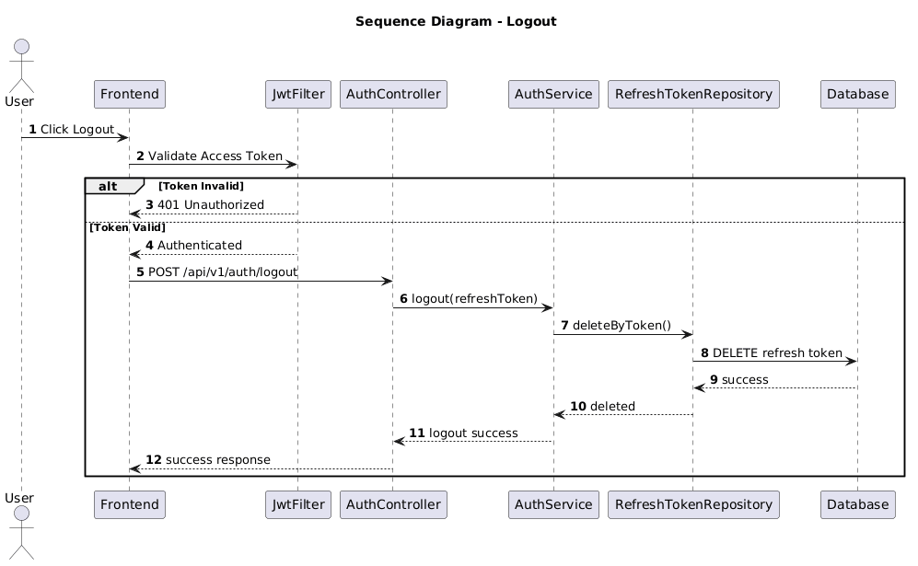

NGUỒN: SƠ ĐỒ SEQUENCE DIAGRAM - LOGOUT [PORTFOLIO]
Code
@startuml
autonumber

title Sequence Diagram - Logout

actor User
participant Frontend
participant JwtFilter
participant AuthController
participant AuthService
participant RefreshTokenRepository
participant Database

User -> Frontend : Click Logout

Frontend -> JwtFilter : Validate Access Token

alt Token Invalid

JwtFilter --> Frontend : 401 Unauthorized

else Token Valid

JwtFilter --> Frontend : Authenticated

Frontend -> AuthController : POST /api/v1/auth/logout

AuthController -> AuthService : logout(refreshToken)

AuthService -> RefreshTokenRepository : deleteByToken()

RefreshTokenRepository -> Database : DELETE refresh token

Database --> RefreshTokenRepository : success

RefreshTokenRepository --> AuthService : deleted

AuthService --> AuthController : logout success

AuthController --> Frontend : success response

end

@enduml

