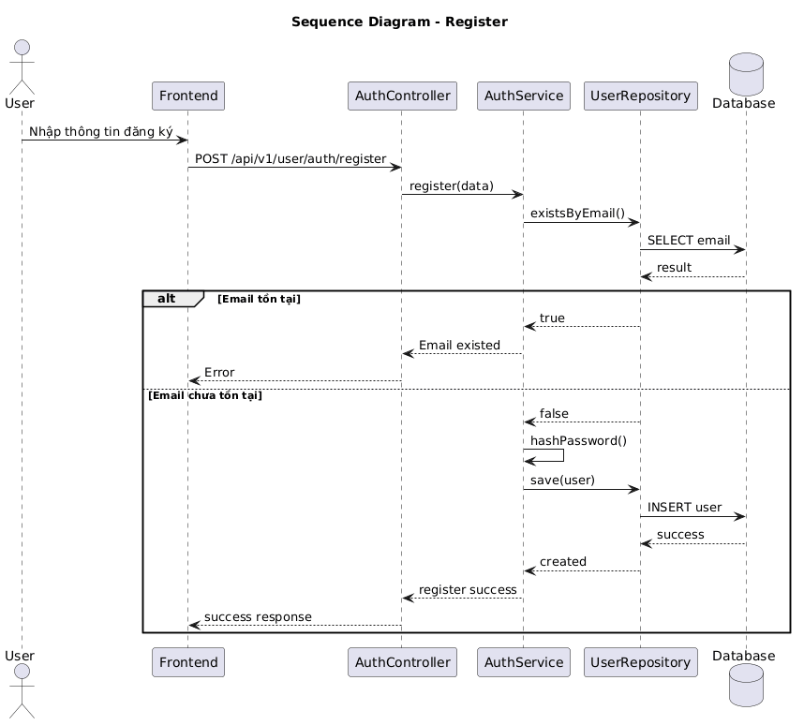

NGUỒN: SƠ ĐỒ SEQUENCE DIAGRAM - REGISTER [PORTFOLIO]
Code
@startuml
title Sequence Diagram - Register

actor User
participant Frontend
participant AuthController
participant AuthService
participant UserRepository
database Database

User -> Frontend : Nhập thông tin đăng ký

Frontend -> AuthController : POST /api/v1/user/auth/register

AuthController -> AuthService : register(data)

AuthService -> UserRepository : existsByEmail()

UserRepository -> Database : SELECT email
Database --> UserRepository : result

alt Email tồn tại

UserRepository --> AuthService : true
AuthService --> AuthController : Email existed
AuthController --> Frontend : Error

else Email chưa tồn tại

UserRepository --> AuthService : false

AuthService -> AuthService : hashPassword()

AuthService -> UserRepository : save(user)

UserRepository -> Database : INSERT user
Database --> UserRepository : success

UserRepository --> AuthService : created

AuthService --> AuthController : register success

AuthController --> Frontend : success response

end

@enduml

