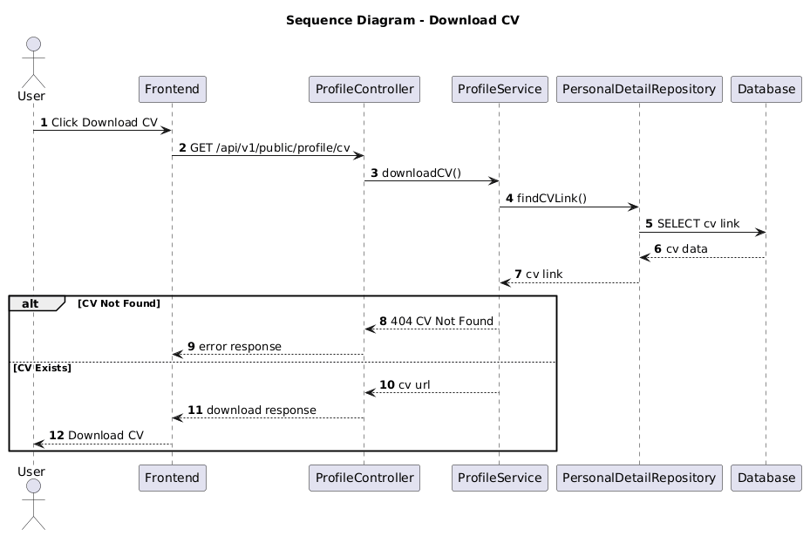

NGUỒN: SƠ ĐỒ SEQUENCE DIAGRAM - DOWNLOAD CV [PORTFOLIO]

Code
@startuml
autonumber

title Sequence Diagram - Download CV

actor User
participant Frontend
participant ProfileController
participant ProfileService
participant PersonalDetailRepository
participant Database

User -> Frontend : Click Download CV

Frontend -> ProfileController : GET /api/v1/public/profile/cv

ProfileController -> ProfileService : downloadCV()

ProfileService -> PersonalDetailRepository : findCVLink()

PersonalDetailRepository -> Database : SELECT cv link

Database --> PersonalDetailRepository : cv data

PersonalDetailRepository --> ProfileService : cv link

alt CV Not Found

ProfileService --> ProfileController : 404 CV Not Found

ProfileController --> Frontend : error response

else CV Exists

ProfileService --> ProfileController : cv url

ProfileController --> Frontend : download response

Frontend --> User : Download CV

end

@enduml

