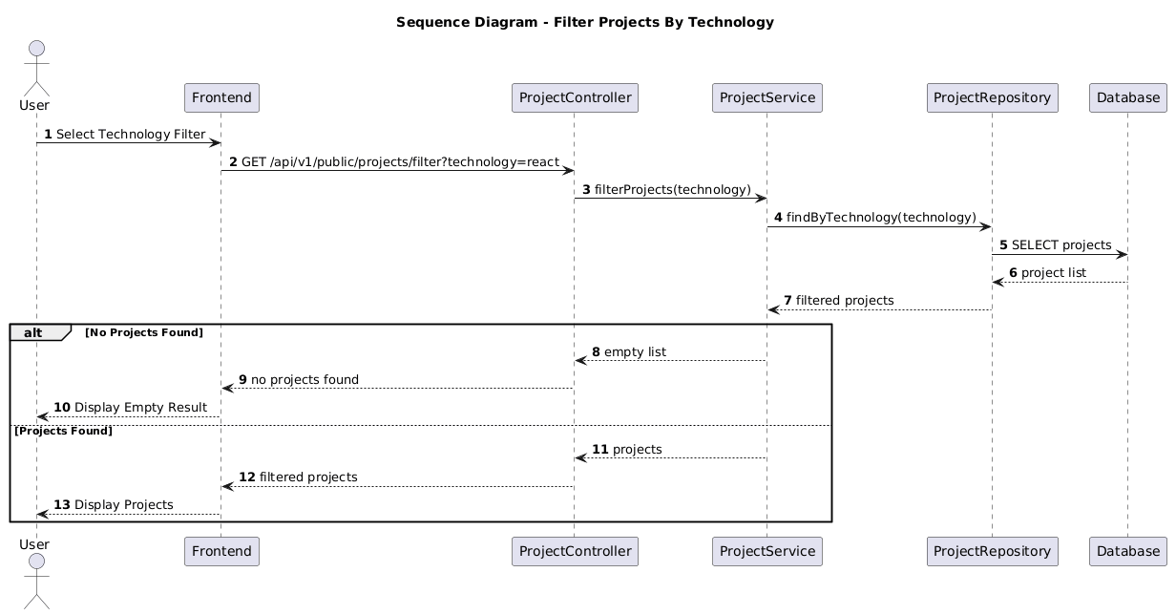

NGUỒN: SƠ ĐỒ SEQUENCE DIAGRAM - FILTER PROJECT BY TECHNOLOGIES [PORTFOLIO]

Code
@startuml
autonumber

title Sequence Diagram - Filter Projects By Technology

actor User
participant Frontend
participant ProjectController
participant ProjectService
participant ProjectRepository
participant Database

User -> Frontend : Select Technology Filter

Frontend -> ProjectController : GET /api/v1/public/projects/filter?technology=react

ProjectController -> ProjectService : filterProjects(technology)

ProjectService -> ProjectRepository : findByTechnology(technology)

ProjectRepository -> Database : SELECT projects

Database --> ProjectRepository : project list

ProjectRepository --> ProjectService : filtered projects

alt No Projects Found

ProjectService --> ProjectController : empty list

ProjectController --> Frontend : no projects found

Frontend --> User : Display Empty Result

else Projects Found

ProjectService --> ProjectController : projects

ProjectController --> Frontend : filtered projects

Frontend --> User : Display Projects

end

@enduml

