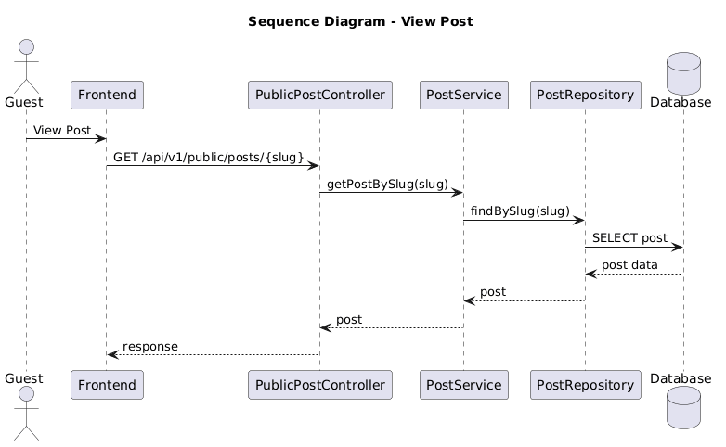

NGUỒN: SƠ ĐỒ SEQUENCE DIAGRAM - VIEW POST [PORTFOLIO]
Code
@startuml
title Sequence Diagram - View Post

actor Guest
participant Frontend
participant PublicPostController
participant PostService
participant PostRepository
database Database

Guest -> Frontend : View Post

Frontend -> PublicPostController : GET /api/v1/public/posts/{slug}

PublicPostController -> PostService : getPostBySlug(slug)

PostService -> PostRepository : findBySlug(slug)

PostRepository -> Database : SELECT post
Database --> PostRepository : post data

PostRepository --> PostService : post

PostService --> PublicPostController : post

PublicPostController --> Frontend : response

@enduml

