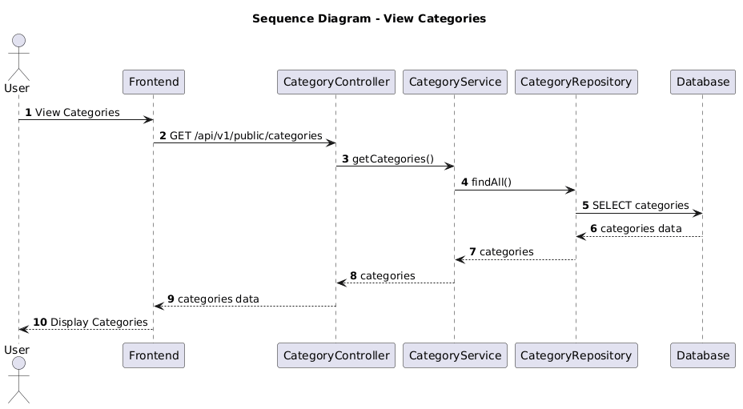

NGUỒN: SƠ ĐỒ SEQUENCE DIAGRAM - VIEW CATEGORIES & TAGS [PORTFOLIO]

Code
@startuml
autonumber

title Sequence Diagram - View Categories

actor User
participant Frontend
participant CategoryController
participant CategoryService
participant CategoryRepository
participant Database

User -> Frontend : View Categories

Frontend -> CategoryController : GET /api/v1/public/categories

CategoryController -> CategoryService : getCategories()

CategoryService -> CategoryRepository : findAll()

CategoryRepository -> Database : SELECT categories

Database --> CategoryRepository : categories data

CategoryRepository --> CategoryService : categories

CategoryService --> CategoryController : categories

CategoryController --> Frontend : categories data

Frontend --> User : Display Categories

@enduml

