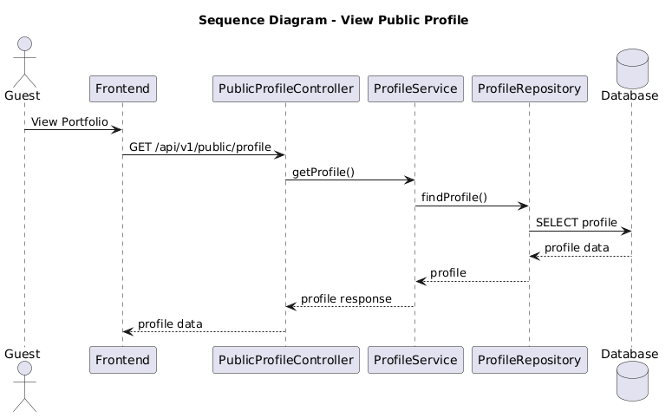

NGUỒN: SƠ ĐỒ SEQUENCE DIAGRAM - VIEW PROFILE [PORTFOLIO]

Code
@startuml
title Sequence Diagram - View Public Profile

actor Guest
participant Frontend
participant PublicProfileController
participant ProfileService
participant ProfileRepository
database Database

Guest -> Frontend : View Portfolio

Frontend -> PublicProfileController : GET /api/v1/public/profile

PublicProfileController -> ProfileService : getProfile()

ProfileService -> ProfileRepository : findProfile()

ProfileRepository -> Database : SELECT profile

Database --> ProfileRepository : profile data

ProfileRepository --> ProfileService : profile

ProfileService --> PublicProfileController : profile response

PublicProfileController --> Frontend : profile data

@enduml

