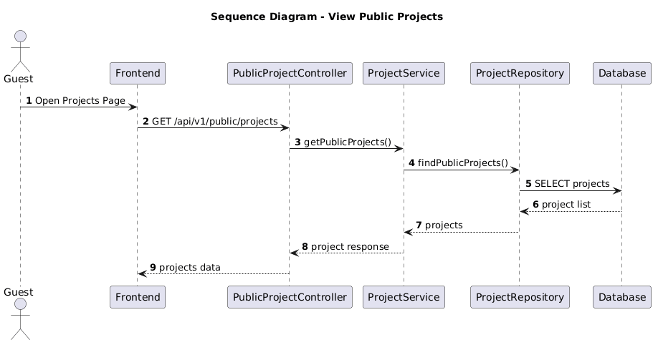

NGUỒN: SƠ ĐỒ SEQUENCE DIAGRAM - VIEW PROJECT [PORTFOLIO]
Code
@startuml
autonumber

title Sequence Diagram - View Public Projects

actor Guest
participant Frontend
participant PublicProjectController
participant ProjectService
participant ProjectRepository
participant Database

Guest -> Frontend : Open Projects Page

Frontend -> PublicProjectController : GET /api/v1/public/projects

PublicProjectController -> ProjectService : getPublicProjects()

ProjectService -> ProjectRepository : findPublicProjects()

ProjectRepository -> Database : SELECT projects

Database --> ProjectRepository : project list

ProjectRepository --> ProjectService : projects

ProjectService --> PublicProjectController : project response

PublicProjectController --> Frontend : projects data

@enduml

