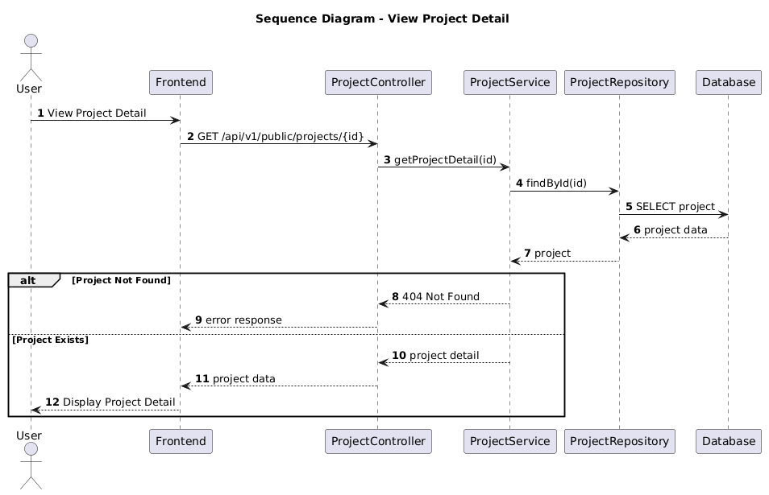

NGUỒN: SƠ ĐỒ SEQUENCE DIAGRAM - VIEW PROJECT DETAIL [PORTFOLIO]
Code
@startuml
autonumber

title Sequence Diagram - View Project Detail

actor User
participant Frontend
participant ProjectController
participant ProjectService
participant ProjectRepository
participant Database

User -> Frontend : View Project Detail

Frontend -> ProjectController : GET /api/v1/public/projects/{id}

ProjectController -> ProjectService : getProjectDetail(id)

ProjectService -> ProjectRepository : findById(id)

ProjectRepository -> Database : SELECT project

Database --> ProjectRepository : project data

ProjectRepository --> ProjectService : project

alt Project Not Found

ProjectService --> ProjectController : 404 Not Found

ProjectController --> Frontend : error response

else Project Exists

ProjectService --> ProjectController : project detail

ProjectController --> Frontend : project data

Frontend --> User : Display Project Detail

end

@enduml

