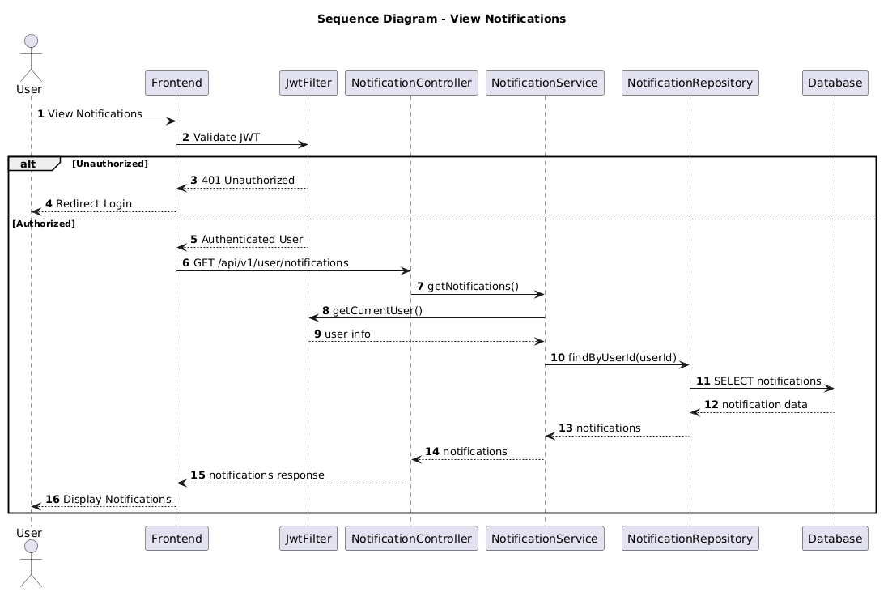

NGUỒN: SƠ ĐỒ SEQUENCE DIAGRAM - VIEW NOTIFICATIONS [PORTFOLIO]

Code
@startuml
autonumber

title Sequence Diagram - View Notifications

actor User
participant Frontend
participant JwtFilter
participant NotificationController
participant NotificationService
participant NotificationRepository
participant Database

User -> Frontend : View Notifications

Frontend -> JwtFilter : Validate JWT

alt Unauthorized

JwtFilter --> Frontend : 401 Unauthorized

Frontend --> User : Redirect Login

else Authorized

JwtFilter --> Frontend : Authenticated User

Frontend -> NotificationController : GET /api/v1/user/notifications

NotificationController -> NotificationService : getNotifications()

NotificationService -> JwtFilter : getCurrentUser()

JwtFilter --> NotificationService : user info

NotificationService -> NotificationRepository : findByUserId(userId)

NotificationRepository -> Database : SELECT notifications

Database --> NotificationRepository : notification data

NotificationRepository --> NotificationService : notifications

NotificationService --> NotificationController : notifications

NotificationController --> Frontend : notifications response

Frontend --> User : Display Notifications

end

@enduml

