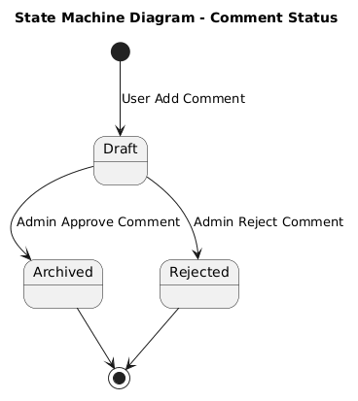

NGUỒN: SƠ ĐỒ STATE MACHINE DIAGRAM - COMMENT [PORTFOLIO]

Code
@startuml

title State Machine Diagram - Comment Status

[*] --> Draft : User Add Comment

state Draft
state Archived
state Rejected

Draft --> Archived : Admin Approve Comment

Draft --> Rejected : Admin Reject Comment

Archived --> [*]

Rejected --> [*]

@enduml

