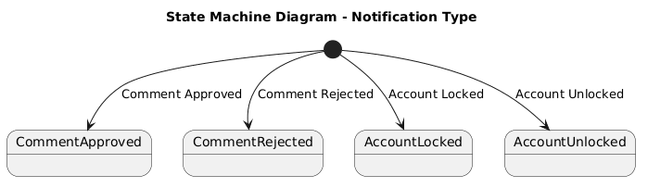

NGUỒN: SƠ ĐỒ STATE MACHINE DIAGRAM - NOTIFICATION [PORTFOLIO]

Code
@startuml

title State Machine Diagram - Notification Type

[*] --> CommentApproved : Comment Approved

[*] --> CommentRejected : Comment Rejected

[*] --> AccountLocked : Account Locked

[*] --> AccountUnlocked : Account Unlocked

state CommentApproved
state CommentRejected
state AccountLocked
state AccountUnlocked

@enduml

